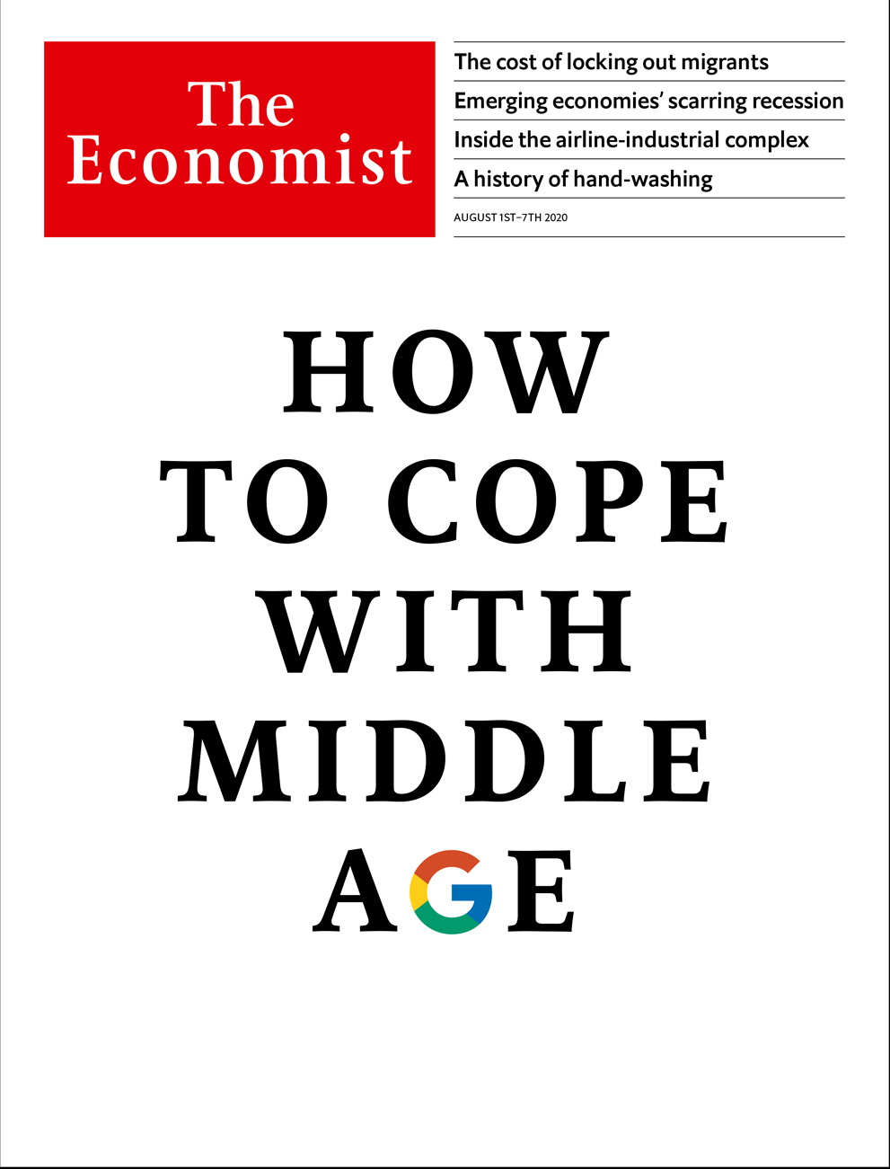

# Table of Contents

The world this week

Politics this week

Business this week

KAL’s cartoon

Leaders

Google: How to cope with middle age

Global migration: Locked out

Sino-American relations: One thing after another

Belarus: The next revolution?

Airlines: Don’t carry flag-carriers

Regional inequality: Levelling up Britain

Letters

Letters to the editor: On race and liberalism

Briefing

Alphabet: Google grows up

Asia

75 years after Hiroshima: Never forget

Singapore: From fairway to highway

Malaysia: Down and out

Sri Lanka’s election: Pax Rajapaksa

Banyan: Spiked

China

Voting with their feet: One country, two passports

Transgender justice: Evolving rights

Chaguan: China digs its past

United States

Policy towards China: Peering through the smoke

Tech titans testify: Hearing without listening

Posthumous hip-hop hits: Dead rappers are killing it

Crime statistics: Few signs of a surge

Lexington: Mid-century modern

The Americas

Canada and America: No Canuck do

Crime in Canada: Rough justice

The Galapagos islands: Fishy business

Bello: The return of rigged elections

Middle East & Africa

Turkey and the Arab world: Ottoman redux

Covid-era travel in the Gulf: Viral vacations

Pollution in Africa: A smouldering sky

South Africa and the IMF: Fund facts

Ethiopia: Urban brawl

Europe

Italy: How to spend it

Covid-19 in Europe: Still with us

The Aegean: Muddying the waters

Turkey: The queen is dead

Charlemagne: Euro crisis (with guns)

Britain

Regional economics: The national tilt

Urban explorers: Beauty in decay

Public transport: Going underground

Obesity: Witness the fitness

Competition policy: A world leader after all

International

Migration after covid-19: Tearing up the welcome mat

Business

The airline-industrial complex: Terminal conditions

Bartleby: Back on the chain gang

Bicycles: Electric shock

Technology companies: Wish upon a STAR

Schumpeter: A GE whodunnit

Finance & economics

Emerging markets: A sigh of relief, a gasp for breath

India’s banks: Delayed reaction

Buttonwood: The SPAC hack

Bridgewater: Troubled waters

The dollar dips: The price of gold surges to an all-time high

The European Union: Filling the coffers

Emmanuel Farhi: A lost asset

Free exchange: The Replacements

Science & technology

Electric cars: Million-mile car batteries are coming

Concussion: RAT tales

Palaeomicrobiology: The bugs that time forgot

Books & arts

Ways of seeing: Attention pays

Cheating in sport: Through the mousehole

Icelandic fiction: Lines of beauty

Understanding data: Sums of all fears

Home Entertainment: “The Seventh Seal”

Perspectives: Cleanliness is next to growth

Economic & financial indicators

Economic data, commodities and markets

Graphic detail

Twitter’s algorithm: Relevant content

Obituary

László Bogdán: The tale of a village



### Friday, July 31, 2020

|  |  |
| --- | --- |
| The world this week | 3 |
| Leaders | 6 |
| Letters | 1 |
| Briefing | 1 |
| Asia | 5 |
| China | 3 |
| United States | 5 |
| The Americas | 4 |
| Middle East & Africa | 5 |
| Europe | 5 |
| Britain | 5 |
| International | 1 |
| Business | 5 |
| Finance & economics | 8 |
| Science & technology | 3 |
| Books & arts | 6 |
| Economic & financial indicators | 1 |
| Graphic detail | 1 |
| Obituary | 1 |

|  |  |  |
| --- | --- | --- |
|  | Sections | Leaders |

The world this week

Politics this week

.

Business this week

.

KAL’s cartoon

.

|  |  |  |
| --- | --- | --- |
|  | Sections | Leaders |

|  |  |  |  |
| --- | --- | --- | --- |
|  | Articles | Sections | Next |

# Politics this week

Jul 30th 2020 |

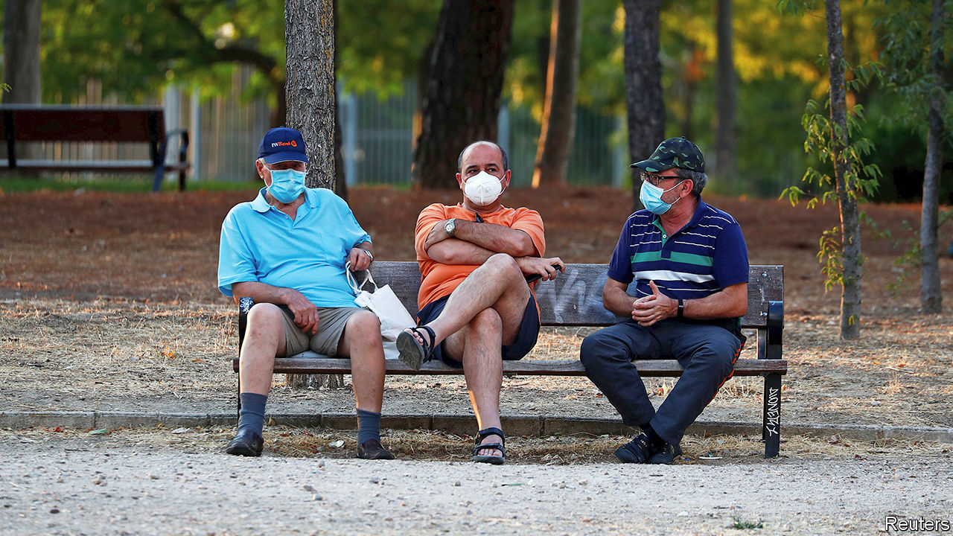

There were fears in Europe of a resurgence of covid-19. Catalonia returned to a form of lockdown. Britain announced that people arriving from Spain, including British tourists coming back from the beach, should quarantine for 14 days. The Spanish government was irked. Croatia, Germany, Luxembourg and Romania all saw localised spikes of coronavirus. Still, Europeans are much better prepared now than they were when the pandemic began. See article.

China recorded dozens of new infections in a day, the biggest tally since March. Most were reported in Urumqi, the capital of Xinjiang. Travel restrictions in the western region were already strict, as the central government seeks to crush dissent among mostly Muslim Uighurs.

China ordered the closure of the American consulate in Chengdu in retaliation for America shutting down the Chinese consulate in Houston. Chengdu is in western China; the American consulate there also covered Tibet, another restive region where foreign scrutiny is unwelcome. See [article](https://www.economist.com/node/21790200).

Hong Kong’s government said it had disqualified 12 pro-democracy figures from standing in elections in September for the Legislative Council, the territory’s (until now) semi-democratic parliament. It also arrested more students. See [article](https://www.economist.com/node/21790256).

Najib Razak, Malaysia’s prime minister from 2009 to 2018, was sentenced to 12 years in jail and fined $49m after being found guilty of seven charges related to the theft of billions of dollars from 1MDB, a development fund. He still faces verdicts in other trials. Mr Naijb, who said he thought the vast fortune in his personal bank account was a donation from a Saudi royal, remains free, pending an appeal. See article.

The US defence secretary, Mark Esper, announced the withdrawal of nearly 12,000 American troops from Germany. President Donald Trump had criticised Germany’s reluctance to spend more on defence. Mr Esper said the decision would bolster NATO and deter Russia. He suggested that some of the troops could be redeployed on Russia’s doorstep around the Black Sea and in the Baltic countries.

The federal quasi-military agents sent to Portland to help quell violent protests are to leave the city’s centre, on the condition that Oregon provides security to protect the federal courthouse there.

South Africa took a $4.3bn emergency loan from the IMF to soften the economic shock of covid-19. The loan marks a big change for South Africa, which had previously shunned the IMF so as not to dilute its economic sovereignty. See article.

Perrance Shiri, Zimbabwe’s agriculture minister, died, reportedly of covid-19. He led the Fifth Brigade in Matabeleland in the 1980s, which tortured and massacred thousands of suspected opponents of the despot, Robert Mugabe, and their families. He once likened himself to Jesus, since he decided who lived and who died.

Parliamentarians in Somalia voted to remove Hassan Ali Khaire as prime minister. America, which supports the Somali army in its fight against the jihadists of al-Shabab, called the process flawed. Lawmakers say Mr Khaire failed to prepare the country for elections next year.

Tundu Lissu, an opposition politician in Tanzania who was shot 16 times in 2017 but survived, returned from exile in Belgium, hoping to run for president. Mr Lissu has also been arrested several times for such things as “insulting” John Magufuli, the incumbent. Elections are scheduled for October.

Israel fired on gunmen from Hizbullah, the Lebanese armed Islamist movement. Binyamin Netanyahu, the Israeli prime minister, said they were trying to “infiltrate our territory”.

Iran fired missiles at a replica aircraft-carrier in the Strait of Hormuz. The exercise was seen as a warning to America. Days earlier Iran accused an American fighter jet of coming too close to an Iranian passenger plane in Syrian airspace.

Five young women were sentenced to two years in prison by an Egyptian court for posting “indecent” videos on TikTok. They had let their fans see them dancing and telling jokes. The authorities are cracking down on popular social-media influencers who they say fail to uphold Egypt’s conservative values.

Ecuador’s defence minister said he was monitoring a fleet of around 260 mostly Chinese-flagged fishing boats that have gathered in international waters close to the Galapagos Islands. Chinese fishermen come each year to the spot, which is teeming with marine creatures. In 2017 a boat was caught with 300 tonnes of wildlife, mostly critically endangered sharks, which are a delicacy in China. See article.

In Bolivia the electoral court postponed the country’s presidential election for a second time. It had been rescheduled to take place in early September, but because of covid-19 the date was pushed back to October 18th. The left-wing opposition rallied its supporters to protest against the delay. It has accused Jeanine Áñez, the centre-right interim president, of using the pandemic to cling to power. See article.

## Coronavirus briefs

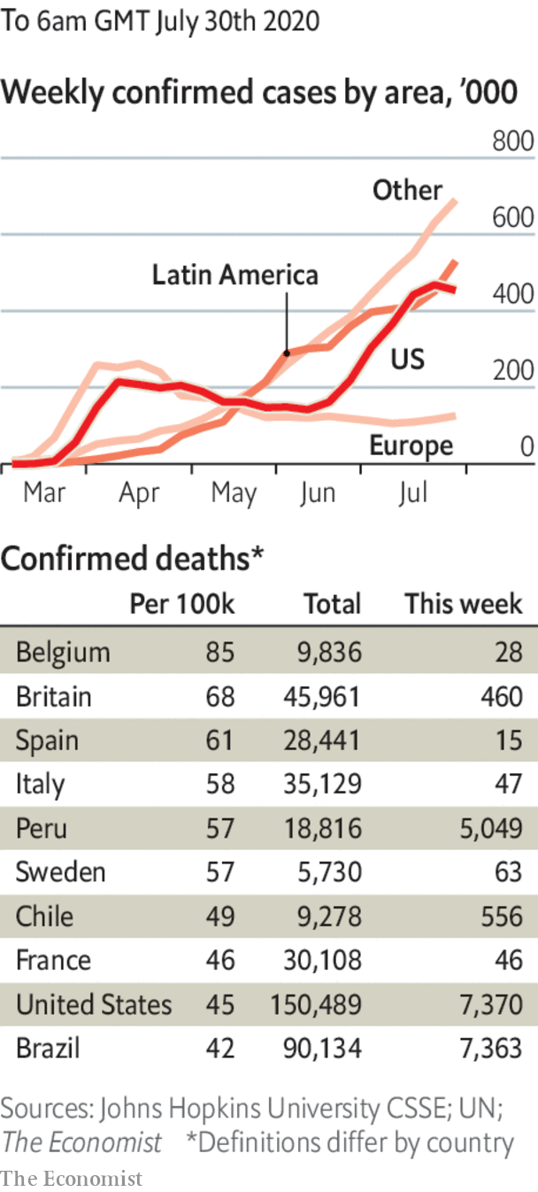

Vietnam recorded its first infections since April. It has still reported no deaths.

North Korea admitted that the virus was in the country. It locked down the border city of Kaesong, and accused a defector who swam back across the border from South Korea of bringing the disease.

Australia had its worst day for deaths and new cases since the start of the pandemic. See [article](https://www.economist.com/asia/2020/07/30/a-second-covid-19-wave-is-worrying-australia-japan-and-hong-kong).

Jair Bolsonaro, Brazil’s president, said he had recovered from covid-19, after a fourth test came up negative.

Robert O’Brien, Donald Trump’s national security adviser, tested positive for the virus, the most senior member of the administration to do so.

Mr Trump in effect cancelled the bit of the Republican convention that was to be held in Jacksonville because of Florida’s surging infections. See [article](https://www.economist.com/united-states/2020/07/26/donald-trump-cancels-his-florida-celebration).

This article was downloaded by calibre from <https://www.economist.com/the-world-this-week/2020/07/30/politics-this-week>

|  |  |  |  |
| --- | --- | --- | --- |
|  | Articles | Sections | Next |

|  |  |  |  |
| --- | --- | --- | --- |
| Previous | Articles | Sections | Next |

# Business this week

Jul 30th 2020 |

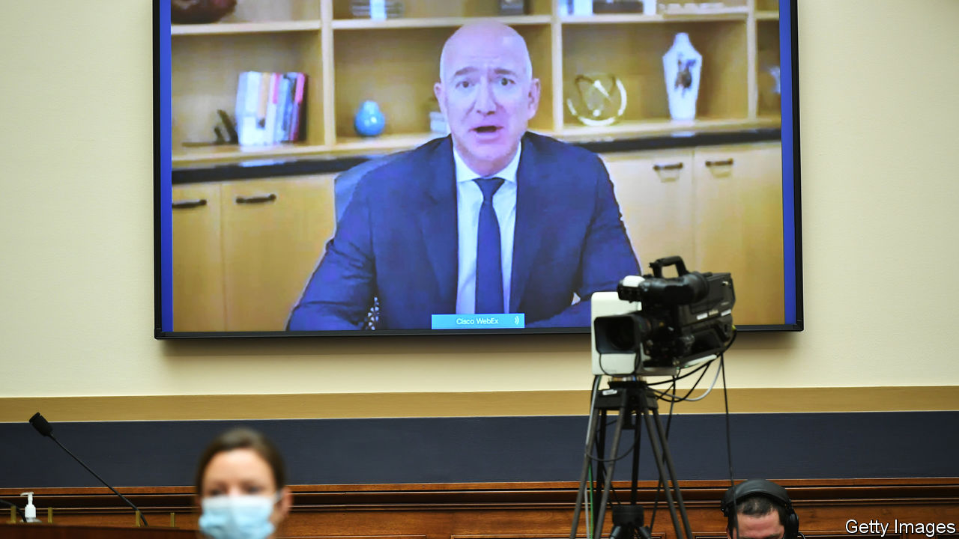

The bosses of Amazon, Apple, Facebook and Google faced sharp questions (remotely) from a committee in America’s Congress about their companies’ market dominance and whether they should be broken up. It was the first time that Jeff Bezos, Amazon’s chief executive, had appeared before lawmakers. He insisted that his platform accounts for only a small portion of overall retail sales, and that it has supported a spurt in growth at small and medium-sized businesses. See article.

Google extended the period during which it expects employees to be working remotely because of covid-19. It will allow most staff to work from home until at least July next year. See article.

After terse negotiations within the party, the Republicans in Congress presented their plan for a new stimulus package, amounting to $1trn in spending. The bill extends a federal top-up to weekly unemployment benefits that has been in place since March, but slashes its generosity from $600 to $200; from September, the scheme would aim to replace 70% of workers’ lost wages. It also provides for another round of stimulus cheques to all households. The Democrats have alternative proposals.

The German economy contracted by 10.1% in the second quarter compared with the first, or by 11.7% from the same three months last year. On both measures, it was the biggest decline in quarterly records that stretch back to 1970.

Russia’s central bank reduced its benchmark interest rate for the fourth time since January, lowering it by another quarter of a percentage point, to 4.25%. Elvira Nabiullina, the central bank’s governor, said that more cuts could come before the end of the year.

Saddled with huge write-downs of assets, around half of which originated in its British retail bank, Santander reported a quarterly loss of €11.1bn ($12.2bn), the first in the Spanish lender’s 163-year history. It is the biggest loss in the banking industry since UniCredit’s €13.6bn-worth of red ink in the last quarter of 2016.

Boeing reported a $2.4bn quarterly loss and made further cuts to production. It also confirmed that it will stop building the 747, which entered service in 1970, bringing cheaper long-haul flights to millions. See article.

## Long fall

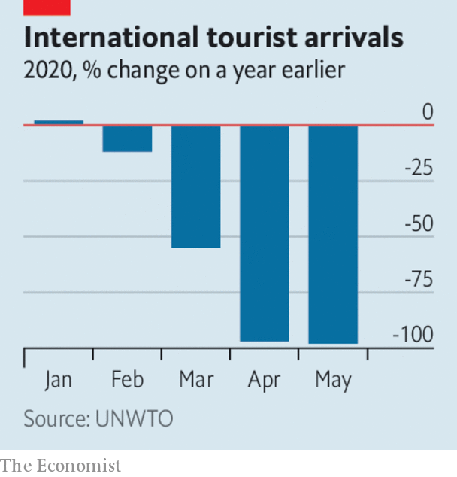

The World Tourism Organisation said that up to the end of May the industry saw a 56% fall in tourist arrivals, year on year, translating to $320bn in lost revenue, three times more than in 2009, during the financial crisis. Although tourism accounts for a much bigger part of the economy in smaller countries, a few big economies will feel the hit, too. Tourism is worth 7% of GDP in France and 12% in Spain; they are the number one and two destinations for holiday-makers.

Goldman Sachs reached an agreement with the government of Malaysia to settle criminal charges related to the 1MDB scandal. The bank will pay $2.5bn to the government and guarantee it receives at least another $1.4bn from 1MDB’S assets that have been seized by authorities around the world. Malaysia’s finance ministry said the settlement represented Goldman’s acknowledgment of misconduct by two former employees.

Nissan said it was on course to register an annual net loss of ¥670bn ($6.4bn); sales in the latest quarter dropped by half compared with the same three months last year. Like most carmakers, Nissan is reeling from plunging demand during the pandemic. Bucking that trend, PSA, the maker of Peugeots and Citroëns, reported a surprise profit for the first half of the year, even though revenues plummeted.

Jaguar Land Rover appointed Thierry Bolloré as its new chief executive. Mr Bolloré was ousted as CEO of Renault in a bout of corporate bloodletting last October, when the carmaker was still reeling from the Carlos Ghosn scandal. He will join JLR in September.

The average age of cars on American roads has approached almost 12 years, and around a quarter are at least 16 years old, according to IHS Markit. That is the highest in two decades; in 2002 the average age was around 9.5 years. Improved mileage and better- built vehicles mean that motorists are more inclined to hang on to their Betsy, perhaps more so now that commuting times have dropped during the pandemic, so cars should last even longer.

## A Kodak moment

It failed to foresee the digital revolution that overthrew the market for camera film, but Kodak has been quick to seek out opportunities in the coronavirus crisis. The company signed a deal with the American government to make active pharmaceutical ingredients for generic drugs with the support of a development loan, the first under a programme to boost domestic production in response to covid-19. In the days following the announcement Kodak’s stock rose by 2,190%.

This article was downloaded by calibre from <https://www.economist.com/the-world-this-week/2020/07/30/business-this-week>

|  |  |  |  |
| --- | --- | --- | --- |
| Previous | Articles | Sections | Next |

|  |  |  |  |
| --- | --- | --- | --- |
| Previous | Articles | Sections | Next |

# KAL’s cartoon

Jul 30th 2020 |

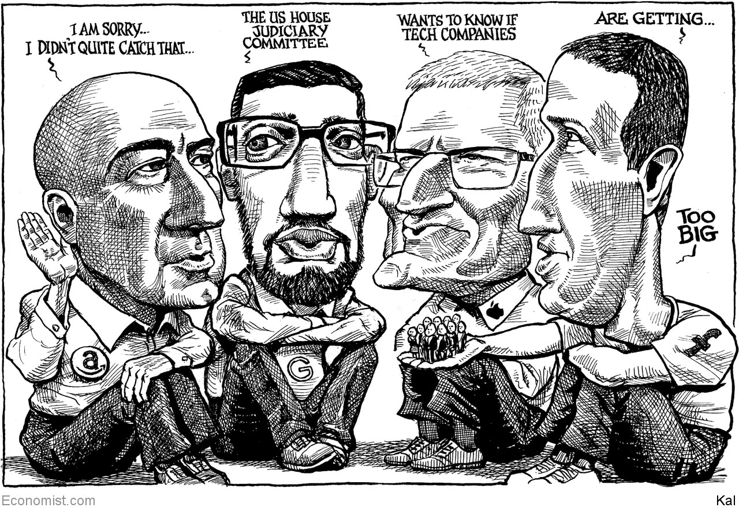

This article was downloaded by calibre from <https://www.economist.com/the-world-this-week/2020/07/30/kals-cartoon>

|  |  |  |  |
| --- | --- | --- | --- |
| Previous | Articles | Sections | Next |

|  |  |  |
| --- | --- | --- |
| The world this week | Sections | Letters |

Leaders

Google: How to cope with middle age

.

Global migration: Locked out

.

Sino-American relations: One thing after another

.

Belarus: The next revolution?

.

Airlines: Don’t carry flag-carriers

.

Regional inequality: Levelling up Britain

.

|  |  |  |
| --- | --- | --- |
| The world this week | Sections | Letters |

|  |  |  |  |
| --- | --- | --- | --- |
|  | Articles | Sections | Next |

#### How to cope with middle age

# Google has outgrown its corporate culture

It is time to learn from its elders

Jul 30th 2020 |



IT MAY BE just 21 years old, but Google is in the midst of a mid-life crisis. As so often in such cases, all seems well on the surface. Every day its search engine handles 6bn requests, YouTube receives 49 years’ worth of video uploads and Gmail processes about 100bn emails. Thanks to its dominance of online advertising, Google’s parent company, Alphabet, made a profit of $34bn last year. Beyond its core operations, it is a world leader in artificial intelligence (AI), quantum computing and self-driving cars. Along with the bosses of Amazon, Apple and Facebook, its chief executive, Sundar Pichai, was grilled this week by lawmakers in Washington, DC, who fret that America’s tech giants need to be restrained because they are so profitable. Crisis? What crisis?

Being hauled before Congress is, on the face of it, a sign of success. But it also marks a difficult moment for Google’s leaders: the onset of corporate middle age (see article). This is a problem as old as business itself. How do companies sustain the creativity and agility that made them great, even as they forge a culture and corporate machine that is built to last? For Google the transition is especially dramatic because its founders, Larry Page and Sergey Brin, tried from the start to build a firm in which this moment would never arrive. As Google prepared to go public in 2004 they declared that it was not a conventional company, and “we do not intend to become one”. They hoped playground-like offices, generous perks and a campus atmosphere would allow it to retain the agility and innovation of a startup as it grew. The appearance of wrinkles on the corporate forehead is an admission of failure.

The signs of ageing are apparent in Google’s maturing business, its changing culture and its ever-more-entwined relationship with government. Take the business first. The firm is running up against growth constraints in its near-monopolies of search and online-advertising tools. Its market share in search ads is around 90%. Unearthing other gold mines has proved difficult. None of the ambitious “moonshot” projects into which Alphabet has poured billions, such as delivery drones and robots, has been a breakout success. To keep growing, Google is having to try to muscle in on the turf occupied by big tech rivals, such as cloud computing and enterprise software and services.

The cultural challenge is fuzzier but no less urgent for a firm that is proud of its unusual corporate character. The freewheeling ethos that was so successful in Google’s early days has become a liability. It works much less well at scale. Google now has nearly 120,000 employees, and even more temporary contractors. Doing things from the bottom up has become harder as the workforce has grown larger and less like-minded, with squabbles breaking out over everything from gender politics and the serving of meat in cafeterias to Google’s sale of technology to police forces.

The third sign of lost youth, the attention of trustbusters, has long looked inevitable. As big tech has grown, so have its interactions with government—as an institution to lobby, as a customer and as a regulator. America’s Justice Department is poring over Google’s online-ads businesses and may soon file an antitrust suit. Scrutiny is unlikely to wane as the tech titans break out of their silos and compete more. Indeed, regulators may take it as a sign of broadening power (see article).

How should Google respond? To be both innovative and mature is a hard trick to pull off. History is littered with failed attempts. In giving it a go, the firm has to decide who it puts its faith in: managers, investors or geeks?

The first route would involve taking a strong dose of managerial medicine to become a more tightly run conglomerate. The archetype for this approach is GE in its heyday under Jack Welch, who persuaded shareholders that sprawling businesses could work well, provided they were run by expert managers (see [article](https://www.economist.com/node/21790213)). But it turned out that GE was disguising weaknesses in its industrial units by leaning on its financial arm, GE Capital. GE’s subsequent woes offer a warning of the peril of relying on one hugely successful division to subsidise less profitable units elsewhere—as Google does with its advertising business.

If doubling down on the conglomerate model is not the answer, what about the opposite approach: spinning off, selling or closing some units and returning money to shareholders? That would please many investors. By some calculations, Alphabet is worth $100bn less than the sum of its parts. Spinning off YouTube would increase competition in internet advertising—a handy sop to regulators—as well as unlocking value. It might be worth more than Netflix, because it need not pay for content, most of which is user-generated. But the experiences of firms like AT&T and IBM highlight the danger that downsizing hollows out innovation. And while Google might hope to retain its distinctive culture in whittled-down form, the truth is that no matter how much it wants to be as youthful and free-spirited as Peter Pan, it is no longer a startup.

That leaves trusting the geeks. Becoming a glorified venture-capital outfit has appeal, but the woes of SoftBank’s Vision Fund warn of hubris. Google would do better to examine how two older tech giants overcame their own mid-life crises (and near-death experiences): Microsoft, nearly broken up by antitrust regulators, and Apple, which spent years in the wilderness before Steve Jobs returned to reinvent it as a maker of portable devices. Both bounced back by rediscovering their core purpose and applying it in a new way. Under Satya Nadella, Microsoft has reinvented itself as a provider of cloud-based software tools and services, rather than its Windows operating system. And Apple, previously known for its elegant, easy-to-use computers, has minted money by applying its genius to smartphones.

Could Google similarly identify what it does best and apply it in new areas? It could decide its mission is helping consumers trade their personal data for goods and services; or using AI to solve more of the world’s problems; or being the data processor of net-enabled gadgets. At the moment it is betting on almost everything. Indiscipline can lead to unexpected innovations, but more often saps vitality. Google’s best way forward is to follow the advice often given to victims of a mid-life crisis: slim down, decide what matters and follow the dream. ■

This article was downloaded by calibre from <https://www.economist.com/leaders/2020/07/30/google-has-outgrown-its-corporate-culture>

|  |  |  |  |
| --- | --- | --- | --- |
|  | Articles | Sections | Next |

|  |  |  |  |
| --- | --- | --- | --- |
| Previous | Articles | Sections | Next |

#### Locked out

# As the pandemic recedes, let migrants move again

Where it is safe enough to welcome tourists, it is safe enough for immigrants

Aug 1st 2020 |

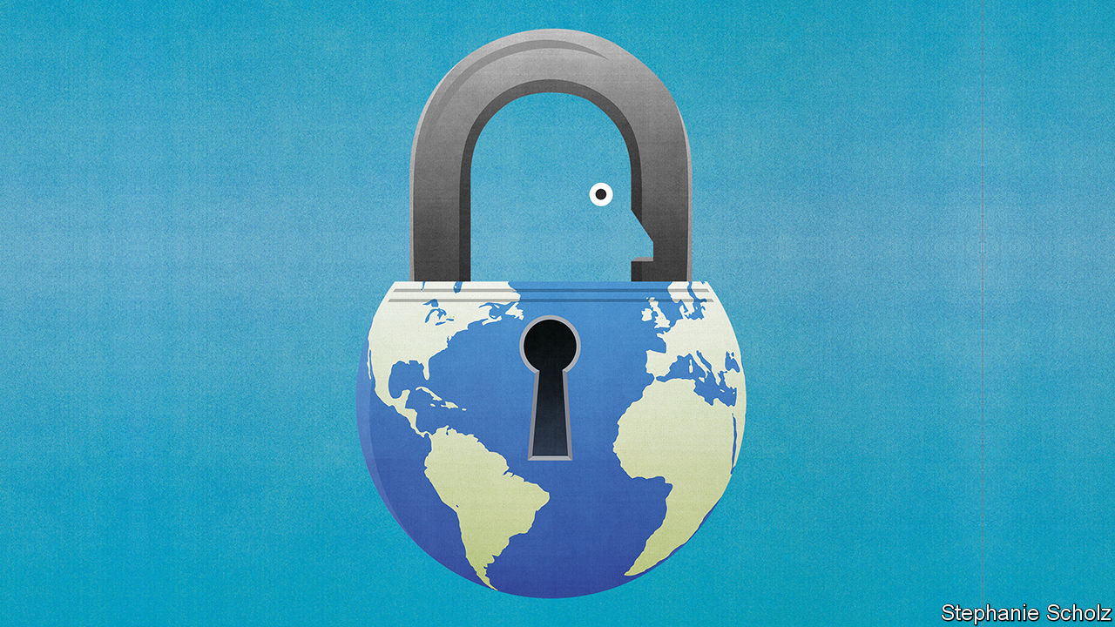

EVERY COUNTRY in the world has closed or partly closed its borders since the pandemic began. In total, they have issued more than 65,000 restrictions on mobility. For some places, especially islands, border controls have bought valuable time to prepare for covid-19. But the costs of global immobility are immense (see article). Billions of cancelled journeys means millions of jobs obliterated, lives blighted and dreams deferred. When bankers and tourists stopped flying to the United Arab Emirates (UAE), for example, the migrants who made beds and stirred soup were laid off. Foreigners without jobs are required to leave the Gulf, but lots of them cannot, because so many flights have been grounded. Globally, tens of millions of migrants have been stranded, burning through the savings they had hoped would lift their families out of poverty and put their children through school. Some have ended up begging; and since that is a crime in the UAE, several have been arrested.

Migration policy is far from the top of any country’s agenda just now. And with the coronavirus still raging, a return to normality will be impossible for some time. But governments will sooner or later have to grapple with an important question. As they gradually and fitfully open up again for tourists and business travellers, will they also welcome migrants?

There are emotive reasons why covid-19 might make countries less willing to accept foreigners even after a vaccine is discovered and the pandemic is suppressed. People are scared: not only of this pandemic but also of the next. Many associate foreigners with disease. (Dramatic news stories, such as a boat full of covid-infected migrants crossing the Mediterranean, can feed this impression.) Suspicion of foreigners is why people who look Chinese have been harassed in many countries, and people who look African have been harassed in China. It is why President Donald Trump has boasted about banning Chinese travellers (even as he downplayed masks), and why one of the South African government’s first actions to curb covid-19 was to build a fence on the border with Zimbabwe (though the virus was already spreading in South Africa).

In addition, covid-19 has caused mass unemployment. Many voters believe that migrants take jobs from the native-born, and so would keep curbs on immigration even after other travel restrictions are loosened. Mr Trump is one of many politicians who make this argument explicitly. His executive order in June suspending most kinds of work visa was aimed at “Aliens Who Present a Risk to the US Labour Market”.

Both these fears are electorally potent, but neither is well-founded. Tourists and business travellers vastly outnumber migrants. In Britain, for example, the total number of arrivals last year was 60 times more than the number of immigrants who showed up. When it is possible to open borders to short-term travellers, it should also be possible to open them for migrants. Unlike tourists, people who plan to stay for years will not object to a two-week quarantine on arrival. The precautions that work best—social distancing, contact-tracing, handwashing and testing—pay no heed to nationality. Nor does the virus.

The idea that more migrants means fewer jobs for locals in the long run is an example of the fallacy that the economy has a fixed “lump of labour”. As well as spending their wages, which supports new jobs, migrants bring a greater diversity of skills to the workforce, allowing the labour market as a whole to operate more efficiently. In the short term, rich countries may not need as many hotel or airline workers, but policymakers can tailor admission criteria to make sure that those who come meet local needs and can support themselves.

This is the opposite of Mr Trump’s nail-the-doors-shut approach. He has locked out skilled workers, internal company transfers and even foreign students, if they have not yet arrived and their courses are online. This is a recipe for a poorer, more insular America, where domestic firms cannot hire the best, foreign investors cannot send in technicians to unblock bottlenecks and brainy youngsters opt to study and settle in Canada.

Alas, America is not the only place where the pandemic has spurred nativists to clamp down. Italy is alarmed at Africans crossing the Mediterranean. Malaysia has pushed boatloads of Rohingya refugees back into international waters. The army chief in the Maldives has called migrant workers a security threat, not least because some date locals. South Africa temporarily closed migrant-owned shops in townships, forcing customers to walk miles to distant grocery stores, thereby spreading the virus.

However, even as covid-19 has immobilised the world, it is making some people appreciate the benefits of mobility. Many voters in rich countries have noticed that doctors are often migrants: 53% in Australia, 29% in America. The same is true of nurses, care-home workers and virus-busting mop-wielders. When people bang pots for health-care workers, they applaud a lot of foreigners.

Migrants are also over-represented among those who make it possible for others to work safely and productively at home, by harvesting and processing food, delivering parcels and fixing software bugs. They turbocharge innovation, too. Some 40% of medical and life scientists in America are foreign-born. Vaccine research depends on large teams of talents from all around the world. Half the big American tech firms were founded by a first- or second-generation immigrant. If the founder of Zoom had never left China, locked-down professionals might not even know what their colleagues’ bookshelves look like.

## Open the windows, open the doors

Some countries may end up more open after the pandemic than they were before. Japan is allowing foreign “trainees”, as it calls migrant workers, to switch jobs. Britain will be less open to migrants from the EU, because of Brexit, but just offered residency to up to 3m Hong Kongers without a perceptible backlash at home (see article).

When the coronavirus is vanquished, migration will still be what it was before: a powerful tool that can lift up the poor, rejuvenate rich countries and spread new ideas around the world. A pandemic is no reason to abandon it. ■

Editor’s note: Some of our covid-19 coverage is free for readers of The Economist Today, our daily [newsletter](https://my.economist.com/user#newsletter). For more stories and our pandemic tracker, see our [hub](https://www.economist.com/news/2020/03/11/the-economists-coverage-of-the-coronavirus)

This article was downloaded by calibre from <https://www.economist.com/leaders/2020/08/01/as-the-pandemic-recedes-let-migrants-move-again>

|  |  |  |  |
| --- | --- | --- | --- |
| Previous | Articles | Sections | Next |

|  |  |  |  |
| --- | --- | --- | --- |
| Previous | Articles | Sections | Next |

#### America takes aim at China

# US-China relations are entering a dangerous period

Why cool heads must prevail

Aug 1st 2020 |

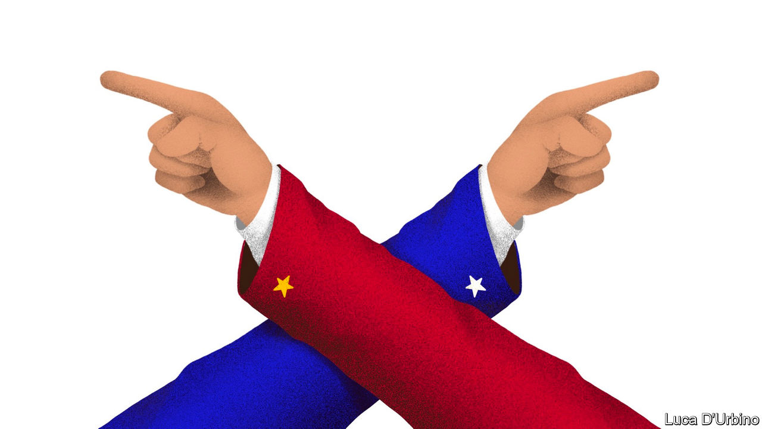

IN A BOOK of essays called “The Next Great War?”, which examines Sino-American relations through the lens of the first world war, Richard Rosecrance warns of “the tyranny of small things”, the points of friction and misunderstanding between rival powers that, without leadership to manage them, can lead to conflict. China and America today are not about to take up arms, but small things are rapidly accumulating. The two distrust each other more now than at any point since Richard Nixon went to China almost 50 years ago. As a presidential election draws near, the potential for dangerous miscalculation is growing.

On July 27th America’s consulate in Chengdu closed on orders from Beijing. It was in retaliation for the Trump administration’s order, a week earlier, to close China’s consulate in Houston, the first such moves since the normalisation of relations in 1979. This capped a month in which America sanctioned a sitting member of China’s Politburo, also a first, over the internment of Uighurs in Xinjiang; declared China’s expansive claims in the South China Sea illegal; ceased to recognise Hong Kong as distinct from mainland China; and claimed a victory in its campaign against Huawei, when Britain announced that it would bar the telecoms-equipment giant from its 5G networks.

For the hawks who surround President Donald Trump, this is overdue. In a series of four speeches that evoked the cold war, they laid out their case for abandoning “blind engagement” with China for a more confrontational relationship. On June 26th Robert O’Brien, the national security adviser, said that Xi Jinping, China’s president, “sees himself as Josef Stalin’s successor”. On July 7th Christopher Wray, the FBI director, claimed that China was seeking to become “the world’s only superpower by any means necessary”, and warned of its extensive efforts to spy on, influence and co-opt Americans. On July 17th William Barr, the attorney-general, charged that Hollywood studios and America’s tech giants had become “pawns of Chinese influence”. And on July 23rd Mike Pompeo, the secretary of state, declared that Mr Xi was engaged in a decades-long battle for global supremacy, and that America and other democracies must fight back.

A new, realistic strategy for standing up to China would be welcome. The atrocities in Xinjiang and the demolition of the rule of law in Hong Kong demand a tougher response than the world has mustered thus far. China’s territorial ambitions in its near seas are worrying. Its economic leverage over trade partners and companies sets it apart as an adversary from its communist predecessor, the Soviet Union. In calling attention to the comprehensive and complex threat Mr Xi’s China poses, Mr Trump’s hawks have achieved something.

But their speeches add up to an attitude, not a strategy. They articulate a compelling argument for imposing pain on China, but no framework for judging how and when to do so. They talk about working with allies in loose, aspirational terms. They have little to offer on larger geopolitical concerns like climate change, other than to say China cannot be trusted to keep its commitments.

Another president might formulate a grand vision for how to engage China under such conditions (see article). These hawks have Mr Trump. His disregard for democratic allies and the cause of human rights, and his personal affinity for Mr Xi, make him singularly ill-suited to lead a contest with China over global values. He has gripes with China, over trade and covid-19, but these are not rooted in principle. His eyes are on what can get him re-elected.

That sets up a combustible dynamic in the months ahead. As the election approaches, Mr Trump could be persuaded to take more dramatic action—say, financial sanctions on Chinese banks in Hong Kong, or a military display of support for Taiwan. A mishap or misunderstanding could prove perilous. It is right to want to chart a more robust course in Sino-American relations—but it would also be wise to beware the tyranny of small things. ■

This article was downloaded by calibre from <https://www.economist.com/leaders/2020/08/01/us-china-relations-are-entering-a-dangerous-period>

|  |  |  |  |
| --- | --- | --- | --- |
| Previous | Articles | Sections | Next |

|  |  |  |  |
| --- | --- | --- | --- |
| Previous | Articles | Sections | Next |

#### Putin’s pal in peril

# The right way to get rid of President Alexander Lukashenko

If change comes to Belarus, let it be peaceful

Aug 1st 2020 |



AUTOCRATS AROUND the world have a lot to learn from Alexander Lukashenko, the president of Belarus, a former Soviet republic of 10m people between Poland and Russia. He was admired by the late Venezuelan president, Hugo Chávez, is championed by Hungary’s Viktor Orban and cordially received by China’s Xi Jinping. Vladimir Putin has copied some of his electoral dirty tricks. Mr Lukashenko has been in office longer than any of them, thanks to a mixture of populism, socialism, repression, Russian cash and European toleration.

But as Belarus heads into an election on August 9th, Mr Lukashenko faces one of the trickiest moments in his 26-year rule. The result is not in doubt—assuming the vote goes ahead. Belarus has not had a free or fair election since 1994, when the former collective-farm boss swept to power pledging to restore stability three years after the Soviet Union collapsed. With two of his challengers in jail and a third in exile, opinion polls banned, independent observers barred and riot police poised to crush protests, Mr Lukashenko is certain to declare himself the winner, with a fat majority. What is much less certain this time is whether Belarusians will accept the result. For the West, the election entails both risks and opportunities. Reducing the first and maximising the second will require principles and nerve.

The anti-Lukashenko surge has been triggered by his mishandling of covid-19, which he dismissed as a “psychosis” that could be treated with a few shots of vodka and a bit of tractor-driving. The underlying causes run far deeper. After nearly a decade of economic stagnation and no glimmer of change, Mr Lukashenko’s version of stability no longer sells. The regime’s opponents have rallied behind Svetlana Tikhanovskaya, a former teacher. She is not a career politician, but registered as a presidential candidate when her husband could not. He is a popular vlogger who was arrested by Mr Lukashenko’s goons to stop him running. She is joined by two other women, who represent the other disbarred candidates. Her only policy is to hold fresh and free elections within six months if she wins. Across Belarus, her rallies have gathered vast crowds and resembled rock concerts, people singing along to a song about tearing down prison walls.

It is hard to imagine Mr Lukashenko losing power. His riot police are conspicuously drilling on the streets of Minsk. His rigged election ten years ago resulted in cracked skulls, arrests, Western sanctions—and congratulations from Russia. This time, though, the discontent is much broader, and the room for manoeuvre narrower—so narrow that he could yet call the election off. Mr Lukashenko has long and skilfully played on the rivalry between Russia and the West. He extracted concessions from Russia for displaying nominal loyalty and touted Russia’s threat to keep the West off his back. But this balancing act has become more precarious. The Kremlin last year put great pressure on Mr Lukashenko to integrate the two countries politically so that Mr Putin could be president of both. Mr Lukashenko said no.

The Kremlin is now in an awkward spot. Mr Putin is facing his own protests in Russia’s far east. He hates the idea of a “colour revolution” in Belarus; but if he were to send troops to stop one, it would trigger more Western sanctions on top of those imposed on him for Russia’s bloody assault on Ukraine in 2014. Better for him, perhaps, to let the Belarusian leader launch his own crackdown, making him a pariah and thus ultimately a supplicant.

That would be a dreadful outcome. The West must use whatever carrots and sticks it can muster to restrain Mr Lukashenko from using force against his own people, while also warning Russia against any subversive action. If change is indeed coming to Belarus, let it be peaceful. ■

This article was downloaded by calibre from <https://www.economist.com/leaders/2020/08/01/the-right-way-to-get-rid-of-president-alexander-lukashenko>

|  |  |  |  |
| --- | --- | --- | --- |
| Previous | Articles | Sections | Next |

|  |  |  |  |
| --- | --- | --- | --- |
| Previous | Articles | Sections | Next |

#### Stop carrying flag-carriers

# Airlines have a chance to emerge from the crisis leaner and greener

But that will require governments to reduce the power of incumbents

Aug 1st 2020 |

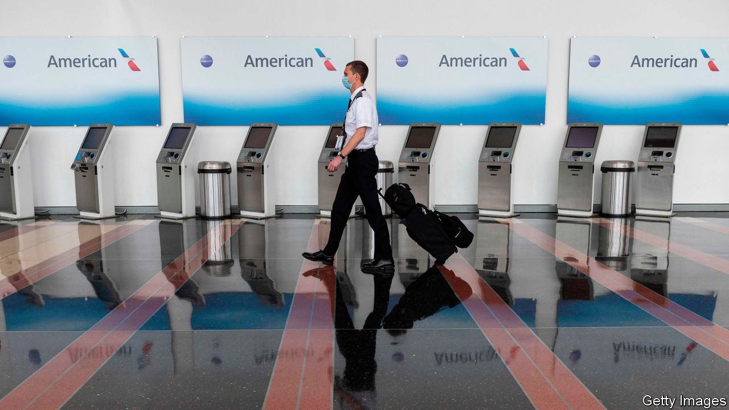

TO SEE THE damage from covid-19 to aviation, look up. Where once a criss-cross of vapour trails told of holidaymakers heading for the sun or executives keeping businesses on track, the wide yonder is now a brilliant blue. This year nearly 5bn passengers might have been expected to take to the skies, but the actual number is likely to be only half as big. A fragile recovery is susceptible to new waves of infection. Britain’s imposition this week of a quarantine on passengers returning from Spain is the latest setback. Traffic may not return to 2019 levels until 2024.

When it does rebound, the twin priorities should be to put the industry on a sounder financial footing, and to make flying less polluting. For both objectives the way forward is the same: to loosen incumbents’ grip on the skies.

Start with carbon emissions. The dramatic declines this year are a distraction because as people resume flying, emissions will start to rise again. Neither should the industry’s sorry financial state today relieve it of recent pressure to decarbonise in the future. For many years aviation mostly had a free pass when it came to regulations of the type that forced carmakers to clean themselves up. Before the pandemic that had been changing. Some airlines had begun to worry about their reputations as “flight shame” raised awareness of how travelling by air accelerated global warming. Aircraft-makers were starting to plan the next generation of cleaner planes.

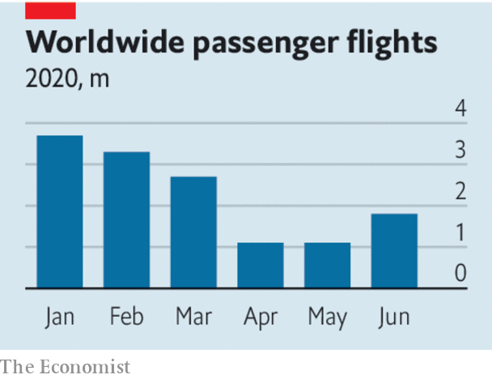

The question is how an industry whose finances are in tatters can make the vast investments and the huge technological leap required for net-zero-emissions flying. Bail-outs are the wrong answer. Only 30 airlines were profitable before the crisis and rescues will keep failing carriers alive. Some green strings are attached to rescue deals—a recognition of the changing mood—but they may not outweigh the zombifying effects of lavish rescue packages. Lufthansa’s €9bn ($9.8bn) bail-out allows it to buy 80 new fuel-efficient planes, but it took more money than it needed to preserve its position as a global airline. France’s aerospace bail-out includes €1.5bn to develop zero-emission planes and obliges airlines not to fly shorter routes between French cities that are served by trains. The exception? Feeder airports for Air France’s Paris hub. America’s airlines, showered with federal subsidies for decades, have trousered $25bn.

These efforts to keep incumbent airlines flying threaten to prevent bolder carriers from expanding. Waivers on airport-slot rules will further hamper new entrants. Regulators around the world suspended use-it-or-lose-it rules for the summer to help stricken carriers. Incumbents want an extension to cover the winter, too. But if slots cannot be reallocated, rivals will be constrained. In Europe agile, low-cost carriers like Wizz Air are rightly calling for slot-blocking to end.

If the industry is in the deep-freeze, it will slow the development of clean aeroplanes. Airbus has a goal of developing such an aircraft by 2035, whether using renewable fuels, electricity or hydrogen power, but the aerospace giants need to be sure that they will have a thriving market if they are to invest in them. Long industry lead times mean that Airbus will have to make firm plans in the next couple of years and Boeing will have to decide whether to respond soon after (see article).

Just as easyJet and Ryanair, now both huge airlines, took advantage of a glut of cheap aeroplanes after 9/11 and the deregulation of European airspace to expand rapidly, so a dynamic airline industry searching for new ways to grow would require new aircraft, encouraging Airbus and Boeing to make air travel greener. As well as setting back the industry, cosseting the old guard will do more damage to the planet. ■

Editor’s note: Some of our covid-19 coverage is free for readers of The Economist Today, our daily [newsletter](https://my.economist.com/user#newsletter). For more stories and our pandemic tracker, see our [hub](https://www.economist.com/news/2020/03/11/the-economists-coverage-of-the-coronavirus)

This article was downloaded by calibre from <https://www.economist.com/leaders/2020/08/01/airlines-have-a-chance-to-emerge-from-the-crisis-leaner-and-greener>

|  |  |  |  |
| --- | --- | --- | --- |
| Previous | Articles | Sections | Next |

|  |  |  |  |
| --- | --- | --- | --- |
| Previous | Articles | Sections | Next |

#### Regional inequality

# Levelling up Britain: Boris Johnson has a big idea, but no plan

The trick is to relinquish power

Jul 30th 2020 |

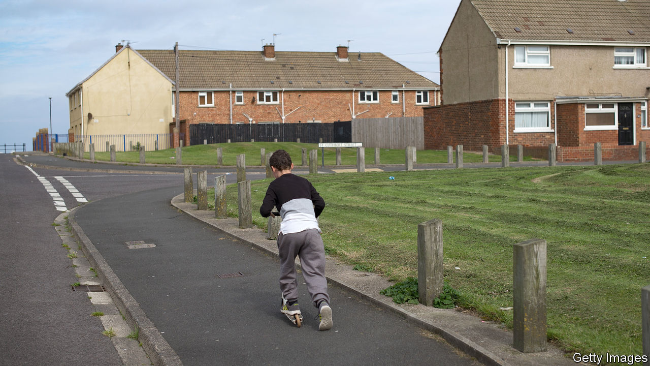

LIKE ANY good journalist, Boris Johnson is a master of the snappy phrase. “Get Brexit done” won him the general election in December 2019. But the slogan that is supposed to define his premiership is “levelling up”. Those two words express a complex set of economic and political ideas and grievances. Much of Britain is lagging behind London and south-east England; often it feels looked down on by the smug metropolitan liberals who run the country from there. Levelling up means bringing everyone up to speed.

Even at the best of times, Mr Johnson struggles to give substance to a slogan, and these are not the best of times. The government’s poor response to the covid-19 pandemic has dented the prime minister’s popularity and crowded out other matters. But regional inequality is a burning issue, for two reasons.

The first is political. Having won lots of seats in the Midlands and north of England, including some in former coal-mining areas where Tories used to be as rare as snowflakes in summer, the Conservative Party needs to hold onto them. It now faces a Labour Party led not by the dismal Jeremy Corbyn but by Sir Keir Starmer, a disciplined politician from a working-class background. The Tories cannot run on a platform of bringing about Brexit, because it has happened. They need another story to tell.

The other reason is that regional inequality really is a blight (see [article](https://www.economist.com/node/21790230)). Take the 10% of small regions with the highest GDP per head and the 10% with the lowest. In Britain the ratio between the two is 4.3—higher than in any other OECD country. Male life expectancy in Glasgow is more than a decade lower than in Westminster. Although it is too early to be sure, covid-19 could widen the gap. If offices, factories, schools and transport are disrupted, the places that will cope best are the ones where most people can work remotely. That is London and the south-east.

It is neither possible nor desirable to distribute wealth perfectly across space. But Britain’s geographical inequalities seem to be reinforcing themselves. Some places, mostly in south-east England, have enjoyed a virtuous spiral of rising productivity, rising investment and rising aspiration. In others, the spiral is downward. The fact that 41% of disadvantaged London 18-year-olds go on to higher education, while only 15% do in Barnsley, hints at how much talent is being wasted.

Ideally, barriers that prevent migration to thriving places would fall—the main ones are the planning rules that make it so hard to build homes in and around cities like Brighton, Leeds and London. Still, people are seldom as footloose as economists think they should be, and they have become less so. Moreover, they dislike being told to move. The perception that their corner of the country is being left to die is dangerous, because it makes people more inclined to support political charlatans and destructive policies. The Brexit vote showed that.

Although Mr Johnson has an idea and a slogan, he has little clue about how to go about levelling up. Downing Street has flung some money at small cities and towns. It promises to spend more on public transport in the north of England. It has briefed about winkling civil servants out of London, and even about moving the House of Lords to York (though it may have been joking about that). A devolution plan is promised.

The government is muddled partly because its analysis is faulty. Ministers often suppose that the places being left behind are towns and villages, and that big cities are fine. Last month Michael Gove, the government’s in-house thinker, complained that previous governments had favoured cities like Sheffield; John Whittingdale, the junior minister for media and data, argues that the BBC panders to Manchester’s “metropolitan elite”. In fact, the problem lies precisely in cities like Sheffield and Manchester. Britain has 40 metropolitan regions, of which only nine are wealthier per person than the national average. Outside London, the metropolitan elite is too small.

A good way of making big cities and their hinterlands more productive is to upgrade their infrastructure. Even on the basis of the Treasury’s narrow cost-benefit calculations, which take too little account of projects’ potential for boosting growth, the south-east gets an unfair share. Transport projects have been approved in London while others in the Midlands and north with better benefit-cost ratios are nixed. That needs to change.

More important, though, is to relinquish control. Economists find that, in the developed world, more devolved systems tend to be more equal, probably because public services are more efficient when run by those who use them. Measured by the percentage of total tax revenue raised centrally, regionally and locally, Britain is by some distance the most centralised country in the G7. The failing is not so much that the Treasury favours the capital; it is that, if you want to widen a major road or electrify a railway line anywhere in England, you must first convince the Treasury to find the money.

David Cameron, who ran a more urbane government than Mr Johnson, began to build metropolitan institutions that can serve as a counterweight to Westminster. Some 37% of English people now live in places with combined authorities and “metro mayors”. These have little formal power but much clout; to judge from the experience of London (which got its first elected mayor in 2000) their powers will grow. Unfortunately, they still depend on the Treasury, so can be pushed around. In 2018 the government cut funding for Greater Manchester because it planned to build 11% fewer homes than it had promised.

To make metropolitan government more independent, it should be given greater power over taxation. Britain is overdue a reform of local property taxes, which are too low and not very progressive. Local and metropolitan authorities could also retain business rates, as some already do. There is even a good case for allowing them to levy income taxes, although within strict limits, to avoid tax competition. Scotland already has that power. There will need to be a balancing mechanism to prevent the poorest areas from losing out in the short term.

Britain has been so politically and fiscally centralised for so long that such changes would be a wrench. They should be tried all the same. Mr Johnson has taken risks before, and won.■

This article was downloaded by calibre from <https://www.economist.com/leaders/2020/07/30/levelling-up-britain-boris-johnson-has-a-big-idea-but-no-plan>

|  |  |  |  |
| --- | --- | --- | --- |
| Previous | Articles | Sections | Next |

|  |  |  |
| --- | --- | --- |
| Leaders | Sections | Briefing |

Letters

Letters to the editor: On race and liberalism

.

|  |  |  |
| --- | --- | --- |
| Leaders | Sections | Briefing |

|  |  |  |  |
| --- | --- | --- | --- |
|  | Articles | Sections | Next |

#### On race and liberalism

# Letters to the editor

A selection of correspondence

Aug 1st 2020 |

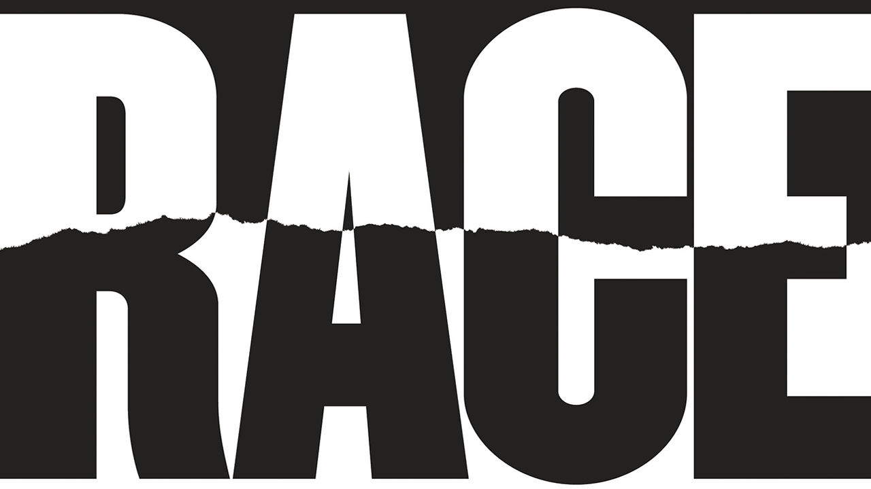

Letters are welcome via e-mail to letters@economist.com

## Liberalism and race

The Economist missed the point about the Black Lives Matter movement (“[The new ideology of race](https://www.economist.com/leaders/2020/07/09/the-new-ideology-of-race),” July 11th). You praised Martin Luther King’s “vigorous protest and relentless argument”, but criticised the methods of today’s activists as “dangerous”, contending that they seek to impose their ideology “through intimidation and power”. King may have taken issue with your position. In his “Letter from Birmingham Jail”, written in 1963, King wrote:

I must confess that over the past few years I have been gravely disappointed with the white moderate…who is more devoted to “order” than to justice; who prefers a negative peace which is the absence of tension to a positive peace which is the presence of justice; who constantly says “I agree with you in the goal you seek, but I can’t agree with your methods of direct action”; who paternalistically feels he can set the timetable for another man’s freedom; who lives by the myth of time and who constantly advises the Negro to wait until a “more convenient season”.

While today’s activists should be open to constructive criticism, this is not the most important issue at hand. The Economist’s line makes clear that it is more interested in maintaining comfort and economic stability rather than achieving change. Its words perpetuate white complacency.

GRIFFIN CONGDON  
New Haven, Connecticut

Your leader dripped with establishment anxiety over the growing influence of Black Lives Matter and the broader progressive movement. It reeked of the classic “you-can’t-say-anything-these-days” terror that radiates off those whose intellectual authority is being challenged. Rashad Robinson, president of Colour of Change, perfectly summarises this type of miscalculation: “Far too often we mistake presence, visibility and awareness for power.” Disappointingly, The Economist fell into this trap, equating the visibility of anti-racist voices in the virtual public sphere with the economic, political and judicial heft of the systems they seek to reform, dismantle and democratise. This false equivalence would be laughable if it wasn’t so insulting.

A. MENSAH  
London

* The new ideology of race? The old has never ended. It has been embedded in Anglo-Saxon thinking for centuries. It has justified the invasion and land theft of today’s America, Canada, Australia and New Zealand. That land was occupied and owned by Aborigine states, and to clear it, the Anglo-Saxon colonists simply invaded, stole and killed off the Aborigines. Then a “whites only” policy was instituted and turned into law, such as the “Chinese exclusion acts” of the early 1900s, and lasted, with Jim Crow laws, into the 1970s. Not to exclude the long-term use of slaves.

So what is new? The draconian suppression of black demonstrators, the exclusion of a growing China, making illegal Chinese advanced technologies that are superior to American ones. Same racial animus, same racial ideology. Only described differently.

HENDRIK WEILER  
Port Perry, Canada

Although liberalism has given the world theoretically unassailable values such as free speech, it has not been as successful dealing with pervasive social problems. The liberal “state of nature” and “veil of ignorance” imagine a society untarnished by politics. Thomas Hobbes, John Locke, and even John Rawls claimed to have established that the equality of mankind was determined by our fear of slaughtering each other, God, or rationality.

No one who studies political philosophy takes this exercise in apolitical history at face value. Their conclusions about government are based on a flawed assumption that humans once lived without politics. Social order has always existed, and therefore, so has politics. The assertion that “all men are created equal” is based on Enlightenment principles that were primarily created to check the power of government and protect property rights. The pursuit of these goals made it possible to ignore social inequality in general and allowed for the hypocrisy of most of the Founding Fathers owning slaves.

As you pointed out, liberal thinkers have always struggled with conceptualising unequal power relationships among groups. Critical theorists, their roots based in Marxism, inevitably face similar challenges when arguments are premised on simplified assumptions. If racism and discrimination are systemic, where do they originate from? Why do they persist, even if no one at an institution holds racist beliefs? And, hardest of all, what about individual rights?

However, it is liberalism that has had centuries to deal with prejudice and the social ills it produces. Thus far, the solutions it has offered are inadequate.

HEATHER KATZ  
Assistant professor of political science  
Southwestern Oklahoma State University  
Weatherford, Oklahoma

* “What is the point” of a theory of justice that is silent on “how the actual world is ravaged by injustice?” My own view: properly applied, John Rawls clears away the whataboutery and wonkishness to expose our persistent racism as a stunning, continuing injustice. A nail may want a hammer, but we need a lamp to see our work.  
  
V.VM.SCARPATO III  
Denver

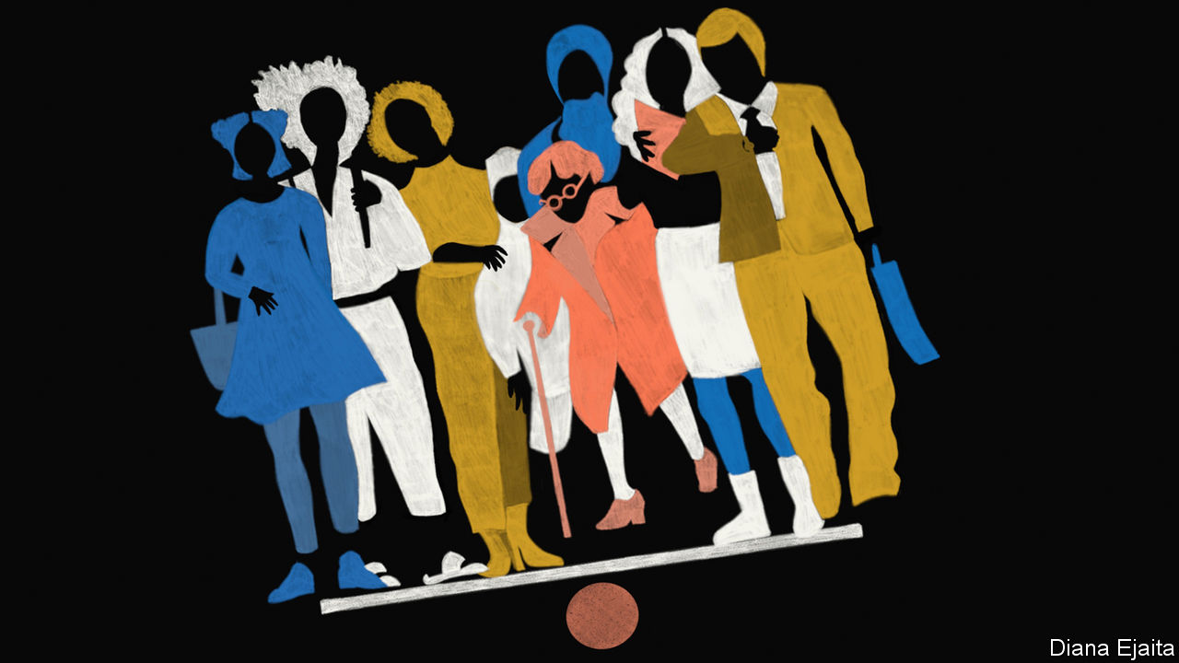

* You lamented the disempowerment of individualism. However, American slavery and subsequent institutional oppression did not operate on an individual basis, but by the desire to keep an entire group of people disenfranchised and powerless. Hence, it is impossible to uproot this mentality from the American way of life. Black people decry daily their inability to carry on simply as individuals, a privilege only afforded to white people. But they do recognise that the institutions that shape their lives are fundamentally biased against their group.   
Data show significant inequalities between the races, and much of black culture has developed as a direct consequence of these inequalities. How can one begin to remedy such differences without considering the historical and ongoing group dynamics?  
  
The truth is that a black person can have individual freedom and the pursuit of happiness only if African-Americans as a group have freedom and the pursuit of happiness. If liberalism cannot incorporate such a moderate idea, perhaps it is time to rethink how progress should be achieved, to dare suggest that another system can give America the “life expectancy, material wealth, poverty, literacy, civil rights and rule of law” for which you credit liberalism, in addition to the racial equality that has eluded it so far.  
  
PATRICK NTWARI  
Boston  
  
* The implicit bias trainings I have attended awakened a notion that we all have a demon inside us that distrusts the different borne of millennia of seeking survival and self-defence. This demon cannot be wished away. Instead, focus on what we control and judge accordingly.

Do we really want to be judged for differences we have no control over? It was Martin Luther King who dreamed of the day when his children will live in a country where they will not be judged by the colour of their skin, but by the content of their character. No human being has a choice about which body to be born into. Prejudice on this basis is patently illogical. Rainbow flags and gay-pride parades herald the type differences we do not control. Focus on the important quality we do control, which is our character. May our character exude kindness rather than malevolence.

PETER ROBERTS  
Seattle

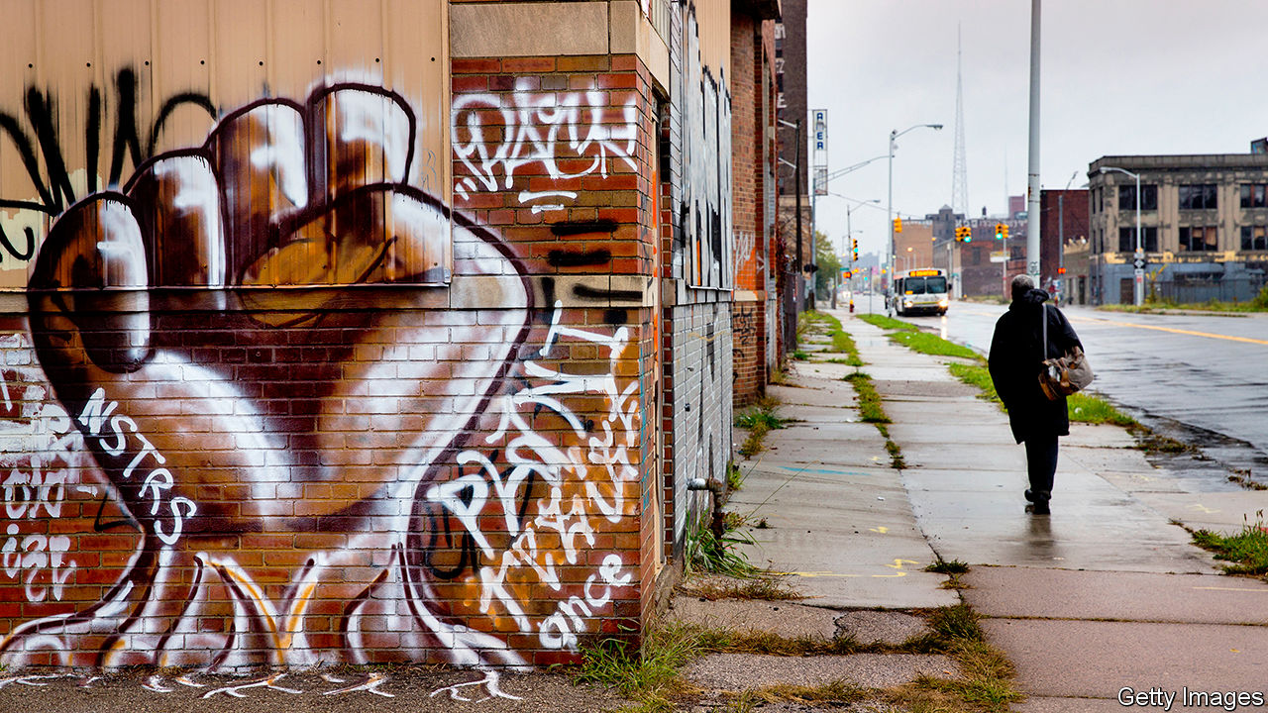

* Imagine a United States where every head of a household with children had a decent full-time job with health insurance. Add this to The Economist’s good ideas about housing and early childhood (“[Staying apart](https://www.economist.com/briefing/2020/07/09/segregation-still-blights-the-lives-of-african-americans)”, July 11th) and few American children of any race would go hungry or suffer the other ills of desperate poverty. Single mothers would not be exploited in jobs with terrible schedules and working conditions. Today’s daunting choice between fighting the coronavirus and creating jobs would be lessened.

More than 40 years ago, President Jimmy Carter introduced the Better Jobs and Incomes Programme. It would have federally financed community jobs to bring about this vision. There are challenges. Meaningful jobs and apprenticeships would need to be created in sectors such as health, energy and the environment. Legislation would have to address geographic differences in the cost of living, unions would have to co-operate, and more. But the challenges are solvable and the benefits substantial.

ARNOLD PACKER  
Former assistant secretary of labour in the Carter administration.  
La Jolla, California

In “Who We Are and How We Got Here”, David Reich, a population geneticist, related the story of how a piece of his research that identified genetic variants associated with an elevated risk of prostate cancer among men of west African descent led to accusations from some of his colleagues that he was “flirting with racism”. Critical race theory does not allow for the possibility that racial disparities in health could be caused by something other than systemic racism. If accepted, its assumptions make it nearly impossible to eliminate any racial disparities that have other causes, because the type of intervention required to address a disparity depends on what the disparity is caused by.

JONATHAN KANE  
Flat Rock, North Carolina

You made a good case for a genuinely liberal approach to race, at a time when the modern left has forgotten what a truly liberal society is. You see what we all see: intellectual rigidity and intolerance of dissent, the fomenting of division, racial obsession replacing colour-blind equality of opportunity, identity politics taking priority over the rights of the individual, all the marks of an authoritarian society, not a liberal one.

Donald Trump’s speech at Mount Rushmore was an attempt to address this issue. You say his speech strived “to inflame a culture war centred on race”, when in fact he was expressing the very concerns you share.

STEVEN VAN DYCK  
Toronto

Congratulations on having the courage to challenge the intellectual hogwash that is the new race and identity politics. Prejudice based on skin colour is among the idiotic of all prejudices and it must be challenged. But to go from there to the construction of a Marxist-derived analysis, this time with “white people” as the new group to hate instead of the “bourgeoisie”, is nonsense on stilts. Its intellectual dishonesty is imbued with a Manichean worldview and totalitarian instincts. George Orwell would recognise all the newly woke, self-haters of the academic and cultural elite, who have meekly caved-in to show trial by Twitter.

SIMON DIGGINS  
Rickmansworth, Hertfordshire

* Critical race theory brings to mind one fundamental Marxist concept: that there is no “objective truth” and each class generates its own “truth”. Race ideology, just like Marxism, did not take “a wrong turn”. As somebody who was forced to study Marxism in a communist country, I see a perfect similarity: an ideology pushed by intellectuals with little contact with the real world, no compassion for real people, and fancy concepts leading to the most unfair and sinister consequences. Critical race theory leads by design to intolerance, the silencing of dissenters and polarisation.

ANDREI TUDORAN  
Houston

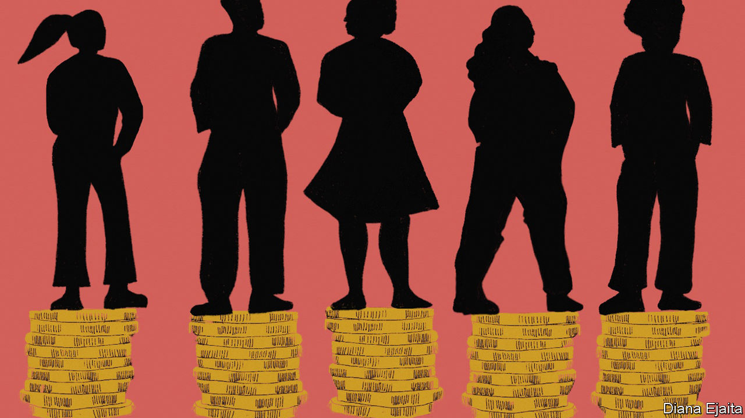

The hard part of resolving America’s racial economic gap starts with facing the actual history of our country. When I attended high school in California in the 1980s, I learned nothing of the lynchings in the post-Reconstruction era, nor of the Tulsa massacre or other white riots, nor the redlining that prevented black Americans from building home equity. White Americans need to fully reckon with this betrayal of their fellow citizens.

MARK SEAMAN  
New York

* I fear a bigger problem for the future. I moved to North Carolina during a year when Jesse Helms was running for Senate. His main campaign ad was a set of white hands crumpling a rejection letter, the implication being that a qualified white did not get a job because of affirmative action to help blacks. We must be careful that in trying to improve black lives we do not once again turn it into a fight between blacks and lower-class whites, with rich whites laughing all the way to the bank. Just as in the 1920s the Northern Ireland government broke an attempt to create a united Protestant-Catholic union in the shipyards by promising all Protestants a job, so the people on top in America succeeded once in turning the racial issue into a fight within the lower class.

ALAN LANE  
Associate professor of history  
Barton College  
Wilson, North Carolina  
  
* The greatest danger to liberalism is not the pantomime villains you boo each week, but rather the choking hypocrisy within its own ranks. Instead of basking in your enlightenment, as individuals you need to petition your local councils for more refugees and disadvantaged people to be housed and schooled in your own communities, whatever the effect on house prices. Stop tilting at Trumpian walls and Orbanite fences, and start addressing the far more formidable and discriminatory socioeconomic barriers that shield you from the adverse side effects of the globalisation and mass immigration that you piously prescribe for others.  
  
ISTVAN SZABO  
London  
  
* I object to your description of the street corner where George Floyd was murdered as “shabby”. In fact, it is home to several successful small businesses and is neither neglected nor unsafe. Our city has already been maligned enough because of recent events and this incorrect description was unnecessary.

THOM ROETHKE  
Minneapolis

One cannot easily shake off unwanted associations with partners picked up during a prolonged binge. As you made quite clear, liberalism awoke to find itself in bed with slave-traders and unbridled imperialists. Singing its prelapsarian virtues now, however sweet the tune, will not readily assuage the critics.

MATTHEW KAPSTEIN  
Director of studies, emeritus  
Practical School of Advanced Studies  
Paris

* Letters appear online and in app only

This article was downloaded by calibre from <https://www.economist.com/letters/2020/08/01/letters-to-the-editor>

|  |  |  |  |
| --- | --- | --- | --- |
|  | Articles | Sections | Next |

|  |  |  |
| --- | --- | --- |
| Letters | Sections | Asia |

Briefing

Alphabet: Google grows up

.

|  |  |  |
| --- | --- | --- |
| Letters | Sections | Asia |

|  |  |  |  |
| --- | --- | --- | --- |
|  | Articles | Sections | Next |

#### Alphabet grows up

# Google’s problems are bigger than just the antitrust case

As the computing conglomerate has grown, so too have the risks that it becomes more like a conventional company

Jul 30th 2020 | MOUNTAIN VIEW



TO GET A good look at Google, climb a barren hill in front of the online giant’s Silicon Valley headquarters—or rather, both of them. To the right lies the old HQ, a clump of low-slung office buildings ringed by dozens of similar boxes. To the left a brand-new corporate centre is rising. From outside it resembles an oversized circus tent, but the inside is still undetermined: pillars, wooden panelling and hardly any walls. The bare-bones structure is meant to provide architectural flexibility. This will come in handy in a post-pandemic world in which offices will look quite different. “We’ll get a chance to reimagine it,” says Sundar Pichai, the boss of both Google and its parent company, Alphabet. And just as the bricks-and-mortar structure is changing, the organisation is in transition, too.

When Mr Pichai took over as chief executive of Google in August 2015, after it became the core of the newly formed Alphabet, the online-search-and-advertising business had annual revenues of $66bn and net income of $14bn. By the time Sergey Brin and Larry Page, Google’s founders, handed him the reins of Google’s parent company last December his division was raking in profits of $34bn on sales of $161bn—and Alphabet was worth almost twice as much as four years earlier.

This enviable track record justifies Mr Pichai’s rich compensation package over several years, of $2m annual salary plus $240m in shares and stock options (depending on performance targets). It would also justify a degree of complacency. Far from it. Mr Pichai realises he inherited an organisation in the middle of momentous change. That is not just because of the founders’ departure or the move next year into the new HQ, but for a deeper reason. As Alphabet has grown—more than 4bn people are thought to use at least one of its products or services—so has the tug of economic and political forces on it.

From the outside, lawmakers and trustbusters are pressing it for explanations over alleged abuses of its market dominance in online-search-and-advertising technology. On July 29th Mr Pichai joined his opposite numbers at Amazon, Apple and Facebook to field angry questions from a congressional committee investigating Big Tech’s alleged anticompetitive practices (see article). On the inside, Google’s core businesses are maturing. After The Economist went to press Alphabet was expected to report the first year-on-year decline in quarterly revenues in its history, hurt by the pandemic-induced tightening of marketing budgets. And the company’s famously freewheeling culture is becoming harder to sustain.

Mr Pichai’s foremost challenge is to prevent Alphabet from becoming what Mr Brin and Mr Page were so bent on avoiding—a “conventional company” that dies a slow death from lack of innovation and declining growth. The task is as delicate as the technology giant is gargantuan.

Today Alphabet is a conglomerate of businesses that sometimes appear to have little in common—a corporate planetary system or Googleverse, if you will. Commercially, its centre of gravity is Google itself, and particularly its online-advertising business. This generates 83% of the group’s revenue and all its profits. It is a constellation unto itself, featuring a plethora of products that together form what is called the “online ad stack”: services to sell, buy and serve ads, and measure their effectiveness, all automatically. In all of these areas, Google is as globally dominant as it is in online search. Its market share in some parts of the ad-serving stack exceeds 90%.

On the surface this might suggest that Alphabet, like most big tech firms, is a “one-trick pony”, in the words of Michael Cusumano of MIT Sloan School of Management. In fact, it is a herd of ponies, some of which look rather more like full-grown Shires. Nine have more than a billion users globally (see chart 2). Every day people make an estimated 6bn search queries on Google and upload more than 49 years’ worth of video to YouTube. More than 300bn emails are said to be sent every day and if only one-third originate on Gmail—a conservative estimate—then a stack of print-outs would be 10,000km high.

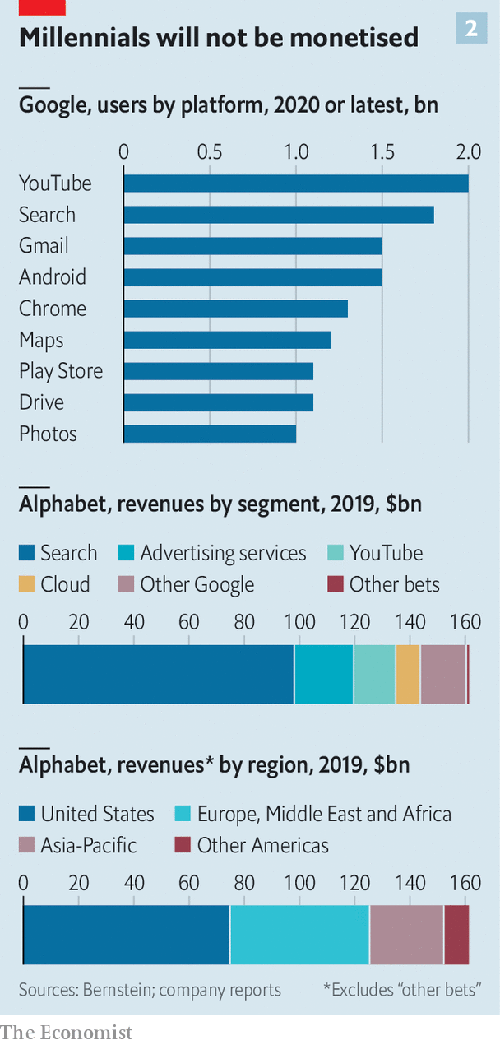

And there is more. “Other bets”, as Alphabet’s financial statements refer to its non-core businesses, now number 11, each with its own capital structure. These include Access (offering fibre-optic broadband), GV (which invests in startups), Verily (a health-care firm), Waymo (a developer of autonomous cars) and X (a secretive skunk works engaged in all manner of moonshots). Commercially these ventures seem only loosely connected with the core. What links them to the main business is information processing—and specifically these days artificial intelligence (AI), which powers everything from search to Waymo’s self-driving cars.

Early on, the founders decided that to enable the company to grow with startup-like speed regardless of its actual size, they would create a singular organisational mix of institutions they knew best: the internet, the open-source-software movement and Stanford’s post-graduate programme, where the duo came up with Google’s original search algorithm in 1996.

Like the internet, Google was envisaged as an ever-expanding collection of groups of engineers linked by a common language and common goals, most prominently to “organise all the world’s information”. Alphabet, too, is a network of networks held together by technical standards. It grows horizontally by adding yet more networks.

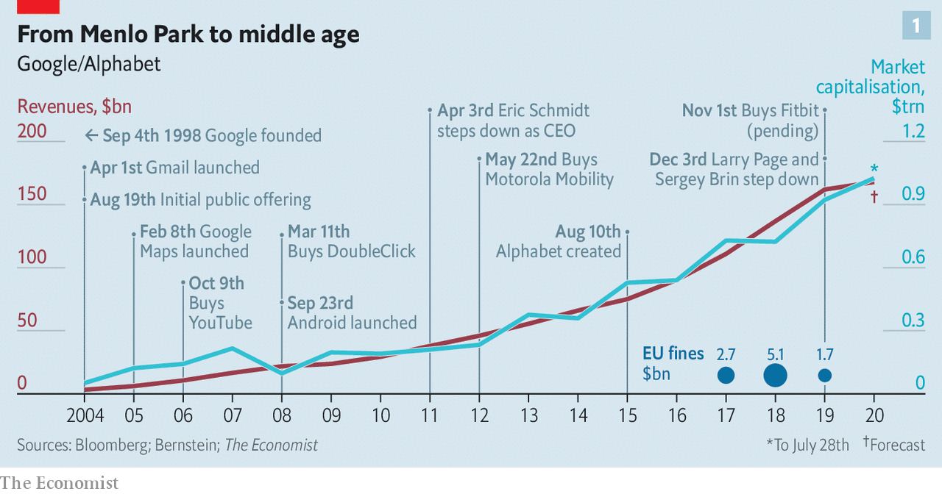

To keep hierarchies flat, Mr Brin and Mr Page briefly went so far as to abolish managers altogether, though the experiment had to be dialled back. A compromise was to give managers a minimum of seven direct reports to limit the time they have to loom over each underling. They also had limited time to accost the two bosses, who at one point got rid of their personal assistants to make it harder to book time with them, forcing executives to ambush them whenever they appeared in public to get a sign-off on decisions.

## Cosmic ambitions

Google resembled a big open-source project by being an open book, at least internally. Any employee could freely access all internal information except for sensitive user data or company finances. All code, project documents, even a colleague’s calendar, were fair game. Workers were encouraged to use one of Google’s plethora of messaging tools, such as mailing lists (of which there are now more than a million). They were also expected to ask tough questions at weekly company-wide town-hall meetings with the founders, called TGIF, for “Thank God It’s Friday” (now held on Thursdays to allow Googlers around the world to participate without having to get up on Saturday morning). Grievances were to be kept within the company’s walls. Leaking, particularly to the press, was a sackable offence. But the place was also meant to be playful; hence the playground-like offices, ping-pong tables and the like.

From Stanford Mr Brin and Mr Page borrowed the idea of letting people follow their passions. Google employees were allowed to spend 20% of their time working on what they thought would most benefit the firm, even if that often led to them working 120%. They also often set their own quarterly goals. Recruiting and promotion were similar to academia, too. Candidates were graded like PhD students and decisions about who should move up the corporate ladder were taken by a committee of peers from across the company, rather than individual managers, who often promote people they like rather than those who would do the best job.

Having created most of this unique structure in 2001 the founders recruited Eric Schmidt, a Silicon Valley veteran who understood both managers and technologists, to help implement it—or, as they themselves put it, to provide “adult supervision”. To shield the setup from potential shareholder pressure, the three of them built a legal moat around it. Google was one of the first Big Tech companies to opt for dual-class shares, which gave the original shareholders ten times the voting power. Although Messrs Page, Brin and Schmidt together held only a small stake, they retained an outsized 38% of voting rights. The founders warned in “An Owner’s Manual” for Google’s shareholders, published before the firm’s initial public offering in 2004, that new investors “will have little ability to influence its strategic decisions through their voting rights”.

Mr Page took over from Mr Schmidt as Google’s CEO in 2011 (though Mr Schmidt remained Alphabet’s executive chairman until 2018), before handing over to Mr Pichai four years later. Since then Mr Pichai has managed Google in much the same way that previously he ran Chrome, Google’s web browser, and other projects. Rather than getting bogged down in details, he put trusted people in charge, giving them resources and nudging them along.

The result is a collection of semi-independent firms with powerful bosses sitting atop each of them: Thomas Kurian at Google Cloud, Susan Wojcicki at YouTube, Rick Osterloh at Google’s hardware division and Hiroshi Lockheimer at the Android operation. In early June Mr Pichai put Prabhakar Raghavan, who already headed Google’s ad business, in charge of search as well, making him Google’s de facto deputy CEO. (Mustafa Suleyman, vice-president of AI policy at Google, sits on the board of The Economist’s parent company.) A company of Alphabet’s breadth would fail if it depended solely on one man’s judgment, Mr Pichai explains. “People have to be able to make their own decisions.”

These decisions are becoming harder. Googlers have always prided themselves on solving the toughest problems in computer science—less so on making money. This may be one reason why some of the company’s hit services generate smaller revenues than they might, like YouTube, or barely any at all, like Maps. Monetisation from the “other bets” has scarcely begun. They racked up more than $5bn in losses in the four quarters to March. Only Access and Verily bring in material revenues. Some could one day turn into huge businesses: Waymo was valued at about $30bn when it raised outside capital this spring. But even that impressive figure is much less than earlier estimates, which valued the autonomous-driving unit at more than $100bn.

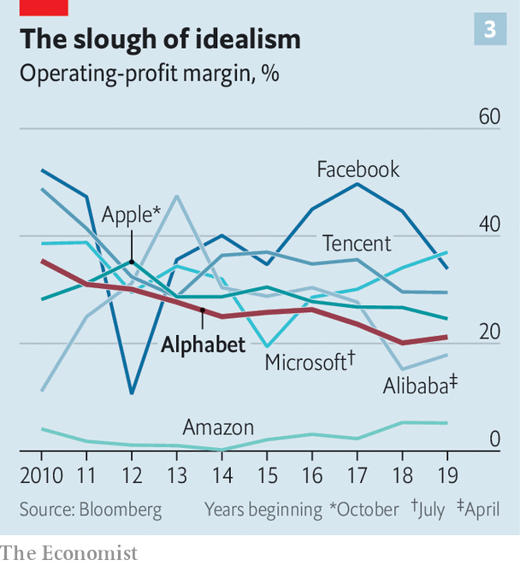

None of this used to matter much, as long as Google’s ad products were “a gold-threaded safety net underneath every daring innovation”, as Steven Levy, one of Silicon Valley’s scribes, put it in 2011. It becomes a problem when it translates into lower margins and weaker stockmarket performance than rival tech giants (see chart 3 and chart 4).

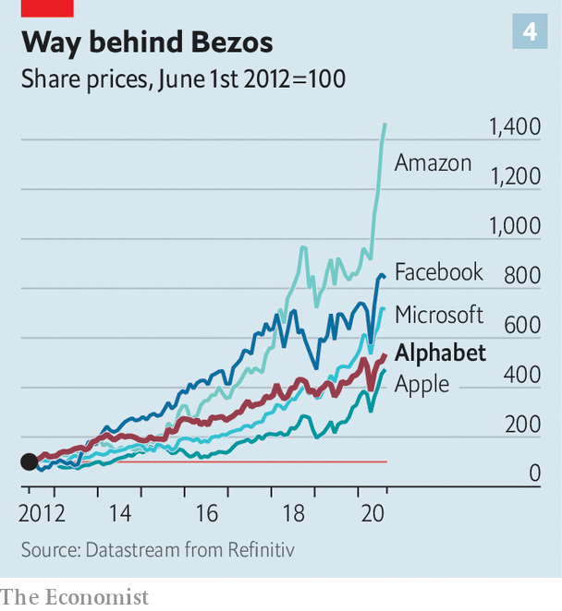

Online advertising overall is far from a mature market, but growth in search ads, which continue to generate about 60% of Alphabet’s revenues, has slowed. In 2019 sales expanded by 15%, a healthy clip but considerably lower than the 22% a year earlier. General online search is also being “hollowed out” by specialised searches, says Mark Shmulik of Bernstein, a research firm. Mr Shmulik estimates that about 60% of product searches now start on Amazon (whose fast-growing online-ad business is already the world’s third-biggest behind Google and Facebook).

## Spaced out

Alphabet’s engineer-driven bottom-up culture is also showing signs of age. It can be hit and miss. “You can paper over a lot of problems by throwing money at it and hiring more bodies,” says a long-time Googler, who previously worked for Microsoft, which was regularly scooped by Google when it came to new products. “I thought they must have really clever strategists,” he recalls, only to discover on joining the firm that it “had hundreds of things happening in parallel”. Alphabet executives often liken their firm’s structure to a “slime mould”—organisms that survive as single cells, but must aggregate to reproduce.



Innovation can indeed mushroom in such a corporate ecosystem. But it may hinder the development of more structured products, which require more sustained co-operation and a strategic vision. This is particularly true of lucrative enterprise offerings, where corporate clients expect providers to be both consistent and responsive to their needs. Google has a reputation for being neither.

Over the years Google has churned out new messaging tools, from Allo and Buzz to Hangouts and Meet, only recently starting to develop a unified communications offering for corporations, similar to Slack or Microsoft Teams. Google’s cloud business has often been criticised for “not having a customer-service bone in its body”, says Brent Thill of Jefferies, a bank. As a result it lags behind Amazon Web Services and Microsoft’s Azure, where customer service verges on an obsession.

It is also becoming increasingly apparent that Alphabet’s organisational setup does not scale well. Even with a workforce of a few tens of thousands Google felt small, notes an employee who left a few years ago and later returned. With the firms’ 120,000 permanent workers complemented by an even more numerous (and less-well-paid) temporary or contract staff, the founders’ original idiosyncratic rules are becoming a drag. Executives grumble that internal promotion by committee is often a time-consuming political exercise. Letting a thousand flowers bloom is leading to an awful lot of compost.

Size creates political tensions, too. After 2016 the firm’s mostly woke workforce began using internal messaging tools to organise and press management to take action on everything from President Donald Trump’s harsh immigration policy to boycotting meat in its cafeterias. As Alphabet has hired engineers at breakneck speed, it is no longer “a country where everybody politically agrees” with the once-dominant liberal bent, says an insider.

Tensions came to a head in 2017 when James Damore, a Google software engineer, published a memo on an internal mailing list arguing that the lack of gender diversity in tech could partly be explained by biological differences. After it was leaked to the press he was fired, but many insiders felt that management, including Mr Pichai, had let the debate fester and did not do enough to help the activist employees who had been “doxxed” (having their personal details published online) by other staffers.

Things went downhill from there. Once unthinkable leaks multiplied. So did internal petitions. In 2018 activist employees forced Google not to renew an AI contract with the Pentagon and to abandon plans for a censored Chinese version of its search engine. Tensions culminated later that year when it emerged that high-performing executives accused of sexual harassment had been sent off with multi-million exit packages. More than 20,000 employees globally staged a walkout in protest.

“The walkout broke Larry’s heart,” says one Googler. It suggested that the goal of creating an engineers’ commune had failed. After that the two founders put more distance between themselves and their creation. They stopped attending the TGIF meetings. In many ways Mr Pichai’s ascent to the top job last year was a formality.

Although Mr Brin, Mr Page and Mr Schmidt remain Alphabet’s biggest individual shareholders—with 13.1% of shares and 56.7% of voting rights—a former senior executive says that the company is now run by a different triumvirate. Besides Mr Pichai it includes Kent Walker, senior vice-president of global affairs, and Ruth Porat, the finance chief poached from Morgan Stanley, an investment bank. Where Mr Brin and Mr Page were technologists and Mr Schmidt a technologist-manager, the new team are simply managers.

This transformation was apparent at Mr Pichai’s first quarterly earnings call as the boss of Alphabet in February, when he delighted analysts by at long last breaking out YouTube’s revenues ($15bn in 2019, up by more than a third from the previous year). He has also accelerated share buy-backs, from $6.1bn in the last quarter of 2019 to $8.5bn in the three months to March. “They are no longer the most hated big tech company from a shareholder perspective,” says Mr Thill of Jefferies.

Alphabet is also becoming shareholder-friendlier in how it manages its other bets. Some of the subsidiaries, like Waymo, have wooed outside investors, suggesting that they will one day be spun off. Others, such as Chronicle, which hoped to revolutionise cyber-security, and Jigsaw, a think-tank, have been folded back into Google. Yet others, like Makani, which is developing flying wind turbines to generate energy, are likely to be shut down or sold.

## To infinity and beyond

Mr Pichai’s shakeup of management is on starkest display at Google Cloud. After he became Google’s boss five years ago it was becoming apparent that cloud-computing was something more than a passing fad. He ramped up investment in the division and in 2018 hired Mr Kurian, a former senior executive at Oracle, a big maker of corporate software, to run it. In keeping with Mr Pichai’s evolving management philosophy, Mr Kurian was granted far more autonomy than his predecessor, Diane Greene, and turned the unit into a more top-down organisation, hiring people from his former employer as well as SAP, its German rival.

It seems to be working. Google’s cloud business, which includes G Suite, its package of professional online services, is growing at more than 50% a year. Revenues are expected to reach $13bn this year, contributing 8% to Alphabet’s total.

However, Mr Kurian’s financial success carries a risk. Insiders report a mini-exodus from the cloud unit to other parts of Alphabet. Plenty of employees worry that the top-down-approach from Google’s cloud business will spread throughout the organisation. Many are beginning to grumble about getting tasks handed down from above with a deadline.

That hints at a bigger unsolved problem with Google’s culture. After the walkouts, management made some tweaks. “When we were smaller, we all worked as one team, on one product, and everyone understood how business decisions were made. It’s harder to give a company of over 100,000 people the full context on everything,” Mr Walker reportedly wrote in November in an internal newsletter. The TGIF meetings are now held only once a month and limited to business-related questions. The largest internal mailing lists are moderated and postings deemed too political are allegedly being taken down. These days employees are being told to access sensitive documents only if they “need to know”. Some staff talk of creating if not a labour union, then at least a group to defend their interests.

In the wake of the killing of George Floyd many Googlers criticised their top management for doing too little, too late to make the company more diverse; after a couple of weeks the firm vowed to raise the “leadership representation of underrepresented groups” by 30% over the next five years. In June more than 2,000 employees signed an open letter to Mr Pichai demanding that the company stop selling its technology to police forces across America.



Over the past few weeks things have seemed to calm down internally. But the respite may be superficial. Many workers are keeping their mouths shut for fear of being laid off, one Googler reports. Few relish the thought of losing a cushy job in a recession. Activists now shun the firm’s communication tools and organise elsewhere online.

All this fuels murmurings and speculation, both inside and outside Alphabet, over whether Mr Pichai is the right person for the job. Some Google executives and engineers describe him as “too checked out” and his leadership as “uninspired”. He is also accused of excessive risk aversion. “I’ve never shied away from making big bets and following my instincts,” Mr Pichai insists. But it is hard to argue that he has shown the vision of Amazon’s Jeff Bezos or Microsoft’s Satya Nadella.

Mr Pichai has an opportunity to prove the sceptics wrong. The covid-19 pandemic offers a convenient pretext to get rid of inefficiencies, such as overlapping products, and cut through Alphabet’s internal red tape. It could result in a new balance being struck between Google’s innovative culture and more systematic exploitation of its products’ and services’ money-making potential. Even the antitrust probes have a silver lining for Mr Pichai. “In some ways, I’m looking for clarity,” he says.

To be a leader in the mould of Mr Nadella, however, he would have to be more daring. One idea is to charge for some of its services. Another is for Google to become more of a data fiduciary that manages people’s information for them—a bit like a bank does with money. The firm has already started developing tools necessary for this, such as software that can mine encrypted data. If Mr Pichai could pull this off, that would be truly inspirational. And it would help keep Alphabet unconventional for a while yet. ■

This article was downloaded by calibre from <https://www.economist.com/briefing/2020/07/30/googles-problems-are-bigger-than-just-the-antitrust-case>

|  |  |  |  |
| --- | --- | --- | --- |
|  | Articles | Sections | Next |

|  |  |  |
| --- | --- | --- |
| Briefing | Sections | China |

Asia

75 years after Hiroshima: Never forget

.

Singapore: From fairway to highway

.

Malaysia: Down and out

.

Sri Lanka’s election: Pax Rajapaksa

.

Banyan: Spiked

.

|  |  |  |
| --- | --- | --- |
| Briefing | Sections | China |

|  |  |  |  |
| --- | --- | --- | --- |
|  | Articles | Sections | Next |

#### Hiroshima, 75 years on

# Atomic-bomb survivors seek new ways to keep their memories alive

Around the world, non-proliferation efforts are faltering

Aug 1st 2020 | HIROSHIMA AND NAGASAKI

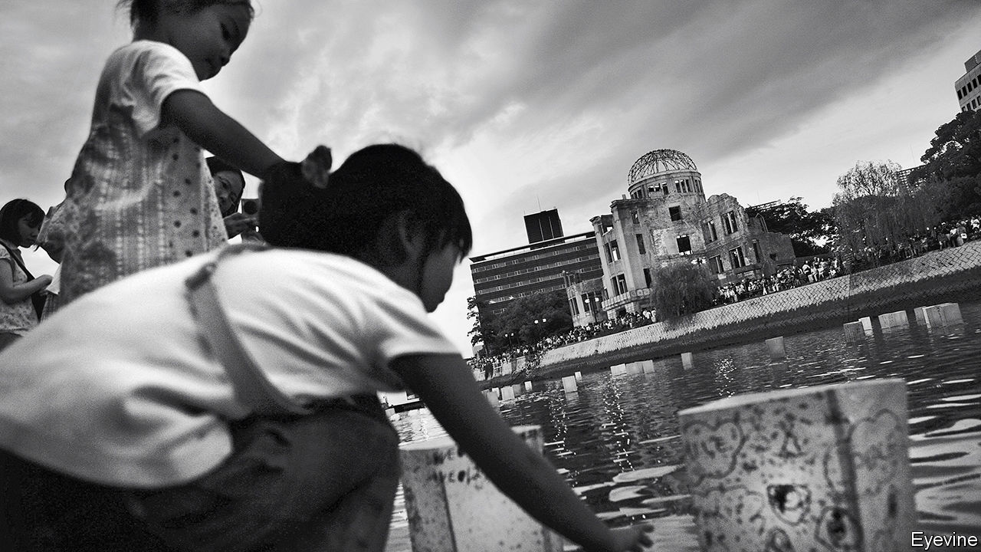

FOR SEVENTEEN-YEAR-OLD Takeoka Chisako, August 6th, 1945 was supposed to be a day off. She had planned to meet two girlfriends at 8:15 that morning, at a train station on the west side of Hiroshima. She was running late, and as she stepped outside her house she lifted a pocket mirror to her face. Then she saw a flash and heard a bang. When she regained consciousness she found herself lying in a potato field 30 metres away, a mushroom cloud rising in the sky. People with charred skin dangling from their arms came rushing over a nearby hillside. They cried for help, but were too feeble to speak their names and too weak to drink the water Ms Takeoka brought them. “Then one by one, they died,” says Higashino Mariko, Ms Takeoka’s daughter.

Ms Higashino tells this tale with the precision of an eyewitness. Yet she was born eight years after American forces flattened Hiroshima with Little Boy, the first atomic bomb used in combat. For decades survivors such as Ms Takeoka, known in Japan as hibakusha, or bomb-affected people, have told their stories publicly. Now their ranks are “declining drastically”, says Takigawa Takuo, director of the Hiroshima Peace Memorial Museum. So the city government in Hiroshima has recruited scores of volunteers like Ms Higashino to become denshosha, or “legacy successors” who take on the job of recounting their experiences. (Ms Higashino is unusual in that she inherited her own mother’s story; most take on a stranger’s.) Nagasaki, which was bombed on August 9th, has created a similar group.

These programmes reflect anxiety in Hiroshima and Nagasaki about fading wartime memories. In August Japan marks the 75th anniversary of the atomic bombings. Although there are still more than 130,000 living hibakusha, their average age is over 83. This will be the “last chance” to hear first-hand from witnesses during a major anniversary, laments Kubo Masayuki, director of the Hiroshima National Peace Memorial Hall.

The suffering of the hibakusha animates Japan’s post-war pacifism, as well as anti-nuclear activism internationally. Many worry that the war’s lessons are being forgotten. Fewer than 30% of Japanese can correctly name the dates of the atomic bombings (in Hiroshima and Nagasaki the numbers are higher). Yuzaki Hidehiko, the governor of Hiroshima Prefecture, says that “fading memories—not only in Japan but around the world” are leading to growing naivety about the horrors of conflict.

Abe Shinzo, Japan’s prime minister, has sought to revise the constitution that America imposed on Japan after the war. He has failed to gather enough votes in the Diet to change Article 9, which renounces war and bars Japan from maintaining “land, sea and air forces”. Japan in fact maintains powerful military forces; Mr Abe wants to make explicit that they are constitutional, and to stretch the limits to what they can do. He has not convinced the public: support for altering Article 9 has fallen from 33% in 2013 to 26% this year. Still, he has increased defence spending, pleasing America.

As Hiroshima and Nagasaki prepare for their anniversaries, politicians in Tokyo have been debating whether to acquire weapons that would enable the country pre-emptively to strike missile bases and other facilities of enemies who may be preparing to attack it. Many hibakusha are aghast. “As we look stronger, it will invite potential attackers to attack earlier,” Mr Yuzaki argues. “We have to be very careful.”

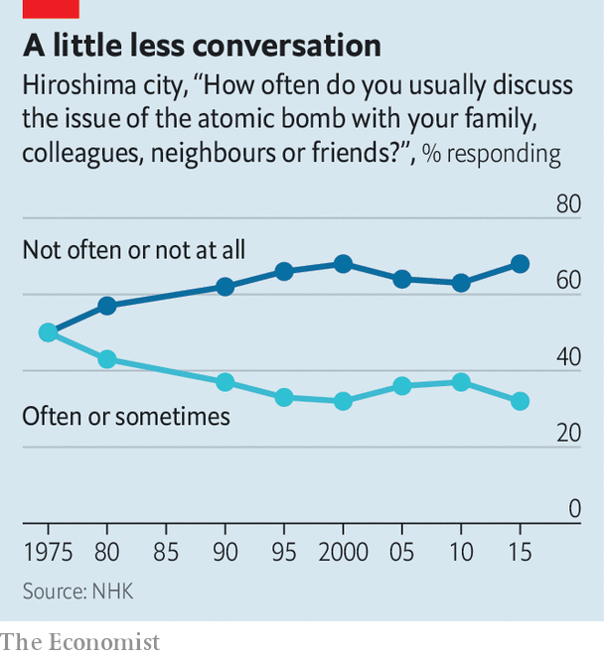

Globally, non-proliferation efforts are faltering. In January the Bulletin of Atomic Scientists moved its Doomsday Clock, a subjective measure of humanity’s proximity to self-annihilation, closer to midnight than at any time since its establishment in 1947. Donald Trump has withdrawn America from the Iran nuclear deal and the Intermediate-Range Nuclear Forces Treaty (after accusing Russia of cheating). Hibakusha are pleased that 82 countries have signed a Treaty on the Prohibition of Nuclear Weapons, created in 2017. It invokes their “unacceptable suffering” in its preamble. Yet no country with nuclear weapons has signed up to it. Nor has Japan, which shelters under America’s nuclear umbrella. Mr Yuzaki regrets that Japan has not used its moral authority as the only victim of atomic weapons to push harder for their abolition.

The hibakusha worried about amnesia even while the rubble was being cleared. “As Hiroshima recovers, the memory of the devastation is fading from people’s minds,” Kimura Kazuo, a college student, wrote in his diary in 1946. Yet equally troubling for some in Japan, and for many in the rest of Asia, is the selectivity of Japanese wartime memory. Hiroshima and Nagasaki’s museums emphasise Japanese suffering but downplay the war that precipitated it. Hiroshima became central to Japanese wartime memory in part because it “allows the victim narrative to dominate”, rather than the atrocities Japanese soldiers committed abroad, argues Fujiwara Kiichi of the University of Tokyo. Both museums place materials about Japan’s aggression in China and the Pacific at the end of their exhibitions. One section at the Nagasaki museum entitled “Events Leading up to the Nagasaki Atomic Bombing” begins by detailing American discussions in 1943 about which places in Japan to target. The Hiroshima museum makes scant mention of foreign nationals who perished during the bombing, such as the tens of thousands of Korean victims, most of them forced labourers.

Yet Hiroshima’s messages are powerful, and preserving its stories is essential. Mr Takigawa speaks of creating “an everlasting museum”. The denshosha programme is part of that effort. Volunteers go through three years of study, training and discussion with hibakusha before being certified to talk in public. There are now 150 practising denshosha, with another 197 in training. Nagasaki’s programme has 83 participants. Anti-nuclear activists have long called for the bomb to be abolished before the last hibakusha passes away. That is unlikely. But their stories may deter the world from ever using it again.■

This article was downloaded by calibre from <https://www.economist.com/asia/2020/08/01/atomic-bomb-survivors-seek-new-ways-to-keep-their-memories-alive>

|  |  |  |  |
| --- | --- | --- | --- |
|  | Articles | Sections | Next |

|  |  |  |  |
| --- | --- | --- | --- |
| Previous | Articles | Sections | Next |

#### From fairway to highway

# Demand for land in Singapore is bad news for golfers

Courses are shrinking or closing to make way for concrete and steel

Aug 1st 2020 | SINGAPORE

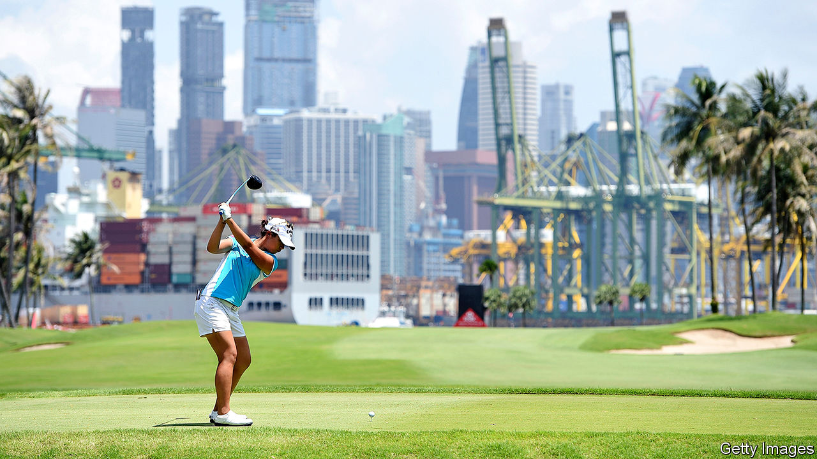

CLOCKS ABOVE the reception at Singapore Island Country Club show the hour in Augusta, Georgia, and St Andrews in Scotland—both places with famously wonderful golf courses. But time may be running short for golf in Singapore. The government is forcing some courses to shrink or close. Greens will give way to cranes; irons to concrete and steel.

Golf in the city-state has had powerful champions. Lee Kuan Yew, Singapore’s first prime minister, loved it. (Golf was his “principal recreation and passion,” said his son, Lee Hsien Yang, in 2015.) The royal and ancient game was once a symbol of middle-class aspiration, says Harvey Neo, a geographer at the Lee Kuan Yew Centre for Innovative Cities. During the 1990s and 2000s Singaporeans were said to covet the “5cs”: cash, car, condominium, credit card and country-club membership.

Yet in 2013 the government, which owns most of the land in Singapore, announced that it would gradually reallocate much of the space taken up by golf courses to public housing and infrastructure. The ruling party, stung by its disappointing performance at elections in 2011, felt it needed to respond to critics who said that it was out of touch with ordinary Singaporeans and who argued that it had overcrowded the tiny island by welcoming too many immigrants. At the time of its announcement 2.1% of Singapore’s land was given over to greens and fairways. By 2030 the number of courses is expected to fall by 40% or so from its peak in 2010. Closures are expected to leave Singapore with one course for every 430,000 residents by 2040, down from one for every 250,000 three decades ago.

Many Singaporeans shrug. The game’s grip on the national imagination is weakening. The number of people who play regularly has not much changed for years, thinks Jerome Ng, general manager of the Singapore Golf Association. Some 55% of golf-club members are 55 or older. “Young people are now into other sports,” says Lee Lee Langdale, who brokers country-club memberships. She says youngsters are put off by the exorbitant cost. Some clubs charge hundreds of thousands of dollars just to join. Garish clothes aren’t cheap, either. The game’s image has suffered. One banker says that he sometimes feels “self-conscious” admitting that he is a golfer.

It will be possible to play golf in Singapore for years to come. But the government has yet to renew the lease of any club beyond 2040, which worries enthusiasts. “We will lose everything,” says Ms Langdale. Others are sanguine. “The people we used to play with are either dead or not playing any more,” says Aidan Wong, who has been swinging irons since he was 12. When his club closes in 2021, he says, “I will probably put my clubs away.”■

This article was downloaded by calibre from <https://www.economist.com/asia/2020/08/01/demand-for-land-in-singapore-is-bad-news-for-golfers>

|  |  |  |  |
| --- | --- | --- | --- |
| Previous | Articles | Sections | Next |

|  |  |  |  |
| --- | --- | --- | --- |
| Previous | Articles | Sections | Next |

#### Conviction politician

# Najib Razak is found guilty on seven charges in the 1MDB scandal

Malaysia’s former prime minister gets a 12-year sentence. More verdicts loom

Jul 30th 2020 | SINGAPORE

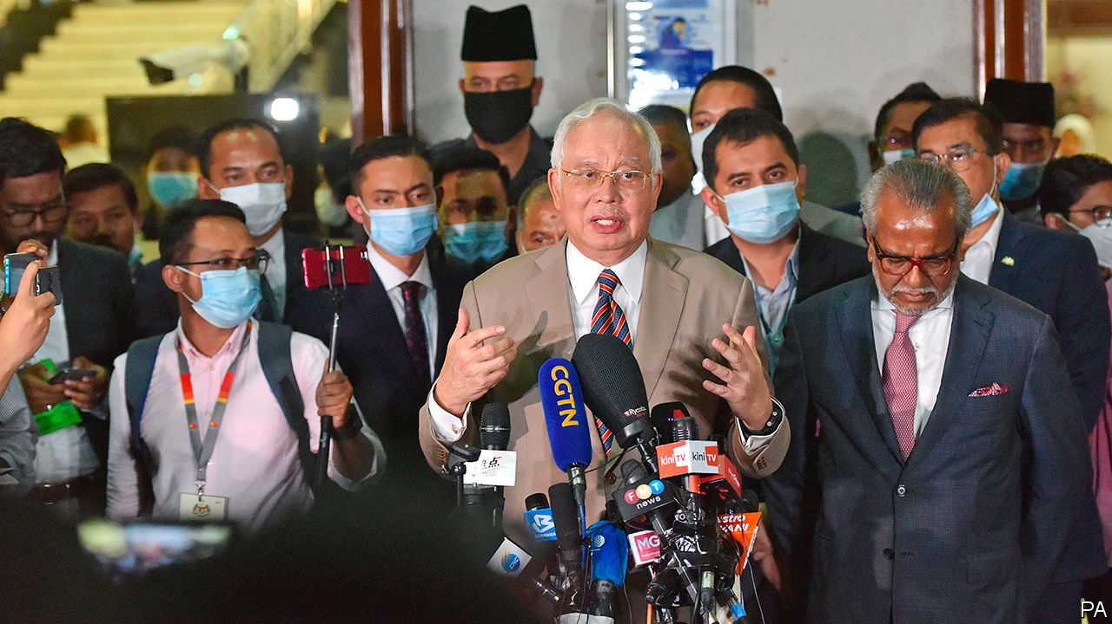

A PAINTING BY Monet and a superyacht. Diamond jewellery and a transparent piano. Many of the things that were bought with the $4.5bn that America’s Department of Justice says disappeared between 2009 and 2015 from 1MDB, a Malaysian sovereign-wealth fund, were rather flashy. The spree attracted investigations in at least six countries.

On July 28th a court in Malaysia convicted Najib Razak, the former prime minister who co-founded and chaired the fund, of seven charges of abuse of power, breach of trust and money-laundering relating to the scandal. The court sentenced him to 12 years in prison and fined him 210m ringgit ($49m). Mr Najib will remain free pending his appeals, which will probably drag on for months. The verdicts came days after Goldman Sachs reached a settlement with Malaysian authorities related to its underwriting of three bond-offerings that raised $6.5bn for 1MDB. The bank will hand over $3.9bn: it is paying $2.5bn in cash and promising to return at least $1.4bn in assets linked to the bonds.

The trial was the first of several facing Mr Najib, who denies wrongdoing. This one concerned payments totalling 42m ringgit made to him by SRC International, a former subsidiary of 1MDB. After hearing evidence for almost 16 months, the judge poured cold water on the argument that Mr Najib had been deceived by associates. He also questioned Mr Najib’s claim that he thought the money was a donation from Saudi royalty. He noted that the former prime minister never sent King Abdullah (who died in 2015) a note of thanks.

The verdicts arrive at a tumultuous time in Malaysian politics. When the scandal became public in 2015 it caused ructions within Mr Najib’s party, the United Malays National Organisation (UMNO). He fired Muhyiddin Yassin, his deputy prime minister, who was demanding an explanation of the affair. At a general election in 2018 voters ousted Mr Najib and UMNO, which had led every Malaysian government for 61 years. They gave power to a coalition called Pakatan Harapan. Its partners included Bersatu, a new party founded as an alternative to UMNO by Mr Muhyiddin and Mahathir Mohamad, another former prime minister.

Their government lasted 22 months before collapsing amid squabbles. Mr Muhyiddin and a group of renegades, including most members of Bersatu, broke away. They combined with UMNO and other parties to form a new coalition, Perikatan Nasional. This bloc now runs the country with Mr Muhyiddin as prime minister.

Relations between Perikatan Nasional’s constituent parties are lukewarm. UMNO and its ally PAS, an Islamic outfit, dominate. They resent Mr Muhyiddin’s leadership. In an apparent bid to keep them sweet, Mr Muhyiddin has created an unusual number of ministerial jobs and doled out roles at government-linked companies. Terence Gomez, a professor of political economy at the University of Malaya, says such appointments are irresponsible while the country is grappling with covid-19. He adds that Malaysia’s sprawling ecosystem of government-linked entities desperately needs reform. 1MDB itself emerged from within it.

Mr Najib was not widely expected to be convicted on all seven charges. Some of his backers could seek to make trouble within Perikatan Nasional. But other UMNO members may be chastened. That would benefit Mr Muhyiddin—as will the opportunity to make tough-sounding noises about corruption, which will please the public.

In the longer term, Mr Najib’s conviction may increase the chance of Mr Muhyiddin choosing to leave his newfangled party and returning to UMNO, four years after his confrontation with the former prime minister led to him being kicked out of it. This possibility is openly discussed by the party’s elites. It could save Bersatu and UMNO from scrapping for the same voters at any future election. It would be a remarkable turnaround if Mr Najib’s conviction were to end up helping his party prolong its time in power.■

This article was downloaded by calibre from <https://www.economist.com/asia/2020/07/30/najib-razak-is-found-guilty-on-seven-charges-in-the-1mdb-scandal>

|  |  |  |  |
| --- | --- | --- | --- |
| Previous | Articles | Sections | Next |

|  |  |  |  |
| --- | --- | --- | --- |
| Previous | Articles | Sections | Next |

#### Pax Rajapaksa

# An election in Sri Lanka will boost the Rajapaksa family

They talk of making big changes to the island’s constitution

Aug 1st 2020 | COLOMBO AND DELHI

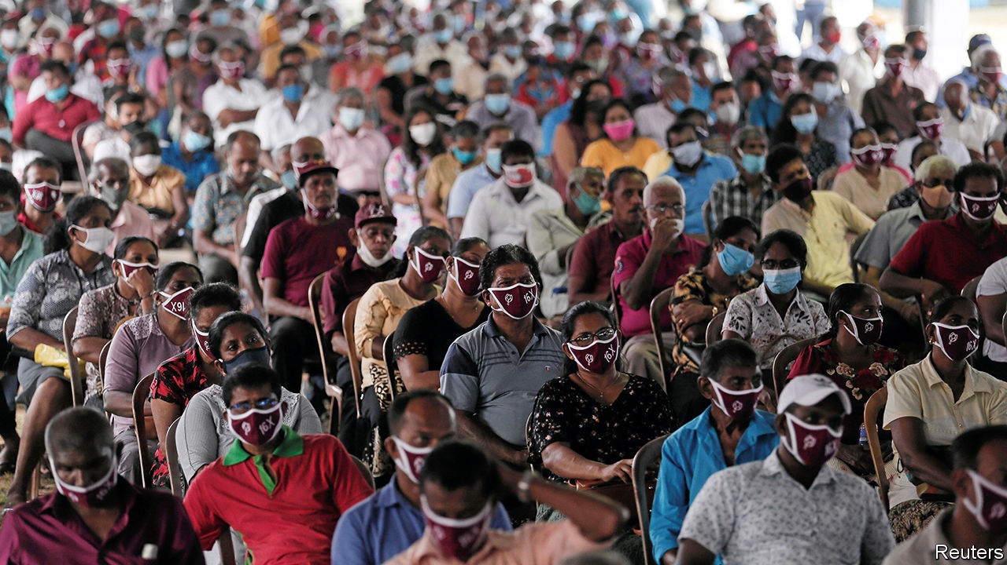

ON THE EVE of an election, what might a political party wish for? A strong brand, an effective party machine, plenty of money, a sympathetic press and a charismatic leader? How about a rival that is tired and discredited after a lacklustre term in office, and has split into factions that hurl more mud at each other than at you?

Such are the advantages enjoyed by the Sri Lanka Podujana Peramuna (SLPP) as it coasts towards a general election on August 5th. The question is not whether it will win. It is whether votes alone will secure two-thirds of the 225 parliamentary seats, or whether the Rajapaksa family—a powerful political dynasty from the south of the island for which the SLPP is essentially a vehicle—will need to coax defectors from other parties to form a supermajority.

Either way, the stage is set for what might be called Sri Lanka’s Second Empire as the Rajapaksas, who ruled in regal fashion from 2005-15, resume unbridled control. They lost this five years ago when the present head of the clan, Mahinda Rajapaksa, then the president, narrowly failed to win a third successive term. During the hiatus, the coalition headed by the rival United National Party (UNP) changed the constitution to trim presidential powers, put in a two-term limit and strengthened independent oversight bodies such as a national election commission.

The Rajapaksas launched a relentless comeback. The youngest brother, Basil Rajapaksa, stitched together the SLPP in 2016. By 2018 it had won big victories in local council elections. A year later another brother, Gotabaya, was elected president. He profited not only from a reputation built as the defence chief who, in 2009, brought a bloody insurgency of almost three decades by minority Tamils to a gory end, but also from the haplessness of the UNP government in the face of an attack by Islamist terrorists that killed more than 250 people on Easter Day in 2019. Gotabaya promptly appointed his brother Mahinda prime minister, at the head of a minority government.

The election is sure to strengthen the Rajapaksas’ hand. Should the SLPP win enough seats, it plans to rewrite Sri Lanka’s constitution. The present one “is like a building where the foundation was built for something else and lots of floors have been added later,” said Basil Rajapaksa recently. “One day that building will collapse and people will die.”

The constitution has its faults. But opposition parties and human-rights activists fear that the Rajapaksas will reconstruct it so as to guarantee their hold on power. The previous period of Rajapaksa rule was marred by the persecution of dissidents, the promotion of sectarian triumphalism, opaque financial dealings and a foreign policy of cozying up to dictatorships, particularly China.

So far in his presidency Gotabaya Rajapaksa has put army officers in control of things ranging from the printing of driving licences to a presidential task force empowered to “Build a Secure Country, Disciplined, Virtuous and Lawful Society”. Asked how he envisaged the SLPP as a ruling party, Basil Rajapaksa blithely responded that the Chinese Communist Party was an admirable model.

Unless a drubbing jolts the opposition into a wrenching overhaul, the Rajapaksas will face little challenge in the medium term. Of the two parties that dominated Sri Lankan politics for a generation, one has been largely absorbed into the SLPP as a junior partner and the other, the UNP, has withered under an old guard that failed to reform. Long allied with the UNP, parties representing minority Tamils and Muslims may now be forced into an accommodation with the Rajapaksas.

This may be bad for pluralism, given the ruling family’s tendencies. But Sri Lanka, a relative success in measures of human development, is in a delicate state. Last year’s terror attacks wrecked two tourist seasons. Even as crushing foreign-debt repayments loomed, Gotabaya Rajapaksa slashed taxes, creating a 25% revenue shortfall. Now the pandemic has hammered tourism again. Remittances, the island’s other main source of income, have plummeted. Perhaps a period of political calm, even under the Rajapaksas, is what Sri Lanka needs. ■

This article was downloaded by calibre from <https://www.economist.com/asia/2020/08/01/an-election-in-sri-lanka-will-boost-the-rajapaksa-family>

|  |  |  |  |
| --- | --- | --- | --- |
| Previous | Articles | Sections | Next |

|  |  |  |  |
| --- | --- | --- | --- |
| Previous | Articles | Sections | Next |

#### Banyan

# A second covid-19 wave is worrying Australia, Japan and Hong Kong

Even Asia’s standouts sometimes lower their guard

Aug 1st 2020 |

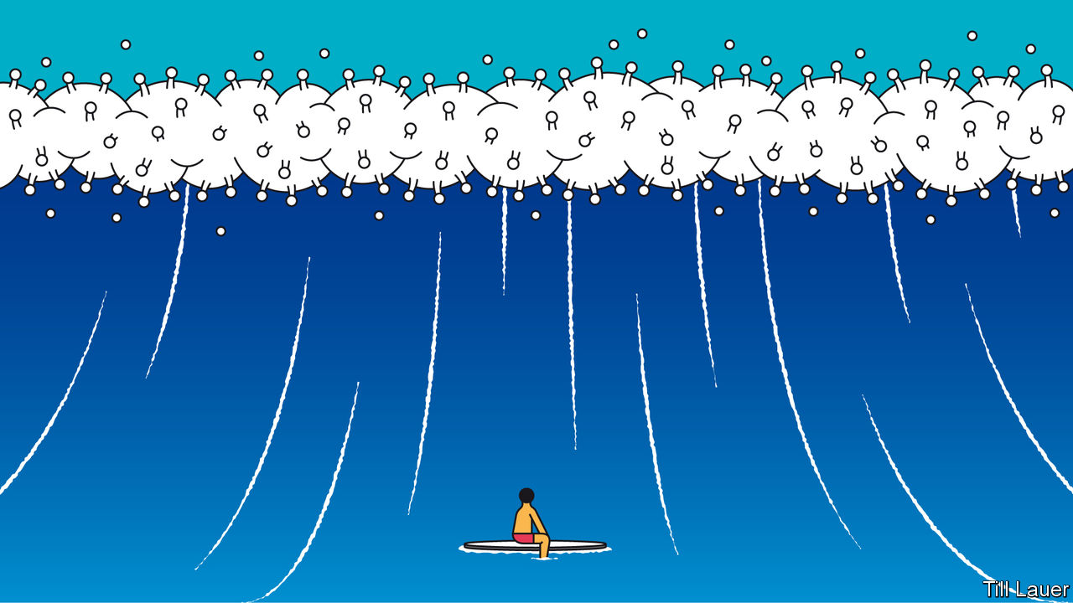

YOUNG AUSTRALIAN returnees in quarantine hotels made whoopee with the security guards who were supposedly supervising their isolation. Presumably they were not thinking of how the 6.6m inhabitants of Victoria state might react. They know now. Some guards took the virus home, from where, in July, it spread fast, just weeks after the state had emerged from a long but successful lockdown. Now Melbourne, Australia’s second most populous city, has reimposed tight restrictions. “Sequels”, tweeted Eric Bana, an actor trapped in his Melbourne home, “are the worst.”

The whole state is isolated, its borders closed, though not before the outbreak snuck out and seeded clusters in restaurants and at funerals in Sydney in next-door New South Wales. Its residents have not yet been shooed back indoors. But the numbers allowed into pubs and clubs have been sharply curtailed, while Queensland and the Northern Territory have banned entry to Sydneysiders, too. Not since the Spanish flu a century ago has the great untrammelled continent thrown up internal barriers in this way.

Australia is recording more daily cases of covid-19—744 on July 30th—than at the peak of the first wave in March and April. Back then its handling of the pandemic earned worldwide admiration. The latest infections undermine a hard-earned reputation and throw plans for economic recovery into disarray. But Australia is not alone among Asian standouts now suffering a troubling second wave of covid-19.

In recent days Japan has recorded sharply higher numbers of infections than during the first peak, notably in Tokyo and Osaka (over 200 daily cases each). Sexual attraction has again reared its head. Outbreaks have been seeded in hostess bars and host clubs, where young staff are paid to flirt with customers. The prime minister, Abe Shinzo, has ruled out another state of emergency. But his government is looking flat-footed. In the lead-up to a four-day national holiday in late July, its “GoTo” travel campaign, intended to boost domestic travel, at first included Tokyo as a destination even as its governor, Koike Yuriko, was urging people to stay at home.

Hong Kong, too, was exemplary earlier this year. Many Hong Kongers swiftly took precautions, their memories of the deadly SARS outbreak in 2003 still vivid. The territory closed borders, schools and restaurants; urged office workers to work from home; and instituted a strict system for returnees that included testing, electronic tagging and isolation. Though there was never a full lockdown, just seven people died of covid-19 in the first wave. By June daily life in the territory of 7m was back almost to normal.

Yet the coronavirus will seek ways in. Quarantine rules were laxer for pilots and seafarers, among others. An imported, and more infectious, strain spread via a hotel where pilots often put up; some took tram trips to the Peak, a tourist spot, while waiting for their test results. Daily infections recently leapt to well over 100. Deaths jumped, to 24. Restaurants and bars have shut again, masks are compulsory even when jogging, and gatherings of more than two people prohibited. On July 20th the chief executive, Carrie Lam, warned of a collapse in Hong Kong’s hospital system.

The new wave of infections is mainly among the young. This helps explain why deaths have not climbed as fast as infections. But the danger is of more vulnerable folks being exposed. The virus is now tearing through Victoria’s nursing homes. There are clusters in Hong Kong homes and wards for the elderly, who account for nearly all of the territory’s recent deaths from covid-19.

Even with these latest spikes, the performances of Australia, Japan and Hong Kong show the United States, Latin America, parts of Europe and struggling India in a dismal light. Nor can other Asian standouts that have avoided second waves, notably New Zealand, South Korea and Taiwan, afford to feel smug about their abilities to detect, contain and treat. Near misses are many. In New Zealand, for instance, two recent returnees were given special permission to leave their isolation to attend their father’s funeral; they later tested positive. Others, including those carrying the virus, have broken free of quarantine facilities, including one who had to sate a craving for pinot noir. Until an effective vaccine is found, or the pandemic burns itself out, the virus will always look for a way to sneak in—and covid-19 carriers for a way to sneak out.

Editor’s note: Some of our covid-19 coverage is free for readers of The Economist Today, our daily [newsletter](https://my.economist.com/user#newsletter). For more stories and our pandemic tracker, see our [hub](https://www.economist.com/news/2020/03/11/the-economists-coverage-of-the-coronavirus)

This article was downloaded by calibre from <https://www.economist.com/asia/2020/08/01/a-second-covid-19-wave-is-worrying-australia-japan-and-hong-kong>

|  |  |  |  |
| --- | --- | --- | --- |
| Previous | Articles | Sections | Next |

|  |  |  |
| --- | --- | --- |
| Asia | Sections | United States |

China

Voting with their feet: One country, two passports

.

Transgender justice: Evolving rights

.

Chaguan: China digs its past

.

|  |  |  |
| --- | --- | --- |
| Asia | Sections | United States |

|  |  |  |  |
| --- | --- | --- | --- |
|  | Articles | Sections | Next |

#### One country, two passports

# Many Hong Kongers are considering emigration

Political and economic uncertainties may drive a new exodus

Jul 30th 2020 |

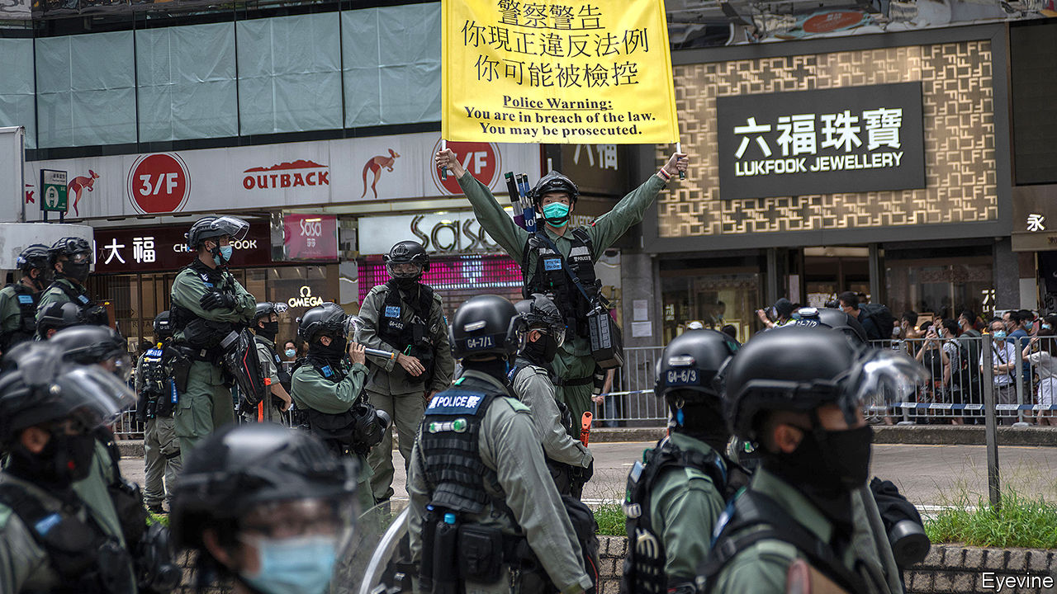

IN SEPTEMBER 2018 Matthew Torne, a British filmmaker, released the third in his trilogy of documentaries about Hong Kong. “Last Exit To Kai Tak” is a bittersweet chronicle of five Hong Kongers who, after the disappointment of the pro-democracy “umbrella” protests of 2014, grapple with what is left for them in the city, as its liberties are chipped away by an increasingly bellicose Chinese government. The burning question, as one character puts it, is this: “revolution or emigration?”

For many people, that question has now been answered. At 11pm on June 30th, one hour before the 23rd anniversary of Hong Kong’s return to Chinese rule, the Communist Party imposed a national-security law designed to squash Hong Kong into submission. The city’s reputation as a haven of free speech within China disappeared overnight, along with the “one country, two systems” framework set up in 1997. In 2014 Communist Party leaders waited for the protesters to lose steam. But by 2020 they had run out of patience.

Several people were arrested for violating the new law on July 1st, but most have been dissuaded from taking to the streets. Then, on July 29th, four students aged 16 to 21 were detained for “inciting secession” on social media. They included Tony Chung, former leader of Studentlocalism, a protest group that had called for Hong Kong’s independence from China. On July 30th Hong Kong’s government said it had disqualified 12 pro-democracy figures from standing in elections in September for the Legislative Council (Legco), Hong Kong’s (until now) semi-democratic parliament. As the euphoria of the protests has dissipated and the new reality has sunk in, the focus for many Hong Kongers has shifted—just as it did a generation before, as the handover loomed—to emigration.

It is not just the crackdown that is pushing people to leave. Hong Kong was already one of the world’s most expensive places to live. It ranked above New York, Tokyo and London in the latest cost of living survey carried out by the Economist Intelligence Unit, a sister company of The Economist. Then came the covid-19 pandemic. The economy shrank by 9% year-on-year in the second quarter of 2020. On July 29th Carrie Lam, the territory’s chief executive, warned the city was “on the verge of a large-scale community outbreak”. (Rumours spread that Legco elections might be postponed as a result.) A poll by the Chinese University of Hong Kong conducted in May, after China announced its intention to impose the law, found that half of 15- to 24-year-olds were considering leaving. “In Hong Kong people learn to survive, not live,” says Thea, a 23-year-old who plans to emigrate. “Even for a middle-class person like me, having my own flat is like an impossible mission.”

Would-be émigrés have many destinations to choose from. Canada is home to more Hong Kong-born people than any other OECD country. More than 275,000 of them emigrated there between 1989 and 1997. A residence permit can be secured by an investment of just C$150,000 ($112,000), a sum easily covered by the sale of a pad in Hong Kong, where the average house price is $1.2m, according to CBRE, a property firm. Australia is offering five-year visa extensions to Hong Kongers already in the country, “with a pathway to permanent residency”. An investment visa is pricier, at around A$1.5m ($1.1m).

Other avenues are also now available. Taiwan has opened an office to help Hong Kongers resettle. Between January and May, there were 3,352 Hong Kong applicants for permanent residence in Taiwan, double the figure in the same period for 2019. Cultural similarity and affordability make Taiwan a popular choice, says Roy Lam, an immigration consultant. A recent poll found that Taiwan was the most popular destination for 50% of Hong Kongers considering emigration.

The biggest difference is that Britain is now offering sanctuary. In 1990 the colonial master offered just 50,000 families British citizenship, and was accused of betrayal for fobbing off the rest (or at least those born before the handover) with a British National (Overseas) passport. This gave Hong Kongers a symbolic connection to Britain, visa-free visits for six months, and some consular protection outside Chinese territory, but not much else. Now, it is offering all 2.9m people who have BNO status the opportunity, with their dependents, to live and work in Britain, with “a path to full British citizenship”. Foreign Secretary Dominic Raab said Britain refuses to “duck our historic responsibilities”. China threatened to take “corresponding measures” (which presumably does not mean letting in 2.9m Brits).

Meanwhile, business is booming for emigration consultancies. Mr Lam relocated 250 families in the first half of 2020, nearly as many as in the whole of 2019. Harvey Law Group, a law firm, had to double the size of its team to meet demand. Andrew Lo’s firm, Anlex, normally receives ten inquiries a day. Since May, it has had 200 a day. He has had to deter bankers from reinventing themselves as butchers for Canada’s rural-immigration programme.

Hong Kong does not track emigration statistics. But there are proxy measures. Applications for certificates of no criminal conviction, a document required for visa applications (as well as adoptions and overseas study), leapt 40% between 2018 and 2019, to more than 33,000. The figure had hovered around 21,600 since 2012.

In 1989 Mr Lo helped people secure escape routes after the June 4th massacre in Beijing sent shudders through Hong Kong. “Today, people are more panicked,” he says. Then, people wanted an insurance plan; now they want to “move immediately”. More than a quarter of the Hong Kongers who moved to Canada between 1991 and 1995 later returned to Hong Kong, heartened by China’s initial light touch. Indeed, most of the 300,000 Canadians in the former colony are Hong Kong-born. “I treasure my Canadian citizenship, and not just as a potential way out of Hong Kong,” says Joyce Lau, who was raised in Canada. Like most foreign-passport holders, she has no plans to leave just yet. Today’s would-be émigrés may be different. “I feel like I need to mentally prepare myself that I might not be able to return to Hong Kong,” says 23-year-old Nicole, who was deeply involved with the protests, and wants to leave.

Some high-profile student leaders have already gone. On July 2nd Nathan Law flew to London, fearing for his safety. For others it is much less clear-cut, not least because those who most want to leave—the young protesters—are the most idealistic about the fight and the least able, financially, to up sticks. “Leaving Hong Kong at this time of desperation just feels wrong,” says Nicole. “I feel like a deserter.”

So, just as in the 1990s, by necessity or choice, there is a third category for Hong Kongers: staying put and making the best of it. The city has always risen from the ashes, say optimists, and perhaps it can again. Many are waiting to see just how bad it gets. Curtis Law, a 28-year-old journalist, is renewing his BNO passport, just in case. “Perhaps it will be useful in the future,” he says. But “without a lot of savings”, moving to Britain is still “a last resort”. ■

This article was downloaded by calibre from <https://www.economist.com/china/2020/07/30/many-hong-kongers-are-considering-emigration>

|  |  |  |  |
| --- | --- | --- | --- |
|  | Articles | Sections | Next |

|  |  |  |  |
| --- | --- | --- | --- |
| Previous | Articles | Sections | Next |

#### Evolving rights

# A Chinese trans woman wins a surprising legal victory

A Beijing court says she can’t be fired for being trans

Jul 30th 2020 |



IN MANY WAYS, Gao Moumou was lucky. She had a good job as a product director in Beijing for Dangdang, an e-commerce firm, which allowed her to save enough money for her gender-reassignment surgery. Her office gave her time off to recover, but on September 6th, 2018, less than three months after her surgery, Dangdang fired Ms Gao, citing her “continuous absenteeism”. Ms Gao thinks the real reason was transphobia. In January this year a court in Beijing surprised many by agreeing with her. It ordered Dangdang to reinstate Ms Gao’s contract and pay her overdue wages. The news circulated online in July, and generated 380m views on Weibo, a microblog. Ms Gao is the first transgender person to win a job-discrimination case in China.

Gay and transgender people are not protected from discrimination in Chinese employment law, but sex discrimination is illegal. People who have legally changed their gender can bring a claim on that basis. The burden of evidence is high. Ms Gao had a “smoking-gun” proof of discrimination, says Darius Longarino of Yale Law School. Dangdang referred to her as “Mr” in a termination letter and called her “mentally ill”. The company said that other colleagues were uncomfortable working with her. But because she had legally changed her gender to female, Dangdang was obliged to treat her the same as other female colleagues, the court said.

It was not just the verdict that was surprising. The court also called for “tolerance” and said society must “respect and protect the personality, dignity and legitimate rights of transgender people”. An online poll of 330,000 people found that 81% viewed the court’s decision positively. But that is “not what most people in China think”, says Alex, who works for an LGBT organisation in Beijing. Chinese society is conservative when it comes to gender roles. Homosexuality was officially classified as a mental illness until 2001, and “transsexualism” still is.

Though there are still few legal protections, being gay is now much more accepted in Chinese cities. But being trans is still difficult, not least because of the many requirements for changing your legal gender, one of which is undergoing full reassignment surgery. That can cost 100,000 yuan ($14,200). A person must also notify—and effectively seek permission from—their family, as well as be over the age of 20, unmarried, and heterosexual according to their self-identified gender. A recent survey found that only 15% of people who said they were transgender had undergone reassignment surgery, the most common obstacle being cost.

Official media rarely discuss transgender issues, though they did report on a recent blogpost by J.K. Rowling, author of the Harry Potter books. The blog was criticised by many trans activists (and applauded by many feminists) in the West. It was good for transgender people in China, says Alex, the LGBT worker. “No matter if it’s positive or negative, it helps us to be seen.”■

This article was downloaded by calibre from <https://www.economist.com/china/2020/07/30/a-chinese-trans-woman-wins-a-surprising-legal-victory>

|  |  |  |  |
| --- | --- | --- | --- |
| Previous | Articles | Sections | Next |

|  |  |  |  |
| --- | --- | --- | --- |
| Previous | Articles | Sections | Next |

#### Chaguan

# Digging up China’s past is always political

Officials claim an archaeological site proves that China has 5,000 years of continuous history

Aug 1st 2020 |

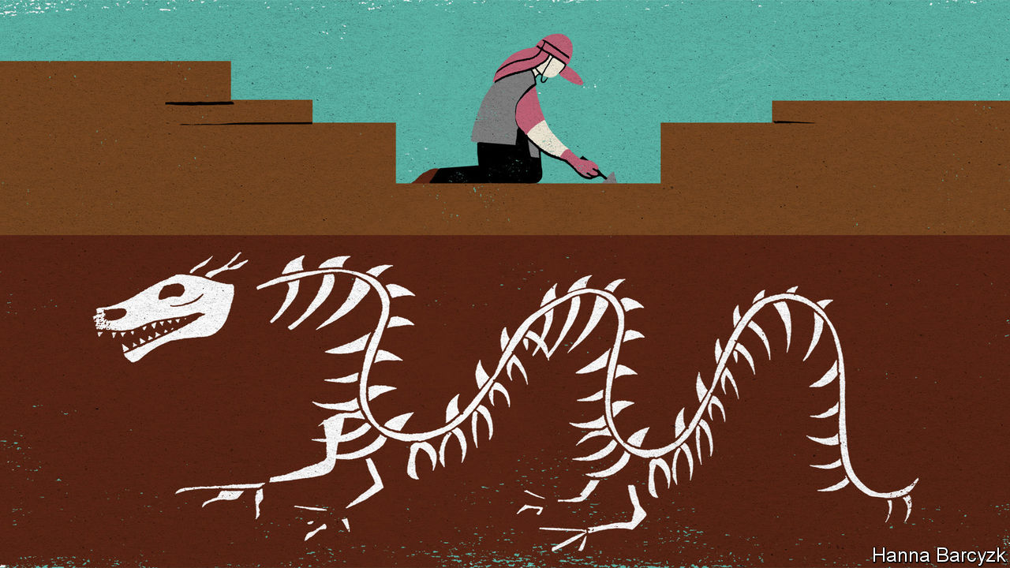

IN THE TIGHT-KNIT world of Chinese archaeology, a sign of a dig’s importance is the sight of Zhou Mingsheng at work. A sun-battered, tousle-haired field technician who has worked at excavations all around China, “Master Zhou” is credited with the gentlest touch in his profession. Born into a farming family, he is a “national-level craftsman” with a talent for using simple tools—a trowel and soft brush—to extract relics that would crumble in other hands, says his current boss, Wang Xu, director of an archaeological site at Shuanghuaishu, a Neolithic settlement near the Yellow River in the central province of Henan.

Master Zhou’s presence, quietly supervising local villagers as they scrape at the hard-packed soil, is not the only proof that this hilltop site has the attention of high-ranking officials. Since digging began in 2013, funding has increased greatly. Sturdy roofs cover much of the site. Vaulted living quarters have been built into a hillside, keeping them cool in summer heat and cosy in winter frosts. A spell at Shuanghuaishu is a prize for top students at Peking University, the country’s most prestigious college. Visits by Chinese dignitaries are a weekly routine.

It is not beauty that lures visitors to Shuanghuaishu. At 5,300 years old, the settlement is the work of a culture too simple to have left behind exquisite bronzes or written inscriptions. The single most precious find, to date, is a finger-length sculpture of a silkworm, carved out of the tusk of a boar. Nor is the setting lovely: a scrubby plateau patrolled by dragonflies and deafening crickets, between a highway and two power stations. Rather, the site’s importance is historical, and thus political. For since the birth of Chinese archaeology in the 1920s, it has been inseparable from claims that China boasts the oldest unbroken civilisation on Earth.

That question caused a genteel tussle between President Donald Trump and his Chinese counterpart, Xi Jinping, during a state visit in 2017. As the pair explored the Forbidden City in Beijing, Mr Trump ventured that he had heard that China has 5,000 years of history, but that Egypt has 8,000. “Egypt is a bit more ancient,” Mr Xi replied. “But the only continuous civilisation to carry onwards is China.” Shuanghuaishu is now part of that debate. Leading archaeologists say that the site boasts the right combination of location, age, grandeur and distinctive cultural elements to be the capital of an early Chinese kingdom. That would make it a bridge between China’s written history, which stretches back 3,000 years, and the era of the Yellow Emperor, who by tradition ruled over these fertile central plains almost five millennia ago, though many foreign scholars have the impudence to dismiss him as a myth. State media call the site proof of China’s 5,000 years of history.

Master Zhou began his career in 1979. He is too diplomatic to say so, but that was a period of cautious rebuilding for Chinese archaeology, after the relic-smashing frenzies of the Maoist era. Back then ancient treasures, if displayed at all, were labelled as evidence of feudal oppression. By the late 1990s patriotic education had replaced class warfare as a favoured tool for mobilising the masses. In 1995 a deputy prime minister, Song Jian, was mortified during a visit to Egypt, where officials showed him a detailed timeline of the pharaohs extending back 4,700 years. He returned arguing that China needed similarly precise dates for its dynasties, writing that history without chronology “can only be called rumour or myth”. The central government tasked a team of 200 archaeologists, historians and other scholars with assigning firm dates to the earliest dynasties listed in classical histories, the Xia, Shang and Zhou. That multi-year project ended with official Chinese declarations of success, and a start date for the Xia dynasty four millennia ago. In contrast, many foreign scholars question to this day whether proof of the Xia has been found.

A second national project to research the origins of Chinese civilisation followed from 2002 to 2015. It was given a further boost by President Xi’s launch in 2013 of a globe-spanning infrastructure scheme, the Belt and Road Initiative, with its talk of reviving ancient trade routes along the Silk Road. Mr Wang recalls how those twin quests to find silk-producing kingdoms led archaeologists to Shuanghuaishu, and then in 2016, to two nearby sites where small urns turned out to hold children buried in silken funeral wrappings. He lists signs of Shuanghuaishu’s sophistication, from its large houses to neatly dug tombs, some containing residents who lived to the then-astonishing age of 40 and have the slender torsos of those spared hard labour. A series of pots was found buried in the precise shape of the plough, a constellation. Foreigners carp about a lack of written records, Mr Wang notes. Perhaps they are missing symbols that will one day be deciphered, for instance in patterned pottery. Maybe the Yellow Emperor was not a literal person, but a tribe. Outsiders “can’t keep using Western standards to apply to Chinese ruins,” he argues.

## Whose emperor are you calling mythical?

To foreigners, a final puzzle remains. Shuanghuaishu is an interesting place. But so are lots of other Chinese sites of the same period. Wang Wei, director of the Institute of Archaeology at the Chinese Academy of Social Sciences (CASS), agrees that similar artefacts—from jade carvings to images of dragons—have been found in several sites dating back five or six millennia. That would seem to bolster those scholars who compare early China to a “starry sky” filled with competing cultures. But unity is what interests Mr Wang. In time, he says: “the stars gathered in central China, and a nation was built on top.” Shuanghuaishu matters because it lies in that central cradle of national greatness. Chinese archaeology has three main missions, says the CASS archaeology boss. The first two are studying human development and agriculture. But the most important is studying the origins of Chinese civilisation. If that sounds like a political answer, in China history and politics are inseparable. And that has been true for thousands of years.■

This article was downloaded by calibre from <https://www.economist.com/china/2020/08/01/digging-up-chinas-past-is-always-political>

|  |  |  |  |
| --- | --- | --- | --- |
| Previous | Articles | Sections | Next |

|  |  |  |
| --- | --- | --- |
| China | Sections | The Americas |

United States

Policy towards China: Peering through the smoke

.

Tech titans testify: Hearing without listening

.

Posthumous hip-hop hits: Dead rappers are killing it

.

Crime statistics: Few signs of a surge

.

Lexington: Mid-century modern

.

|  |  |  |
| --- | --- | --- |
| China | Sections | The Americas |

|  |  |  |  |
| --- | --- | --- | --- |
|  | Articles | Sections | Next |

#### US-China relations

# Would a Biden administration be softer than Trump on China?

Relations with Beijing will loom large in America’s presidential campaign

Jul 30th 2020 | NEW YORK

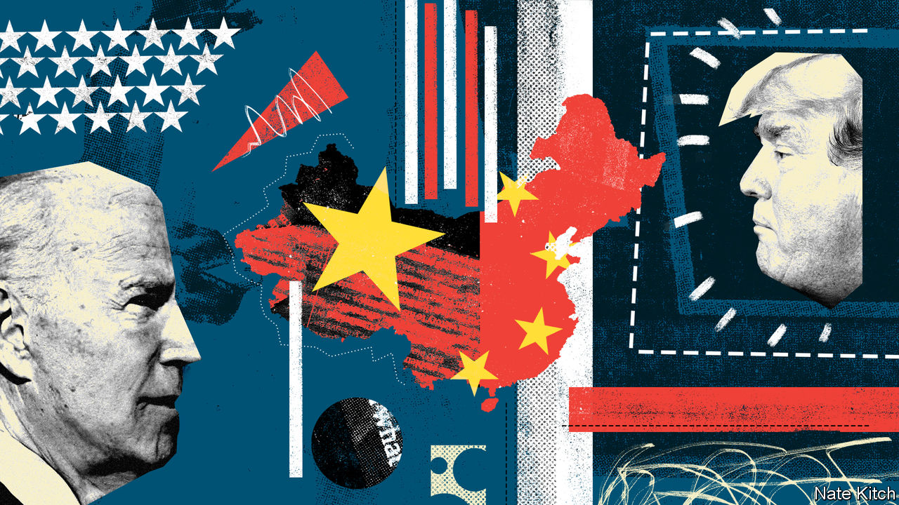

IN DECEMBER 2018 China hawks in the Trump administration pushed a series of punitive measures in what some referred to internally, according to a new book by Bob Davis and Lingling Wei, as “Fuck China Week”. That was as nothing compared with what happened in the month of July 2020.

In recent weeks America has imposed sanctions on senior Chinese officials, including a member of the Politburo, for their part in atrocities against Uighurs in Xinjiang; added 11 Chinese companies to the Commerce Department’s blacklist, for complicity in those atrocities; declared China’s sweeping claims in the South China Sea illegal; revoked Hong Kong’s special status for diplomacy and trade; announced criminal charges against four Chinese nationals who officials say were spies for the People’s Liberation Army; and ordered the closure of China’s consulate in Houston, supposedly a hub for espionage and influence operations, the first such move since the normalisation of relations in 1979 (China retaliated by closing America’s consulate in Chengdu). The first hint of trouble in Houston came when videos surfaced online of Chinese diplomats hurriedly burning documents in their courtyard—an apt metaphor for more than 40 years of diplomatic engagement going up in smoke.

All this has happened under a president, Donald Trump, who displays a personal affinity for his Chinese counterpart, Xi Jinping, and (according to his former national security adviser, John Bolton) told Mr Xi that building camps for Uighurs was “the right thing to do”. He has shown little appetite for fights with China except over trade and, to deflect blame for his response to covid-19, the pandemic. But with time running out in his first term—and perhaps his presidency—hawkish officials around him are trying to fix in concrete a more confrontational posture than America has adopted since before Richard Nixon went to China almost half a century ago.

On July 23rd, at the Nixon Presidential Library in California, Mike Pompeo, the secretary of state, concluded a series of four speeches in as many weeks by top officials portraying China’s regime as the greatest threat to liberty and democracy globally. The national security adviser, Robert O’Brien, the FBI director, Christopher Wray, the attorney-general, William Barr, and Mr Pompeo argued that China sought to export its ideology and “control thought” beyond its borders. They castigated corporate chiefs and Hollywood studios for bowing to Beijing, warned of extensive Chinese espionage operations in America and contended that Mr Xi is on a decades-long quest for “global hegemony”. Mr Pompeo said that America and its allies must push China to change, or risk ceding the 21st century to Mr Xi’s authoritarian vision. “The old paradigm of blind engagement with China simply won’t get it done,” he said. “If we bend the knee now, our children’s children may be at the mercy of the Chinese Communist Party.”

Unnamed in these speeches—but an unavoidable backdrop to them—are Joe Biden and the presidential campaign. Mr Trump’s campaign wants to portray the presumptive Democratic nominee as soft on China, suggesting Mr Biden while vice-president underestimated the threat. A senior administration official says that part of the calculus driving recent actions is to set China-US relations on a trajectory that would be difficult to reverse no matter who wins in November. Some officials believe they have come close to achieving this, with the help of a broadly hawkish bipartisan consensus in Congress, which has passed tough legislation in response to the treatment of Uighurs and Hong Kong. The Communist Party’s own actions—turning Xinjiang into a gulag and stripping Hong Kong of the rule of law—have almost certainly ensured that America cannot return fully to its former relationship with China.

Still, some hawks outside the administration, including a few who say they will vote for Mr Biden, worry that he would be less confrontational with Mr Xi as he searches for co-operation on issues like climate change and nuclear-arms control. Many of his foreign-policy advisers are, inevitably, veterans of the Obama administration. Hawks deride it as having accommodated China’s rise too readily for the sake of, say, the Paris Agreement. Would a Biden administration be softer, too?

## No more Mr Soft Guy

Mr Biden’s advisers push back in a few ways. First, they argue that he would restore moral authority by calling out China for human-rights abuses. Second, they say he intends to work with allies to press China to change its behaviour. Third, he would invest at home to make America a stronger competitor in areas like 5G. Mr Trump, they contend, has weakened America’s standing relative to China on all three fronts: giving a green light to human-rights abuses; undermining allies while cosying up to dictators; and letting America’s institutions and infrastructure rot. “We’re weaker and China’s stronger because of President Trump,” says Tony Blinken, an adviser to Mr Biden.

Mr Trump’s officials lay stress on their actions, not the president’s words. Before July’s salvos officials had moved to cut off the supply of American technology to Huawei, part of a campaign against the telecoms giant that has won some support among allies: Britain has now said it will bar Huawei from its networks (Australia did so before America). The FBI has taken a more aggressive approach to investigating Chinese espionage—in his speech on China, Mr Wray said he was opening a new case every ten hours. The State Department recently decided to cancel the visas of as many as 3,000 graduate students connected to military institutions in China, the latest uptick in scrutiny of Chinese nationals coming to America for study or research. And the Department of Defence has become more assertive in conducting freedom-of-navigation operations in the South China Sea and the Taiwan Strait.

Most provocative, perhaps, have been shows of support for Tsai Ing-wen, the president of Taiwan, which China claims as its own. This has raised the question of how far they might go in testing one of the most delicate aspects of Sino-American relations. A senior official says that after decades of risk-averse diplomacy, the administration is determined to impose costs for China’s behaviour.

Mr Biden’s advisers are on weak ground when they claim the Obama administration was tough on China. A more persuasive argument is that, though he has surrounded himself with China hawks, Mr Trump is no hawk himself, and could undercut his administration’s policies at a stroke. He admitted, in an interview in June, that he delayed imposing sanctions on Chinese officials over Xinjiang because he did not want to jeopardise a trade deal. And the policy he is keenest on, tariffs, has been a failure, netting a flimsy agreement from China to buy more farm goods (which Mr Bolton says the president asked Mr Xi to do to help him win re-election).

Voters seem unimpressed. In a poll conducted by Suffolk University and USA Today in late June, 51% of respondents said Mr Biden would do a better job of handling China, compared with 41% for Mr Trump.

Might the president be willing to take more radical measures against China, egged on by the hawks around him? Ideas which staffers have considered recently include a ban on all 92m Communist Party members and their families visiting America, or sanctions on Chinese banks in Hong Kong. These may be too provocative for Mr Trump now—but could perhaps seem less so as the election approaches.

In China, officials have so far responded with relative restraint. They can read polls too, and may want to see if the current trajectory of relations continues after January. Some propagandists have suggested they would like Mr Trump to win, on the argument, like Mr Blinken’s, that he has weakened America’s strategic position and strengthened theirs. That may be bluster. Or they may also view Mr Biden as someone who would back up tough talk on issues like human rights, rather than turn matters of principle into bargaining chips. On that score even hawks who are wary of Mr Biden do not doubt his sincerity. China has changed since he was vice-president, as has the elite consensus in Washington. It will take more than an election to end the dark new era in US-China relations. ■

Dig deeper:  
Sign up and listen to Checks and Balance, our [weekly newsletter](https://www.economist.com/checksandbalance/) and [podcast](https://www.economist.com/podcasts/2020/07/24/checks-and-balance-our-weekly-podcast-on-american-politics) on American politics, and explore our [presidential election forecast](https://projects.economist.com/us-2020-forecast/president)

This article was downloaded by calibre from <https://www.economist.com/united-states/2020/07/30/would-a-biden-administration-be-softer-than-trump-on-china>

|  |  |  |  |
| --- | --- | --- | --- |
|  | Articles | Sections | Next |

|  |  |  |  |
| --- | --- | --- | --- |
| Previous | Articles | Sections | Next |

#### Tech titans’ testimony

# Big Tech’s grilling provides more show than substance

Hearing without listening

Jul 30th 2020 | SAN FRANCISCO

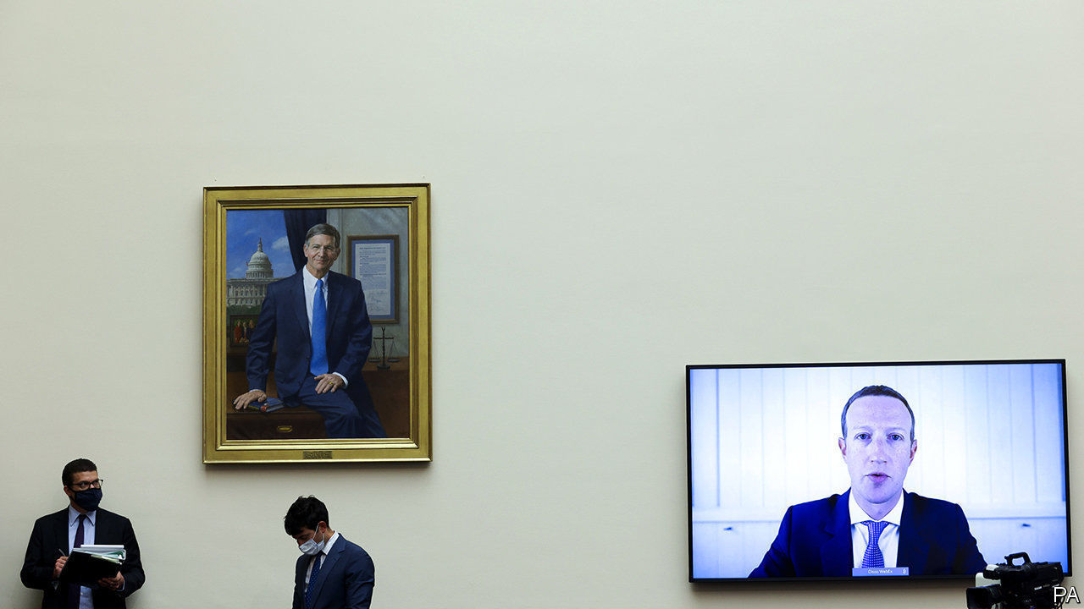

“SO CAN WE all agree that this #antitrusthearing has...nothing to do with antitrust?” The tweet, sent midway through the five-hour congressional grilling on July 29th of the bosses of Alphabet (Google’s parent), Amazon, Apple and Facebook, was only a slight exaggeration. The much-hyped, mostly virtual event will not do a lot to move forward the debate about what, if anything, to do to rein in the titans of tech. Instead it was yet more proof that in the current hyper-partisan environment such hearings have become a bit of a farce.

In advance, aides to the antitrust subcommittee of the House Judiciary Committee, which held the hearing, suggested that the bosses would be confronted with plenty of smoking guns. In 13 months of investigation of big tech firms, intended to provide the basis for proposals on how to reform America’s antitrust law, it collected hundreds of hours of interviews and waded through 1.3m documents, mostly emails. Yet if there was smoke, it was thin.

The most damning emails came from Facebook, which many accuse of having systematically taken over other social-media firms, such as Instagram and WhatsApp, to prevent them from becoming serious competitors. “One thing about startups though is you can often acquire them. I think this is a good outcome for everyone,” the firm’s founder, Mark Zuckerberg, wrote in April 2012, shortly after Facebook bought Instagram. In another email one of his colleagues talks about acquisitions as a way to “neutralise a potential competitor”.

The four bosses generally managed to bat away such accusations. Mr Zuckerberg admitted that Instagram was a competitor, but said it would never have become as big as it is today without Facebook’s help. The legislators succeeded in showing that the firms were indeed “gatekeepers” to the digital economy, as David Cicilline, the chairman of the subcommittee, argued in his opening statement. What remains much less clear is what to do about this, and whether the companies abuse their power.

The problem is that the firms’ actions can often be seen as anticompetitive and as benefiting consumers simultaneously. Asked why Apple removed from its App Store some apps that help parents control their children’s devices, the firm’s boss, Tim Cook, could argue that this was not done to hurt apps competing with similar offerings from Apple, but to protect users’ data (although he struggled to explain why this took place right after Apple introduced its own offering and why six months later it let the other apps back in, without major changes to their data policies).

The long afternoon was mostly filled with lawmakers answering their own questions. They quizzed the bosses and let them say a few sentences, before talking over them and making their own statements. Democrats at least stayed on topic; Republicans seemed more interested in conspiracies. They argued that Google is somehow in bed with the Chinese government and that tech firms have an inbuilt bias against “conservative views” in the way they moderate content—even though their platforms are the most important distribution channels for right-wing opinions.

The most interesting insight came from how differently the four CEOs performed. Mr Zuckerberg did best; he has been grilled, in Congress and elsewhere, many times before. Mr Cook also put in a solid showing, although he faced the fewest questions. By contrast, Jeff Bezos of Amazon, appearing for the first time at a congressional hearing, could do with a tad more coaching: he appeared to admit some of the accusations levelled at Amazon, for instance that it uses data gathered from merchants on its e-commerce platform to develop rival offerings. But it was Sundar Pichai, Google’s boss, who performed the worst, too scripted and apparently overwhelmed by the conspiracy theories coming his way.

The subcommittee will now write a report, to be published later this year. It is unlikely to lead to any legislation, at least in the near future. Nobody expects much to happen before the presidential election in November. Even after that, would antitrust be a priority? What a re-elected Donald Trump would do is anybody’s guess (“If Congress doesn’t bring fairness to Big Tech...I will do it myself with Executive Orders,” he tweeted before the hearing). As president, Joe Biden, who has not shown much interest in tech matters, would have his plate full with other projects, such as fixing health care and the economy.

If there is big antitrust news before the election it is likely to come in the form of lawsuits. Insiders say the Department of Justice is intent on filing one by September—perhaps with some state attorneys-general—against Google for having extended its monopoly in online-search advertising into other areas of digital marketing. The Federal Trade Commission may follow suit by going after Facebook, though it is unclear what it would focus on. Such cases tend to take years. The four tech bosses may have had a few unpleasant hours, but their power is safe for now. ■

Dig deeper:  
Sign up and listen to Checks and Balance, our [weekly newsletter](https://www.economist.com/checksandbalance/) and [podcast](https://www.economist.com/podcasts/2020/07/24/checks-and-balance-our-weekly-podcast-on-american-politics) on American politics, and explore our [presidential election forecast](https://projects.economist.com/us-2020-forecast/president)

This article was downloaded by calibre from <https://www.economist.com/united-states/2020/07/30/big-techs-grilling-provides-more-show-than-substance>

|  |  |  |  |
| --- | --- | --- | --- |
| Previous | Articles | Sections | Next |

|  |  |  |  |
| --- | --- | --- | --- |
| Previous | Articles | Sections | Next |

#### Hip-hop hits

# Posthumous albums by young rappers are topping the charts

For many fans, such success is bittersweet

Jul 30th 2020 |



BY NOW HIP-HOP fans are all too familiar with the success that can come after an artist’s untimely death. Tupac Shakur and Notorious B.I.G., two American rappers who were murdered in 1996 and 1997 respectively, have sold more music in death than in life. Other well-known rappers to notch up hits after their deaths include Eazy-E (who died in 1995), Big L (1999) and J Dilla (2006). The past few years have seen a flurry of such posthumous hits. Juice WRLD, a rapper who died in December, has now reached the top of America’s Billboard 200 charts for the second time with his third album, “Legends Never Die”. By one reckoning, it is the most successful posthumous release in two decades.

An analysis by The Economist suggests that, in the world of hip-hop at least, the sales boost generated by posthumous albums may be growing. We looked at recent releases by hip-hop artists Lil Peep, XXXTentacion, Mac Miller, Pop Smoke and Juice WRLD. To measure the commercial success of a release, we used the album-equivalent unit (AEU), a measure developed by Billboard and Nielsen SoundScan, a research firm, which treats 1,500 song streams or ten song downloads as equivalent to an album sale. To avoid comparing albums released before and after the adoption of the AEU in 2014, we restricted our analysis to those released in the past five years.

All five posthumous albums in our sample performed better in their first week than previous works by the same artists. Pop Smoke and Juice WRLD’s posthumous albums, both released in the past month, amassed roughly four and seven times more AEUs, respectively, than the average releases during their lives. The posthumous works of Lil Peep and Mac Miller also recorded huge jumps in first-week sales (see chart).

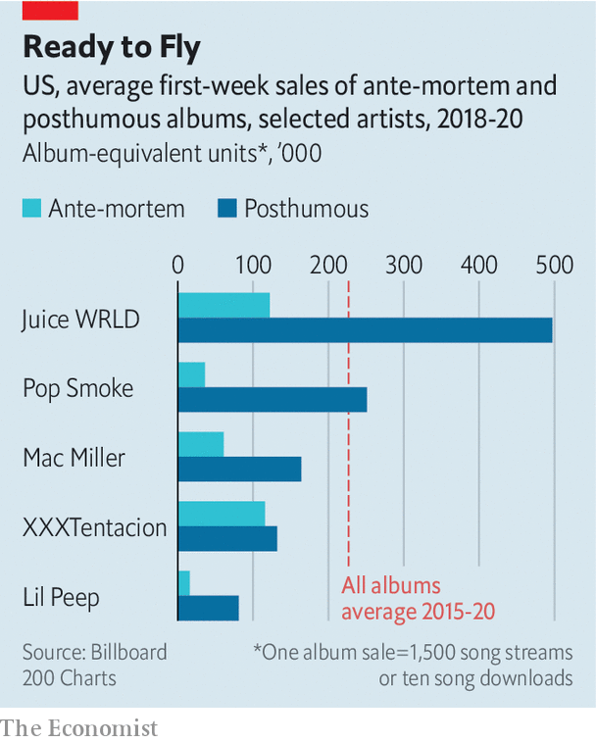

Critics of posthumous releases—including fans, music critics and artists alike—say they are a corporate cash-grab and a blight on a dead artist’s career. They allege that record labels compiling posthumous releases cram them with filler tracks and unfinished songs, in part to boost sales figures (the AEU system favours releases with more songs). There may be some truth to that. Since 2018, according to our figures, there has been a positive correlation between the number of tracks on a chart-topping album and its AEUs during the first week. But the relationship is very weak.

So why do posthumous albums often outperform their ante-mortem predecessors? The answer may be humdrum. Fans rally to their beloved artists. The day after David Bowie’s death in 2016, the rocker’s streams on Spotify surged by 2,700% compared with their typical levels. Living musicians can benefit, too. Artists who re-emerge after a hiatus, as Tool, a Los Angeles band, did last August after 13 years without releasing an album, have seen their discographies appear on the Billboard charts. How unfortunate for artists to have more success when the mic cable is severed for good.

This article was downloaded by calibre from <https://www.economist.com/united-states/2020/07/30/posthumous-albums-by-young-rappers-are-topping-the-charts>

|  |  |  |  |
| --- | --- | --- | --- |
| Previous | Articles | Sections | Next |

|  |  |  |  |
| --- | --- | --- | --- |
| Previous | Articles | Sections | Next |

#### Crime statistics

# Fears that America is experiencing a serious crime wave are overblown

Few signs of a surge

Aug 1st 2020 |

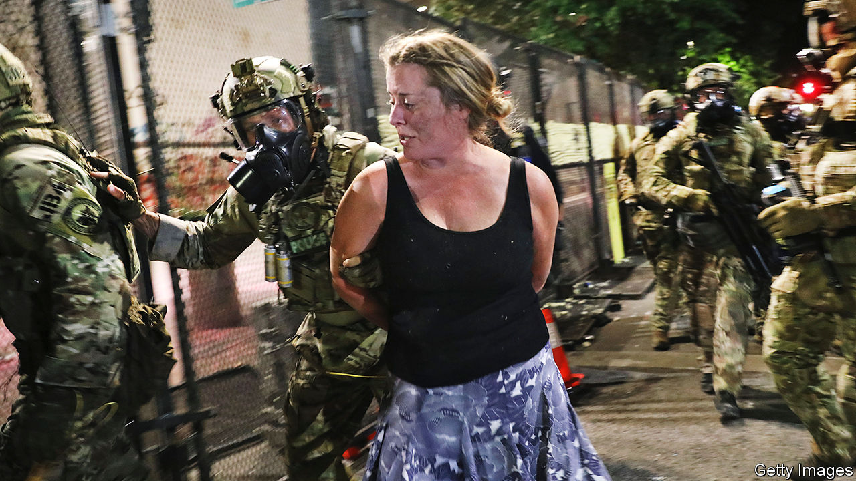

THE DEATH of George Floyd under the knee of a Minneapolis police officer on May 25th has sparked large anti-racist protests in cities across America. “Defund the police”, a call to reallocate some of the money spent on law enforcement to other services, is becoming a mainstream slogan on the left. President Donald Trump claims that the “anti-police crusade…has led to a “shocking explosion of shootings, killings, murders and heinous crimes of violence.” On July 22nd he announced he would send a surge of federal agents to police big cities, including Chicago and Albuquerque (although those that had been deployed in Portland, Oregon, are starting to leave.)

But the evidence that America is experiencing a major crime wave is mixed at best. Official national crime statistics, compiled by the FBI, are generally published with over a year’s delay, so researchers have to turn to other sources. David Abrams of the University of Pennsylvania, pulls together data from some two dozen major cities on citycrimestats.com. His figures show that so far this year crime is actually down by around 10% compared with the same period in 2015-19 (see chart).

It is possible that this drop is simply an artefact of reporting. Covid-19 has meant fewer people on the streets, hence fewer potential witnesses who might call the police. However, Mr Abrams notes that the share of police stops which have resulted in arrests has not changed, which suggests that the drop in crime is genuine. It seems even drug dealers have been adhering to social-distancing guidelines.

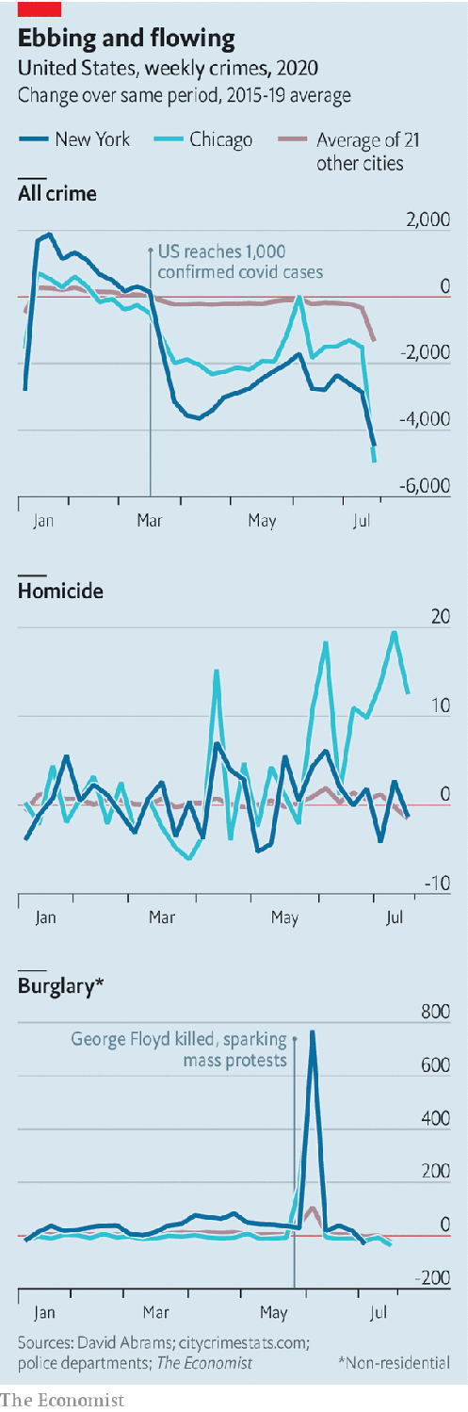

There are some exceptions to this decline. Non-residential burglaries spiked in early June, coinciding with the peak of the George Floyd protests, when looting of retail stores was common. Domestic violence has also probably increased. Data are sparse because only a small fraction of victims report being abused, and because police departments can be slow to share what numbers they do have. Research by Emily Leslie and Riley Wilson of Brigham Young University finds that calls related to domestic violence in March to May rose by an average of 7.5% in 14 cities compared with the same period in the previous year.

Alarmingly, murder also seems to be on the rise. So far this year, homicides in big cities appear to be up by around 20% against the average for the same period in 2015-19. Interpreting these numbers is tricky, since murder rates can vary a lot from year to year. An Economist analysis of FBI statistics finds that the total number of homicides in big cities fluctuated from year to year by an average of roughly 20% between 1990 and 2018. Murders in Chicago this year may be up by 51% through July 20th, compared with the same period in 2019, but by only 9% on 2017. Except in a handful of the cities in Mr Abrams’s data set, homicide rates did not change much relative to prior years after government shutdown orders were put in place.

One city which has seen a marked increase in violence in recent weeks is New York. Chris Herrmann of the John Jay College of Criminal Justice, a former analyst with the New York Police Department (NYPD), says this may be partly because many police officers who would normally patrol the outer boroughs have been redirected to Manhattan, where many of the protests are occurring. He also notes that covid-19 has forced jails and prisons to release inmates, including many convicted of, or awaiting trial for, violent offences.

The police usually benefit from a natural dividend in the autumn. Homicide rates tend to fall in September as the weather cools and teenagers head back to classrooms. But Mr Herrmann fears the country might not be as lucky this year. Many schools are unlikely to reopen. Courts have been shuttered, making it harder for prosecutors to stop gang violence. Michael LiPetri, chief of crime-control strategies at the NYPD, says the share of shootings involving gang members in his city has more than doubled since last year. And, as Jens Ludwig, director of the University of Chicago Crime Lab, points out, America’s covid-induced recession will take a serious toll on city finances, putting further pressure on the budgets of police departments.

Drastically cutting police funding without adequately investing in other areas, such as social work, would be risky. A recent working paper by Tanaya Devi and Roland Fryer, both economists at Harvard University, analysed the impact of state and federal investigations into police departments. It found that, though most probes had a small positive impact in reducing crime, “viral” ones prompted by national scrutiny appear to cause the police to retreat too far. When Freddie Gray was killed by the Baltimore police in 2015, the national media and federal investigators poured into the city. Police officers, fearful for their jobs, pulled back. They stopped fewer people in the streets and arrested fewer suspects. And homicides rose. ■

Dig deeper:  
Sign up and listen to Checks and Balance, our [weekly newsletter](https://www.economist.com/checksandbalance/) and [podcast](https://www.economist.com/podcasts/2020/07/24/checks-and-balance-our-weekly-podcast-on-american-politics) on American politics, and explore our [presidential election forecast](https://projects.economist.com/us-2020-forecast/president)

This article was downloaded by calibre from <https://www.economist.com/united-states/2020/08/01/fears-that-america-is-experiencing-a-serious-crime-wave-are-overblown>

|  |  |  |  |
| --- | --- | --- | --- |
| Previous | Articles | Sections | Next |

|  |  |  |  |
| --- | --- | --- | --- |
| Previous | Articles | Sections | Next |

#### Lexington

# Mid-century modern

Americans should stop harking back to the 1950s. Many of the decade’s delights are still available

Aug 1st 2020 |

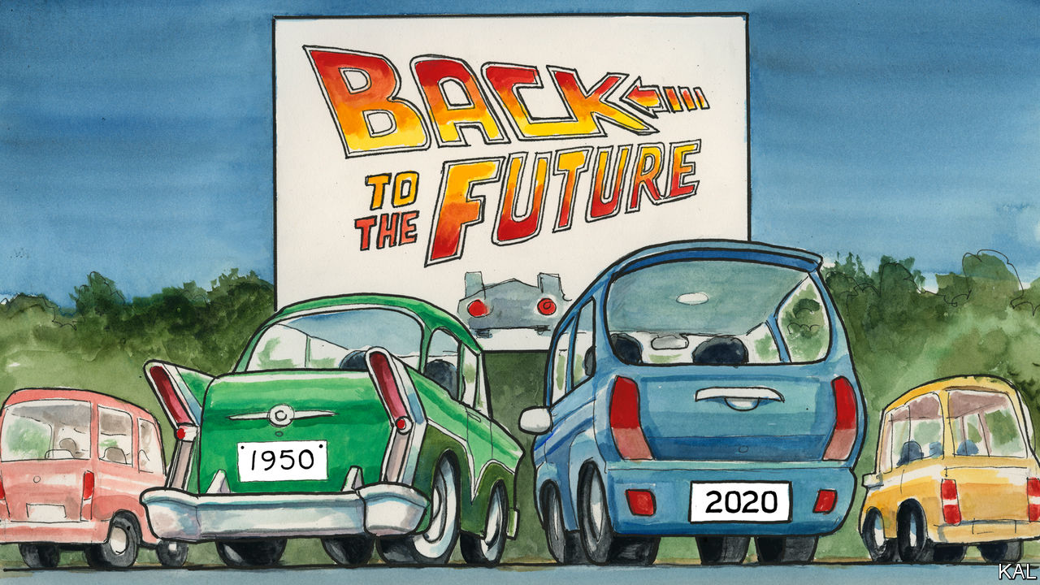

THE GIANT movie screen at Bengies was illuminated by a thrilling golden sunset when the cinema’s owner and compere, D. Edward Vogel, began reciting the house rules one recent Friday evening. It was dark before he had finished.

Bengies, a drive-in outside Baltimore, does not allow alcohol, profanity, car-horns or headlights—which seemed reasonable. It also bans barefoot children (even when carried), photography, vehicles left unoccupied without an explanatory note, and refunds or ticket changes of any kind, which seemed a bit over the top. “This is not an exclusive list of our rules, but it’s a pretty good start,” said Mr Vogel, as the sky darkened over the 120-foot-long movie screen. He still hadn’t got through his covid-19 stipulations.

Mr Vogel, whose uncle started Bengies in 1956, says its rules are necessary because many of his patrons are new to drive-ins (of 4,000 fresh-air theatres in 1958, fewer than 400 remain). But this was not true of the families setting out chairs and speakers around Lexington and his tribe. From Pennsylvania, Virginia and far-flung Maryland, they were Bengies habitués. They came for its giant screen, grandiose playing of the anthem and unreconstructed snack bar selling Bengies cola, foot-long hot dogs and much more. They revelled in its eccentricity. The drive-in is named after a 19th-century president, Benjamin Harrison, and known for the snarky messages on its neon billboard. Best of all they loved the juxtaposition of electronic entertainment and hot night air.

These virtues were also apparent to first-timers. Like time-travelling Michael J. Foxes, your columnist and his family found the drive-in at once novel and deeply familiar. The experience has been depicted in a thousand films. More acutely, the same combination of mid-century technology, bossiness and cheesy family-mindedness is still remarkably common. America is suffused with the culture of the 1950s. The pandemic, which has inspired pop-up drive-ins around the country, has made this even more evident.

The fact that theme parks and bowling alleys have been conspicuous victims of the economic shutdown has underscored how popular they remain. Disney World’s winning struggle to reopen in plague-ridden Florida this month was a major economic event. Fast food, another 1950s signature, is similarly pre-eminent, and the coronavirus has re-emphasised its most iconic form, the hamburger served to the car-window. McDonald’s, America’s favourite restaurant now as then, collected 70% of its revenues from drive-thrus even before the pandemic made them more popular.

Pent up in suburbia, where a third of Americans lived in 1960 and over half live today, families have been rediscovering the 1950s combination of board games before the kids go to bed and cocktails afterwards (and sometimes before; unless that is a British version). Sales of Scrabble—patented in 1948—and liquor are through the roof. With flying not advised, many are also taking vintage holidays. Lexington is currently on a family road-trip in New England, an undertaking synonymous with the 1950s, which also helps explain why the decade’s culture is so enduring.

Millions made for America’s beaches and parks back then, because they suddenly had the means to do so: 1950 was the first year the average household owned a car. The country’s two most famous bears, Smokey, a wildfire-orphaned cub who became a sensation in 1950, and Yogi, who hit televisions in 1958, were also alluring. And whereas citizens of drearier rich countries have been liberated by foreign holidays, Americans’ vast backyard remains too wonderful to be supplanted. Americans are much less likely to travel abroad than rich Asians or Europeans—not only, or mostly, because they are afraid to, but because they don’t need to.

This rationale has helped preserve the recreational culture of the 1950s. It is especially evident in the state parks that have provided an alternative to shuttered pools this summer. Generally smaller, more accessible and more crowded than national parks, many were converted from forestry land around the 1950s. And they retain, with their roped-off swimming lakes and pedalos, a distinctive mid-century feel. After a summer of surveying America from such vintage vantages, your columnist has these reflections.

Unfavourable comparisons between America now and in its golden decade of capitalism are understandable. Yet 1950s nostalgists should find comfort in the decade’s cultural endurance. That goes beyond board games. The warm civic-mindedness Americans exude in their mid-century pursuits recalls that confident time. When your columnist’s neighbours at Bengies discovered it was his children’s first trip to a drive-in, they bought them a celebratory ice-cream. That would not happen in a video arcade.

Nostalgists should also consider two cautionary points. First, as per Bengies’ rules, the 1950s was a hectoring time. For all its thrust and novelty, there was usually someone telling you what to do. The suburbs were an experiment in social engineering. Housewives there were bombarded with home economics, their teenagers with “mental-hygiene films”. Americans would not submit to that today because they are freer. (Though it would be good if they would submit to wearing face-masks, as you must at Bengies.)

## Back to the future

Second, many Americans were barred from the 1950s cultural treats because of their skin colour. Cinemas were segregated in the South until the passage of the Civil Rights Act in 1964. So were many state parks. When Sandy Point, a small beach on Chesapeake Bay, opened in 1952, it was the only one in Maryland available to African-Americans. And they could use only a scruffy corner of it.

When your (white) columnist and his family visited the teeming beach this summer, they were in the minority. It is now a magnet for Hispanic families from Prince George’s County and black ones from Baltimore. Hip-hop and salsa fight it out above the multilingual, multiracial throng. All things considered, 1950s America is better now than it was in the original.■

Dig deeper:  
Sign up and listen to Checks and Balance, our [weekly newsletter](https://www.economist.com/checksandbalance/) and [podcast](https://www.economist.com/podcasts/2020/07/24/checks-and-balance-our-weekly-podcast-on-american-politics) on American politics, and explore our [presidential election forecast](https://projects.economist.com/us-2020-forecast/president)

This article was downloaded by calibre from <https://www.economist.com/united-states/2020/08/01/mid-century-modern>

|  |  |  |  |
| --- | --- | --- | --- |
| Previous | Articles | Sections | Next |

|  |  |  |
| --- | --- | --- |
| United States | Sections | Middle East & Africa |

The Americas

Canada and America: No Canuck do

.

Crime in Canada: Rough justice

.

The Galapagos islands: Fishy business

.

Bello: The return of rigged elections

.

|  |  |  |
| --- | --- | --- |
| United States | Sections | Middle East & Africa |

|  |  |  |  |
| --- | --- | --- | --- |
|  | Articles | Sections | Next |

#### No Canuck do

# Covid-19 has strained Canada’s relations with America

Donald Trump wants Canada to open its border to Americans. Canadians say no

Aug 1st 2020 | OTTAWA

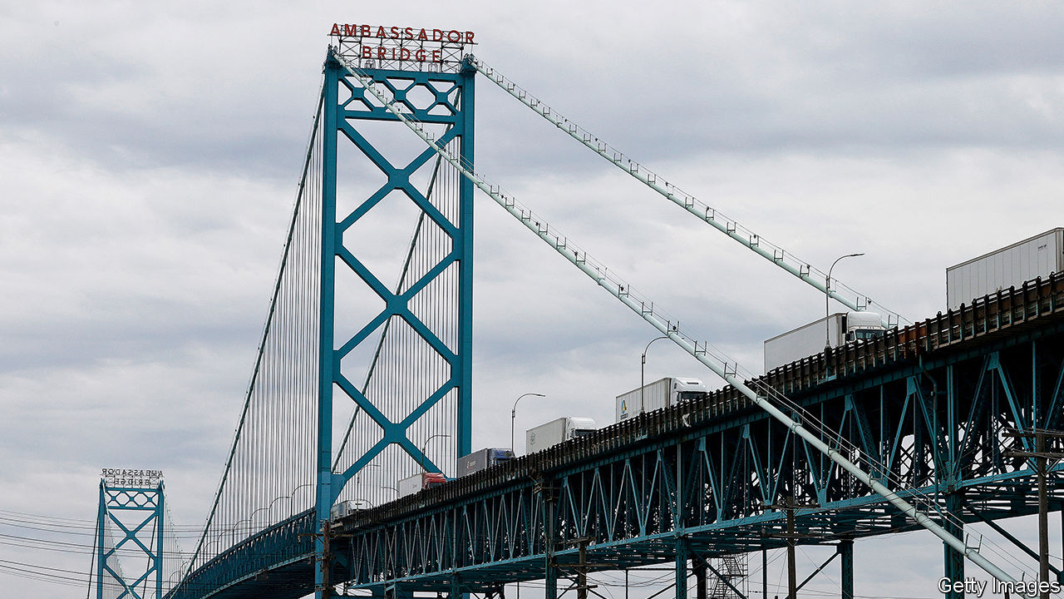

HAVING BEEN stopped for most of the year, Major League Baseball finally started its diminished 2020 season on July 23rd. For the Toronto Blue Jays, however, the only Canadian team in the league, restarting play was not easy. The Canadian government refused to let American teams into the country to play in front of no fans in Toronto. The risk players will bring covid-19 with them is too high, public-health officials ruled. That led to a scramble to find a home in America. For the rest of the summer, all the Blue Jays’ “home” games will be just across the border in Buffalo.

Managing the border has dominated relations with the United States since March. America would like Canada to reopen, but with covid-19 spreading fast in most American states, Canadians are less keen. Justin Trudeau, their prime minister, has tried to avoid confronting Donald Trump. He is famous for avoiding awkward questions about the American president. But the pandemic is just one of several issues that may force his hand.

On July 22nd Canada’s federal court cited the Charter of Rights to throw out the “safe third-country” deal between Canada and America on refugees. Since 2004 Canada has been turning back arrivals at land-border crossings, saying they should have sought refugee status in the United States when they first landed there. But under Mr Trump, America has been jailing those returned by Canada, which the court said violates Canadian principles of justice. The court gave the government until January to make changes (or appeal against the decision). That means negotiations will persist throughout the American presidential election campaign.

It will not be the only problem. America has also threatened to impose new tariffs on Canadian aluminium. The next court date in the extradition of Meng Wanzhou, a Huawei executive who is wanted in America on fraud and sanctions-busting charges, is in August. Another argument bubbling away is over Canada’s defence spending: Mr Trump would like Canada, a fellow NATO member, to spend more.

Yet it is the pandemic that has most sharply pushed Mr Trudeau into confrontation. Canada has coped with covid-19 relatively well, with fewer than 9,000 deaths among its 38m people. New infections are up slightly as the country reopens but still under 400 a day. That contrasts dramatically with America, where new infection rates have been rising in 42 out of 50 states.

The border has been closed since March, and not just to baseball players. Canadians can return home, and lorry drivers and some commuters can cross, but most visitors cannot. Except for essential workers all entrants to Canada are expected to quarantine for two weeks on arrival.

In June only 64,000 American residents entered Canada by road, compared with 1.6m a year before, a drop of 96%. Air traffic fell by 98%. Those numbers have risen again in recent weeks, but only a bit. Parts are also moving again between car factories and the like. But the cost of immobility is still high. Destination Canada, a tourism-promotion agency, says 40% of all tourism businesses in Canada may fail; on the American side they are suffering too.

For that reason the American government would like Canada to reopen. The bipartisan Northern Border Caucus of 29 Congress members has called on Canada to allow Americans to visit holiday homes they own north of the border. They also want a “comprehensive framework” towards reopening.

Yet Canadians prefer to keep Americans out. John Williamson, an MP from a border region of New Brunswick, says he sees little appetite for relaxing restrictions, even though his constituents are deprived of the opportunity of buying cheaper petrol in America. A poll published on July 10th found 90% of Canadians want no change. As long as the pandemic rages, restrictions will stay, reckons Laurie Trautman, the director of the Border Policy Research Institute at Western Washington University.

Could the pandemic permanently alter Canada’s relationship with the United States? In early July Mr Trudeau turned down an invitation from Mr Trump to visit Washington, DC, on the basis that complying with quarantine rules on his return north would be too disruptive. Many saw it as a snub. Yet although the arguments are over real issues, Mr Trump’s personality does not help. If Joe Biden wins the election in November, Canadian officials will relax, reckons Colin Robertson of the Canadian Global Affairs Institute, a think-tank. But if Mr Trump finds a way to win, Canada’s problems are likely to intensify. And regardless of what happens, the Toronto Blue Jays may find themselves stuck south of the border for some time to come.■

Editor’s note: Some of our covid-19 coverage is free for readers of The Economist Today, our daily [newsletter](https://my.economist.com/user#newsletter). For more stories and our pandemic tracker, see our [hub](https://www.economist.com/news/2020/03/11/the-economists-coverage-of-the-coronavirus)

This article was downloaded by calibre from <https://www.economist.com/the-americas/2020/08/01/covid-19-has-strained-canadas-relations-with-america>

|  |  |  |  |
| --- | --- | --- | --- |
|  | Articles | Sections | Next |

|  |  |  |  |
| --- | --- | --- | --- |
| Previous | Articles | Sections | Next |

#### Rough justice

# Canadian courts test the “rough sex” defence

Was it murder, or a sex act that went tragically wrong?

Aug 1st 2020 |

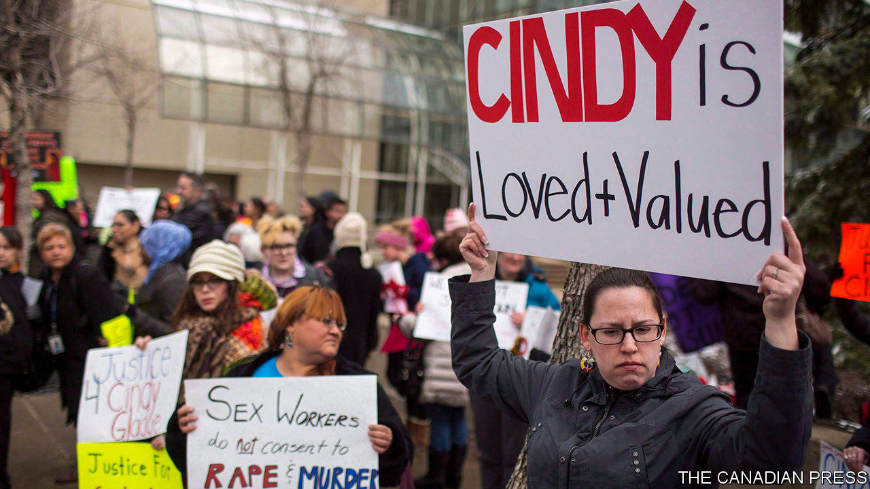

IN A TRIAL in Canada later this year, one of the questions is whether Cindy Gladue liked rough sex. Specifically, if she liked it rough enough to consent to digital penetration that tore an 11cm wound in her vaginal wall. Ms Gladue bled to death, so she cannot testify. Bradley Barton, charged with her manslaughter, says her death was a tragic accident. Mr Barton’s case, a retrial, will be heard in November. The verdict in another case is expected on July 31st. David Miller is accused of first-degree murder of his girlfriend, Debra Novacluse, in 2016. He told police that her death was a result of rough sex gone too far.

The cases come as a group of academics have called for a restriction on the use of the “rough sex” defence in homicide cases. Elizabeth Sheehy, Isabel Grant and Lise Gotell, who specialise in gender studies and the law surrounding violence against women, argue that the law shouldn’t recognise the consent of the victim as a defence for causing bodily harm or death. “Rough sex rebounds on women,” they say.

It is not just in Canada that the so-called “50 Shades of Grey” defence appears. Men in America, Britain, Germany, Italy and Russia have claimed that their partner’s death was a tragic, kinky accident. We Can’t Consent To This, a British campaign group, has counted 27 cases since 2010. The group recently celebrated the addition to a proposed domestic-abuse law of a clause barring the use of consent as a defence for bodily harm (although this principle was already established in common law).

It is unclear how often the defence is used in Canada. In March, Kalen Schlatter used it as part of his (unsuccessful) defence against the charge of murdering Tess Richey. Ms Sheehy, Ms Grant and Ms Gotell say it has become more common since 2015. Angela Marie MacDougall, the director of Battered Women’s Support Services in Vancouver, says that since 2010 her organisation has heard more complaints from women that their partners have been violent during sex.

Canadian law says that a person cannot consent to bodily harm in the context of a fist fight. But punch-ups are not usually engaged in for pleasure. “The difficulty is that our Supreme Court [did not say whether] this same rule would apply in the context of sexual contact,” say Ms Grant and her colleagues. Some think harm during sex should be illegal regardless of consent.

But despite, or because of the risks, some people do like rough sex. BDSM, or bondage, domination, sadism and masochism, can feature acts that some people would find extreme. Some of these acts, such as asphyxiation, are dangerous. “It’s very debated in the community if it can ever be safe,” says Andrea Zanin, a Canadian writer who focuses on BDSM. Ms Zanin rejects any proposals to criminalise kinky sexual behaviour, especially the notion that a person can’t consent to harm. However, consent should be explicit, and can never be assumed. “You can’t say that because someone is involved in kink, [assaulting her] is okay,” she adds.

Still, when people engage in risky acts, accidents happen. Just ask any athlete. A person can be strangled into unconsciousness in 15 seconds. No one really knows how long death takes after that. Estimates range from 30 seconds to several minutes. There are no controlled experiments, for obvious reasons.

When evidence is heard in court, the verdict largely depends on whom juries believe. What jurors believe depends on what they find plausible. In recent years public awareness and acceptance of diverse sexual practices has increased. But male violence against women has not gone away.

The worry is that a murderer could deliberately make the crime look like “rough sex” gone wrong. Even if false, his story could be consistent with the physical evidence. A murder charge requires proving that someone intended to kill or seriously harm the victim. So much of the evidence hinges on accounts of intention and consent. “He said, she said” cases are notoriously tricky. In a concerning number of trials, it’s a case of he said, she’s dead. ■

This article was downloaded by calibre from <https://www.economist.com/the-americas/2020/08/01/canadian-courts-test-the-rough-sex-defence>

|  |  |  |  |
| --- | --- | --- | --- |
| Previous | Articles | Sections | Next |

|  |  |  |  |
| --- | --- | --- | --- |
| Previous | Articles | Sections | Next |

#### Fishy business

# The Galapagos islands face an invasion of trawlers

A new treaty is the best hope of stopping it

Aug 1st 2020 | BOGOTÁ



ON JULY 16TH the Ecuadorian navy announced it had spotted a fleet of 260 fishing vessels, most of them Chinese, anchored in international waters near the Galapagos islands. Ecuador’s government reacted as if it were facing some sort of invasion. It increased patrols to ensure that the ships would not venture into the Galapagos Exclusive Economic Zone, where Ecuador claims a sole right to resources. President Lenín Moreno formally complained to China.

Overfishing in high seas near the Galapagos is endangering the unique species that thrive there. Yet there is little Ecuador can do to stop foreign fleets from ransacking its stock of marine wildlife. No laws regulate fishing in international waters. The ships use bait to lure sharks out of Ecuadorian waters and then catch as many as they can.

It is impossible to track how much the ships fish. The Chinese under-report the international catch coming in through their ports, says Alex Hearn, of MigraMar, a marine-wildlife research organisation. But Ecuadorians got a glimpse in 2017, when one Chinese vessel was intercepted in the Galapagos Marine Reserve. The authorities found 300 tonnes of fish, most of it scalloped hammerhead shark, a critically endangered species. Two-thirds of hammerhead fins found in Hong Kong markets belong to species that depend on Galapagos waters.

China claims the vessels belong to independent companies it does not control. But there is no way Chinese ships would go all the way to fish around Ecuadorian waters without government subsidies and technical support, says Max Bello of Mission Blue, an NGO based in California. China’s distant-water fishing fleet is the world’s largest but it is not the only country to have one. Taiwan, South Korea and America subsidise theirs, too. Global Fishing Watch, another American NGO, says much of the industry would collapse without subsidies.

Ecuador had played a big role in pushing countries to promise to negotiate a new UN treaty to regulate the fishing of endangered species. But its government took a back seat when the negotiations started, in deference to its own fishermen, who also trawl international waters. Thanks to the Chinese fleet, Ecuador is now “eager to reassess its position”, says Jeff LeBlanc, a government adviser. “We now see there are more pros than cons.” He hopes the new treaty will be signed next year, in time to save some threatened species. If not, fishing fleets will loot the waters near the Galapagos until there is little left.

This article was downloaded by calibre from <https://www.economist.com/the-americas/2020/08/01/the-galapagos-islands-face-an-invasion-of-trawlers>

|  |  |  |  |
| --- | --- | --- | --- |
| Previous | Articles | Sections | Next |

|  |  |  |  |
| --- | --- | --- | --- |
| Previous | Articles | Sections | Next |

#### Bello

# The return of rigged elections in Latin America

A worrying new trend of banning politicians from running

Jul 30th 2020 |

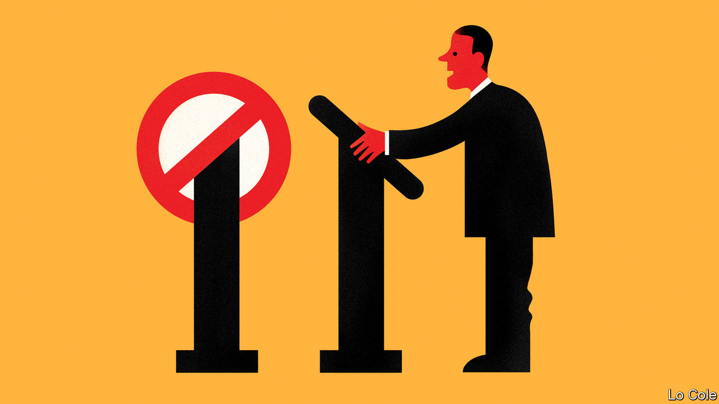

IN 1955 THE armed forces overthrew Juan Perón, Argentina’s populist president, driving him into exile. They banned him and his party from the election that eventually followed, a prohibition which remained in effect until 1973. A doddery Perón was then re-elected, but military rule soon returned. Apra, a Peruvian party with tendencies akin to Peronism, was similarly banned for decades. So, during the cold war, were many Communist parties. But with the spread of mass democracies across Latin America in the 1980s, such clear rigging of elections seemed a thing of the past. Any citizen could become president.

Now that fundamental democratic principle is under threat. Like several recent bad habits in the region, the revival of this one started in Venezuela. In 2008 Hugo Chávez’s regime barred Leopoldo López, an opposition leader, from public office for six years (Mr López was later arrested for organising protests in which 43 people died; he is now in the Spanish ambassador’s residence in Caracas). In 2017 the regime banned Henrique Capriles, who claimed to have won a presidential election against Chávez’s successor, Nicolás Maduro. As if this was not enough, in June Mr Maduro’s people used legal chicanery to take over the main opposition parties, installing regime stooges ahead of a legislative ballot later this year.

Despite its charade of holding elections, Venezuela is widely seen as a dictatorship. But the practice of narrowing the electoral field is spreading in democracies in the region. In Guatemala last year Thelma Aldana, a popular former attorney-general who had helped to jail a corrupt president, was kept off the presidential ballot by a charge of embezzlement her supporters say is bogus.

In other instances candidates have been barred after their conviction in controversial but better-founded cases. Luiz Inácio Lula da Silva, a left-wing former president of Brazil, was legally barred even when leading opinion polls in a presidential election in 2018, after his conviction for corruption was upheld by an appeal court. Rafael Correa, a populist former president of Ecuador now living in Belgium, received in absentia a jail sentence for corruption in April. Under the constitution he cannot run again. The electoral council went on to bar his party, claiming it submitted invalid signatures in its bid to register. The council also ruled that candidates have to register in person, meaning that if Mr Correa wanted to run for vice-president he would be arrested.

In Peru’s election in 2016 the electoral authority barred a well-placed candidate on a technicality. José Domingo Pérez, a Peruvian prosecutor, last month asked a court to ban for two and a half years (ie, until after the next election) Popular Force, the party of Keiko Fujimori, a former presidential candidate. He claims that it is a “criminal organisation” because it tried to cover up a $1.2m donation from Odebrecht, a Brazilian construction company, in 2011. Mr Pérez has been investigating Ms Fujimori for three years, but has yet to prove his case. She has spent 16 months in jail without trial.

Bolivia is the most worrying example of the new electoral prohibitionism. Last November Evo Morales, its president since 2006, was overthrown by a popular uprising amid claims of fraud in an election at which he sought an unconstitutional fourth term. An interim government led by a conservative senator, Jeanine Áñez, took office with the job of organising a fresh election. Twice postponed because of the pandemic, this is now due on October 18th. Ms Áñez exceeded her mandate as a caretaker by announcing that she would run. Polls suggest Mr Morales’s candidate, Luis Arce, might win. Ms Áñez’s supporters are seeking Mr Arce’s disqualification by the electoral tribunal, on a technicality. They also talk of postponing the poll indefinitely because of the pandemic.

Either would be a dangerous course. Disqualifying Mr Arce would deny legitimacy to the election’s winner and condemn Bolivia to years of conflict. Far better would be for Ms Áñez to back Carlos Mesa, a former president who was Mr Morales’s main rival last year. She should recall the analogy of Argentina in 1955. “Instead of destroying Peronism …persecution swiftly reinvigorated it,” concluded David Rock, a historian.

Mr Morales and Mr Correa were less than fully democratic in office, undermining the separation of powers and riding roughshod over opponents. Their critics fear that if allowed back, they would hold power for keeps. But democracy cannot be saved by curbing it.

This article was downloaded by calibre from <https://www.economist.com/the-americas/2020/07/30/the-return-of-rigged-elections-in-latin-america>

|  |  |  |  |
| --- | --- | --- | --- |
| Previous | Articles | Sections | Next |

|  |  |  |
| --- | --- | --- |
| The Americas | Sections | Europe |

Middle East & Africa

Turkey and the Arab world: Ottoman redux

.

Covid-era travel in the Gulf: Viral vacations

.

Pollution in Africa: A smouldering sky

.

South Africa and the IMF: Fund facts

.

Ethiopia: Urban brawl

.

|  |  |  |
| --- | --- | --- |
| The Americas | Sections | Europe |

|  |  |  |  |
| --- | --- | --- | --- |
|  | Articles | Sections | Next |

#### Ottoman redux

# Turkey is wielding influence all over the Arab world

Its muscle-flexing worries many

Aug 1st 2020 | ISTANBUL

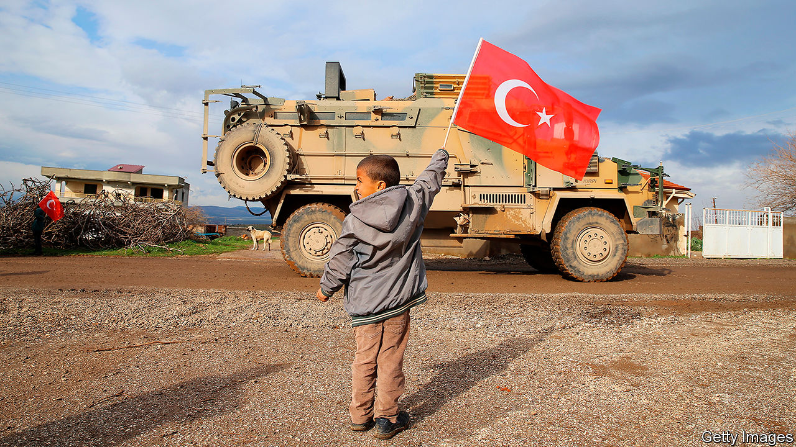

AZAZ HAS experienced quite the turnaround. The city in northern Syria was once controlled by Islamic State (IS), which continued to terrorise it even after leaving in 2014. That is when other jihadists and rebels swooped in. Today, though, Turkey is calling the shots. It keeps the lights on and supplies the local shops. The list of Turkish projects under construction ranges from schools and universities to hospitals and roads. “The infrastructure is better than before the revolution,” says an architect who is building new housing as part of another Turkish project.

Turkey is expanding its footprint across the Arab world, using force more than diplomacy. In the past year it has occupied north-eastern Syria, punched deep into Iraq and intervened in Libya’s civil war. Its military spending has increased by nearly half since 2016.

Yet Turkey’s strongman, Recep Tayyip Erdogan, does not appear to have an all-encompassing vision for the region. Rather he is pursuing Turkey’s economic interests and dealing with perceived threats—sometimes by violating the borders of other countries. Thus is he fulfilling a promise made four years ago to “go and confront [problems] wherever they nest”.

Turkey is no newcomer to the Middle East. Its predecessor, the Ottoman empire, ruled the region for 500 years, until European powers rolled it back. More recently it has exerted cultural and economic influence, especially through Turkish soap operas and construction projects. After the Arab spring of 2011 brought Islamist movements to the fore, Mr Erdogan promoted Turkey as a model of Islamist governance—and himself as leader of the Muslim world. As the Islamists were pushed back (or crushed) and Western powers lost interest in the region, Turkey grew more assertive.

Start in Syria, where Turkey has long backed the rebels trying to topple Bashar al-Assad’s regime. They have all but lost, but Turkey continues to protect the areas still under their control in the north-west. It does not want another flood of refugees to cross its border, so it has tried to stabilise the region—further digging in. It trains police, funds a civil service and has replaced the Syrian pound with the steadier Turkish lira. In cities such as Azaz it is building rapidly. Backers of Mr Erdogan suggest that this is an investment for the long run.

Turkey has been even bolder in the part of northern Syria once controlled by the main local Kurdish force, the People’s Protection Units (YPG). The YPG grabbed a large swathe of territory while helping America defeat IS. But the YPG has close ties with the Kurdistan Workers’ Party (PKK), a separatist Kurdish group in Turkey. So when America pulled out in October, Turkish troops moved in, backed by local Arab rebels. Together they pushed the Kurds out of much of their statelet. Turkey now occupies a 30km-deep strip in Syria extending for 145km along their border.

Mr Erdogan is also battling the PKK in the Kurds’ autonomous region in northern Iraq. Turkey says it has “neutralised” over 1,400 Kurdish fighters in Iraq and Syria this year. Sometimes the Turks have attacked 200km inside Iraq. They insist it is a short-term operation aimed only at the PKK, but they have set up a number of new outposts in the country. Many suspect their aim is to carve out a buffer zone along the border, as they did in Syria. Iraq’s Kurds fear a Turkish presence would endanger their aspirations for statehood and, if it extends far enough, cut them off from the Kurds in Syria.

Turkey’s intervention in Libya is different. The countries of the eastern Mediterranean have long argued over who controls which part of the sea—and the gasfields beneath it. Mr Erdogan feared that an alliance of Egypt, Israel, Greece and Cyprus might squeeze Turkey out of the area. So last year he signed a deal with Libya’s UN-backed government that demarcated their maritime boundaries and supposedly gave Turkey the right to drill in waters off Greek islands. (Greece is having none of it.) In return Turkey has provided troops, arms, drones and mercenaries (from Syria) to the Libyan government and its allied militias, tipping the war in their favour. Earlier this year the forces of Khalifa Haftar, a rebellious Libyan general, were pushed out of western Libya.

Turkey is now a force to be reckoned with along a 600-km stretch of the Mediterranean. It controls an airbase in al-Watiya, close to Libya’s border with Tunisia. Its frigates protect Libya’s coast in the west. Some say Mr Erdogan is trying to turn the eastern Mediterranean into a Turkish sea.

He is active elsewhere, too. He has installed a Turkish garrison in Qatar, an ally and fellow backer of Islamist movements that has been threatened by Saudi Arabia and the United Arab Emirates (UAE). He has also shown an interest in Yemen’s civil war, offering Turkey as a safe haven for the Islamists fighting on behalf of the exiled president, Abd Rabbo Mansour Hadi. (He may do the same for Mr Hadi if Saudi Arabia grows tired of hosting him.) Across the Red Sea, in Sudan, Turkey is hoping to develop Suakin, a ruined Ottoman port. And it has established its largest overseas base in Mogadishu, the Somali capital.

Does Turkey have staying power? Its armed forces may already be stretched thin, having lost thousands of officers to show trials and purges in the past decade. And its adventurism isn’t cheap. Its operations in Syria alone cost up to $3bn a year, says Nihat Ali Ozcan of TEPAV, a think-tank. But Mr Erdogan focuses on the benefits. Qatar, for example, has gone on an investment spree in Turkey. Earlier this year it helped shore up the weakening lira by tripling its currency-swap agreement with Turkey to $15bn. It may also be helping to pay for the operation in Libya, where Turkey expects to win new contracts when peacetime reconstruction resumes.

There is a domestic political benefit for Mr Erdogan, too. His attacks on the Kurds and posturing in the Mediterranean have delighted the nationalists who are his allies in parliament. They, in turn, have influence over the police and army.

But the going could get tougher. Egypt has mobilised its forces on Libya’s border and vows to cross it if Turkey advances further. Saudi Arabia and the UAE, staunch anti-Islamists, would probably back Egypt. Russia is also on the opposing side in Libya—and in Syria, where it is believed to have killed dozens of Turkish troops in February. Mr Erdogan may soon feel he has bitten off more than he can chew. ■

This article was downloaded by calibre from <https://www.economist.com/middle-east-and-africa/2020/08/01/turkey-is-wielding-influence-all-over-the-arab-world>

|  |  |  |  |
| --- | --- | --- | --- |
|  | Articles | Sections | Next |

|  |  |  |  |
| --- | --- | --- | --- |
| Previous | Articles | Sections | Next |

#### Viral vacations

# What it’s like to go on holiday in Dubai during a pandemic

A package deal includes airfare, hotel—and funeral insurance

Aug 1st 2020 | DUBAI



THE LIFEGUARDS sweating in masks and latex gloves sometimes looked in need of rescue themselves. For much of the week it was 42°C in the midday sun, with the palpable humidity making it seem hotter. One afternoon’s sunbathing was interrupted by a sandstorm that turned the sky grey. “It’s like a dream,” grins a Dutch woman sipping a cocktail by the pool, her ice long since melted.

In normal times jetting off to Dubai in July is an act of masochism. Summer weather is hot enough to bake cookies on a parked car (as YouTube videos prove). Citizens and well-paid expats flee to cooler climes. Five-star hotel rooms that cost 1,000 dirhams ($272) a night in high season go for a third of that.

These are not normal times. Dubai allowed tourists back on July 7th, one of the first destinations to open its doors after covid-19 slammed them shut. Visitors are welcome from anywhere with only a coronavirus test; from August 1st arrivals from hard-hit countries will need two. Officials call it a calculated risk: their economy needs travellers. Last year Dubai took in 17m tourists, whose spending made up 12% of GDP.

Tourists are not exactly flooding in yet. A rental-car clerk at the airport signs up only one customer a day. Most hotel guests are residents on “staycations”. Still, a trickle of foreign visitors desperate for a trip—a diplomat posted in Bangladesh, a group of women from Ukraine—arrived in July to endure the heat.

Masks are mandatory in public, with a 3,000-dirham fine for scofflaws. Some hotels have done away with valet parking, making guests walk (quelle horreur!) to car parks. Diners may be shamed into skipping a fourth round of crab legs at lavish buffets that are no longer self-service. Bars may serve alcohol only with meals, ostensibly to stop people from lingering in high-risk settings (in practice a lonely bowl of edamame can suffice as a “meal”). At the door to a seaside Mexican restaurant, a British couple wondered if their lobster-pink sunburns would trip the infrared thermometers used to check diners’ temperatures.

The United Arab Emirates (UAE), of which Dubai is a part, has logged about 60,000 cases of covid-19. At 6,000 per 1m people it ranks in the top quintile of all countries. But the death toll, at 35 per 1m, is well below most Arab and European countries’. Authorities say 90% of cases are asymptomatic. The number may reflect one of the world’s best testing regimes. As of July 29th the UAE had conducted 4.9m tests, equal to nearly half its population, the highest figure per person bar tiny Luxembourg.

Still, other emirates are less gung-ho about reopening. The airport in Abu Dhabi, the UAE’s capital, is shut to non-residents. But Dubai feels its hospitals can handle any imported cases. Emirates, the national airline, offers free health insurance for travellers who catch covid-19. For holidays that do not quite go to plan, the policy will stump up €1,500 ($1,750) towards funeral costs.

Editor’s note: Some of our covid-19 coverage is free for readers of The Economist Today, our daily [newsletter](https://my.economist.com/user#newsletter). For more stories and our pandemic tracker, see our [hub](https://www.economist.com/news/2020/03/11/the-economists-coverage-of-the-coronavirus)

This article was downloaded by calibre from <https://www.economist.com/middle-east-and-africa/2020/08/01/what-its-like-to-go-on-holiday-in-dubai-during-a-pandemic>

|  |  |  |  |
| --- | --- | --- | --- |
| Previous | Articles | Sections | Next |

|  |  |  |  |
| --- | --- | --- | --- |
| Previous | Articles | Sections | Next |

#### Smoke gets in your eyes

# Africa’s skies are badly polluted

But a lack of data makes it impossible to know how badly

Aug 1st 2020 |

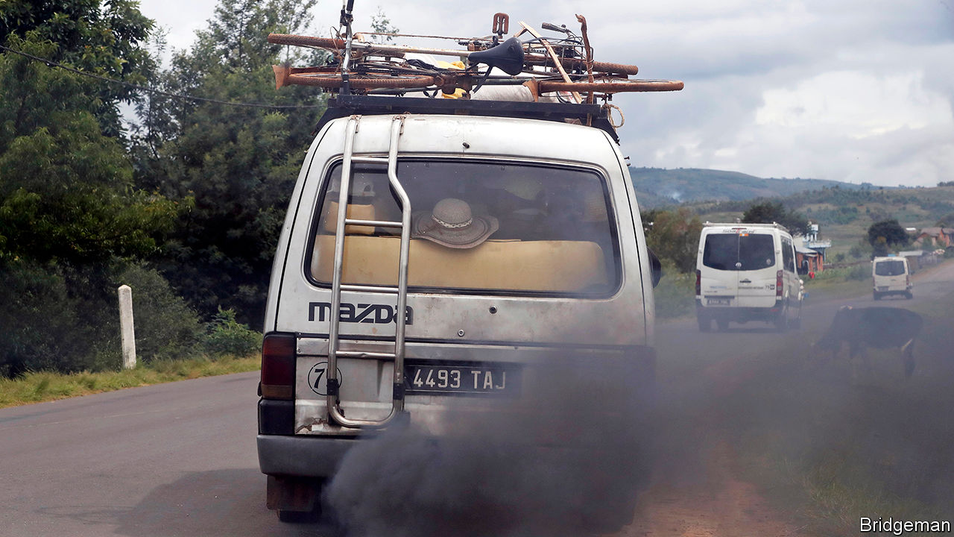

GORéE ISLAND, a former slave-trading hub, is so close to Dakar, Senegal’s capital, that hundreds of amateurs swim out to it every year. Yet some days it disappears from sight, lost in a haze of pollution and dust. In the Nigerian city of Port Harcourt, part of its oil-producing region, black soot settles on everything. Tiny particles clog lungs and invade the bloodstream.

Some 4.2m people die prematurely every year from dirty outdoor air, says the World Health Organisation (WHO). The World Bank reckons the worldwide costs of deaths from air pollution run to $5trn a year. Africa is plainly affected, but it is hard to know how badly. Outdoor pollution in the continent is rarely measured.

Fetid rubbish, old cars and filthy factories fill Africa’s air with smoke, rarely hindered by environmental standards or enforcement. Take Nigeria, where international commodity traders exploit weak regulations by importing fuel that is vastly more toxic than the stuff found in Europe, and even dirtier than fuel produced by bush refineries in the Niger Delta, says a study by the Stakeholder Democracy Network, a pressure group. Rana Roy of the OECD, a club of mainly rich countries, reckons air pollution of all types causes more premature deaths in Africa than dirty water, poor sanitation or the malnutrition of children. The WHO says the Nigerian city of Onitsha is the most polluted in the world.

Yet the WHO reckons that only 0.5% of African towns and cities have accessible air-quality data (Dakar is one of them). That would be unthinkable in the West (see map). Children are particularly at risk. In Europe and North America 72% of children live within 50km of an air-monitoring station versus only 6% of African children. Even in African cities that do track air quality, the data are patchy. “Most of the equipment in use is obsolete,” says Kofi Amegah of the University of Cape Coast in Ghana.

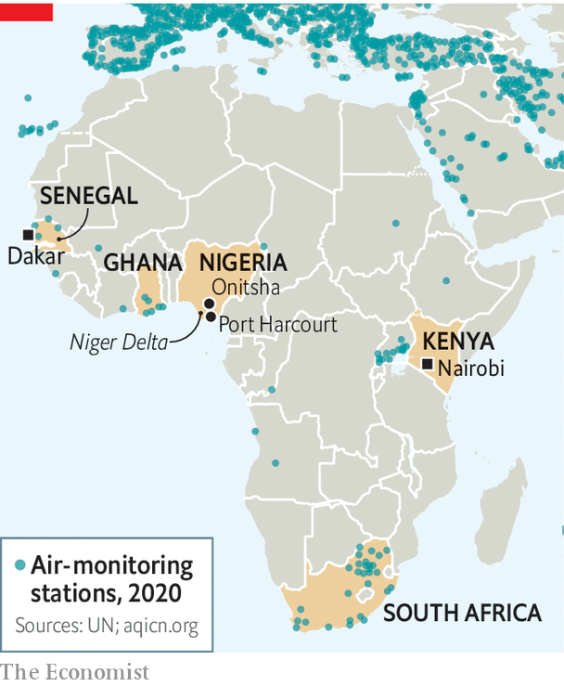

South Africa is an exception. There, as in much of the West, air-quality data are constantly and publicly available, so commuters and asthmatics can avoid the worst smog. Researchers can estimate the damage both to people’s health and the economy with reasonable accuracy.

Yet almost everywhere else in Africa, what little information is collected is rarely made public. Some governments think people should pay for it to help cover costs. That is ludicrous, thinks Mr Amegah, since data collection is anyway paid for by taxpayers and is meant to help improve public health. Many governments are simply worried that better data will lead to more criticism of them, says Dan Westervelt of Columbia University.

Information sometimes gets out anyway. American embassies in six African capitals have first-rate instruments and publish findings every day. In Beijing in 2008 the American embassy began releasing air-pollution data. A diplomatic spat ensued, but campaigners were able to challenge official claims, leading to new standards, more testing—and cleaner air.

African activists are following suit, buying cheap air sensors. The most basic cost $25 apiece, though they are less accurate than high-grade ones. Local data matter. A campaign to cut pollution from factories in Syokimau, a Nairobi suburb, succeeded thanks to four cheap sensors provided by Code for Africa, a network for open-data activists. It hopes to install 3,000 more sensors in African cities. ■

This article was downloaded by calibre from <https://www.economist.com/middle-east-and-africa/2020/08/01/africas-skies-are-badly-polluted>

|  |  |  |  |
| --- | --- | --- | --- |
| Previous | Articles | Sections | Next |

|  |  |  |  |
| --- | --- | --- | --- |
| Previous | Articles | Sections | Next |

#### Fund facts

# South Africa borrows from the IMF for the first time since apartheid

And it may not be the last

Jul 30th 2020 | JOHANNESBURG

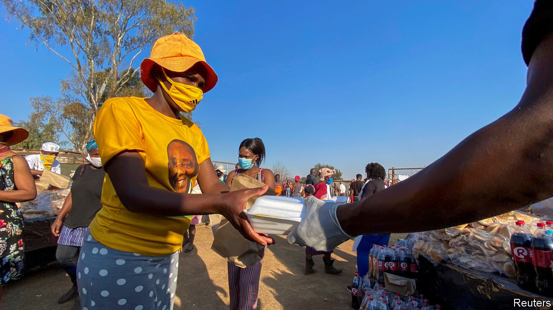

ALTHOUGH IT IS rarely shy about spending other people’s money, the African National Congress (ANC), South Africa’s ruling party, has long been wary of the IMF. After Nelson Mandela came to power in 1994 the fund practically begged to help his new government. Mandela eventually saw the potential benefits of a cheap loan. But the ANC rejected the offer.

Opposition to the IMF has remained a shibboleth of the party. Yet on July 27th South Africa said it had agreed to a $4.3bn loan from the IMF. The deal signed by South Africa, one of 78 countries to have received covid-19-related help, is not a standard IMF programme and thus does not have stringent conditions. But the need for it nevertheless reflects the extent of the country’s underlying economic problems.

For some of the ANC’s self-styled comrades the worry about the IMF has perhaps been that it would make it harder for them to loot state coffers. For others, including Thabo Mbeki, Mandela’s successor, an IMF loan would have meant an intolerable violation of sovereignty.

Despite his doubts about the IMF, Mr Mbeki pursued macroeconomic policies so orthodox that a rabbi might have blessed them. Under Trevor Manuel, finance minister from 1996 to 2009, and Tito Mboweni, governor of the reserve bank from 1999 to 2009, South Africa closed its budget deficit and tamed inflation, which had averaged 14% in the 1980s. Though the ANC’s patronage machine kept whirring, GDP grew by more than 5% a year from 2005 to 2007.

Then came Jacob Zuma. Under his presidency corruption thrived and public spending ballooned. The negative effects of rigid labour markets and affirmative action intensified. Real GDP per person has shrunk every year since 2015. The ratio of public debt to GDP rose from 26% in 2008 to 56% in 2018. As early as 2015, writers such as R.W. Johnson warned that South Africa was heading for a bail-out.

This condition-light deal is not quite the Rubicon-crossing that some envisaged. But it is a toe in the water. In a letter to the fund, Mr Mboweni, who in 2018 returned to the government as finance minister, and Lesetja Kganyago, the reserve bank’s current governor, made several pledges, primarily relating to public finances.

They promised to cut the share of spending that goes on public-sector wages and to speed up structural reforms, for example to state-owned enterprises such as Eskom, the indebted electricity utility. They are open to a self-imposed “debt ceiling” (public borrowing is projected to hit 87% of GDP in 2024 before declining). But little of this is new. In June Mr Mboweni gave a statement to parliament with similar commitments.

South Africa’s problem is not a lack of ideas. It is politics. Although he has said he supports Mr Mboweni, President Cyril Ramaphosa has done little to show it. He has often made the job of his finance minister harder, for instance by promising that there would be no “mass retrenchment” of public employees, and by dithering over state enterprises. Corruption remains rife. Credit-rating agencies doubt that Mr Mboweni will meet his targets. Few believe that Mr Ramaphosa will face down trade unions or his party ahead of its National General Council and local elections in 2021.

So this may not be the last time South Africa turns to the fund. The next bail-out would come with tough conditions, which would infuriate the ANC. But the party ought to appreciate what Mr Mbeki and Mr Manuel understood: that the way to protect your economic sovereignty is to avoid the need for the IMF in the first place. ■

This article was downloaded by calibre from <https://www.economist.com/middle-east-and-africa/2020/07/30/south-africa-borrows-from-the-imf-for-the-first-time-since-apartheid>

|  |  |  |  |
| --- | --- | --- | --- |
| Previous | Articles | Sections | Next |

|  |  |  |  |
| --- | --- | --- | --- |
| Previous | Articles | Sections | Next |

#### Urban brawl

# How land disputes erupt in Ethiopia

The edges of cities are often flashpoints of ethnic violence

Aug 1st 2020 | ADDIS ABABA AND SHASHAMENE

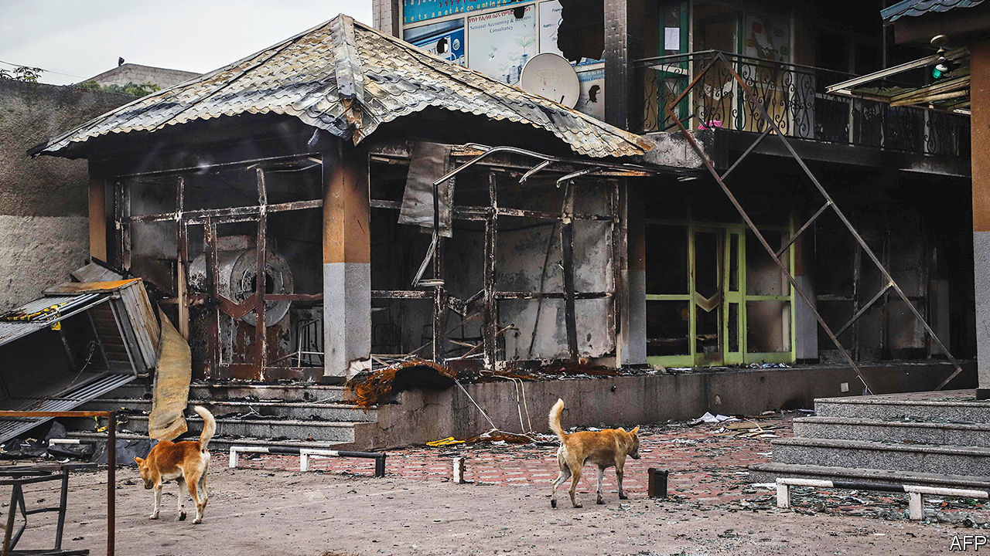

“WE WERE BORN here, we grew up here, but now we live like beggars,” fumes Tsige Bule, gazing from a rain-splattered porch towards the grey and unfinished apartment block that looms over what remains of her family’s farmland. Several years ago the Ethiopian authorities confiscated almost all of it to build public housing for residents of Addis Ababa, the capital. In the past decade the expanding city has inched ever closer to Tsige’s village. She sold her cows and began buying jerry cans because water from the nearby river had become toxic. Her sons dropped out of school to work as labourers on nearby building sites. A life of modest comfort teetered toward destitution.

There is a deep well of anger in the suburbs and countryside around the Ethiopian capital. In July riots took place near Tsige’s home after the assassination of Hachalu Hundessa, a popular musician and activist from the Oromo ethnic group. New housing estates were pelted with stones, cars and petrol stations were set alight. Towns across the vast region of Oromia, which surrounds Addis Ababa, were similarly ravaged. Much of central Shashamene, a booming entrepot some 200km south, was burned to the ground. There were widespread attacks on minorities, notably Amharas, the largest ethnic group after the Oromo. Hotels, businesses and homes were destroyed or damaged. By one count 239 people were killed, some murdered by mobs, others by security forces.

The threads that connect the carnage in Oromia with the plight of Tsige’s family are real, even if hard to see. In recent years towns and cities in southern Ethiopia, especially in Oromia, have been flashpoints for political and ethnic turmoil. The latest bout was triggered by national politics: many Oromos saw Hachalu’s murder as an attack on the Oromo opposition movement. Much of their anger is also stoked by a fear that Abiy Ahmed, the prime minister, has reneged on promises he made in 2018 to end both authoritarian rule and the alleged marginalisation of Oromos. But a closer look at the pattern of violence in certain places suggests that local factors such as who owns land and businesses may also have played a big part.

Many southern towns began as imperial garrisons after the conquests of Emperor Menelik II, an Amhara, in the late 19th century. Establishing cities sometimes involved the eviction of those already on the land, including the Oromo clans who lived on ground that was taken for Addis Ababa. As towns expanded they attracted settlers from Ethiopia’s northern highlands, who spoke Amharic and dominated urban commerce and the state bureaucracy. Amharic-speakers are still perceived to control much of the urban economy. “If you take 50 hotels in the city, only three are owned by Oromos,” alleges the owner of a juice bar in Adama, the second-largest city in Oromia.

Old tensions are exacerbated by two factors in modern Ethiopian politics. The first is the 1995 constitution, which carved up territory along ethnic lines. In doing so it introduced the notion of ethnic ownership of cities and towns. This is particularly pronounced in the case of Addis Ababa, in which the constitution granted Oromia a “special interest”. Oromo nationalists claim the city is part of their historic “homeland” and demand a final say over its governance. But similar conflicts fester elsewhere, sometimes turning violent, as in the eastern city of Harar, where a minority of ethnic Harari enjoyed political privileges at the expense of much larger Oromo and Amhara populations.

The system also hardened perceptions of non-indigenous folk as alien settlers. In Shashamene mobs went from door to door checking identity cards, which record ethnicity, before burning property belonging to Christians and non-Oromos. “They have a plan to dominate the economy of this town,” frets a non-Oromo. “At the core this is about the concentration of economic power and opportunity in urban areas,” says Eshetayehu Kinfu of Hawassa University near Shashamene.

The second factor is land. In Ethiopia, all land is owned by the state. Although the constitution guarantees free land to farmers, in practice farmers and poor folk in cities have few legal protections from eviction, says Logan Cochrane, also of Hawassa University. For urban officials, leasing and administering high-value land is a source of revenue, rents and patronage. So many grab lots of it, adding to the ranks of the landless and jobless.

“Our fathers lost their land, so we have nothing to inherit,” says Tsige’s son Betemariam. An added sore is that public housing built on land that belonged to Oromo farmers was typically given to more prosperous city-dwellers. “It’s not fair,” says Beshadu Degife, who lives down the lane. “This land is ours but now it’s people from other places who are enjoying it.”

The growing perception is that towns with mixed populations are strongholds of Abiy’s Prosperity Party, which seeks to have no ethnic slant. This perception may further aggravate tensions. As Ethiopia prepares for delayed elections some time next year, towns will be places to watch—and worry about. ■

This article was downloaded by calibre from <https://www.economist.com/middle-east-and-africa/2020/08/01/how-land-disputes-erupt-in-ethiopia>

|  |  |  |  |
| --- | --- | --- | --- |
| Previous | Articles | Sections | Next |

|  |  |  |
| --- | --- | --- |
| Middle East & Africa | Sections | Britain |

Europe

Italy: How to spend it

.

Covid-19 in Europe: Still with us

.

The Aegean: Muddying the waters

.

Turkey: The queen is dead

.

Charlemagne: Euro crisis (with guns)

.

|  |  |  |
| --- | --- | --- |
| Middle East & Africa | Sections | Britain |

|  |  |  |  |
| --- | --- | --- | --- |
|  | Articles | Sections | Next |

#### How to spend it

# Italy has to work out what to do with all its new EU money

In the past it has wasted a lot

Aug 1st 2020 | ROME

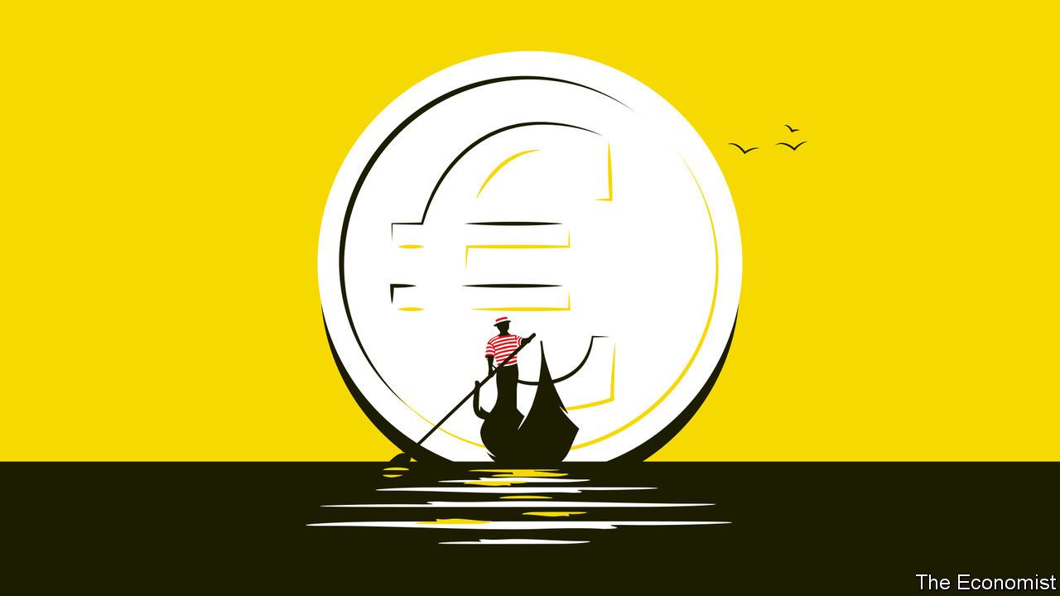

TO OPEN A motor-repair business in Italy, you need 86 permits. Opt for something simpler, like selling pizza by the slice, and things may not stay simple for long: your firm will be subject to checks by 21 different government agencies. Get into a commercial dispute and you can expect it to drag on for three years on average, twice as long as in Spain.

These facts and figures, assembled for the website of Corriere della Sera, a daily, help explain why Italy was ranked fifth-worst among EU states in the World Bank’s latest survey of obstacles to doing business. They also help explain why this month’s European summit lasted five days as a quartet of flinty countries resisted approving a landmark deal to fund the EU’s recovery from the covid-19 pandemic.

The new facility involves the European Commission borrowing €750bn ($880bn) to give or lend to member states according to how badly their economies have been hit by the virus, but also according to how much their economies need to modernise.

There are two ways of considering the so-called New Generation EU (NGEU) project: pessimistically, as it could presage endless redistribution from the efficient north to the inefficient south, or as a historic opportunity to bring the south up to the level of the north so that such transfers will no longer be needed. As the main beneficiary, Italy bears a huge responsibility.

Precisely how much Italy will get is unclear. Giuseppe Conte, the prime minister, claims it will be €209bn: €81bn in grants and €127bn in loans. But though Italy’s loan entitlement can be calculated, what it actually borrows will depend on factors including the commission’s assessment of Italy’s spending proposals and its government’s willingness to take on yet more debt: extra borrowing to cope with covid-19 has nudged the total to at least 155% of GDP. As for the grants, 30% of the money will not be doled out until mid-2022.

As a net contributor to the EU’s finances, Italy may eventually have to pay for much of its supposedly free lunch, when the bonds issued by the commission mature, though the rules have yet to be settled. A more immediate objection is that the “frugal four” (Austria, Denmark, the Netherlands and Sweden) were bought off with budget rebates that could cost Italy’s taxpayers some €11bn.

That still leaves a handout of €70bn—five times what Italy got in today’s money from the post-war Marshall Plan, though a better yardstick is its relation to the size of the economy at the outset: 4.3% of Italy’s estimated GDP this year, against 8.3% of its GDP in 1948.

Small wonder that Mr Conte’s handling of the negotiations won him some plaudits even from the opposition—but not from the hard-right Northern League, whose concerns focus on the loan: “damned dangerous” in the view of Claudio Borghi, the chairman of the lower house budget commission. He argues that, as preferred debt, Italy’s loans from Brussels will subordinate its existing bonds, making them vulnerable to market panic if circumstances alter.

So far, investors are unfazed. Since the recovery funds were approved, the yield gap between Italian and German government bonds, which reflects market worries about Italy, has narrowed by 14 basis points, to just 1.49%. Giovanni Zanni, chief euro-area economist for NatWest Markets, says investors focus on two things. One is a government’s ability to repay its debts: with interest rates falling, he predicts that Italy’s annual borrowing costs could soon be down to 2% of GDP. The other factor is a government’s willingness to repay: with the Eurosceptic League out of government, there is no threat of Italy leaving the euro and re-denominating, or renouncing, its debts. Mr Conte has a fragile grip on office, with a wafer-thin majority in the Senate, but one of his first moves on returning from Brussels was to reach out to Silvio Berlusconi’s increasingly moderate Forza Italia party for extra support.

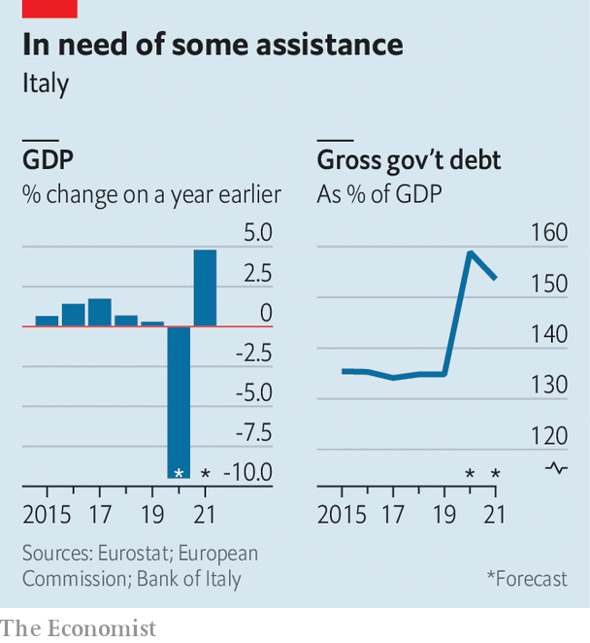

To some extent, Italy’s spending priorities will be dictated from Brussels; and the frugals have won an emergency brake on disbursements if things go wrong. That could cause problems. The country has for years fought against demands for unpopular structural reforms in return for EU concessions. But the aims of the recovery fund include making Europe greener and more digital. That chimes with the priorities of Mr Conte’s government, especially its largest component, the Five Star Movement.

A serious drag on economic growth is the time Italians waste interacting with the state. And it has increased. The proportion of people who report spending more than 20 minutes when queuing at registry offices has risen by more than two-thirds in the past 10 years. Parliament is debating legislation sponsored by the minister for innovation and digitalisation, Paola Pisano, to make the entire range of government services accessible via an app. She says she will be pushing for NGEU money to be spent on improving connectivity and digital education, particularly in the south of the country, where it is most lacking.

That raises perhaps the most important question of all. Italy exemplifies the EU’sdivision, with a north almost as rich as Germany and a south nearly as poor as Greece. If the NGEU can be used to pull the south closer to northern levels of prosperity, it would solve many problems, not just for Italy. But it has been tried many times before and has always run into the same obstacles: a mentality of dependence on the state, poor infrastructure and organised crime. The shortcomings of the south are also the main reason for Italy’s dire record of using past EU funds. Italy cannot afford to miss out in the same way on its biggest opportunity in 70 years. As Ms Pisano says: “This is a train that will only pass once.” ■

Editor’s note: Some of our covid-19 coverage is free for readers of The Economist Today, our daily [newsletter](https://my.economist.com/user#newsletter). For more stories and our pandemic tracker, see our [hub](https://www.economist.com/news/2020/03/11/the-economists-coverage-of-the-coronavirus)

This article was downloaded by calibre from <https://www.economist.com/europe/2020/08/01/italy-has-to-work-out-what-to-do-with-all-its-new-eu-money>

|  |  |  |  |
| --- | --- | --- | --- |
|  | Articles | Sections | Next |

|  |  |  |  |
| --- | --- | --- | --- |
| Previous | Articles | Sections | Next |

#### The new hotspots

# Curbing the covid-19 comeback in Europe

Young people are flouting the rules

Aug 1st 2020 |

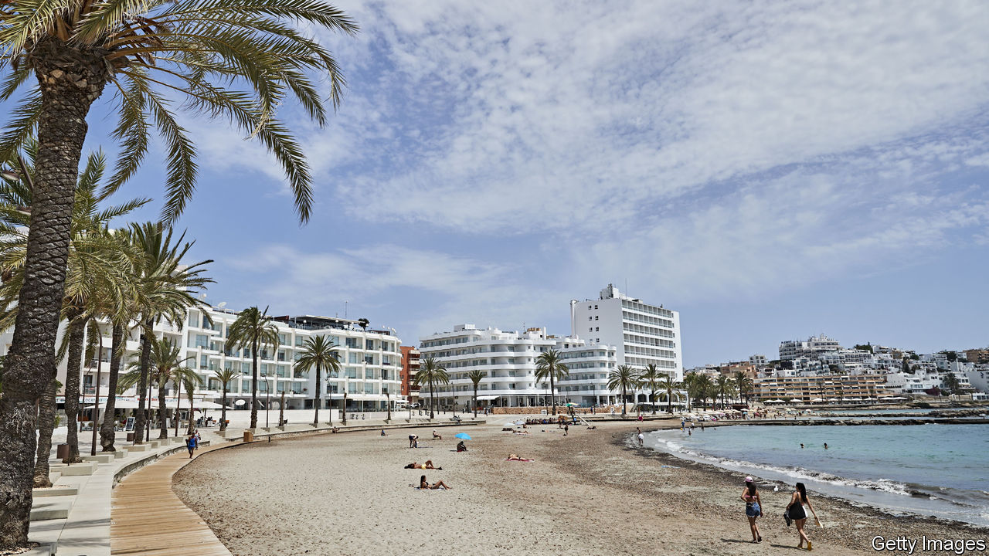

THE WAVES of an epidemic tend to rise like a tsunami—slowly, almost surreptitiously, before a precipitous surge. In parts of Europe there are now fears that covid-19 cases may again be nearing a menacing inflection point. In Spain, daily new cases in the week to July 28th have risen sharply to nearly ten times the low they had descended to in June, when the lockdown was lifted. Less dramatic but worrying increases in cases are starting to bubble up in other European countries.

For the moment, the spikes in Europe are largely confined to a few hotspot countries, regions within them or even towns. Infection rates are particularly high in the Balkans and in Spain, which has notched up about 27 cases per 100,000 people in the past week. The corresponding case rate in Germany, France and Italy is in the single digits. In both low- and high-rate countries, the bulk of new cases is often concentrated in particular locations. Roughly two-thirds of Spain’s cases in the past week are from just two regions, Catalonia and Aragon, which are home to a fifth of Spaniards. About 20% of Italy’s cases in the same period are in the Emilia-Romagna region, which has just 7% of the population.

The rise in cases across Europe is not surprising, says Hans Kluge of the World Health Organisation. As lockdowns were lifted and people resumed travel and mingling, both imported cases and the local spread of the virus have pushed tallies up. What is different now is that testing and tracing systems are catching local spikes early, and authorities are battling them with localised measures. On July 27th Antwerp, Belgium’s most populous province, announced a night curfew for non-essential movement and made masks mandatory in public spaces; people were told to stay at home as much as possible. Covid clusters have emerged across Germany, in care homes, workplaces and private parties, forcing officials to impose localised lockdowns. In mid-July the Catalan authorities reimposed a strict lockdown in Lleida, a city of 140,000. Nightclubs in Barcelona and other hotspots in Spain were recently shut or ordered to close early.

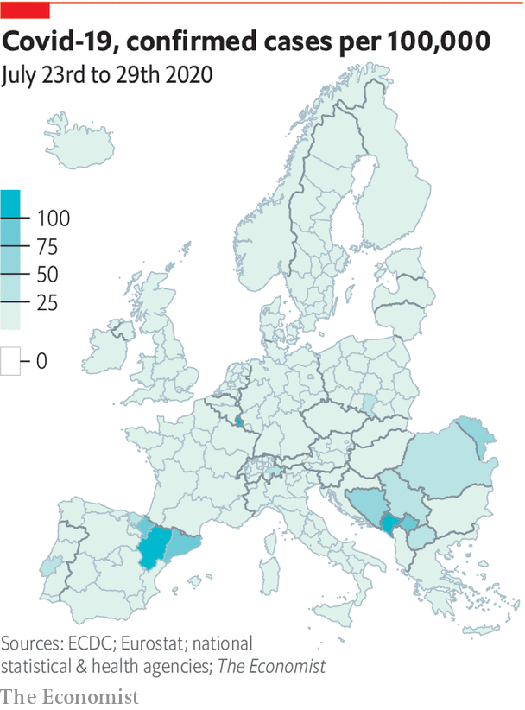

Varying covid-19 rates across Europe have prompted countries to make some tough choices. In a normal year, some 18m Britons seek fun in the sun in Spain, along with lots of other northern Europeans. But as cases in Spain notched up, Britain and Norway swiftly brought back quarantine for people coming from Spain. Vacationers to Greece from some Balkan countries must now show proof of a negative covid-19 test to enter the country. That has dealt a blow to whatever remained of the foreign tourist season in much of southern Europe. But there has been a collective sigh of relief among health officials watching with trepidation clubs and beaches crowded with drunk foreigners.

That, however, still leaves the matter of intensifying local transmission. A pattern that cuts across Europe is that new cases have been mostly among people in their 20s and 30s; clusters linked to large parties have become a recurring theme across the continent. German politicians have warned that citizens are growing complacent about the dangers; surveys confirm suspicions that fewer people are avoiding crowded public spaces or private gatherings. Dr Kluge says that the priority in Europe now is to ensure that young people comply more with such precautions. If that fails, he says, it won’t be long before infections spread to older, vulnerable people.

As the summer starts to wind down, the need to contain outbreaks across Europe will become increasingly acute. A huge worry in all countries is the autumn, when people start to spend more time indoors and flu and other respiratory infections rise as they do every year, filling hospital beds. Countries that reach that point with a high plateau of covid-19 cases could see a return to exponential growth that overwhelms hospitals again. Across Europe, they are better prepared for a second wave than they were for the first, with new measures to curb the spread of covid-19 in hospitals and extra beds and field hospitals that are mothballed now. But how hard they are hit will depend largely on how much their citizens choose to play by the rules of the new normal.■

Editor’s note: Some of our covid-19 coverage is free for readers of The Economist Today, our daily [newsletter](https://my.economist.com/user#newsletter). For more stories and our pandemic tracker, see our [hub](https://www.economist.com/news/2020/03/11/the-economists-coverage-of-the-coronavirus)

This article was downloaded by calibre from <https://www.economist.com/europe/2020/08/01/curbing-the-covid-19-comeback-in-europe>

|  |  |  |  |
| --- | --- | --- | --- |
| Previous | Articles | Sections | Next |

|  |  |  |  |
| --- | --- | --- | --- |
| Previous | Articles | Sections | Next |

#### Muddying the waters

# Turkey and Greece avoid coming to blows, for now

But a dispute over drilling rights is far from settled

Aug 1st 2020 | ATHENS, BODRUM AND PATMOS

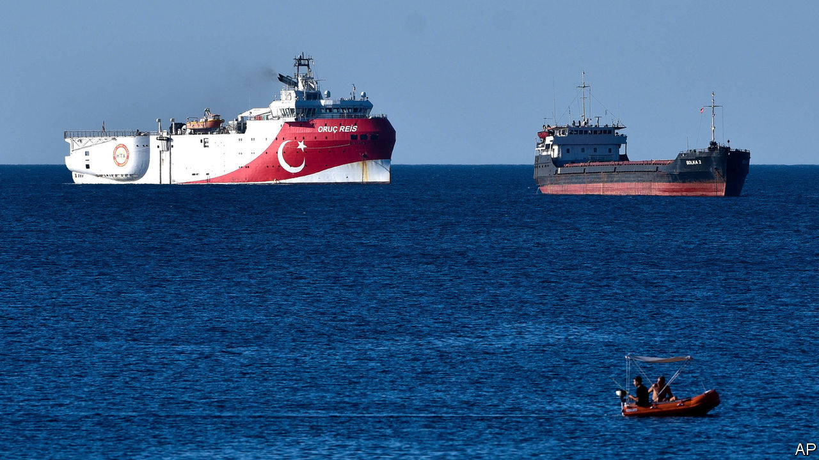

ON PATMOS, A small Greek island popular with jet-setters, flags flew at half-mast on July 24th. Church bells tolled every hour in protest against Turkey’s transformation of the Hagia Sophia, in Byzantine times the grandest cathedral in Christendom, from museum to mosque. That was not the islanders’ only concern. Coastguards, together with almost all the Greek navy and air force, were placed on high alert after Turkey announced on July 21st that the Oruc Reis, a drilling ship, would carry out ten days of exploration for oil and gas in a disputed area of the south Aegean.

The dispute has simmered for years. Turkish drilling ships periodically sail into exploration blocks off Cyprus to underline Turkish demands for a stake in potentially lucrative gasfields. This time the target was Kastellorizo, a far-flung Greek island opposite Kas, a pleasant resort town on the Turkish mainland. Tourist ferries between the two have been suspended this year because of covid-19. A couple of warships now cruise the area instead. Fighter jets occasionally split the sky above.

The two NATO countries have had their share of dust-ups of late. Earlier this year Turkey’s President Recep Tayyip Erdogan encouraged tens of thousands of migrants to breach the border with Greece. More recently the conversion of the Hagia Sophia saw the country’s top mufti delivering a sermon while clutching an Ottoman sword. The border crisis helped Mr Erdogan distract public opinion at home from an air strike that killed dozens of Turkish troops inside Syria (see [article](https://www.economist.com/node/21790210)). The reconquest of the Hagia Sophia came amid the economic fallout from the coronavirus crisis. Both were also intended to put pressure on Greece.

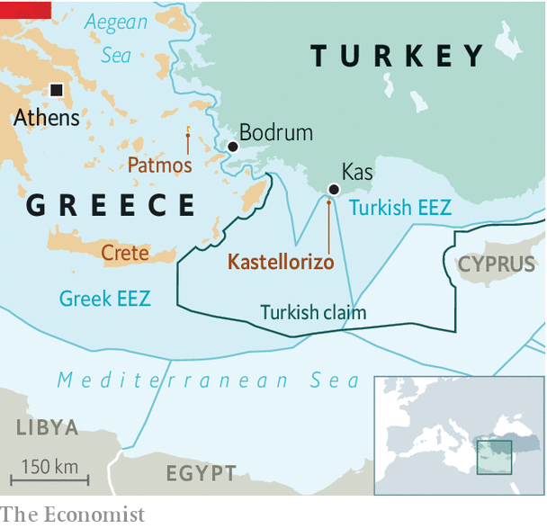

Turkey and Greece are staking competing claims to the waters between them, and the energy riches that may lie beneath the waves. Greece holds that its islands, even the smallest, have continental shelves where it has the sole right to drill. The EU and America agree. The Eisenhower, an American aircraft-carrier, accompanied by 12 smaller vessels, recently held a joint exercise with a Greek frigate and several Greek F-16 fighter jets off the island of Crete. Meanwhile, France threatened to slap Turkey with sanctions.

Turkey has long refused to recognise the economic zones around the Greek islands hugging its shores. An island like Kastellorizo, only a couple of kilometres offshore from Turkey, should not be able to generate 40,000 square km of maritime jurisdiction, says an official in Ankara. To make its point, Mr Erdogan’s government last year signed an agreement with Libya’s UN-backed government which it says gives Turkey the right to waters off Crete and other Greek islands. Greek officials say the deal is not worth the paper it is written on, and suggest they are close to signing a competing agreement with Egypt.

Maritime law does not offer clear solutions in the Mediterranean. “Good claims could be made either way,” says Brenda Shaffer, an energy expert at the Atlantic Council, adding that such disputes usually end up having to be settled by force or by agreement.

Agreement does seem possible. After a phone call between Angela Merkel, the German chancellor, and Mr Erdogan, Turkey said on July 28th that it would suspend plans to drill off Kastellorizo and give talks a chance. The Oruc Reis stayed tied up in port. In return, Kyriakos Mitsotakis, the Greek prime minister, offered to meet the Turks in Berlin, if calm prevails in the Aegean for the rest of the summer. That is hardly guaranteed. But Mrs Merkel’s willingness to get involved in one of southern Europe’s knottiest issues is a good sign. ■

This article was downloaded by calibre from <https://www.economist.com/europe/2020/08/01/turkey-and-greece-avoid-coming-to-blows-for-now>

|  |  |  |  |
| --- | --- | --- | --- |
| Previous | Articles | Sections | Next |

|  |  |  |  |
| --- | --- | --- | --- |
| Previous | Articles | Sections | Next |

#### The queen is dead

# Turkey mourns a revered drag artist

But the government is more censorious than it was

Aug 1st 2020 | ISTANBUL



HE WAS DEVOUT as a teenager and irreverent as an adult, but always kind, and bequeathed his fortune to charity. She was large, loud, and in her own words ugly to others but beautiful to herself with her blonde wig, improbable breasts and a tongue as sharp as a nettle. He was Seyfi Dursunoglu, a bureaucrat. She was the Grumpy Virgin, the persona he began to inhabit in the 1970s, in small clubs at first and then on national TV, on her way to becoming Turkey’s most beloved drag queen. They were one and the same person, and died on July 17th, at the age of 87.

Being gay or trans in Muslim-majority Turkey has always been hard. But homophobia has now become policy. Over the past month alone, Turkey’s president, Recep Tayyip Erdogan, called the LGBT movement a “cursed perversion” and an attempt “to poison young minds”, while his officials forced Netflix to cancel a new show because it featured a gay character and mused about withdrawing from a convention on violence against women because it contained references to sexual minorities.

The paradox is that many of Turkey’s most famous singers and entertainers have been gay or trans. Some of them still appear on TV. Mainstream culture in Turkey continues to welcome gay celebrities, so long as they do not discuss their sexuality openly.

The Grumpy Virgin outlasted a dozen prime ministers. But as Turkey’s politics have turned more Islamic and more inward under Mr Erdogan, she seemingly failed to keep up with the times. In 2007 the media watchdog banished her from the airwaves. Turkish TV shows these days are increasingly populated by Ottoman warriors and army commandos, and news programmes by martyrs, traitors and terrorists. Male ministers with long faces regularly vow to protect the nation from foreign plots. Turkey, it seems, is fast losing touch with its feminine side.

This article was downloaded by calibre from <https://www.economist.com/europe/2020/08/01/turkey-mourns-a-revered-drag-artist>

|  |  |  |  |
| --- | --- | --- | --- |
| Previous | Articles | Sections | Next |

|  |  |  |  |
| --- | --- | --- | --- |
| Previous | Articles | Sections | Next |

#### Charlemagne

# Europe still lacks a foreign policy

Yet in matters of currency it has hung together better than predicted

Aug 1st 2020 |

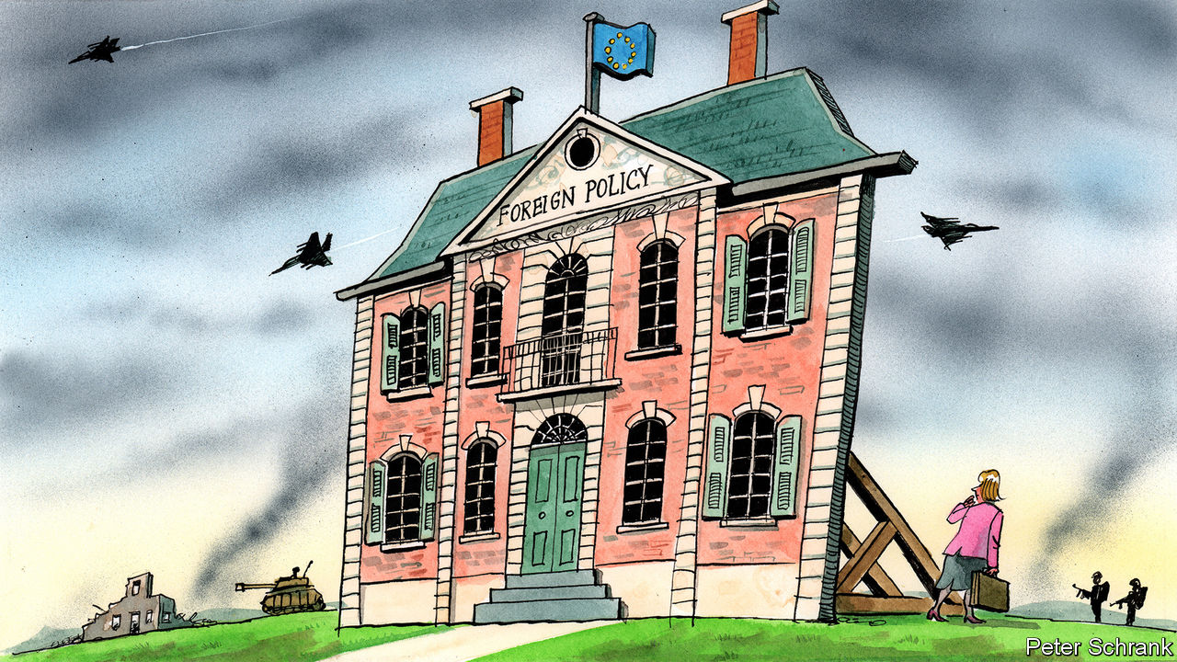

TO DEPRESS AN EU diplomat, lay out a map of Europe. On one border is Russia, posing a physical threat to the bloc’s eastern members and a digital one to the rest. To the south-east the western Balkans remain a mess. Turkey has evolved from partner to awkward neighbour to menace. In Ukraine a war still rumbles on, while Belarus, previously a place of autocratic stability, looks wobbly. Around the Mediterranean a line of unstable or failed states stretches from the Middle East to north Africa.

A coherent foreign policy in such circumstances would make sense. Instead the EU has a contradictory one. Russia is regarded as an existential threat by the likes of Poland, but a potential ally by France. Turkey is viewed in a similarly erratic way. Countries in the western Balkans should be hugged close or shoved away, depending on whom you ask. In Libya, perhaps the apogee of EU foreign-policy bungling, member states managed to find themselves on different sides of a civil war, while both Russia and Turkey carved out a foothold on the EU’s southern underbelly.

The EU is a victim of geography when it comes to foreign policy. But it is also a casualty of its own policy failures. To understand these problems it is worth remembering how it handled another predicament: the euro-zone crisis. The two have more in common than first appears. In both cases an indispensable national government lurks as the cause of, and solution to, the bloc’s problems. During the euro-zone crisis this role was played by Germany, argues Alexander Clarkson of King’s College London. A near-hegemonic economic power, Germany was often the biggest obstacle to reforms that would have shored up the euro, such as mutual debt issuance. At the same time its stern preference for balanced budgets and low debt limited the bloc’s economic policy options.

When it comes to Europe’s collective geopolitical clout, France plays a similar role, says Mr Clarkson. France is the closest thing the EU has to a global power. After Brexit, it is the bloc’s sole nuclear power and only member with a permanent seat on the UN security council. The French government has been a noisy advocate for European sovereignty—essentially demanding that the EU get its act together to a point where it can happily ignore the demands or threats of China and America. In practice, however, this has tended to manifest itself in an expectation that the EU should simply follow French policy. A paradox has emerged: while France calls most loudly for a canny European strategy, it is often the first to undermine it. In the western Balkans, it fought a rearguard protest against North Macedonia and Albania taking a step towards joining the bloc, despite the region’s importance. In the case of Libya, France was the EU’s main sympathiser for Khalifa Haftar, a rogue general who launched an assault on the UN-recognised government in Tripoli, which ostensibly had EU support.

The EU is trying to fix the problems at its borders with the trappings of a foreign policy but not its actual tools, just as politicians tried to save the euro without always having the right institutions in place. The euro’s designers built the currency on the expectation that further integration would inevitably follow, which it did, albeit in a sometimes chaotic manner. This strategy was known as the Monnet method, after Jean Monnet, one of the EU’s founding fathers. But when it comes to foreign policy the tactic has so far failed. The EU is left with a botched Kevin Costner project: they built it, but nobody came. An EU foreign policy exists only so far as member states allow it, with any decision requiring unanimity. Instead the union offers Potemkin diplomacy, with missions across the globe flying EU flags and staffed with well-paid diplomats but with little in the way of strategy to promote. As a result the bloc is burdened by responsibility without power: expectations that it should do something rise, while the capacity for the bloc actually to do anything remains static.

A final similarity with the euro-zone crisis is an unwillingness of governments to admit that their fates are bound together. It took a pandemic-induced recession for Germany to learn this lesson, but learn it did. After opposing common debt issuance to solve the euro-zone’s ills, the German government at last gave the nod earlier this year, paving the way for the biggest federalising step the EU has taken since the euro’s creation. Even those countries which protested compromised, leading to a €750bn recovery fund, with €390bn handed to governments as grants. (While all EU countries were involved, the main targets were euro-zone economies in the bloc’s south.) It was a step towards the EU becoming a little more recognisably state-like. But in foreign policy no such breakthrough is visible. Member states do not yet believe that the pain of a shared foreign policy—with contentious issues settled by qualified majorities, backed by a proper military capability—is worth the benefits of one.

## The euro was the easy bit

There are differences between the foreign-policy crisis and its euro cousin. Unlike euro policy, the EU’s foreign policy is not entirely in its gift to solve. There is no obvious buzzer marked “Fix Libya” that EU leaders are refusing to press. Markets cheer when the EU shows a modicum of political unity over the future of the euro. Given a similar breakthrough in foreign policy, leaders in Turkey and Russia would probably simply shrug. Likewise, while economic concerns are always at the top of voters’ minds, foreign policy appears only when something goes badly wrong. There is less political impetus to boost the EU’s geopolitical standing.

A totemic belief for EU officials is that crisis breeds integration. It is a view first put out by Mr Monnet that Europe is “forged in crisis”. Such an attitude can lead to complacency but in the case of the euro it stood the test. The currency bloc stumbled but never fell, with politicians taking necessary steps, albeit belatedly. A similar path is available when it comes to the EU’s foreign policy. After all, there are plenty of crises to test the theory on. Just look at a map. ■

This article was downloaded by calibre from <https://www.economist.com/europe/2020/08/01/europe-still-lacks-a-foreign-policy>

|  |  |  |  |
| --- | --- | --- | --- |
| Previous | Articles | Sections | Next |

|  |  |  |
| --- | --- | --- |
| Europe | Sections | International |

Britain

Regional economics: The national tilt

.

Urban explorers: Beauty in decay

.

Public transport: Going underground

.

Obesity: Witness the fitness

.

Competition policy: A world leader after all

.

|  |  |  |
| --- | --- | --- |
| Europe | Sections | International |

|  |  |  |  |
| --- | --- | --- | --- |
|  | Articles | Sections | Next |

#### Regional inequality in Britain

# Why Britain is more geographically unequal than any other rich country

Other countries have poor bits. Britain has a poor half

Jul 30th 2020 |

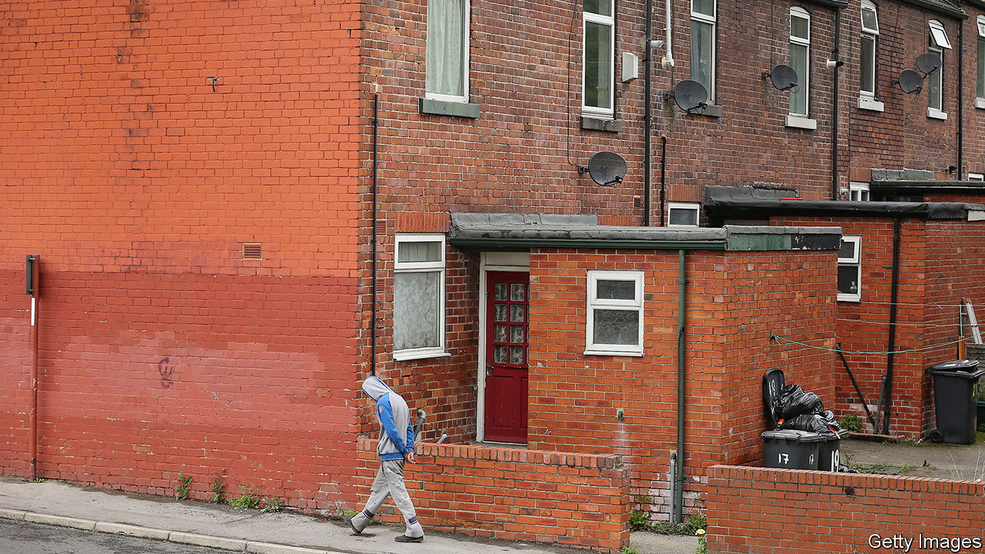

“SOMEONE’S BEEN busy”, says John Trueman, a builder. Apart from an old sign at the entrance, there is little hint that the enormous patch of ground in South Yorkshire was a working mine until 2013. The baths where the men washed before Maltby Colliery closed are a pile of rubble. An old car park is being used to store construction vehicles for auction. A site that once employed more than 1,000 people is quiet, except for one security guard, who is breezily informed by Mr Trueman that trespassing is not a crime.

Maltby grew quickly in the early 20th century after coal started coming out of the mine. “It seemed as though a town of bricks had been carried bodily through the air and dropped”, remembered Fred Kitchen, a farm labourer who published a memoir in 1940. It has declined almost as quickly. The village seems past its best, bereft of wealth, and lagging. The miners welfare club is boarded up; the high street is full of bargain shops. One street still has flags up from Remembrance Day, eight months ago.

The village is also at the centre of a political revolution. Maltby lies in the constituency of Rother Valley, which was created in 1918 and held by the Labour Party without interruption for a century. Last December, however, Rother Valley went Conservative. That was surprising; what is more, the new MP, Alexander Stafford, was educated at Oxford and was previously a local councillor in west London. Three constituencies touching Rother Valley swung from Labour to the Tories at the same time.

That upheaval, which was caused largely by the defection of white working-class voters to the Conservative Party, creates a political problem. Conservatives (like Labourites) have talked for years about the need to revive the poorest parts of Britain. Now, as Mr Stafford puts it, the party has skin in the game. If the Tories cannot work out how to improve the lives of their new supporters in left-behind places, they might not survive the next election.

Many wealthy countries contain poor regions. America has the rural South and the Mexican border area; Germany has the former East Germany; Italy has the lower part of the boot. But Britain is unique. On a regional level, it is exceptionally unbalanced, and becoming more so. Look closer, to the towns and cities within those regions, and Britain seems even odder.

In 2017 The Economist pointed out that the gap between GDP per person in the richest and poorest parts of Britain is larger than in other rich countries. That remains true; indeed, it has grown. The richest bit (Camden and the City of London) is now 30 times richer than the poorest (Ards and North Down in Northern Ireland). Not everybody likes that comparison; some argue that GDP per person is distorted by commuters, and that the data are skewed by the way regional boundaries are drawn.

No measure is perfect. So Philip McCann, an economist at the University of Sheffield, has compared Britain with other rich countries on 28 of them. He looks at large regions and smaller ones, and uses various yardsticks—GDP, gross value-added and regional disposable income. Britain can be compared with between 10 and 26 other countries. On all 28 of Mr McCann’s measures, Britain is above average for geographical inequality. On six, it comes top. “We’re a world beater”, he says.

It is not as though nobody has tried to do anything about it. “Regional policy is not a new thing—it goes back to 1937,” says David Higham, who used to oversee the government’s efforts in north-west England. Between the 1940s and the 1960s businesses and people were pushed out of London and other big cities; the population of the capital eventually fell by 2m. Since the 1970s governments have launched local and regional regeneration schemes at the rate of about one per year.

The net effect of all those city grants, local strategic partnerships, local enterprise growth initiatives, city region pilots, local enterprise partnerships, regional growth funds and the rest has been: not much. Since the 1960s London and the regions next to it have powered ahead relentlessly. In 1998 productivity per head in London was 65% above the British average. At the last count, in 2018, it was 77% higher. Half of all foreign direct investment projects go to London and south-east England.

Covid-19 has knocked the capital back. The streets of central London are quieter than elsewhere, according to mobile-phone data analysed by the Centre for Cities, a think-tank. In the year to June 11th the unemployment claimant count in the capital rose by 4.8 percentage points to 7.5%. That is a higher increase than any other region. On the other hand, the brain-workers of London and south-east England have probably not become much less productive. Their swift conversion to remote working, which is a calamity for the baristas of central London, bodes well for southern England’s long-term fortunes.

North of a line from the Severn estuary to the Wash, and south of Hadrian’s wall, lies an area that (measured by purchasing-power parity) is as poor as the American state of Alabama or the former East Germany. The regions therein—the East and West Midlands, North West, Yorkshire and the Humber, North East, Wales and Northern Ireland—contain 47% of Britain’s population. By contrast, 20% of Germans live in the former Democratic Republic, and only 15% if you exclude Berlin.

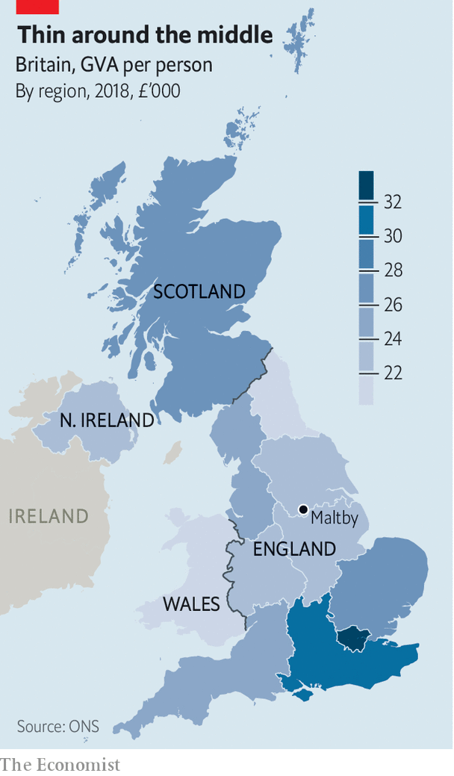

The former East Germany is emptying as young people drift west. In Britain every region is growing. Yorkshire and the Humber, which includes Maltby, is swelling three-quarters as quickly as the United Kingdom as a whole. Maltby is shedding people, but slowly for a place that has lost its main industry. Since 2002 the parish population is thought to have fallen by 4% to 16,500. Homes are cheap, and many former miners have paid off their mortgages. They can get by on money from odd jobs.

Eight miles west of Maltby, in Rotherham’s city centre, Deborah Bullivant has created something remarkable. Officially, Grimm and Co is an apothecary’s shop that has existed since 1148 but was made visible to mortals in 2016; more straightforwardly, it teaches creative writing and sells strange objects. It has been so successful that it will soon move into an enormous new premises in a former Methodist church. The shop is a quirky place, with hidden doors and a beanstalk for sliding down. But Ms Bullivant’s wonderful illusion dissolves when you look out of the front window. The view from Grimm and Co is of a charity shop, a closed bank, a closed electrical-goods store and a closed clothes shop.

“Thirty or forty years ago, this was a wealthy town,” says Andrew Denniff, head of the local chamber of commerce. Now Rotherham is on its uppers. Local people claim that nearby shopping centres have sucked away customers, and that others have been scared off by a sex-abuse scandal and a series of far-right marches. The truth is bleaker. The metropolis of which Rotherham is part—which also includes Sheffield and contains 1.2m people—is ailing.

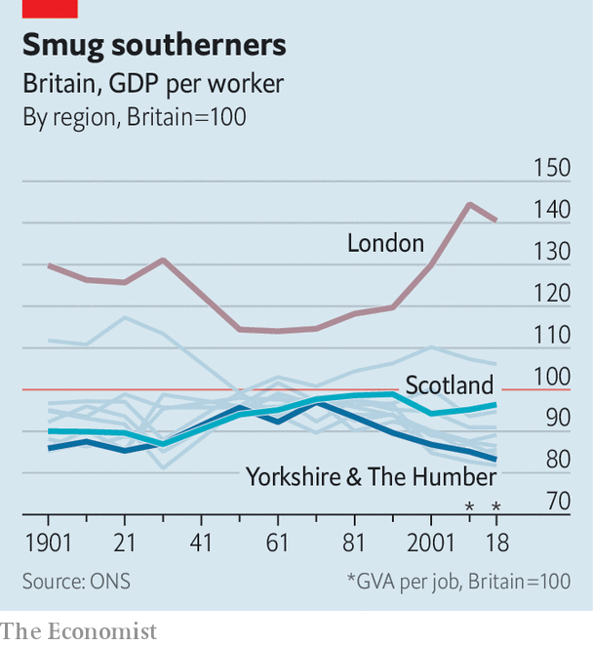

In other countries, cities are often islands of prosperity in poor regions. In the former East Germany, for example, Dresden and Leipzig are doing increasingly well. They are wealthier than the state in which they are located, and are climbing towards the national average. Britain is different. In 2017 GDP per person in the Sheffield metropolitan area was just 70% of the British average, according to the OECD—its lowest share since the turn of the century. Only nine of Britain’s 40 metropolitan regions that can be analysed are wealthier than the country. Just one of the nine, Preston, is in northern England.

The real economic divide in Britain is not between urban and rural areas, or between big cities and small towns, says Mr McCann. Wealthy regions tend to contain wealthy cities and towns; poor ones have mostly poor cities and towns. The real gap is between regions—or, to look at it another way, between urban areas in poor regions and urban areas in richer ones. The puzzle is why, with the great exceptions of Edinburgh and London, Britain’s large cities do not lift their hinterlands.

## A hub with no spokes

The answer is not simply that southern cities suck talent out of northern ones. By tracking tax records, the Office for National Statistics found that 94% of young people in Rotherham stayed put between 2011 and 2015, or moved only within the Sheffield area. Fewer than 1% went to London. People who move to affluent areas tend to be from affluent areas. The government’s Social Mobility Commission has divided places into “hot spots” with lots of opportunities (mostly in London and the south-east), “cool spots” that lack them, and “medium spots” in between. It finds that migration between hot spots is seven times greater than moves from cool spots to hot spots.

Poor places tend to grow too little talent in the first place. When Mr Trueman was at school, a truce existed between teachers and working-class children: “If you weren’t bothered, they weren’t bothered.” These days Maltby’s academy fares better. And in Rotherham, 21% of disadvantaged 18-year-olds from state schools and colleges go on to higher education—not far below the English average of 25%. Still, London is miles ahead: 41% of disadvantaged 18-year-olds there go on to higher education.

Another reason for many cities’ weak performance is that they are not larger. England has 14 urban green belts, covering 12% of the land area. Along with height restrictions and NIMBYism, these push up property prices in prosperous cities both southern and northern, making it hard for people in places like Maltby to move to them. “If we didn’t constrain their growth so much, Oxford and Leeds would be a hell of a lot bigger,” says Henry Overman of the London School of Economics.

Some metropolises are so hard to get around that they do not benefit much from their concentrations of businesses and people. As northern cities complain, London absorbs a large share of infrastructure money. In 2017-18, 28% of public expenditure on transport—and 46% of capital expenditure on railways—went there. The capital’s advocates argue that it gets a lot of public money because a lot of people take public transport. But two economists, Diane Coyle and Marianne Sensier, have shown that projects with low benefit-cost ratios are more likely to go ahead there.

London is exceptionally good at making the case for public and private investment in itself. It has the highest-profile mayor (a former occupant of that office, Boris Johnson, once argued that “the jam from London must not be spread too thinly over the dry Ryvita of the regions”). It has the biggest businesses and the best transport agency. The capital’s only real English rival is Manchester, which has been cleverly led since the 1990s. What crumbs fall from London’s table, such as the Commonwealth Games, the HS2 railway and much of the BBC’s production, tend to go there.

The other success is Scotland. “If you look back, there was no real difference between Scotland and the rest of the UK until the 1950s and 1960s,” says Graeme Roy of the Fraser of Allander Institute, a think-tank. But Scotland was represented by the powerful Scottish Office, which lobbied for its interests in Westminster. As local governments in England lost powers, Scotland gained them. A generous public-spending formula, and the opening of the North Sea oilfields, helped it become the richest part of Britain outside south-east England.

Sheffield and its neighbours, by contrast, are divided and fractious. In 2015 they were offered a “city deal” by Westminster, giving them more power and money. Two members of the gang, Barnsley and Doncaster, demurred, arguing that Yorkshire should be treated as a single unit. After much tedious argument (at one point the Archbishop of York was asked to mediate) a deal was agreed earlier this year. “If we can’t help ourselves, why should we expect anybody else to help?” asks Mr Denniff.

These are all knotty problems, which cannot be unpicked quickly. They compound each other. Just as people are seldom poor for one reason, regions do not fall behind only because they have poor transport, poor schools or poor leadership, but for all those reasons and more. Ideally, Britain would develop a bold plan for regional development that could be followed by successive governments, as Germany did for its eastern part. Tera Allas of McKinsey, a consultancy, argues that improving education is crucial, even if the returns are not immediately obvious. It is easier to improve schools than to persuade businesses to move to a part of the country.

But that is not much good for a government that feels compelled to do something before the next election, probably in 2024. So Tory thinkers are increasingly arguing for a different approach. Never mind the big cities, they say. Concentrate instead on giving the residents of small cities and towns things that make them proud of where they live. That could mean a better bus service or a spruced-up high street. “It’s about money, but not necessarily about growth,” says Will Tanner of Onward, an influential conservative think-tank.

Mr Stafford, Maltby’s new MP, agrees. The Tory vote is not growing in big cities like London and Manchester, he points out. The party’s future lies in places like Rother Valley. He is a critic of the High Speed 2 railway line, which will connect big cities, but a fan of restoring local railway services. He insists locals want small, incremental improvements that they can see. “They want their little part of England to be a little bit better than it was before,” he says.■

This article was downloaded by calibre from <https://www.economist.com/britain/2020/07/30/why-britain-is-more-geographically-unequal-than-any-other-rich-country>

|  |  |  |  |
| --- | --- | --- | --- |
|  | Articles | Sections | Next |

|  |  |  |  |
| --- | --- | --- | --- |
| Previous | Articles | Sections | Next |

#### Beauty in decay

# Britain’s urban explorers worry their playgrounds will be demolished

A plan to knock down abandoned buildings is bad news for some

Aug 1st 2020 |



“THIS MIGHT look like some spooky wreck,” says the urban explorer, as he studies the abandoned airfield from the unstable rooftop of its old officers’ mess. “But it’s where real life happened.” The dilapidated barracks, pillboxes and watchtowers are overgrown with plants. Some lack roofs. In one building, your correspondent reached the top of a flight of stairs and stepped into thin air where a floor should have been. He grabbed a door frame just in time.

Britain has lots of abandoned buildings, relics of the country’s fading industrial and military might. And the country is a hotspot for urban exploration, an odd hobby that combines a passion for history with an addiction to trespassing on private property. Its most serious practitioners are working-class and approaching middle-age, although they are sometimes joined by skateboarders and graffiti artists, who have their own uses for empty buildings. They congregate on online forums like Derelict Places and 28DaysLater. “A good urban explorer has a mental map of every abandoned building in a few hundred miles, sometimes more,” says the airfield trespasser.

Proposed changes to planning laws, which will make it easier to demolish vacant buildings to make way for housing, have shaken the explorers. They argue that the ruins are reminders of social history, and that they should be converted, not demolished. Some of the most sought-after ruins are old factories that evoke working-class life. “Walk into these old mills, and you can still smell the engine oil,” says Simon Sugden, an urban explorer and photographer who will soon publish a book on the subject. “You can picture all the people working away in the heat.”

The urban explorers are a passionate lot. “The building was beckoning me, like it wanted me to take pictures of it,” says Mr Sugden of Drummond Mill in Bradford, which was later destroyed by fire. To their occasional annoyance, others share their enthusiasm. YouTubers venture onto their sacred territory in search of quick celebrity. Some ruins have been leased to specialist live-action role-play companies, which use them as apocalyptic backdrops for airsoft battles or fake zombie attacks.

But the competition worries the urban explorers much less than the threat of demolition. “I just want people to see the beauty in it,” says Mr Sugden. “People should be more appreciative of these buildings.”

This article was downloaded by calibre from <https://www.economist.com/britain/2020/08/01/britains-urban-explorers-worry-their-playgrounds-will-be-demolished>

|  |  |  |  |
| --- | --- | --- | --- |
| Previous | Articles | Sections | Next |

|  |  |  |  |
| --- | --- | --- | --- |
| Previous | Articles | Sections | Next |

#### TfL’s money woes

# London’s transport agency needs a new funding model

For political reasons, it may not get one soon

Aug 1st 2020 |

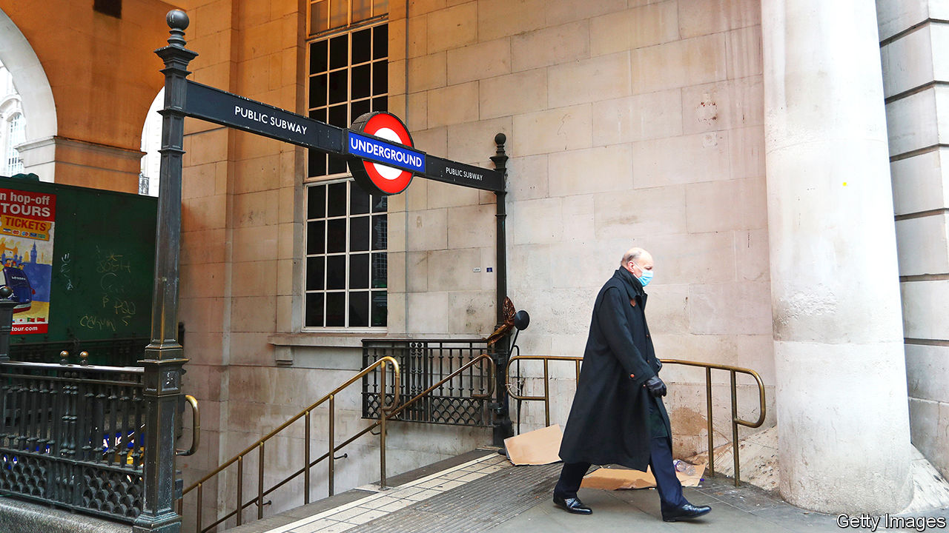

“IT WAS THE most unusual start to any job I’ve ever had,” says Andy Byford, London’s new Transport Commissioner, who took up his role on June 29th. “I walked into an almost empty office, running almost riderless Tubes with a severe financial challenge.” Transport for London (TfL), the capital’s public-transport authority, issued a revised budget for the second half of the current financial year on July 24th. It is asking central government for £4.9bn ($6.4bn) to cover a revenue shortfall over the next two years. That would come on top of an initial funding package of £1.6bn agreed in May.

TfL is unusual among large public-transport operators because it relies so heavily on passenger fares. Ticket sales generate over 70% of its income compared with under 40% in Paris or New York, where Mr Byford previously ran the transport authority. TfL used to receive around £700m a year from the Treasury, but that was phased out in 2018 as a result of a deal agreed with a former mayor, Boris Johnson. Since then it has come to rely on Tube revenues to subsidise buses. It was bound to suffer badly from a collapse in travel (see chart).

Mr Byford says that getting the finances on a sounder footing is one of his two priorities—the other one is opening the much-delayed Crossrail line. He argues that “going with the begging bowl out to the Treasury every six months” is not a long-term solution. Instead he wants a “sustainable, affordable and predictable” funding model, ideally one that will last for decades. That will not be easy.

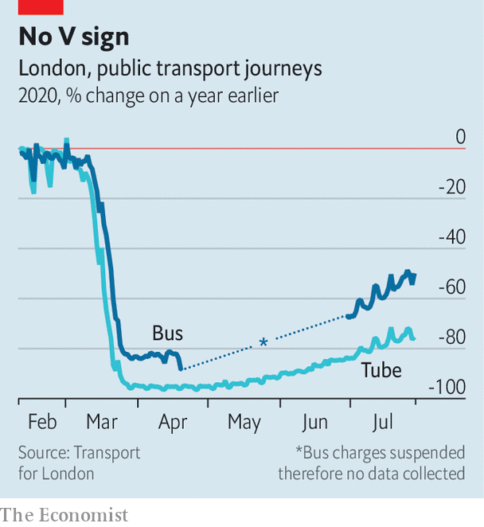

Sadiq Khan, the Labour mayor of London, was due to face the voters in May this year. The pandemic has delayed elections until next spring. That context may explain why TfL has been treated more harshly than the railway companies, says Tony Travers, a long-time watcher of the capital’s institutions from the London School of Economics: “The rail industry got a quiet £3.5bn bail-out with little fanfare. Meanwhile TfL got less than half as much cash, had to drop concessionary fares, raise the congestion charge, take two new government-appointed directors and accept a financial review. There’s some politics here.”

The agency’s travails are a useful stick for Mr Khan’s Conservative challenger, Shaun Bailey, to use to beat the mayor. “It’s easy for the mayor to blame the virus,” he tweeted after the new budget was released, “but if he had managed TfL’s finances properly, he wouldn’t have needed one bail-out, let alone two.”

This is nonsense. Mr Khan’s freeze in fares cost TfL around £640m over four years, a sum dwarfed by the estimated £1.9bn drop in passenger income expected this year. Simon Kilonback, its finance director, argues that £1bn had already been taken out of operating costs in the four years before covid-19 hit. TfL’s funding is now the subject of two concurrent reviews, one overseen by the Department for Transport, the other by the Mayor of London. Mr Byford diplomatically notes that he looks forward to engaging with both.

Tube tickets are already among the most pricey in Europe, suggesting there is not much room to increase fares. Both Mr Byford and Mr Kilonback want to make more innovative use of TfL’s land and generate more income from commercial development. Mr Travers expects that some of the financial hole will have to be filled by some kind of a tax on Londoners. The congestion-charging zone, in which motorists pay to drive, could perhaps be expanded. Or existing services could be mothballed. Mr Byford says that he did not take the job to oversee a reduction in passenger services. He may not have a choice.■

This article was downloaded by calibre from <https://www.economist.com/britain/2020/08/01/londons-transport-agency-needs-a-new-funding-model>

|  |  |  |  |
| --- | --- | --- | --- |
| Previous | Articles | Sections | Next |

|  |  |  |  |
| --- | --- | --- | --- |
| Previous | Articles | Sections | Next |

#### Fat chance

# Boris Johnson’s plans for a fitter nation

Why the prime minister is a healthy-eating convert

Aug 1st 2020 |

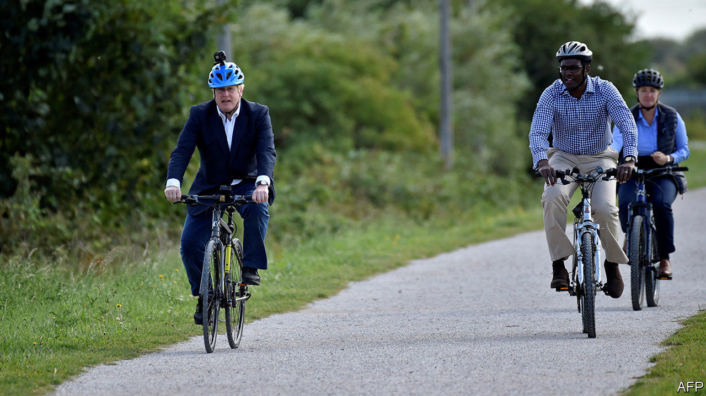

WHEN THE British army was humiliated by a guerrilla force of southern African farmers at the turn of the 20th century, politicians turned to Britain’s diet. A third of men who had appeared at recruiting stations to fight the Boer settlers were rejected on the grounds of being too puny or sickly to fight. The decline of home cooking and a diet of white bread, cheap jam and tea was partly to blame, an official inquiry into the state of the “national physique” later concluded. It recommended regular medical check-ups and argued that schools should provide “adequate nourishment to children in attendance”.

The coronavirus pandemic has stirred similar concerns about the country’s dining habits. On July 27th Boris Johnson announced that Britain will ban the advertising of unhealthy food on television before 9pm and consider an outright ban online. Restaurant and takeaway chains will need to add calorie counts to their menus, and the government will consult on whether to require similar labels for alcoholic drinks. Mr Johnson wants Britons to cycle to work, and doctors to prescribe cycling to fat patients. Repeating a line that persuaded most people to obey the lockdown, the government argues that Britons should shed some weight to reduce the pressure on the National Health Service.

The prompt is the country’s covid-19 death rate—the second highest in the world—and the fear that wide waistlines contributed to it. Nearly two-thirds of Britons have a body-mass index above 25, meaning they are overweight; a figure higher than in France, Germany or Italy. A recent paper by Public Health England, a government agency, concludes that overweight covid-19 patients were more likely to experience serious complications and death. It noted that poor and non-white people are more likely to be obese, and that they have suffered higher death rates.

Politicians have toyed with anti-junk food policies for decades. David Cameron, while leader of the opposition, questioned why WH Smith, a shop found on railway-station concourses, promoted cut-price chocolate oranges near the tills but not fresh fruit. He did little in office to remedy the matter. His successor as prime minister, Theresa May, ditched plans to ban promotional cartoon characters such as the Milky Bar Kid and the Honey Monster, although she did introduce new taxes on sugary drinks.

As a newspaper columnist, Boris Johnson ridiculed public-health campaigns, arguing that the “true conservative knows that do-goodery is often far more dangerous than masterly inactivity.” His brush with death has changed his mind. He was, he said, “way overweight” when he was admitted to an intensive-care unit with the virus in April, and has since shed more than a stone thanks to a regime of early-morning dog walking.

The proposed advertising ban is supported by more than two-thirds of people, according to YouGov, a pollster. And, as in the Edwardian era, poor public health has become a political risk. The public may forgive the government if they think Britain’s high coronavirus death toll is a result of reasonable short-term errors, suggests one Tory MP. But if they conclude that a decade of Conservative government has “made Britain sick” then the political price could be much higher.

The plans were welcomed by public-health experts, with the proviso that they are unlikely to make a huge difference to British waistlines. Although a Cochrane review of nutritional labelling found that it may have a small impact on food consumption, it noted the evidence was weak; two more recent studies by researchers at the University of Cambridge found that posting calorie counts in workplace cafeterias made no difference to eating habits.

Children are watching half as much broadcast commercial television as they were a decade ago, notes Enders Analysis, a media-research firm. Online advertising is harder to regulate, because YouTube, unlike a broadcaster, is not legally responsible for the adverts it carries. As the committee of 1904 noted, they were fighting “popular taste, which it may take generations of educative influence to correct.” ■

This article was downloaded by calibre from <https://www.economist.com/britain/2020/08/01/boris-johnsons-plans-for-a-fitter-nation>

|  |  |  |  |
| --- | --- | --- | --- |
| Previous | Articles | Sections | Next |

|  |  |  |  |
| --- | --- | --- | --- |
| Previous | Articles | Sections | Next |

#### “World-leading” after all

# Britain has some good ideas for dealing with tech giants

But technocrats and government may find themselves at odds

Aug 1st 2020 |

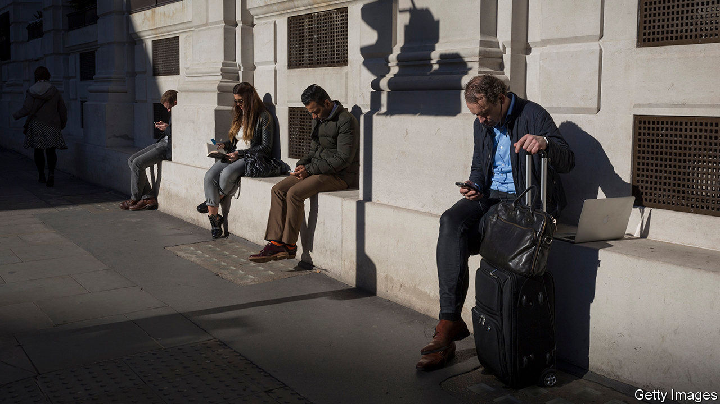

ON MARCH 11th the World Health Organisation declared covid-19 a pandemic, the Bank of England cut interest rates to 0.25% and Rishi Sunak, the chancellor, announced what then seemed like a fiscal bonanza. Another episode that day got less attention. The government accepted the recommendations of the Digital Competition Expert Panel, chief among which was to set up a “digital markets unit” (DMU), a regulator to oversee big tech companies and encourage competition online.

Then, on July 1st, the Competition and Markets Authority, a powerful regulator, released its study of the digital advertising market. It identified problems “so wide ranging and self-reinforcing that our existing powers are not sufficient to address them”. It set up a taskforce to figure out what a new regulatory framework might look like.

One purported advantage of Britain leaving the EU is that it can regulate business better. In the case of technology, this might be true. Margrethe Vestager, Europe’s competition tsar, is said to be looking at Britain as inspiration for changes to the EU’s antitrust regime. Cristina Caffarra, an expert on European competition at Charles River Associates, an economics consultancy, has argued that the country “is first in Europe to set off on an explicit regulatory experiment and articulate a detailed agenda”.

The big idea at the heart of the CMA’s work is what lawyers call “ex ante” regulation. Competition law generally works on the principle of “ex post” enforcement. Broad rules are applied across sectors; antitrust authorities investigate and fine companies that breach them. For an industry as big, rich and fast-moving as tech, this can be ineffective. It is hard to prove harm in the traditional sense, and in any case companies pay up and move on. The new regime, which complements the existing one, would make rules specific to online platforms such as Google and Facebook (and potentially Apple and Amazon). These could include forcing companies to share data with competitors, making it easier for consumers to switch platforms and mandating the separation of data from different services owned by the same firm.

The government is considering an “Online Harms Bill”, which would impose a duty of care on tech firms. A House of Lords committee recently recommended a code of practice for online political advertising. The government has also accepted recommendations to establish codes of conduct around the treatment of news media by online platforms. There is little co-ordination between these efforts, nor is anyone in government tasked with bringing them together. But many of these measures lead back to the prospective DMU, which will probably be some combination of the CMA, the Information Commissioner’s Office and Ofcom, the media and telecoms regulator. The taskforce is due to complete its work by the end of the year.

After that, politics takes over. The thing to remember, says a senior adviser to the government, is that policy wonks get excited about regulating tech companies, but most people love their products. And Brexit brings challenges, including the difficulty of imposing regulation on American tech firms at the same time as Britain negotiates a trade deal with America. Moreover, regulating online advertising seems at odds with the desire to make Britain more attractive to big internet platforms, points out Ashley Hurst, a competition lawyer with Osborne Clarke, a law firm.

The government says it is “committed to making sure that digital markets work for all”. What that vague aspiration means in practice will become clear once the taskforce finishes its work.■

This article was downloaded by calibre from <https://www.economist.com/britain/2020/08/01/britain-has-some-good-ideas-for-dealing-with-tech-giants>

|  |  |  |  |
| --- | --- | --- | --- |
| Previous | Articles | Sections | Next |

|  |  |  |
| --- | --- | --- |
| Britain | Sections | Business |

International

Migration after covid-19: Tearing up the welcome mat

.

|  |  |  |
| --- | --- | --- |
| Britain | Sections | Business |

|  |  |  |  |
| --- | --- | --- | --- |
|  | Articles | Sections | Next |

#### Tearing up the welcome mat

# When covid-19 recedes, will global migration start again?

Many curbs on immigrants could outlast the pandemic

Aug 1st 2020 | DUBAI, JOHANNESBURG, SINGAPORE, SYDNEY, TOKYO AND WASHINGTON, DC

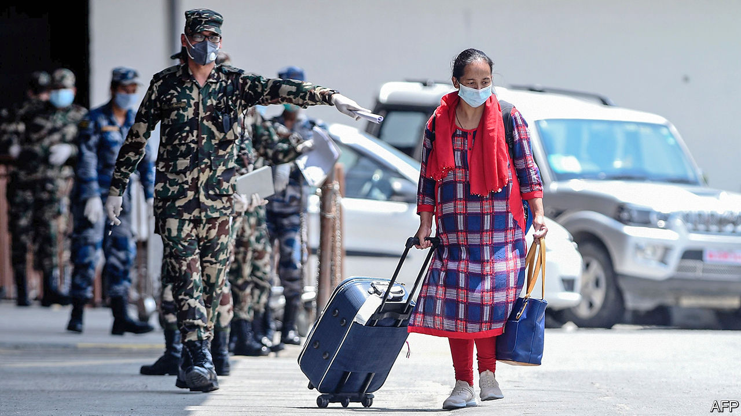

EVERY WEEKEND the removal vans come to a leafy suburb of Dubai. Expatriates are packing up. The United Arab Emirates (UAE), of which Dubai is part, will lose 10% of its population this year, reckons Nasser al-Shaikh, an ex-finance minister. Covid-19 has devastated the Gulf’s trade-and-transport hub. Emirates, Dubai’s airline, says it may cut 30% of its roughly 100,000 staff.

Nearly all of those losing their jobs in the UAE are migrants, who are almost 90% of the population. Without a job, they have to leave the country. This is irksome enough if they are bankers or architects. For those who used to wash dishes in hotels or lay bricks on building sites that are now shuttered, it can be a nightmare. Some 500,000 Indians in the UAE have registered to be evacuated; less than half have been.

Many blue-collar migrants have waited so long for flights that they have blown their savings. Asad (not his real name) got a $1,100 pay-off when he lost his construction job in April, but has had to spend nearly all of it on food and other necessities, which are far costlier in Dubai than back home in Pakistan. This week he was huddling outside the airport for a cigarette before a flight to Lahore. “Two years [and] I go home with almost nothing,” he says. Some of his friends are even worse off: they still owe money to the labour brokers who brought them to the Gulf in the first place.

Covid-19 has immobilised the world. Planes are grounded, borders are closed, people are hunkered down at home. Every country has restricted travel because of the coronavirus—issuing more than 65,000 rules in total. Some countries are starting to open up but it will be a long time before people can globetrot as freely as before.

For tourists who have to take a domestic holiday instead of a glamorous foreign one, global immobility is annoying. For would-be migrants, it can be life-shattering. Millions who would have set off to start a new life this year cannot. Workers who might have quadrupled their wages will remain poor. Students who might have stretched their minds on foreign campuses will stay at home.

Tens of millions of migrants who have already moved now face deportation, having lost their job, according to the International Labour Organisation. Millions have gone home to places like the Philippines, India and Ukraine. Millions more are stranded, sometimes in crowded conditions that foster the spread of the virus.

Locals are not always sympathetic. Malaysia, which used to welcome Muslim Rohingya refugees, has started pushing their vessels back into the sea. Italy has stepped up efforts to turn back boatloads of Africans. A Kuwaiti actress suggested that migrant workers, who are 70% of the labour force in Kuwait, be thrown into the desert to free up space in hospitals.

Global remittance flows, which are over three times bigger than foreign aid to poor countries, will fall by 20% this year, predicts the World Bank. Families that used to rely on cash from a migrant son or aunt to see them through hard times are finding that times are suddenly much harder and the flow of cash from abroad has dried up.

Businesses that depend on mobile labour have been hobbled. Pokka Singapore, a drinks-maker, employs about 120 Malaysians who used to commute across the border to Singapore. When the borders closed, more than half decided to remain in Malaysia, says Rieko Shofu, the firm’s boss. She has gone without half her Malaysian workforce for months, with no end in sight.

Travel curbs have made cross-border investment harder. Before committing money to a venture, you need to be “able to walk the factory floor” and “physically validate what you read in the PowerPoint presentation,” says Stephen Forshaw of Temasek, Singapore’s sovereign-wealth fund. Now, if you are not already there, you can’t.

Even if tourism and business travel return to something resembling normal as the pandemic fades, some restrictions on migration may remain. Where people had a settled right to move which was temporarily suspended for health reasons, within the European Union for example, that right will surely be restored. But where permission to move is granted by the host government, it may become permanently harder.

Much will depend on how covid-19 affects people’s view of immigrants. Fear could make them more hostile. Many will conclude that letting in foreigners is a health risk (though the vast majority of travellers are not migrants). Because the virus originated in China, bigots in many countries have mistreated people who look Chinese. Bigots in China, meanwhile, have evicted black immigrants from their homes and barred them from hotels, after hearing a rumour that Africans were likely to be infected. Future migrants will not quickly forget footage of a no-blacks sign on a McDonald’s in Guangzhou.

With economies reeling, many will also conclude that it is time to stop immigrants from competing with natives for scarce jobs. In countries where lots of migrants have been laid off and are allowed to live on the dole, locals may resent the expense.

The pandemic might also hurt illicit migrants. Some of the snooping tools that governments have introduced to trace the spread of covid-19 could outlast it, making it harder to work in the shadows. In China, to take the most extreme example, malls and subways often deny entry to those who lack an app on their phone to show they are healthy, which no one can get without a formal address. “It may become virtually impossible to live without papers,” writes Roberto Castillo of AfricansInChina.net.

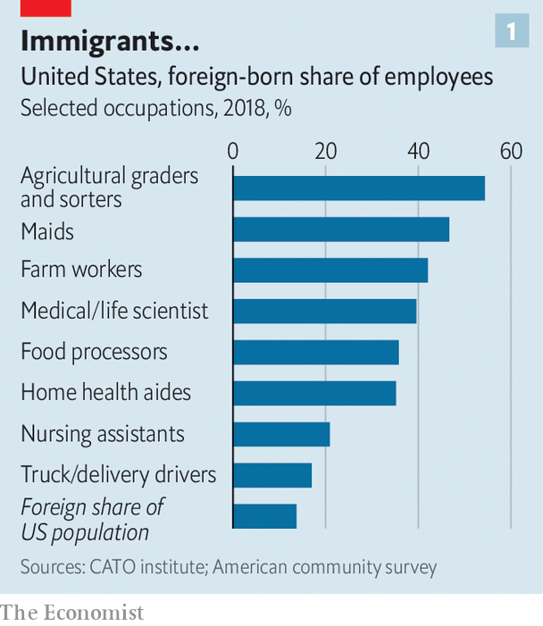

In other ways, however, the pandemic could make people friendlier towards immigrants, many of whom have risked their lives to do essential work during the crisis (see chart 1). Health services in rich countries could not function without them (see chart 2). Roughly half the doctors in Australia and Israel are foreign-born. In America migrants were 14% of the population in 2018 but 29% of doctors. Medical research, of the sort that will one day yield a vaccine, depends on teams of the most talented minds from around the world getting together and collaborating. Some 40% of medical and life scientists in America are foreign-born. The Oxford Vaccine Group, which unveiled promising vaccine trial results in July, includes scientists from practically everywhere.

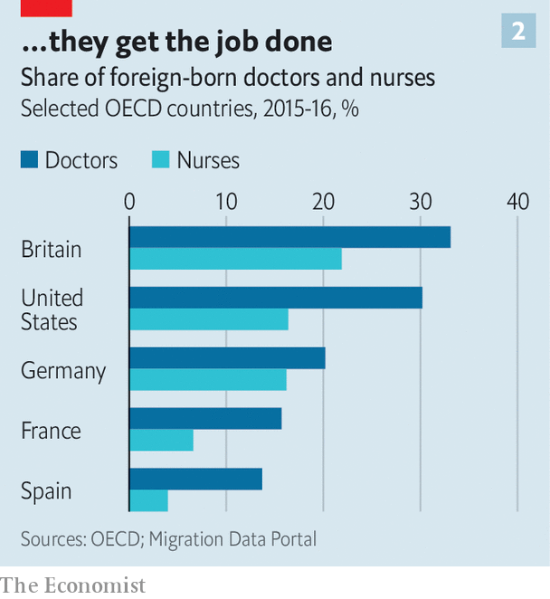

Immigrants also do a big share of the jobs that “make it possible for the rest of us to work safely from home,” observes Doris Meissner of the Migration Policy Institute, a think-tank. They grow food (42% of farm workers in America are foreign-born), deliver things (18% of industrial truckers) and disinfect floors (47% of hotel maids and 25% of janitors). More than half of American tech giants were founded by immigrants or their children. That includes Zoom, Amazon and Google, without whose products remote working would be tricky.

With covid-19 rife, immigration policy is not at the top of the agenda anywhere. But it is bubbling up. Europe seems more hostile to migrants crossing the Mediterranean. In Australia the opposition Labor Party’s immigration spokeswoman said the country should move away from its “lazy” reliance on “cheap” foreign workers who take “jobs Australians could do”.

Among rich countries the debate is playing out most dramatically in America. Long before covid-19 was discovered, Mr Trump associated immigrants with germs. He spoke of “tremendous infectious disease…pouring across the border” with Mexico. Stephen Miller, a hardline adviser, had long argued that public health could provide a legal justification for shutting them out. After the coronavirus struck, Mr Trump enacted a wishlist of restrictions.

He banned foreign travellers from China. This did not protect America since Americans were free to return home from covid-19 hotspots. Nonetheless, Mr Trump praised his own decisiveness. “I banned China,” he repeated, often.

Immigration to the United States was falling even before the pandemic, thanks to aggressive enforcement, reduced quotas and the eloquence with which Mr Trump tells migrants they are not wanted. The net increase in the foreign-born population was a mere 200,000 in 2017-18, down from over 1m in 2013-14. Mr Trump seems eager to lower that number to zero.

In June he issued a “Proclamation Suspending Entry of Aliens Who Present a Risk to the US Labour Market Following the Coronavirus Outbreak”. It froze four types of visa for the rest of the year: H-1Bs (for highly skilled workers); H-2Bs (for less-skilled workers); J visas, for au pairs, temporary summer workers and some academics; and L visas, for professionals who are moved within the same company.

## With every word, they drop knowledge

These new rules, combined with a neartotal shutdown of visa offices, will destroy American jobs, not create them. Holders of H-1B visas mostly work in information technology, where there is a skills shortage. Adam Ozimek of Upwork, a freelancing platform, estimates that the use of IT to enable remote working has reduced the risk of job losses by between a third and a half. And a new paper by Britta Glennon of the Wharton School finds that when America restricts H-1B visas, multinationals do not hire more Americans. They shift operations to Canada, India and China.

Curbing the flow of talent will constrict economic growth. Consider the baffling decision to stop intra-company transfers. Multinationals routinely bring in key managers or technicians from abroad to solve bottlenecks. If they cannot do this, their businesses are less likely to succeed—so they will be less likely to invest in America at all. “About 80% of my portfolio consists of at least one founder who has immigrant roots,” says Joydeep Bhattacharyya, a venture capitalist in Silicon Valley. “Many have started outside the United States, and then the entrepreneur has moved over, employing a lot of American workers. This year it’s completely stopped. No matter how well they’re doing, they can’t come.”

Banning au pairs won’t create jobs for Americans, either. On the contrary: by providing cheap child care, au pairs make it easier for American parents to go out to work. Families that couldn’t afford a nanny can often afford an au pair because part of the au pair’s compensation is a place to stay and a chance to learn English.

Jason Patwell, a defence contractor, is a single father of three boys, one of whom has special needs. He was aghast when he realised that an au pair would not be coming. “I would love to say I have a back-up plan, but I don’t. I can throw money at the problem, and go into debt. I’ll survive until the end of the summer,” he says.

In worse-off countries, where the state lacks the cash to cushion the economic shock of covid-19, the debate about migration is even more fraught. Consider South Africa, where xenophobia was common, sometimes lethally so, even before the pandemic. Like America, South Africa shares a long, porous land border with a large continent where wages are much lower. Workers and traders flock there from all over Africa. The World Bank estimates that each one creates on average two jobs for natives, because migrants import skills, start businesses and spend money. But most South Africans think otherwise. They are nearly twice as likely to say that immigrants are a burden than to say they make the country stronger, says a Pew poll. (In America, those figures are reversed.)

One of the first things South Africa’s government did to fight covid-19 was to build a 40km fence on the border with Zimbabwe. It has more holes than a bagel warehouse. A local farmer calls it “a complete farce”. It would not be much of a public-health measure in any case. Covid-19 has largely entered South Africa by air, from Europe, and is circulating widely.

In March a minister announced that foreign-owned shops, which are the only outlets in many areas and are disproportionally owned by Ethiopians and Somalis, would have to close. Locals were forced to travel miles to buy groceries, which helped spread the virus. Enforcement was relaxed in April, but the hassles did not end.

When the offices that issue permits were closed, the government promised that all expiring permits would automatically be extended, first until July 31st, then until October 31st. However, police and soldiers have allegedly detained and demanded bribes from foreigners with out-of-date papers. A few Zimbabweans got on privately organised repatriation buses. Upon leaving South Africa, some were banned from returning for five years, despite promises to the contrary. An overhaul of immigration laws is due later this year—to be drafted by securocrats, not economists.

Some countries may emerge from the pandemic more open to migration. In Japan covid-19 may have spurred the government to make its pro-immigration policies more explicit. The country is ageing and needs young foreigners to clean hotels and staff shops. The polite fiction was that many of these foreign workers were “trainees”, learning skills to bring back home.

## Got a lot farther by working a lot harder

But from April the government ditched the requirement that these “trainees” stick with the firm that sponsored their visa. It did not want to deport migrants who had lost jobs in one sector (eg hotels) when others (eg hospitals) were crying out for them. So it announced that they could switch employers. By doing so, it has dropped the pretence that the trainee programme is about anything more than coping with Japan’s own labour shortage, argues Menju Toshihiro of the Japan Centre for International Exchange, a non-profit. Indeed, migrant workers are so valuable that calls to exclude them from the government’s covid-19 stimulus package fell on deaf ears.

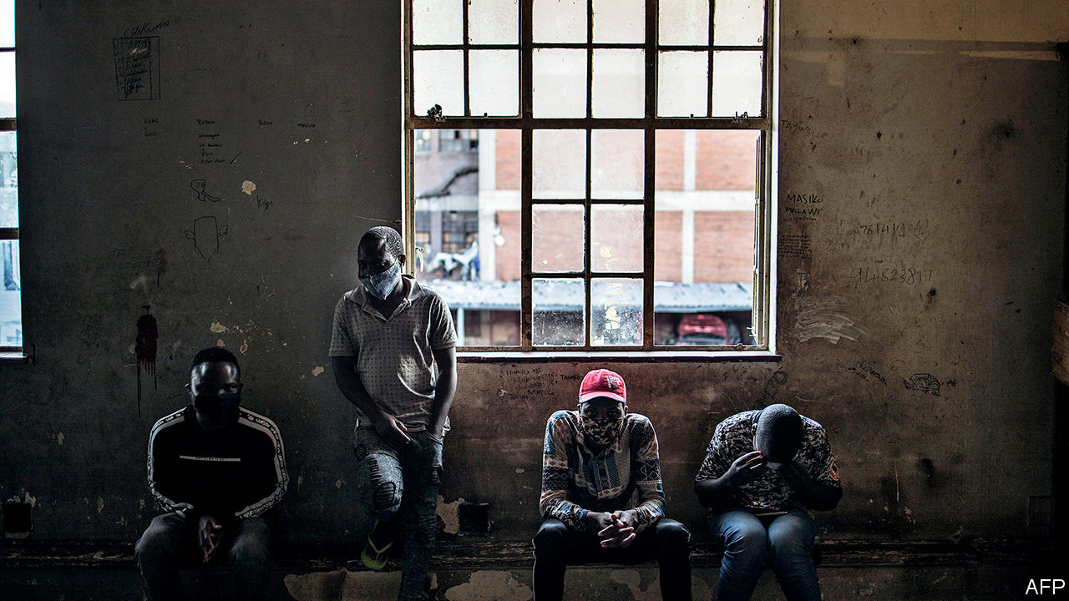

Do they know what you overcame?

In Britain anti-immigration sentiment peaked around the time of the Brexit referendum of 2016, but has since subsided. Many who voted to leave the EU because they thought there was too much migration now feel Britain has taken back control of its borders. In the wake of covid-19, views of immigration will continue to mollify, predicts Jonathan Portes of King’s College London. A recent decision to extend residence rights to up to 3m Hong Kongers passed without fuss. Under a proposed points-based system, EU nationals will find it harder to work in the UK, and few workers from anywhere will be admitted if they make less than £25,600 ($33,231) a year. But the rules will be looser for health workers. And voters have noticed that many migrants who make less than £25,600 have been indispensable of late. “Care workers, bus drivers and supermarket staff all fulfil essential functions, and it is far from obvious that there will be public support for an immigration system that excludes them all in favour of relatively junior bankers,” writes Mr Portes.

In America, for all Mr Trump’s fist-waving, the share of people who think that illegal immigration is a “very big problem” has fallen markedly since the pandemic began, from 43% last year to 28% in June. This could be because the influx has dried up, or because, compared with covid-19 itself, nothing seems like a “very big problem”. The country is divided. A new Economist/YouGov poll finds Americans roughly evenly split between wanting immigration to resume after the pandemic at the same pace as before or faster (40%) versus slower or remaining frozen (42%).

Still, the inability of populist leaders such as Mr Trump and Brazil’s Jair Bolsonaro to cope with covid-19 could cost them their jobs—and thereby usher in a less drawbridge-up type of government. The Economist’s prediction model gives Joe Biden about a nine-in-ten chance of winning the American presidency in November. He would clearly be different. He says “Trump has waged an unrelenting assault on our values and our history as a nation of immigrants.” He could immediately revoke Mr Trump’s executive orders and stop separating migrant children from their parents. He vows to promote laws to increase the number of skilled migrants, create an easier path to citizenship and let cities with labour shortages petition for more migrants.

Covid-19 has shown that the freedom to migrate, which was always constrained, can be cancelled at will when people are scared. Consider Subha Nawer Pushpita’s experiences. She is a Bangladeshi studying computer science at the Massachusetts Institute of Technology. America was built by people like her: immigrants at MIT have won more Nobel prizes than China. So she was gobsmacked to learn, on July 6th, that she might be deported. The government said that foreigners at American universities who take only remote classes would have to leave the country.

Eighteen states sued to have the rule scrapped. The week after, it was. “I felt incredibly relieved and excited. I called my mom and I was shouting,” recalls Ms Pushpita. She will be able to study. But many others won’t. On July 24th the Trump administration said that new foreign students who have not yet reached America will be barred if their classes are taught remotely. “As long as he’s in office, something else will pop up,” sighs Ms Pushpita.■

Editor’s note: Some of our covid-19 coverage is free for readers of The Economist Today, our daily [newsletter](https://my.economist.com/user#newsletter). For more stories and our pandemic tracker, see our [hub](https://www.economist.com/news/2020/03/11/the-economists-coverage-of-the-coronavirus)

This article was downloaded by calibre from <https://www.economist.com/international/2020/08/01/when-covid-19-recedes-will-global-migration-start-again>

|  |  |  |  |
| --- | --- | --- | --- |
|  | Articles | Sections | Next |

|  |  |  |
| --- | --- | --- |
| International | Sections | Finance & economics |

Business

The airline-industrial complex: Terminal conditions

.

Bartleby: Back on the chain gang

.

Bicycles: Electric shock

.

Technology companies: Wish upon a STAR

.

Schumpeter: A GE whodunnit

.

|  |  |  |
| --- | --- | --- |
| International | Sections | Finance & economics |

|  |  |  |  |
| --- | --- | --- | --- |
|  | Articles | Sections | Next |

#### Terminal conditions

# Air travel’s sudden collapse will reshape a trillion-dollar industry

The pandemic has knocked the airline-industrial complex harder than it has most sectors

Aug 1st 2020 |

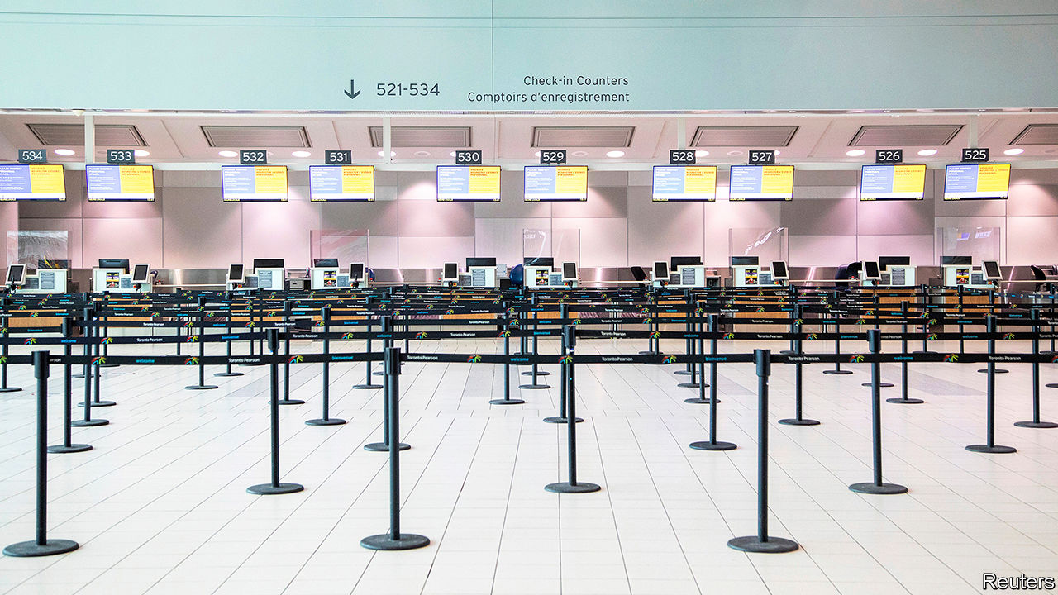

LIKE MOST international jamborees these days the Farnborough air show wrapped up on July 24th as a virtual event. Webinars featuring grim-faced executives were not as entertaining as noisy acrobatic displays by fighter jets. But commercial aviation’s most important showcase at least marked a point when heads began to turn away from the devastation wrought by covid-19 and towards what comes next.

As airlines sell fewer tickets, owing to pandemic travel restrictions or travellers’ fear of infection, the industry that makes flying possible faces a reckoning. Aircraft-makers will make fewer passenger jets and so need fewer parts from their suppliers. Ticket-sellers will see less custom and airport operators, lower footfall. Many firms have cut output and laid off thousands of workers. The question now is how far they will fall, how quickly they can recover, and what will be the long-lasting effects.

The airline-industrial complex is vast. Last year 4.5bn passengers buckled up for take-off. Over 100,000 commercial flights a day filled the skies. These journeys supported 10m jobs directly, according to the Air Transport Action Group, a trade body: 6m at airports, including staff of shops and cafés, luggage handlers, cooks of in-flight meals and the like; 2.7m airline workers; and 1.2m people in planemaking. In 2019 they helped generate revenues of $170bn for the world’s airports and $838bn for airlines. Airbus and Boeing, the duopoly atop the aircraft supply chain, had sales of $100bn between them. For the aerospace industry as a whole they were perhaps $600bn. Add travel firms like Booking Holdings, Expedia and Trip.com, and you get annual revenues of some $1.3trn in normal times for listed firms alone, supporting roughly as much in market capitalisation before covid-19—and rising.

## Taxiing times

Instead, the coronavirus has lopped $460bn from this market value (see chart 1). Airline bosses are reassessing trends in passenger numbers, which had been expected to double in the next 15 years, just as they had with metronomic regularity since 1988, despite blips after the 9/11 terrorist attacks of 2001 and the financial crisis of 2007-09. Rather than increase by 4% this year, air-transport revenues will fall by 50%, to $419bn. After ten years of unusual profitability the $100bn of total losses forecast for the next two years is equal to half the nominal net profits the industry raked in since the second world war, calculates Aviation Strategy, a consultancy. Luis Felipe de Oliveira, director-general of ACI World, which represents the world’s airports, gloomily predicts that revenues there will fall by 57% in 2020.

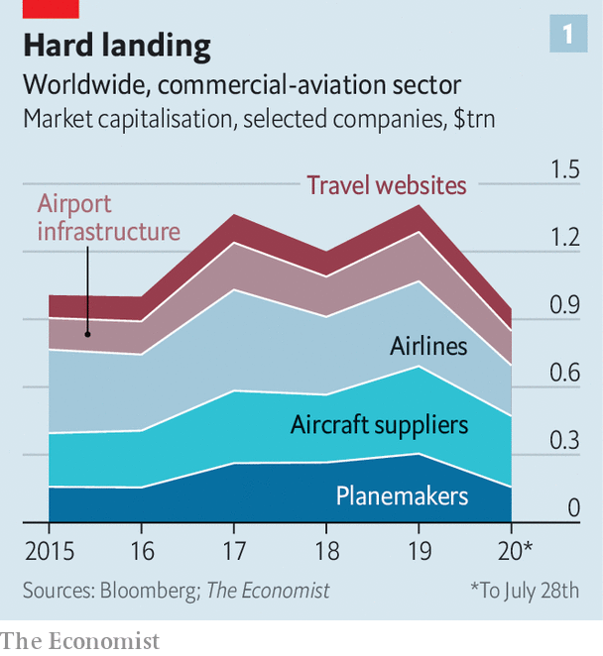

Despite signs of life, particularly on domestic routes in large markets like America, Europe and China, the outlook remains uncertain. The wide-body jets used for long-haul flights stand idle. Carriers that rely on business passengers and hub airports are struggling. Although some American airlines expect a return to near-full operation next year, a second wave of covid-19 could dash these hopes. A small outbreak in Beijing in June set back the recovery in Chinese domestic flights. As one senior aerospace executive says, “It’s hardest to talk about the next 12 months.”

According to Cirium, another consultancy, around 35% of the global fleet of around 25,000 aircraft is still parked—less than the two-thirds at the height of the crisis in April but still terrible. Even if traffic recovers to 80% of last year’s levels in 2021, as some optimists expect, plenty of aeroplanes will remain on the ground. Citigroup, a bank, forecasts excess capacity of 4,000 aircraft in 18 months’ time.

Aircraft-makers, which had been preparing to crank up production, are forced to do the opposite. Airbus, with a backlog of more than 6,100 orders for its A320 jets, was rumoured to be raising output from 60 of the popular narrow-bodies a month to 70. Instead it is making 40. Its long-haul planes have suffered similar declines. Boeing’s situation is made worse by the protracted grounding in 2019 of its 737 MAX, a rival to the A320, in the wake of two fatal crashes. It has kept making the aircraft and hopes to have it recertified for flight later this year. The American firm will slowly increase production to 31 a month by the start of 2022. But like Airbus, it too has announced cuts to wide-body production.

This will open a big gap between what the pair, along with Embraer and Bombardier, makers of smaller regional jets, hoped to sell and what they actually will (see chart 2). According to consultants at Oliver Wyman, by 2030 the global fleet will be 12% smaller than if growth had continued unabated. That amounts to 4,700 fewer planes, which could translate to $300bn or so in forgone revenue for Boeing and Airbus, according to a rough calculation by The Economist.

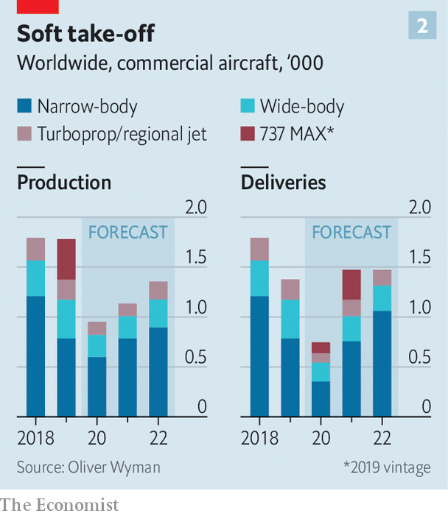

With so many aircraft sitting idle and balance-sheets in tatters, airlines are getting rid of planes. Even low fuel prices will not save older, thirstier models. Four-engine wide-bodies are all but finished. On July 17th British Airways (BA) said it would retire all 31 of its Boeing 747 jumbo jets. IBA, an aviation-research firm, expects 800 planes around the world to be retired early.

Not all orders will dry up. Airlines, as well as leasing firms, which now own close to half the global fleet, are contractually obliged to take aircraft on order. Many buyers will have made pre-delivery payments of up to 40% of the price. Airbus and Boeing are, to varying degrees, pushing customers to take deliveries. Most negotiations have centred on deferring deliveries. EasyJet, a British low-cost carrier, has pushed back delivery of 24 Airbuses by five years. At Boeing, delays related to the problems of the 737 MAX allow airlines to ask for refunds. More assertively, Airbus’s boss, Guillaume Faury, does not rule out suing customers who renege on their orders.

A stock of “white tails”, as unsold planes are known in industry vernacular, may be the price to pay for protecting a supply chain that had been investing heavily for ever-higher production rates. Airbus will make 630 planes this year but deliver only 500, Citigroup reckons. It has the balance-sheet to carry inventory, thinks Sandy Morris of Jefferies, another bank. The new rate will preserve jobs and industrial efficiency, and make an eventual ramp-up easier.

Even this artificially high production will struggle to sustain the planemakers’ supply chain, however. This comprises manufacturers of engines (like Rolls-Royce and GE), producers of fuselages and other parts (such as Spirit AeroSystems), specialised materials firms (Hexcel and Woodward) and companies that produce avionics and electrical systems (including Honeywell and Safran). And that is not counting their myriad smaller suppliers; Boeing’s MAX supply chain stretches to around 600 firms. Many had invested heavily before the crisis, expecting strong demand. Defence contracts, which firms from Airbus and Boeing down are involved in and which covid-19 has not really affected, provide only partial respite. On July 29th Boeing said it had delivered just 20 planes in the second quarter, down from 90 a year ago, and that commercial-aircraft revenues had dropped by 65%, to $1.6bn. The next day Airbus and Safran also disclosed sharp falls in revenue.

The engine-makers provide a case in point. Besides lower demand for their kit—Rolls-Royce was gearing up to supply 500 units a year to Airbus but will now probably make 250—they face a collapsing aftermarket for spares and fewer overhauls, points out David Stewart of Oliver Wyman. Airlines with in-house maintenance divisions can scavenge parts or whole engines from grounded planes. Rolls-Royce, whose engines power two-fifths of all long-haul jets, has suspended dividends, said it would cut 9,000 jobs and taken a £2bn ($2.6bn) loan. It may have to ask investors for another £2bn. GE’s second-quarter revenues from its aviation business fell by 44%, year on year, dragging down the conglomerate’s overall results (see article).

At the other end of the air-travel industry are airports. About 60% of their revenues comes from charges on airlines and passengers, and the rest from things like retail and parking. All are taking a hit. Airport shops and restaurants in America will lose $3.4bn between now and the end of 2021, forecasts the Airport Restaurant & Retail Association. As Mr de Oliveira of ACI World notes, two in three airports were losing money before the crisis; now all are. Some smaller ones may close if subsidies to support tourism from regional and national governments start to dwindle. Outside America commercial operators have not been treated by governments as generously as airlines have.

In July Standard & Poor’s again downgraded the debt of four European airports, including Amsterdam’s Schiphol and Zurich, and placed London Gatwick and Rome on watch, questioning their ability to raise charges while airlines continue to bleed cash. The rating agency estimates a cut of €10bn ($11.8bn) in planned capital spending by European airports in 2020-23, which may crimp efforts to install contactless technology that could help reassure travellers that terminals are safe to re-enter.

As dark as the skies have grown for the air-travel complex, there are some opportunities. Airlines are restructuring. Europe’s big legacy carriers, under pressure from low-cost rivals, are slashing costs. BA has suspended 30,000 workers and wants to rehire them on less generous terms. Bankruptcies and cutbacks will leave gaps in the market, aircraft are cheap, once-scarce pilots are plentiful, and airports will have spare slots, if they are allowed to redistribute them.

Strong challenger carriers have a chance to gain market share. Wizz Air, a Hungarian low-cost carrier, hopes to add capacity by March; its main markets in central and eastern Europe have been hurt less by the pandemic than those elsewhere, its customers are generally young and less worried about getting on a plane, and two-thirds of demand is related to visiting family and friends, which seems more resilient to covid-19 than business travel is.

Some carriers may radically rethink their financial structures, which could help leasing grow even faster. Domhnal Slattery, boss of Avolon, a big lessor, thinks that heavy debts airlines incur to survive the pandemic may convince many of them that they need not own aircraft but should instead concentrate on sales and marketing, just as hotel chains have turned their backs on owning property.

The industry is also rethinking its environmental footprint. Bolder airlines with stronger balance-sheets may use the crisis to renew their fleets, making them greener. They have bargaining power: everything is negotiable, including deferrals, prepayments and price.

## Rolling with the punches

Warren East, boss of Rolls-Royce, suspects that the “pre-covid call for sustainability will come back stronger than ever”. Airbus is still committed to the journey to zero-emissions flying, Mr Faury says; he sees it as an opportunity. Boeing would have to respond to stay competitive. European governments in particular regard it as a priority. France’s €15bn aid package for its aerospace sector includes a €1.5bn research-and-development fund to help Airbus launch a zero-emissions short-haul passenger jet by 2035 (probably powered by either biofuels or hydrogen). Mr Faury accepts that there is less money to invest. But also, he says, “more need”. The crisis has led to greater collaboration with suppliers that could make innovation “faster, leaner and cheaper” (though that has meant laying off 15,000 workers).

China, desperate to become a power in commercial aerospace, may see the disruption as a way to speed up entry into the global market, says Robert Spingarn of Credit Suisse, a bank. He speculates that Brazil’s Embraer, whose merger with Boeing fell apart in April, might collaborate with China’s COMAC to build a plane capable of competing against Airbus and Boeing. The Brazilians could supply the industrial knowhow and the Chinese the industrial might.

To the masked passengers on half-empty planes, boarded from ghost-town airports of shuttered shops, it may seem that the experience of flying will never be the same again. Yet aviation has bounced back before. It is likely to do so again—and may change for the better in the process. ■

Editor’s note: Some of our covid-19 coverage is free for readers of The Economist Today, our daily [newsletter](https://my.economist.com/user#newsletter). For more stories and our pandemic tracker, see our [hub](https://www.economist.com/news/2020/03/11/the-economists-coverage-of-the-coronavirus)

This article was downloaded by calibre from <https://www.economist.com/business/2020/08/01/air-travels-sudden-collapse-will-reshape-a-trillion-dollar-industry>

|  |  |  |  |
| --- | --- | --- | --- |
|  | Articles | Sections | Next |

|  |  |  |  |
| --- | --- | --- | --- |
| Previous | Articles | Sections | Next |

#### Bartleby

# Employees and employers both face trade-offs as offices reopen

Back on the chain gang

Aug 1st 2020 |

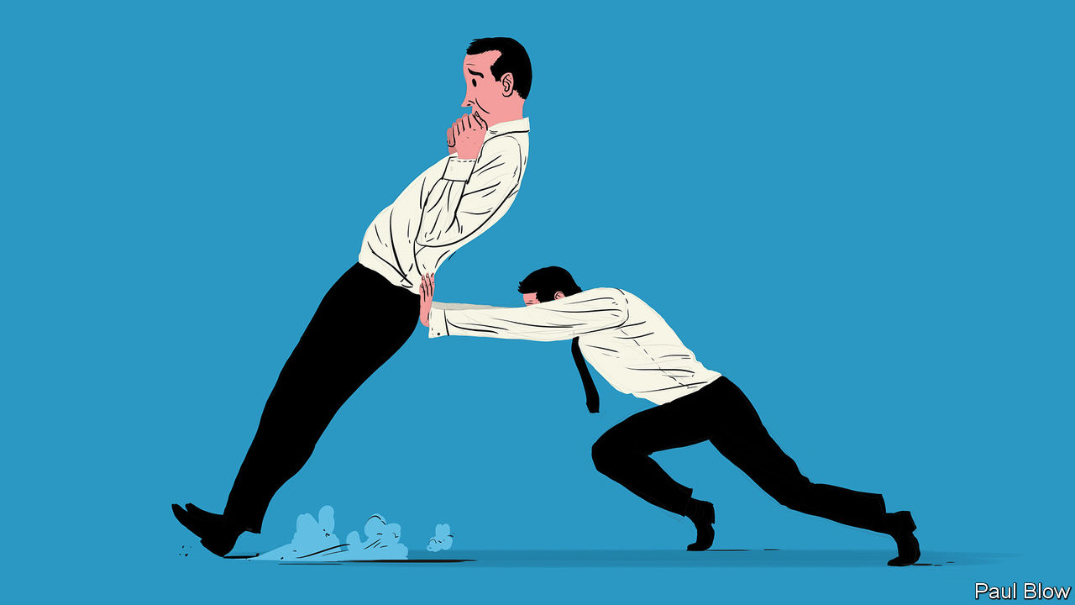

REMEMBER THE 7am alarm? The rushed goodbye with spouse and children as you dash out of the house? The nervous patting of pockets to check for keys, season ticket, security pass and phone? And the clogged traffic or crowded train carriage?

Most office workers have escaped those familiar rituals for the past four months. But offices are slowly reopening again. And governments are keen to lure workers into the cities, where they can spend their money and help to revive battered economies.

A group of academics led by Ethan Bernstein of Harvard Business School has been surveying American workers during the crisis*. It found that many felt they could be just as productive at home as they had been at the office. In terms of job satisfaction, a small wobble in the first few weeks of lockdown eased as workers adjusted to new routines. But once that adjustment was made, satisfaction increased. Stress levels have fallen by more than 10%. That despite the fact that workers toil for longer: an analysis of one technology company showed that working hours have increased by 10-20% during the pandemic.

That contrasts with less positive results of previous case studies of home-working. Mr Bernstein and his colleagues suggest that the main difference this time is that all employees have been forced into the same situation. In the past, those who worked at home were in the minority, often felt excluded from the group, and so were less likely to identify with the company.

If they were right, then this problem may reassert itself when office work resumes. At the moment, those who have returned to the office are in a minority, comprising those who find it most difficult to work at home. But the balance may shift as time goes on, perhaps because people become more relaxed about the virus, or because people will miss the fellowship of their colleagues. At that point those who remain at home may start to feel isolated.

The emotion that is most likely to lure workers back to the office is paranoia. The pandemic may have caused managers to realise who is indispensable and who isn’t. Bartleby realises he is entirely dispensable: an amuse bouche between the meaty stuff of structural reform and vaccines. Fail to amuse enough bouches and he will be shuffled into retirement. Millions may reason the same way. When the number of those back at work reaches a critical mass, the rest may be obliged to follow suit.

The trade-off for employers is rather different. Most companies will be thinking about whether they need all that expensive office space. If they do want to lure back their employees, they may have to spend a lot on contactless, socially distant office design to keep their workers safe, such as doors that open automatically.

Some firms may be worried about security. On July 27th a British standard-setting board issued guidance for financial firms about the security risks of fixed-income and currency traders working at home. Other companies may worry about the long-term impact of home working on productivity. One missing element may be the casual interaction that occurs between employees outside formal meetings—those chats by the fridge may spark ideas or suggest new ways of co-operating. Indeed, employees may find it more difficult to build relationships throughout the company without meeting colleagues in person.

This will be particularly difficult for new employees. It is not always easy even for those who have been doing their job for a while to perform the same tasks at home. And newcomers must adjust to a firm’s culture, which usually happens by picking up subtle cues from the people around them. Companies may bombard them with training modules and video chats—“onboarding”, in the jargon of human-resources departments. But that may be no more useful than reading a manual as your only preparation for trying to ride the winning horse in the Kentucky Derby.

Given the state of the global economy it will take time before most companies hire a lot more employees or lower employee interaction weighs on corporate performance. With many employees happy to work from home, that may mean no great rush to repopulate the office. You may not have to resume your morning routine until 2021.

* “The implications of working without an office” by Ethan Bernstein, Hayley Blunden, Andrew Brodsky, Wonbin Sohn and Ben Waber, Harvard Business Review, June 2020

Editor’s note: Some of our covid-19 coverage is free for readers of The Economist Today, our daily [newsletter](https://my.economist.com/user#newsletter). For more stories and our pandemic tracker, see our [hub](https://www.economist.com/news/2020/03/11/the-economists-coverage-of-the-coronavirus)

This article was downloaded by calibre from <https://www.economist.com/business/2020/08/01/employees-and-employers-both-face-trade-offs-as-offices-reopen>

|  |  |  |  |
| --- | --- | --- | --- |
| Previous | Articles | Sections | Next |

|  |  |  |  |
| --- | --- | --- | --- |
| Previous | Articles | Sections | Next |

#### Electric shock

# The pandemic is giving e-bikes a boost

Two wheels good. Two wheels plus a motor better

Aug 1st 2020 |

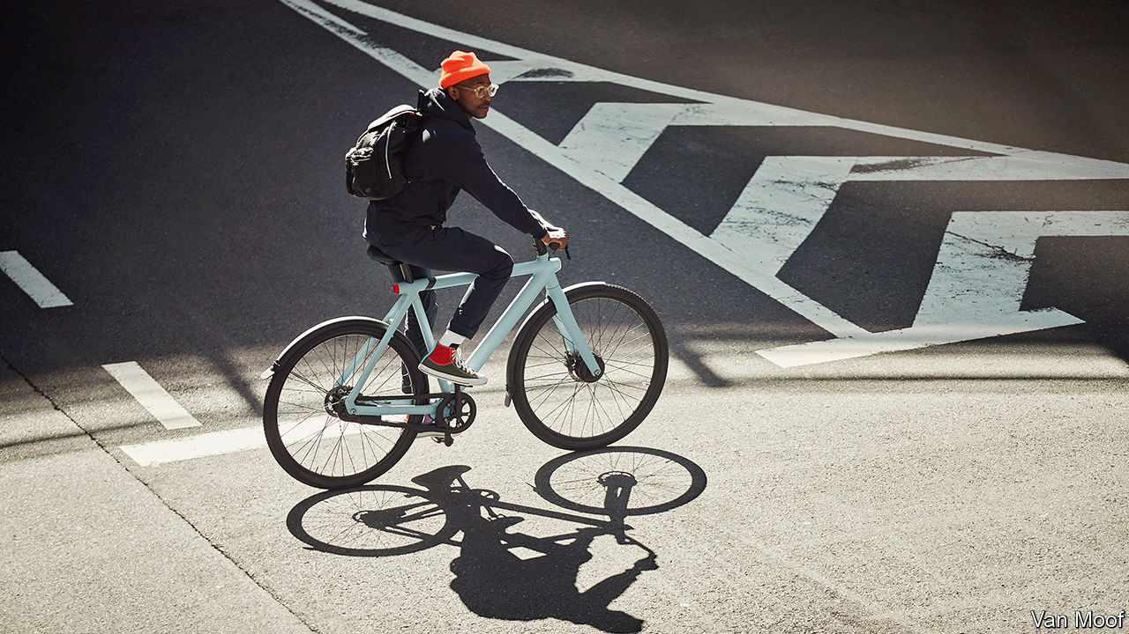

VANMOOF, A DUTCH bicycle-maker, is known for sleek designs and clever advertising. In a television spot for its newest model, images of the evils of car culture—accidents, gridlock and pollution—are projected onto the skin of a luxury car, which melts, turning into one of the company’s elegant e-bikes.

Electrically assisted bicycles are not about to replace cars. But they are booming, especially in Europe, where sales rose by 23% in 2019, to 3m units. E-bikes are unlocking even saturated bicycle markets like the Netherlands, where the average person already owns 1.3 pushbikes. Last year Deloitte, a consultancy, estimated the number of e-bikes worldwide at 200m, and expected it to hit 300m by 2023.

That may prove to be an underestimate now that coronavirus-wary commuters are shunning public transport and cities are expanding cycle lanes. Sales, which braked in March and April owing to supply-chain wobbles and shuttered stores, shifted into high gear when lockdowns lifted. In June revenue at Accell, Europe’s biggest bicycle manufacturer, was 53% higher than a year ago, largely thanks to e-bikes.

Big firms such as Accell and Giant of Taiwan compete with sporty brands such as America’s Cannondale and affordable city rides from QWIC. Brompton, a British maker of fancy folding bikes, has been making 10% of its £42.5m ($56m) in annual sales from the electric sort, and hopes eventually to raise that figure to 40%. VanMoof, which raised $13.5m from investors in May, bills itself as the Tesla of e-bikes. Like the electric-car maker it designs its own parts, motors and software rather than relying on off-the-shelf bits and bobs. The result is a more seamless product, boasts Taco Carlier, a Dutch engineer who co-founded VanMoof with his brother in 2009.

Demand is growing faster than manufacturers can keep up, leading to long backlogs and premium prices, which start at around $1,000. Giant says that its gross margin on e-bikes is around 25%, above its average of 21%. VanMoof’s machines go for $2,000 a pop. Mr Carlier may, however, have to rethink his firm’s marketing strategy. Though its polemic against traffic jams evokes French nouvelle vague cinema, the ad was banned in June by French authorities, for trying to “discredit the automobile sector”.

Editor’s note: Some of our covid-19 coverage is free for readers of The Economist Today, our daily [newsletter](https://my.economist.com/user#newsletter). For more stories and our pandemic tracker, see our [hub](https://www.economist.com/news/2020/03/11/the-economists-coverage-of-the-coronavirus)

This article was downloaded by calibre from <https://www.economist.com/business/2020/08/01/the-pandemic-is-giving-e-bikes-a-boost>

|  |  |  |  |
| --- | --- | --- | --- |
| Previous | Articles | Sections | Next |

|  |  |  |  |
| --- | --- | --- | --- |
| Previous | Articles | Sections | Next |

#### Wish upon a STAR

# Why China’s answer to Nasdaq is going gangbusters

Shanghai’s tech-focused STAR Market is benefiting from Sino-American tensions

Aug 1st 2020 |



TO SEE THE world of technology shift before your eyes, look at the short history of the Shanghai Stock Exchange Science and Technology Innovation Board. China’s president, Xi Jinping, unveiled plans for the new exchange, modelled on New York’s Nasdaq and known as the STAR Market, in November 2018. It was to be a freer route to capital markets for Chinese tech firms. It opened in July 2019 with 25 companies and rocketing valuations. A year later, on July 23rd, the exchange launched an index of its 50 biggest companies.

A few months ago most people had never heard of the STAR Market or its firms. The most valuable was AMEC, a low-key Chinese manufacturer of chipmaking tools with a market capitalisation of around 100bn yuan ($14bn). Other big members, which make semiconductors (Montage Technology), office software (Kingsoft) or railway electronics (China Railway Signal & Communication), were mostly anonymous to Western ears.

That all changed in July. First, Semiconductor Manufacturing International Corporation (SMIC) listed its shares on the board, raising $6.5bn from the offering. A week later Ant Group, the payments arm of Alibaba, China’s e-commerce titan, said it would also list shares there (as well as in Hong Kong). Ant may be the most valuable private company on Earth, valued at $150bn or so. That flotation alone could push the STAR Market past the Nasdaq as the world’s top venue for tech capital-raising this year. And Ant isn’t alone. Geely, a big Chinese carmaker; the fintech arm of JD.com, an online retailer; Imagination Technologies, a British chip designer with Chinese investors: all are reportedly mulling listings. The bourse already hosts 141 firms. Another 409 are in the process of registering.

The STAR Market’s most eye-popping valuations are for companies whose products are central to the Chinese government’s desire for an independent domestic semiconductor industry. Shares of SMIC and AMEC, for instance, trade at 200 and 500 times earnings. The average price-to-earnings ratio of STAR 50 firms is a juicy 71, compared with 52 for Nasdaq.

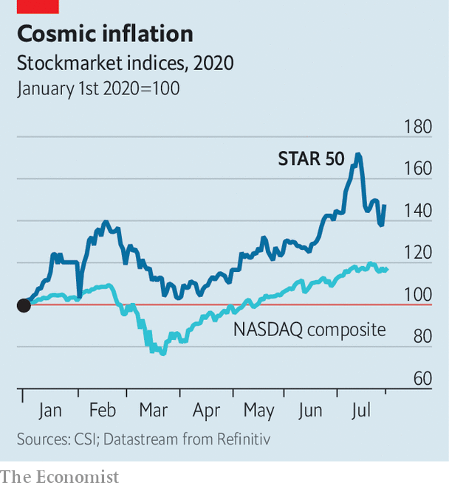

By all technical accounts that looks rich. Experts consider SMIC and AMEC to be behind cutting-edge Western rivals. So how did the STAR Market come from nowhere to become the world’s largest money pile for tech in just a year?

The short answer is the tussle for technological and economic supremacy between America and China. SMIC delisted from the New York Stock Exchange last year, ostensibly for administrative reasons—but looming American legislation that could bar Chinese companies from American exchanges may well have weighed on its decision, too. An investment in the likes of SMIC or AMEC is, in other words, a wager that Beijing’s ambition of semiconductor independence is realistic—and that the Communist Party will not allow its champions to fail, even if they could not match high-end global competition. Judging by the STAR 50 index, up by nearly 50% so far this year (see chart), plenty of investors like those odds. ■

This article was downloaded by calibre from <https://www.economist.com/business/2020/08/01/why-chinas-answer-to-nasdaq-is-going-gangbusters>

|  |  |  |  |
| --- | --- | --- | --- |
| Previous | Articles | Sections | Next |

|  |  |  |  |
| --- | --- | --- | --- |
| Previous | Articles | Sections | Next |

#### Schumpeter

# A GE whodunnit

The downfall of America’s industrial giant is a cautionary tale for all big firms

Aug 1st 2020 |

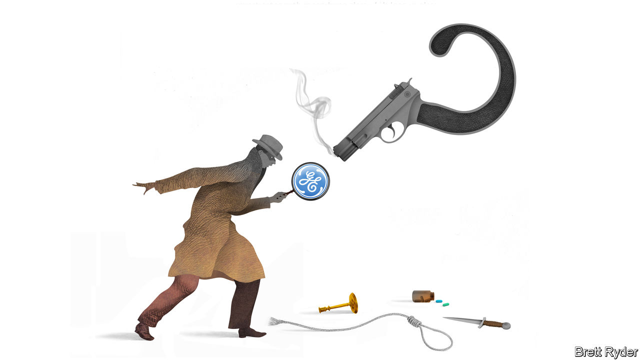

ONE OF THE most intriguing questions in business is what happened to GE, a company once so dear in America that its near-collapse in 2018 beggared belief. It still limps on, but the suspects behind a destruction of $500bn in value over little more than 20 years are so many that the mystery feels like a whodunnit.

Does blame start with the late Jack Welch, boss from 1981 to 2001, who created the myth that GE could walk on water? Does it belong to Jeff Immelt, his successor for 16 years, who continued to peddle that illusion even as the waters rose treacherously around his—and the company’s—neck? Should it be shared by his short-lived successor, John Flannery? Or Larry Culp, the current boss, who has so far been unable to turn back the tide? And do the supposed guardians of corporate America—the boards, regulators, analysts, investors and CNBC talk-show hosts, none of whom can (along with Schumpeter) resist the temptation to anthropomorphise business success and failure—also bear responsibility?

Two Wall Street Journal reporters, Thomas Gryta and Ted Mann, have written a book, “Lights Out”, that seeks to find out what went awry. It twists and turns through almost 40 years of GE’s modern history in a way that is at times as bewildering as the conglomerate itself. But the thread that runs through consistently enough to prevent motion sickness comes from a phrase Mr Flannery used shortly before taking over from Mr Immelt in 2017: “No more success theatre.” For decades GE managers had an over-exalted sense of their own abilities, which led to narcissism, hubris and the bending, if not breaking, of accounting rules to hit their profit targets. This eclipsed any strategic vision they may have had.

Welch set the tone. His tenure coincided with the dismantling of other conglomerates, such as AT&T. But he convinced investors that GE was the exception to the too-big-to-manage rule thanks to the brilliance of its executives. By slashing jobs, shutting laggard divisions and overseeing about 1,000 acquisitions, worth $130bn, over 20 years, he rejuvenated the company—and the reputation of American capitalism. Yet, as the book shows, his main contribution was building up GE Capital, the finance arm. It could borrow cheaply because of its AAA credit rating derived from GE’s industrial strength. Its success ensured that GE shares traded at a high price relative to earnings, helping Welch use stock to pay for takeovers. And it helped smooth group-wide earnings in opaque ways, which may have made it easier to hit Welch’s exacting profit targets.

GE Capital eventually came to drag the company down. Within months of Mr Immelt’s taking over in 2001, the scandal surrounding Enron, an energy giant, drew scrutiny of earnings-enhancing accounting tricks, forcing GE to show it was playing by the book. Mr Immelt failed to tame it in time for the financial crisis of 2007-09, which became a near-death experience for GE. For years afterwards, the perception of riskiness weighed on its share price, encouraging Mr Immelt to move away from financial services in order to reinvigorate the industrial heart of the company: jet engines, power turbines and health care. Yet after he launched the sale of much of GE Capital in 2015, the relief was short-lived. A disastrous $10bn acquisition of the power and grid businesses of Alstom, a French competitor, the same year would become Mr Immelt’s biggest mistake. Problems in GE’s power business have dogged the company since. They contributed to the huge cash crunch that culminated in Mr Flannery’s dethronement in October 2018, a mere 14 months after he became boss.

The book puts most of the blame for GE’s woes on Mr Immelt, a salesman who appeared to treat it more as a company to sell to investors than a maker of products to sell to the world. He used Botox-like gimmicks, produced by his biker-jacket-clad marketing sidekick, Beth Comstock, to persuade markets that GE was no hoary industrialist but a digital innovator. But he came up with little that was fresh or exciting. He wasted money on dinosaur industries like oil and gas. He gave away cash via share buy-backs. And he betrayed hints of pharaonic delusion: when he travelled on business, his retinue reportedly sometimes included not one but two company jets.

Still, blaming one man, or even several men, for the collapse of an empire as closely watched as GE is a bit glib. It is, using Tolstoy’s conceit in “War and Peace”, like attributing the fall of Moscow only to Napoleon and Alexander. Bigger factors were at play.

Start with size. Almost every boss wants to run a bigger company. Investors often applaud size for its own sake. But the more complicated a business becomes, the greater the information gap between managers and markets. That makes it easier to disguise what is really going on. Next is America’s cult of the chairman-chief executive. When both roles are held by one man (they are mostly men), underlings and boards find it harder to challenge big decisions, even when potentially ruinous.

A third common problem is stockmarket mythmaking. Ms Comstock’s approach to digging GE out of a hole was to, as she put it, “pick a simple story…and tell it again, and again”. Analysts, business editors, even the occasional columnist, fall for this far too often. In GE’s case, this included articles with titles likening the company to a whizzy startup. Better to have kept a closer eye on its old-economy power division, the company’s real Achilles heel.

## Mr Immelt, with the turbine blade, in the private jet

Ultimately, firms are never fully in charge of their own destinies. The internet, the rise of China, the financial crisis and greener energy all played a role in GE’s downfall. Second-quarter results on July 29th revealed that covid-19 has halted Mr Culp’s rescue mission, hurting GE’s most profitable industrial businesses, especially aviation. As businesses age, events will inevitably wear them down. To forestall that, companies have few better options than to perfect what they are good at and embrace the simple life—even if this makes for less suspense. ■

This article was downloaded by calibre from <https://www.economist.com/business/2020/08/01/a-ge-whodunnit>

|  |  |  |  |
| --- | --- | --- | --- |
| Previous | Articles | Sections | Next |

|  |  |  |
| --- | --- | --- |
| Business | Sections | Science & ... |

Finance & economics

Emerging markets: A sigh of relief, a gasp for breath

.

India’s banks: Delayed reaction

.

Buttonwood: The SPAC hack

.

Bridgewater: Troubled waters

.

The dollar dips: The price of gold surges to an all-time high

.

The European Union: Filling the coffers

.

Emmanuel Farhi: A lost asset

.

Free exchange: The Replacements

.

|  |  |  |
| --- | --- | --- |
| Business | Sections | Science & ... |

|  |  |  |  |
| --- | --- | --- | --- |
|  | Articles | Sections | Next |

#### A sigh of relief, a gasp of breath

# In emerging markets, short-term panic gives way to long-term worry

Emergency measures have helped keep economies alive, but could have nasty side-effects in the long term

Aug 1st 2020 |

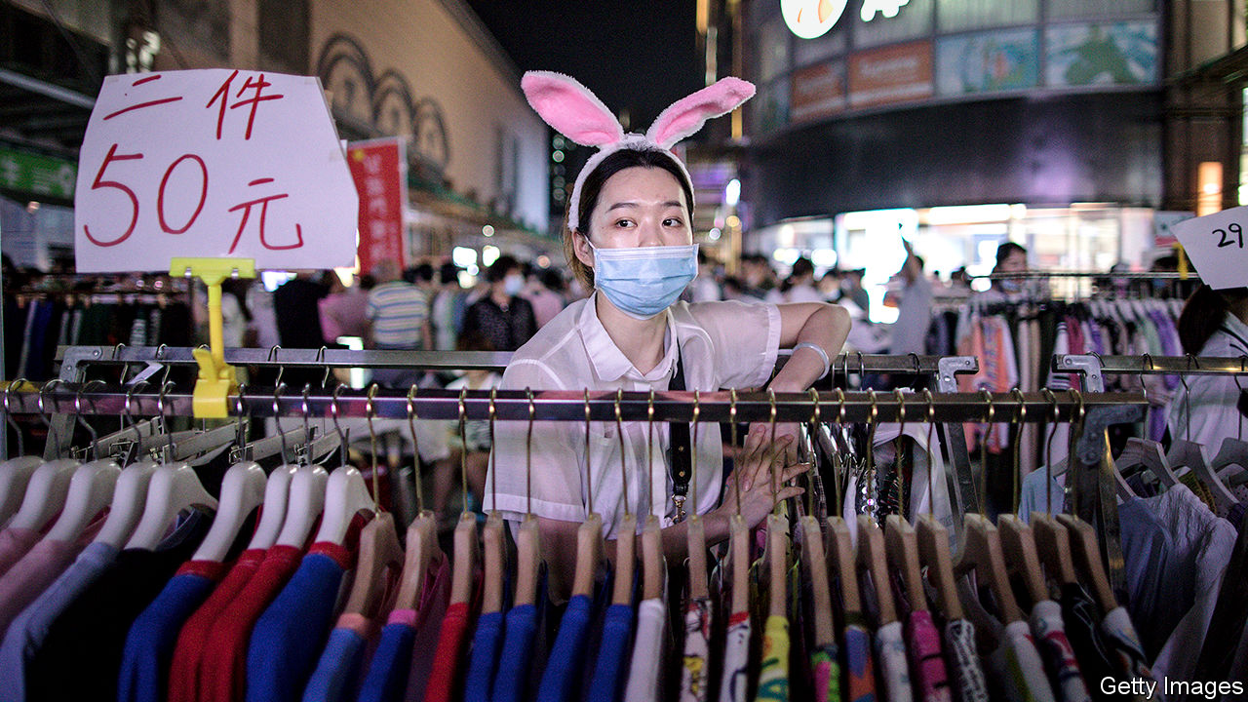

FATIGUE. SHORTNESS of breath. Frayed nerves. Lungs mottled by scars. Months have passed since early survivors of covid-19 recovered from the disease. But some still report lingering after-effects. The disease, it seems, can inflict lasting damage, even in cases that did not prove critical. The same may be true of the pandemic’s impact on economies, especially in the developing world. Some acute dangers seem to be receding. But chronic problems loom. What does not kill these economies may still leave them weaker.

A few months ago the coronavirus shock looked financially lethal. But emerging-market bonds, currencies, and shares have rallied strongly since plumbing dramatic depths in March (see chart), thanks to a determined effort by the Federal Reserve, America’s central bank, to allay financial stress at home by relieving a shortage of dollars worldwide.

In China, the biggest emerging economy of all, the revival of activity has been remarkable. Its GDP somehow grew by 11.5% in the second quarter, compared with the first, an annual pace of 59%, according to UBS, a bank. That left it 3.2% higher than in the prelapsarian era of April-June 2019. Capital Economics, a consultancy, now expects that by the end of this year China’s output will have caught up to where it would have been without the pandemic.

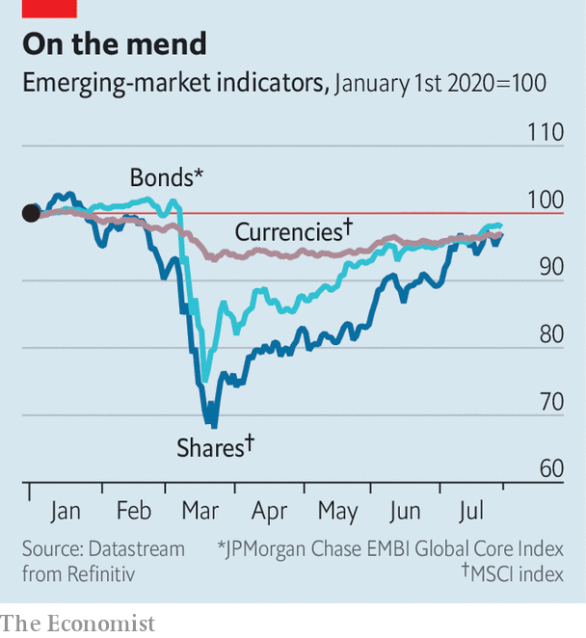

China’s growth has helped lift commodity prices, benefiting the roughly two-thirds of developing countries that export oil, metals and other primary products. The dollar value of Indonesia’s goods exports in June was 2.3% above that of a year earlier, defying expectations of a 12.3% fall. Other big emerging economies have also reported pockets of resilience or piecemeal recovery. In Mexico remittances were over 3% higher in May than a year earlier, perhaps because its emigrants took the opportunity to send money home while the peso was cheap. India in May and June regained over 90m of the 114m jobs lost in April, according to the Centre for Monitoring Indian Economy, a research firm.

Two big concerns remain, however. The long-term worry is that the virus leaves behind economic scars even after it departs. The more immediate concern is that it has yet to depart. Indeed, the surprisingly strong response to the easing of lockdowns (dubbed “revenge consumption”) in some countries may have contributed to an uptick in infections in parts of China and Vietnam (as well as richer economies like Australia and Japan) that had successfully contained the virus. And the resumption of ordinary life has no doubt contributed to the continued strong growth in infections in India and much of Latin America. The “recovery is unlikely to be a smooth process”, note analysts at Capital Economics.

Nor is it likely to be complete. Past epidemics have left a permanent mark. Three years after SARS, MERS, Ebola and Zika, investment was 9% lower in stricken economies, on average, compared with the unstricken, according to the World Bank. Output per worker was almost 4% lower. The lasting damage from covid-19 is likely to be far worse.

The pandemic has, for example, interrupted the education of many of the developing world’s youngsters. Those aged between five and 19 constitute a bigger share of the population in poor countries than in rich ones (26% versus 17%) and therefore a more significant share of the future workforce. The hiatus in their schooling is also more likely to become permanent. People cannot afford to remain on the “sidelines” in poor countries, points out Ayhan Kose of the World Bank. Youngsters feel a “bigger push” to get a part-time job, which can easily end up severing their ties to school.

Human capital is not the only kind that will suffer. When growth prospects are weak and uncertain, entrepreneurs are unlikely to invest in new premises, ideas or machinery, even if they can raise the finance to do so. According to the bank, governments in 58 developing countries have offered credit guarantees of various kinds to encourage lending. But banks remain risk-averse, says Bhanu Baweja of UBS.

The pandemic has also disrupted trade, which was already unsettled by tensions between America and China. For emerging economies, trade and foreign investment are sources of both hard currency and know-how. Firms learn about the world by selling to it; countries learn by hosting firms from elsewhere. By damaging global supply chains and denting international collaboration, “the pandemic could alter the very structures upon which the growth of recent decades was built”, warn Mr Kose and his co-authors in the bank’s latest “Global Economic Prospects” report.

If that is true, some industries in emerging economies will need reinvention. But contrary to folk wisdom, a crisis is not a good time for such a makeover. Research by Lucia Foster and Cheryl Grim of America’s Census Bureau and John Haltiwanger of the University of Maryland found that the reallocation of workers across firms slowed in America during its last recession. The crisis winnowed out productive firms as well as weaker rivals. Job destruction increased. But job creation fell just as much. In better times, workers can leave sunset industries for promising, sunrise sectors. But in a crisis, ousted workers simply get lost in the gloaming.

To their credit, policymakers in emerging economies have tried to keep banks and firms intact. In March central banks in 42 developing countries cut interest rates, according to the World Bank, far more than in any month in 2008. Many have also become more ecumenical lenders of last resort. India’s central bank, for example, is helping to shore up shadow banks.

A number of central banks have also bought sovereign bonds, helping governments provide as much stimulus as they dare (see chart). During the global financial crisis, recalls Mr Kose, some policymakers would say: “Maybe we shouldn’t do this, or we shouldn’t do that.” Those conversations have not happened this time.

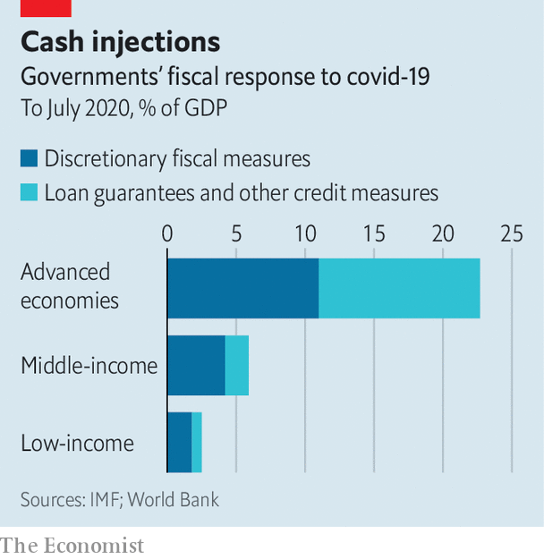

On top of fiscal stimulus, financial regulators have become more forgiving. They have eased prudential limits on banks and allowed lenders to indulge in creative accounting, turning a blind eye to souring loans. In Russia, financial institutions can value the securities they hold at prices on March 1st. India introduced a moratorium on loan payments (see next story).

In some cases these macro-imprudential measures have interrupted reforms going in the other direction. China’s credit push reverses several years of attempted deleveraging. In the Philippines, an amendment to the central bank’s charter had strengthened its financial independence from the finance ministry. Now the central bank is busy buying its bonds.

Measures of this kind were necessary. But they may prove tricky to undo. Governments will have to arrest the increase in their debt without jeopardising the recovery. And regulators will eventually have to allow some loans to be written off and some firms to go bust, if new industries are to enjoy room to grow.

One reason why covid-19 inflicts lasting harm on those infected is the aggressive immune reaction it can trigger. This “cytokine storm” may help kill the disease. But it can also endanger the patient. Policymakers in developing countries must take care to prevent something similar happening to their economies. They have responded with justifiable aggression to the pandemic. If left unchecked, however, this storm of defensive measures could have some nasty side-effects of its own. ■

Editor’s note: Some of our covid-19 coverage is free for readers of The Economist Today, our daily [newsletter](https://my.economist.com/user#newsletter). For more stories and our pandemic tracker, see our [hub](https://www.economist.com/news/2020/03/11/the-economists-coverage-of-the-coronavirus)

This article was downloaded by calibre from <https://www.economist.com/finance-and-economics/2020/08/01/in-emerging-markets-short-term-panic-gives-way-to-long-term-worry>

|  |  |  |  |
| --- | --- | --- | --- |
|  | Articles | Sections | Next |

|  |  |  |  |
| --- | --- | --- | --- |
| Previous | Articles | Sections | Next |

#### Pain deferred

# Has India’s moratorium on loan payments delayed the pain for banks?

It has shielded borrowers; but some banks may struggle once defaults are realised

Aug 1st 2020 |

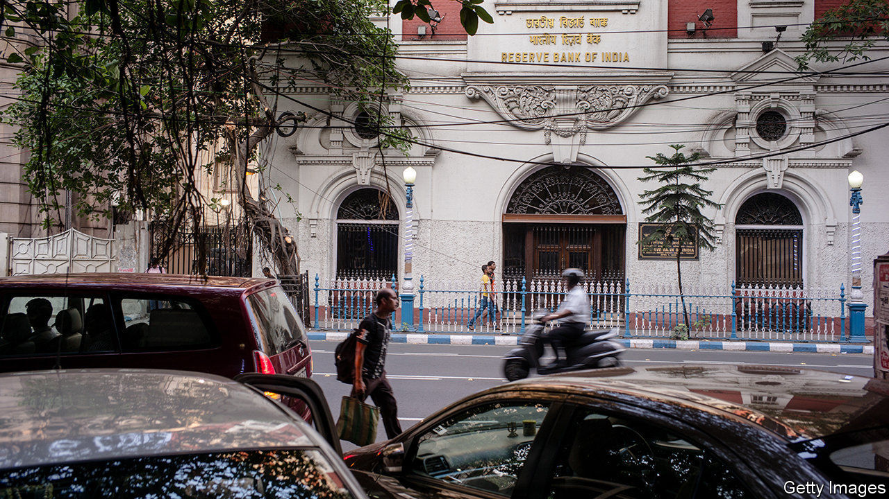

SOON AFTER India went into a strict lockdown in March, its central bank allowed borrowers to put off loan repayments for three months. That moratorium has since been extended by a further three months, and another extension is reportedly being considered. It appears to have been a boon to borrowers. But top financiers, such as Deepak Parekh, the chairman of HDFC, a big mortgage lender, and Uday Kotak, the chief executive of Kotak Mahindra Bank, are beginning to worry that it is damaging the financial system. They are urging the Reserve Bank of India (RBI), the central bank, to change course.

The moratorium was intended to prevent the cash crunch induced by lockdowns translating into a more lasting shock, by allowing revenue-starved companies time to pay back their debts. India has not been alone in using payment holidays, though those in other countries have tended to be more limited in duration and scope. But India’s government is less able than those in the rich world to afford other ways of supporting borrowers, such as generous cash handouts.

Huge numbers of borrowers have availed themselves of the payment holiday. In its financial-stability report, published on July 24th, the RBI noted that half of all loans went unpaid in April. Fully two-thirds of loans made by publicly controlled banks, which hold 70% of the industry’s assets, were unpaid. A smaller yet sizeable chunk of lending went unpaid at private banks, from a third of total loans at domestic lenders to a tenth at foreign ones.

One reason for the disparity between private and public lenders is that different banks attract different sorts of borrowers. Small and medium-sized firms, which rely on state-run lenders, were keen users of the moratorium. These are unlikely to have huge cash buffers; as revenues dried up they may have had little recourse but to defer loan payments. By contrast, foreign banks mainly serve multinational companies with deeper pockets. Some banks asked borrowers to opt in to the scheme. Others at first employed a more generous “opt-out” approach, though they have since changed tack.

Banks’ earnings reports for the second quarter, released over the past two weeks, suggest that the take-up of the schemes may well have reflected the exigencies of lockdown. Axis Bank and ICICI, large private lenders, reported that loans held under moratorium had fallen from 30% in April to under 20% in June; Kotak Mahindra reported a fall from 26% to 10%. State-owned banks are only beginning to release their earnings, but their use of the moratorium seems likely to have fallen too.

Analysts are now asking whether loans and interest obligations will be fully repaid once the moratorium ends. The RBI predicts that non-performing assets, as a share of the total, could rise from 8.5% in March to 12.5% in 2021. It reckons this could exceed 16% for public-sector banks in a “severely stressed” scenario, which would surely push some banks’ capital ratios below regulatory requirements. Shaktikanta Das, the RBI’s governor, urged banks to “proactively augment” capital now, rather than waiting for shortfalls to be revealed later. On July 27th Fitch, a rating agency, was blunter, warning that “state banks face solvency risk without fresh capital injections”.

How much capital is needed is unclear, given the uncertainty over loan losses. In April Prakhar Sharma, an analyst at Jefferies, an investment bank, put the fresh capital needed by the public banks at 889bn rupees ($12bn) and at half that for the private lenders. Some banks are beginning to prepare themselves: Kotak Mahindra raised nearly $1bn in May; ICICI plans to seek a similar amount, as does the State Bank of India, the country’s largest lender. But many of India’s weaker banks, saddled with legacy problems and uncertain loan losses, are likely to attract scant interest from investors. Much of the RBI’s early response to the pandemic involved protecting borrowers. It may yet find itself being forced to step in to save some lenders. ■

Editor’s note: Some of our covid-19 coverage is free for readers of The Economist Today, our daily [newsletter](https://my.economist.com/user#newsletter). For more stories and our pandemic tracker, see our [hub](https://www.economist.com/news/2020/03/11/the-economists-coverage-of-the-coronavirus)

This article was downloaded by calibre from <https://www.economist.com/finance-and-economics/2020/08/01/has-indias-moratorium-on-loan-payments-delayed-the-pain-for-banks>

|  |  |  |  |
| --- | --- | --- | --- |
| Previous | Articles | Sections | Next |

|  |  |  |  |
| --- | --- | --- | --- |
| Previous | Articles | Sections | Next |

#### Buttonwood

# The SPAC hack

The latest twist in the power struggle between Silicon Valley and Wall Street

Aug 1st 2020 |

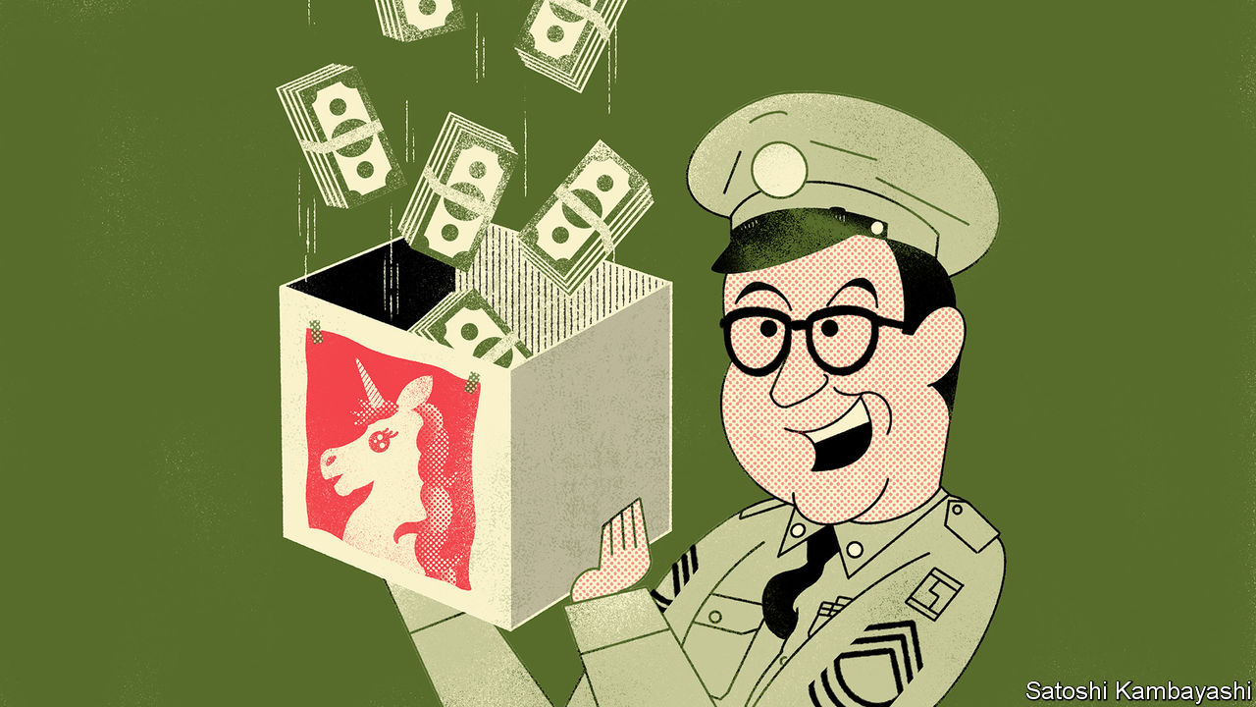

IN AN EPISODE of “The Phil Silvers Show”, a 1950s TV comedy, Ernie Bilko (played by Silvers) discovers that his fellow army sergeants have fleeced a new recruit in a poker game. His plan to get the money back involves leasing a shop. “It’s just an empty store,” he insists. The others fear they are missing out. “When the smartest operator in the whole United States army suddenly decides to rent a store, we don’t ask no questions,” says one. “We just want to be cut in.”

An empty vessel can accommodate all manner of dreams. This trait helps explain the growing allure of the “special purpose acquisition company” (SPAC), a shell company listed on the stock exchange with a view to merging it with a real business. Ventures such as Virgin Galactic, in space tourism, and Nikola, in electric vehicles, have become listed companies by this route. Silicon Valley’s dream factory spies a way to sidestep the trials of an initial public offering (IPO). Bill Ackman, a shrewd hedge-fund manager, has just raised a $4bn mega-SPAC. He is looking for a unicorn to make a home in his empty store.

The view in Silicon Valley is that an IPO is a rotten process. There is typically a fixed fee, of up to 7% of the sum raised. And the value of the company is lowballed, say tech types, to allow for a satisfying first-day “pop” in the share price. Yet cost is not the only bugbear—and, perhaps, not even the main one. What entrepreneurs and their venture-capital backers hate about the IPO is the loss of control. They are used to being big shots in Silicon Valley. They do not like deferring to Wall Street types at all.

An IPO is meant to be a young company’s coming of age. It can be more like a funeral: a distressing ordeal that leaves you at the mercy of those you put in charge of it. The problem lies with an asymmetry. For the firm going public, the IPO is a one-off. But not for the underwriting banks. They have a relationship with the people buying shares. It is natural for them to favour repeat customers. The bankers run the roadshow to build a book for the IPO. They control the allocation of shares. And crucially, they set the price. If the IPO goes well, the banks retain the right to issue more stock to “stabilise” the market—a valuable option, known as a greenshoe. This, complains a Silicon Valley bigwig, is a “rapacious practice”.

Enter the SPAC, which is a sort of pre-cooked IPO. A shell company is set up by a sponsor. The SPAC is listed on the stock exchange via an IPO. The sponsor then finds a private business for the SPAC to acquire with the proceeds. Typically this will be a late-stage (ie, fairly mature) private company, whose owners and venture-capital backers are looking to cash out. The private company merges with the SPAC, following a shareholder vote. It is then a public company.

You can see the appeal for Silicon Valley. There is no roadshow, no ploughing through the same slide-deck ten times a day for a fortnight. It all takes much less time. That is handy in the present circumstances, when venture-capital firms need to get cash-burning unicorns off the books. Because this is a merger, and not an IPO, the selling firm can disclose more information to the buyer, including financial projections. The price is negotiated directly with the buyer—and after the money has been raised, not before. And it is all but certain, rather than at the mercy of the changing moods in the stockmarket, or a last-minute discount imposed by the bankers to sweeten the deal for favoured clients.

There is a downside, of course. Fees are unavoidable. Sponsors are typically paid with a 20% stake in the SPAC. This is in essence an indirect charge on the acquired firm. It is not obviously cheaper than an IPO. In principle the sponsor can dilute his effective “fee” by, for instance, co-ordinating another round of capital-raising from private-equity or hedge funds at the time of the merger. A few sponsors might inspire a halo effect, increasing the share price just by association. Investors will not question a really big name; they just want to be cut in. And the 20% fee is not set in stone. Mr Ackman, for instance, is taking a much smaller cut and making it conditional on reaching performance targets.

Trustworthy sponsors will keep their own capital tied to the venture. But Bilko is not to be trusted, of course—where would the comedy be in that? His three rival sergeants realise too late that he has sold each of them a one-third stake in a worthless venture. “Don’t you own a piece of it?” asks one in a panic. “Me? I’m in the army,” replies Bilko. “What would I want with an empty store?”

This article was downloaded by calibre from <https://www.economist.com/finance-and-economics/2020/08/01/the-spac-hack>

|  |  |  |  |
| --- | --- | --- | --- |
| Previous | Articles | Sections | Next |

|  |  |  |  |
| --- | --- | --- | --- |
| Previous | Articles | Sections | Next |

#### Troubled waters

# Bridgewater faces losses and a lawsuit

The most successful hedge-fund firm of all time hits a rough patch

Aug 1st 2020 | NEW YORK

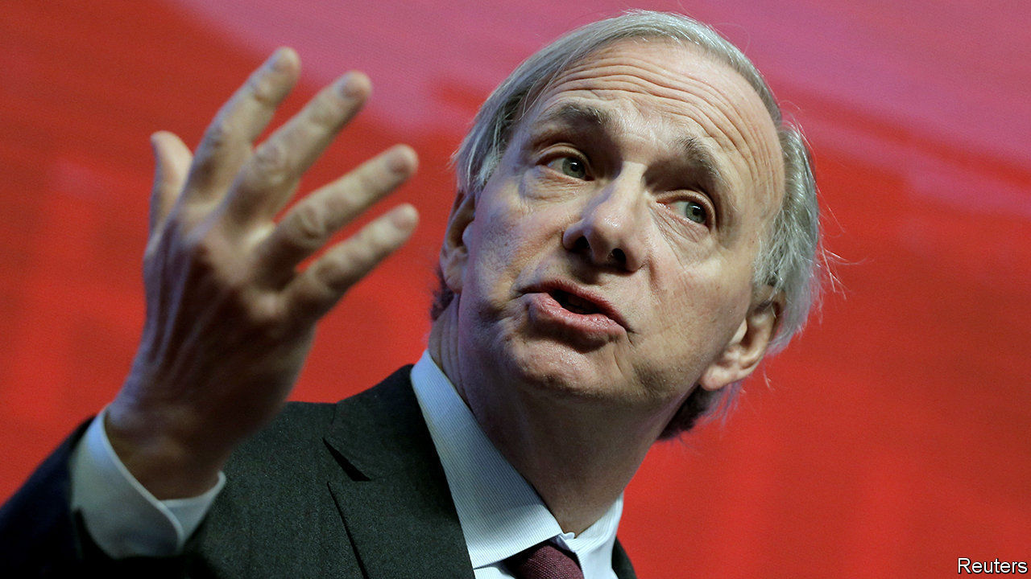

“WE’VE MADE more money for our clients than any other hedge fund in existence,” declared Ray Dalio, the founder of Bridgewater Associates, the world’s largest hedge-fund manager, in 2017. In early 2020 Bridgewater was head and shoulders above the rest, having made $58.5bn, net of fees, for its clients since the firm’s inception in 1975. Mr Dalio is worth $17bn, making him one of the richest people in the world. He stepped back from running the firm in 2017, but it has been shaped by his deep economic analysis, and his unorthodox management style, which he calls “radical transparency”.

In recent months, though, Bridgewater’s performance has suffered, and questions have been raised about how transparent its management really is. Start with its performance, which has struggled during the pandemic. The firm has two main types of funds: “pure alpha”, which makes active bets based on its predictions for the economy, and “all weather”, where holdings of stocks and bonds are based on their underlying volatility. The latter strategy lost around 7% in the first quarter. The pure-alpha funds fared even worse. In mid-March Mr Dalio said they were down between 7% and 21% since the start of the year. According to reports, they subsequently recovered a bit, with losses pared by June, but were still significantly down on the year.

That is in contrast to the performance of many other “macro” hedge funds. According to Preqin, a data provider, these made small positive returns, of 1.4% on average, in the first half of the year.

As a result of its losses, and investors pulling their money out of its funds, Bridgewater’s assets under management have fallen—from $163bn at the end of February to $138bn at the end of April.

The all-weather funds have low, fixed management costs and no performance fees. So it is the performance of pure alpha that largely determines Bridgewater’s overall financial health. That might explain why the firm is retrenching. Even as many businesses have laid off workers during the pandemic, few hedge funds are thought to have done so. But on July 24th the Wall Street Journal reported that Bridgewater had shed several dozen employees across its research, client-services and recruitment teams, out of a reported headcount of around 1,500 employees. Most of its incoming graduate investment analysts have had their start dates pushed back a year.

Bridgewater has also become engaged in a public spat with its former co-chief executive, Eileen Murray, who left in March. She has since alleged that the firm discriminated against her and claims it offered her a smaller exit package than those offered to male peers. In response, the firm is seeking to withhold deferred compensation, worth between $20m and $100m, from Ms Murray. It claims that, by speaking publicly about her allegations, she may have violated the confidentiality terms of her contract. On July 24th Ms Murray filed a lawsuit in Connecticut saying that she had followed, and would continue to respect, the rules on the disclosure of the firm’s confidential information and trade secrets. In court documents she claimed that the firm was using a “bad faith assertion” to avoid paying her deferred compensation, “as part of a cynical plan to intimidate and silence” her.

Even hedge funds with clever managers and successful long-term strategies stumble occasionally. Many stage a speedy recovery. As the number of covid-19 cases in America rises, the economy continues to wobble and the spat with Ms Murray escalates, though, Bridgewater’s troubles may continue to mount. ■

This article was downloaded by calibre from <https://www.economist.com/finance-and-economics/2020/08/01/bridgewater-faces-losses-and-a-lawsuit>

|  |  |  |  |
| --- | --- | --- | --- |
| Previous | Articles | Sections | Next |

|  |  |  |  |
| --- | --- | --- | --- |
| Previous | Articles | Sections | Next |

#### Going for gold

# The price of gold surges to an all-time high

And the dollar weakens against the euro

Jul 30th 2020 |

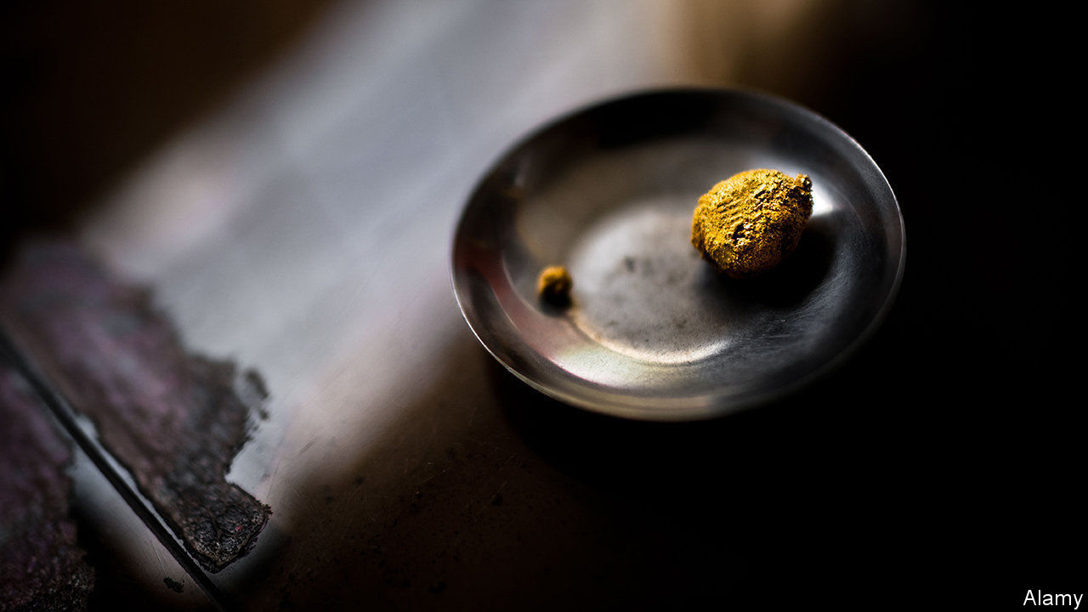

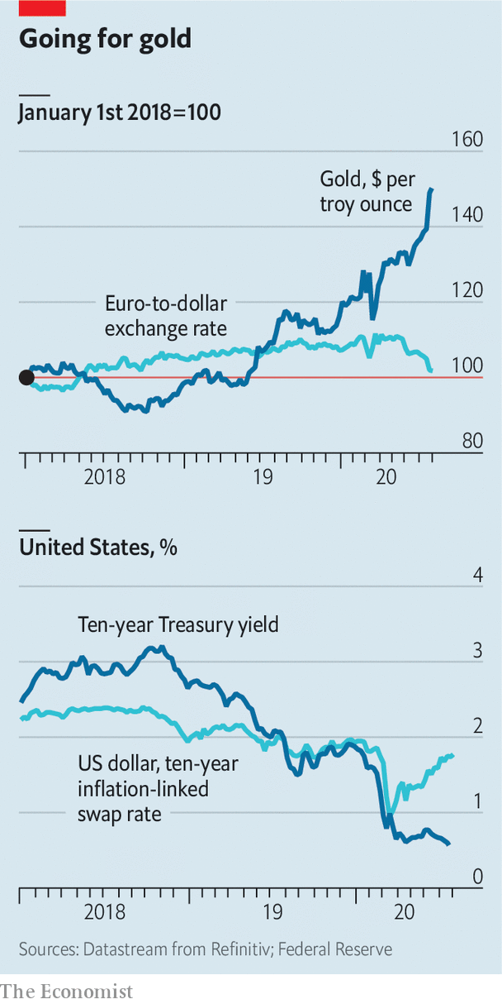

ON JULY 29TH the price of gold surged to an all-time high, as the dollar fell to its lowest level against the euro in nearly two years. Yields on ten-year Treasuries have stayed low, on fears of a rocky economic recovery, even as expectations of inflation have risen. That has depressed real yields, making dollar assets less attractive and adding to gold’s lustre.

This article was downloaded by calibre from <https://www.economist.com/finance-and-economics/2020/07/30/the-price-of-gold-surges-to-an-all-time-high>

|  |  |  |  |
| --- | --- | --- | --- |
| Previous | Articles | Sections | Next |

|  |  |  |  |
| --- | --- | --- | --- |
| Previous | Articles | Sections | Next |

#### Filling the coffers

# The EU’s recovery fund revives a debate on common taxes

But for every tax proposed, there is a national veto

Aug 1st 2020 | BERLIN

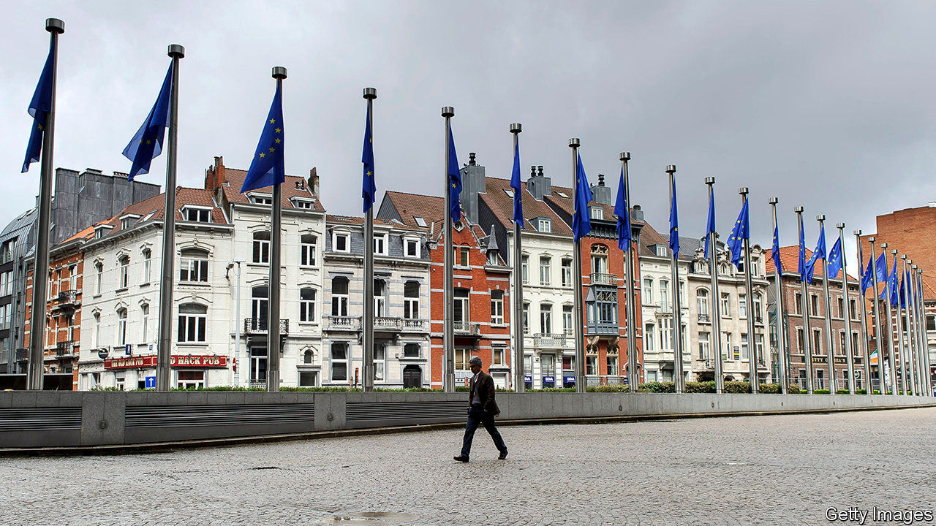

NOTHING IN THIS world is certain, mused Benjamin Franklin, except death and taxes. He never had to contend with the European Union’s unanimity rule. Eurocrats have long sought to bolster the EU’s budget with “own resources”—ie, revenues that accrue to it, rather than cash handed over by member countries on the basis of national income. But almost every attempt to centralise taxation has fallen foul of a national veto. The last big reform to EU revenues was over three decades ago.

Some think the club’s coming borrowing splurge will revive the debate. On July 21st the EU’s 27 national leaders agreed to allow the European Commission to borrow up to €750bn ($880bn) and dish out the proceeds, more than half in the form of grants, to help countries recover from the covid-19 recession. Repayment will start in 2028; new “own resources”, the leaders said, should contribute. Once-sceptical members are now keener. “Countries see more concretely that taxes will either have to be collected by the EU or included in national contributions,” says Mario Monti, a former Italian prime minister who led an inquiry into own resources in 2017. For fans of “more Europe”, common taxes on top of common debt would mark a decisive step towards fiscal union.

An EU levy on plastic waste may funnel €7bn a year towards the budget from 2021. But beyond that, the commitment is thin. The logic of vetoes has not changed, notes Eulalia Rubio at the Jacques Delors Institute, a think-tank. Every proposal is opposed by one government or another. One idea is to direct revenues from the EU’s carbon-trading scheme to Brussels. But that might deprive national treasuries of income; Germany and Poland are sceptical. Another idea is a “single-market” tax on companies. But the Dutch and the Irish are reluctant to squeeze firms. Some members have long pledged a tax on financial transactions. But as James Tobin, its intellectual godfather, supposedly said, the levy is like the Loch Ness Monster: the idea occasionally pops up then disappears for years.

National vetoes might make taxing foreigners look attractive. Leaders said they would try to implement two such levies by 2023: a “carbon border-adjustment mechanism” (a tariff on climate-unfriendly imports), which could raise €5bn-14bn a year, and a less lucrative levy on (mainly American) tech firms. Yet these face problems too. The border mechanism is devilish to design and will be challenged at the World Trade Organisation. America’s opposition to a digital tax has stalled a parallel process at the OECD, and given pause to governments trying to impose national versions.

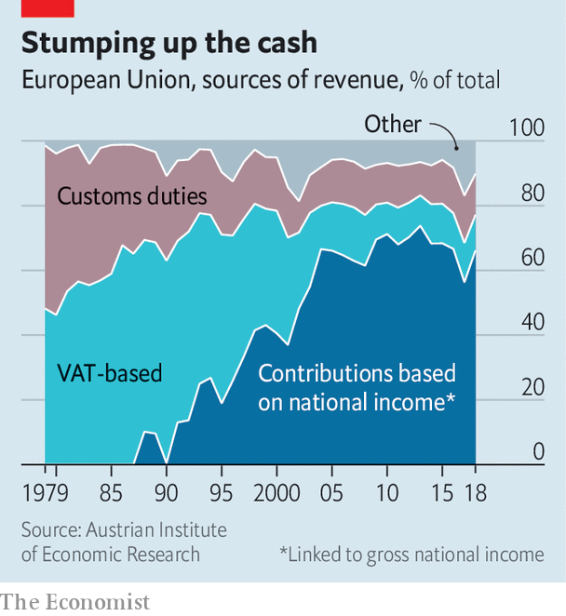

Contributions from members based on national income have long made up the bulk of the EU’s budget (see chart). Every seven years countries grapple over minor adjustments to it; the summits are bruising, but governments retain control. Introducing fresh own resources would jolt them out of such zero-sum thinking, says Valérie Hayer, a French member of the European Parliament, and give heft to common priorities, such as climate. The parliament, which must approve last week’s deal, will seek to ensure that governments’ vows on own resources are not “empty”, she adds. Yet it cannot force their hands.

If the own-resources discussion flops, countries could simply pay more into the next budget to repay the recovery-fund debt. But history shows that governments under fiscal pressure prefer to cut the EU’s spending, says Ms Rubio; common endeavours such as research were slashed to preserve the recovery fund last week. Still, a lot can happen before 2028. For the EU to borrow and redistribute hundreds of billions of euros would have seemed unimaginable a year ago. The topic of own resources “was never sexy”, says Mr Monti. “Now it is beginning to become so.” ■

Editor’s note: Some of our covid-19 coverage is free for readers of The Economist Today, our daily [newsletter](https://my.economist.com/user#newsletter). For more stories and our pandemic tracker, see our [hub](https://www.economist.com/news/2020/03/11/the-economists-coverage-of-the-coronavirus)

This article was downloaded by calibre from <https://www.economist.com/finance-and-economics/2020/08/01/the-eus-recovery-fund-revives-a-debate-on-common-taxes>

|  |  |  |  |
| --- | --- | --- | --- |
| Previous | Articles | Sections | Next |

|  |  |  |  |
| --- | --- | --- | --- |
| Previous | Articles | Sections | Next |

#### A lost asset

# Emmanuel Farhi has died at the age of 41

The economist was one of the brightest minds of his generation

Jul 30th 2020 | WASHINGTON, DC

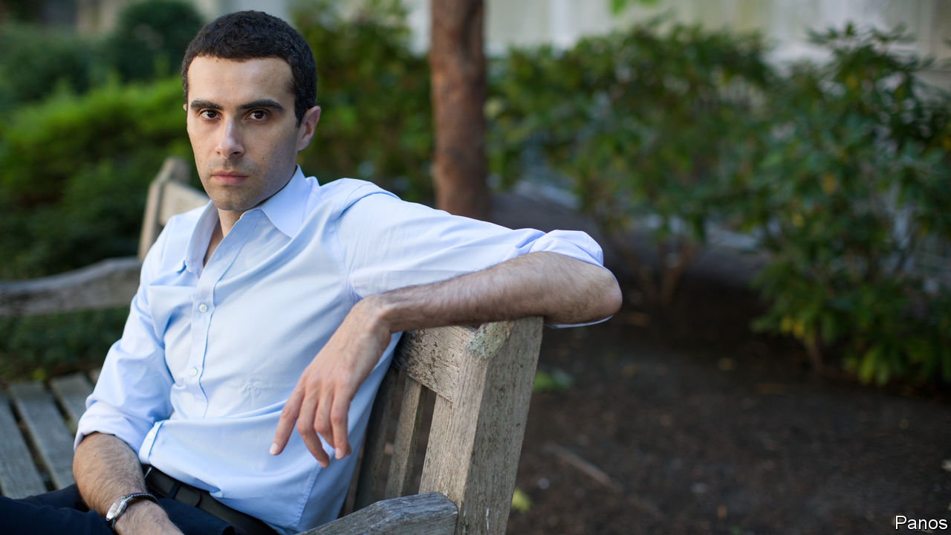

EMMANUEL FARHI showed a lot of promise in a lot of fields. At 16 he won a national physics competition in France. In the test to enter its most prestigious engineering school, he received the highest mark. After considering a career in maths, he settled on economics, where he flourished. “He was one of the greatest economic minds of his generation,” says Xavier Gabaix, a colleague at Harvard University. But on July 23rd that career was cut short when Mr Farhi died unexpectedly at the age of 41.

His research interests were unusually broad, covering competition, international macroeconomics, tax and productivity. The common thread was a motivation to help policymakers understand the world. With Mr Gabaix, Mr Farhi considered how to design taxes when people are not as rational as economists typically assume. Carbon taxes are thought to be a way of forcing consumers to bear the environmental costs of their choices. But if future fuel consumption is not on people’s minds when they shop for cars, such a tax may not work, and rules that limit emissions would be better. In research with David Baqaee of the University of California, Los Angeles, he studied the sources of productivity growth, and showed that ignoring firm-level differences could obscure the overall picture.

Mr Farhi’s most-cited work was on safe assets, written in 2008 with Ricardo Caballero of the Massachusetts Institute of Technology and Pierre-Olivier Gourinchas of the University of California, Berkeley. They argued that the global demand for safe assets had outpaced supply over recent decades. America’s economic and political might made it well-placed to service this savings glut. As a result, its current-account deficit had bulged, and its assets accounted for a bigger slice of global portfolios.

That paper spawned more research on how the world was stuck in a “safety trap”. Demand for havens had led to an appetite for pseudo-safe assets, such as packaged subprime loans. But these were soon revealed to be far from safe. And, after the debt crisis of 2010-12, investors realised that sovereign bonds in the euro zone were wobbly. The result was a severe global shortage of safe assets. Interest rates fell but, having fallen to around zero, could not decline further. The result was that interest rates for households and firms were, in effect, too high—and, in turn, their consumption and investment too low.

Mr Farhi saw America’s role as the world’s banker as unsustainable. If it produced too few safe assets then, with interest rates unable to adjust fully, global aggregate demand would stay depressed. But if it tried to keep up with investors’ demand for safety, its ability to repay its debts might one day be called into question. Speaking to the Richmond Federal Reserve in 2019, he noted America’s shrinking share of the global economy and worried that its role was becoming too much to bear.

One solution would be for other issuers of safe assets, such as the European Union or China, to emerge—though in a paper with Matteo Maggiori of Harvard, Mr Farhi warned that the transition could be messy. For now, investors doubting the safety of American government bonds had few other places to park their cash. But as alternatives became available, Treasuries would become much more vulnerable to self-fulfilling crises. The dominance of the dollar would be challenged, said Mr Farhi in 2019, though “you have to take the long view here and think about the next decades, not the next five years”. The tragedy is that he did not live long enough to test the prediction.

This article was downloaded by calibre from <https://www.economist.com/finance-and-economics/2020/07/30/emmanuel-farhi-has-died-at-the-age-of-41>

|  |  |  |  |
| --- | --- | --- | --- |
| Previous | Articles | Sections | Next |

|  |  |  |  |
| --- | --- | --- | --- |
| Previous | Articles | Sections | Next |

#### Free exchange

# The fear of robots displacing workers has returned

But do not expect tech-induced lay-offs just yet

Jul 30th 2020 |

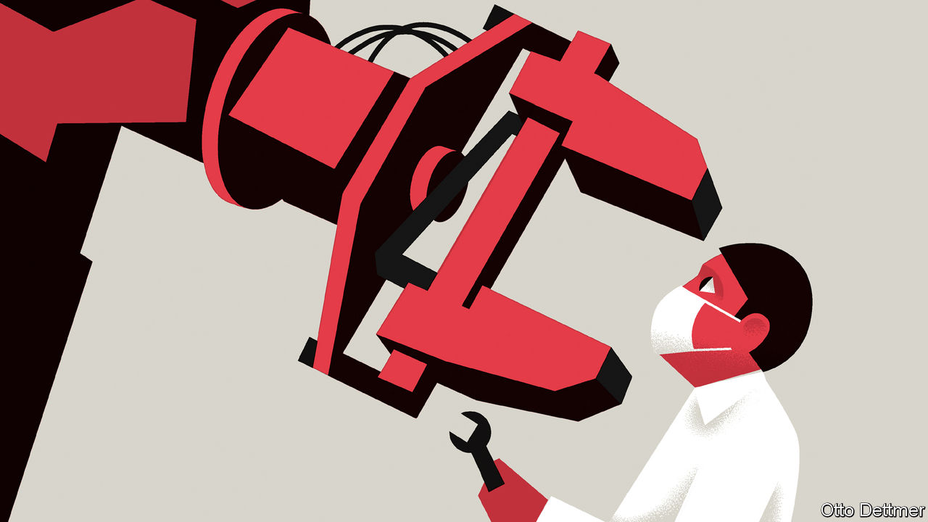

COVID-19 PRESENTED employers with a simple choice: find ways for workers to do their jobs safely, or shut down. At least some have chosen a third option, of dispensing with humans altogether. Among the many breathless headlines prompted by the pandemic are those warning of a new wave of job-destroying automation. The pace of automation in some parts of the economy, like factory floors and warehouses, is almost certain to accelerate. Yet on the whole, robot-induced mass unemployment should remain near the bottom of workers’ lists of worries.

The world has only recently recovered from a bout of robophobia. In the early 2010s advances in robotics and artificial intelligence (AI), described ominously in countless papers and books, seemed to portend a wave of job destruction. High unemployment after the global financial crisis of 2007-09 added to fears of a job scarcity. Fretting about robots in a downturn is not entirely irrational: firms appear to do most of their job-slashing during slumps. Nir Jaimovich of the University of Zurich and Henry Siu of the University of British Columbia argue that labour-market recoveries have grown weaker in recent decades as a result. Worries can be overdone, though. By the end of the decade unemployment had dropped like a stone and driverless vehicles were struggling to turn left. The earlier panic seemed a touch hysterical.

High rates of joblessness and eye-catching technological advances are again contributing to a new round of fears. In recent weeks, for instance, mind-boggling examples of the capabilities of GPT-3—an AI-based language-processing model developed by OpenAI, a research organisation—have zoomed around the internet. Another cause for anxiety has been businesses’ strategies for coping with the pandemic. Anecdotes of covid-motivated automation are easy to find. Many organisations have turned to software to automate paper-processing tasks that cannot be done by homebound workers. Those facing a deluge of customer enquiries, such as hospitals, are supplementing human assistants with chatbots. Employers’ interest in automating tasks in high-risk environments, such as slaughterhouses, is reportedly on the rise.

Any effect of these on unemployment has almost certainly been swamped by stronger economic forces, such as social-distancing measures and collapsing aggregate demand. And the pace of automation is likely to be gradual rather than disruptively speedy. Many jobs, even those commonly classified as “low-skilled”, require manual and social dexterity that machines cannot yet match. Workers in face-to-face industries—in bars or restaurants, say, or hair and nail salons—are especially vulnerable to covid-19. But there is little scope for, or interest in, replacing them with robots. In New York thousands of public-transport workers caught the virus, and dozens died. Despite billions of dollars of investment in driverless vehicles, though, computers cannot yet pilot buses through chaotic city streets.

Furthermore, automation is only one of the technological solutions available to firms as they weather the crisis. The pandemic’s most profound labour-market legacy will probably be a rise in remote work. About half of all Americans who were working before the arrival of covid-19 were doing their jobs remotely by May, according to one estimate. Surveys of firms indicate that some of the shift will not be reversed. If remote work slashes overheads and enables people to move to cheaper cities, it could preserve jobs, by alleviating cost pressures on struggling firms.

Telework may have some job-destroying effects, though. The pandemic has sped the adoption of technology in labour-intensive sectors like education and health care. Telemedicine and distance learning might mean that fewer doctors and teachers can serve more patients and students. Their largest impact is likely to be on blue-collar workers, such as clerical and janitorial staff, whose services become less necessary as the physical footprint of education and health institutions gets lighter. In a recent essay David Autor and Elisabeth Reynolds of Massachusetts Institute of Technology warn that such a dynamic could play out more widely. Over the past half-century employment growth in cities polarised: middle-skill work declined, and employment grew in white-collar professions and the services that support them. If remote working proves a lasting shift, then the café staff, taxi drivers and cleaners who depend on their custom could find themselves out of work.

Such severe, lasting labour-market pain in the aftermath of the pandemic may actually delay automation, by depressing wages. Developing and deploying new technologies costs money. Would-be automators deciding whether or not to make the needed investment could be swayed by the large reservoir of underemployed labour, willing to work for low pay. In America slaughterhouses—which often hire from a big pool of low-wage workers, many of them undocumented immigrants—are far less automated today than in parts of northern Europe, for example.

## Automatic transition

Tech-induced mass unemployment, then, seems unlikely. But there is one scenario where covid-19 could unleash the robots—if labour costs start to drift upwards, perhaps as global supply chains break down, or minimum wages rise. The reshoring of manufacturing jobs could lead to pressure to replace cheap foreign labour with robots at home. Production could no longer take advantage of low-cost labour, as America’s meat-processing industry does.

Years of economic dysfunction have energised campaigns for higher minimum wages and a more generous welfare state. The economic devastation wrought by the pandemic lends them momentum; like past crises, it could lay the groundwork for a new social contract. If post-pandemic policy were to enable workers to enjoy more security on fewer hours worked, firms might then face some genuine labour scarcity. And that would really work up an appetite for disruption. ■

This article was downloaded by calibre from <https://www.economist.com/finance-and-economics/2020/07/30/the-fear-of-robots-displacing-workers-has-returned>

|  |  |  |  |
| --- | --- | --- | --- |
| Previous | Articles | Sections | Next |

|  |  |  |
| --- | --- | --- |
| Finance & economics | Sections | Books & arts |

Science & technology

Electric cars: Million-mile car batteries are coming

.

Concussion: RAT tales

.

Palaeomicrobiology: The bugs that time forgot

.

|  |  |  |
| --- | --- | --- |
| Finance & economics | Sections | Books & arts |

|  |  |  |  |
| --- | --- | --- | --- |
|  | Articles | Sections | Next |

#### Electric cars

# What the million-mile battery means for electric cars

It is mainly about greater reliability

Aug 1st 2020 |

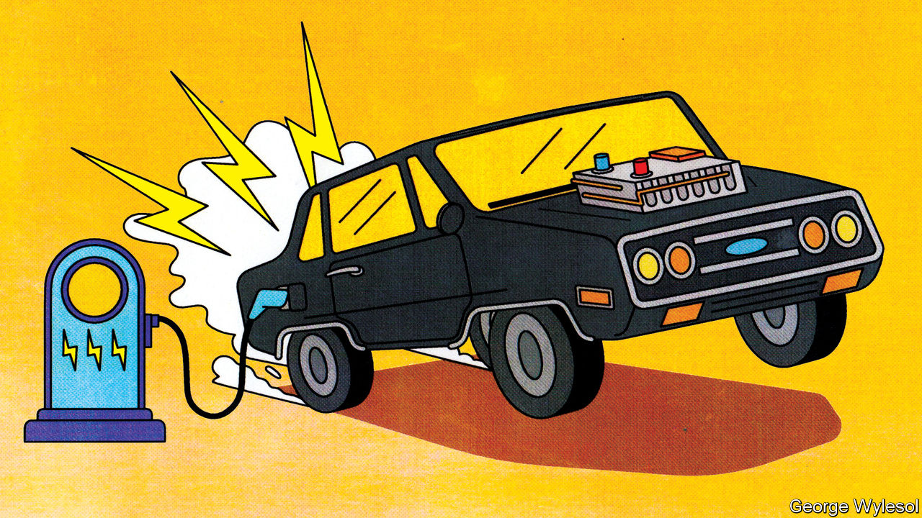

AS EVERY MOBILE-PHONE owner knows, after a year or so the battery starts to fade and the beast needs recharging more frequently. That is a nuisance, but a phone’s batteries can be replaced fairly cheaply—or the whole handset traded in for the latest model. An electric car, however, is a much bigger investment. And batteries are its priciest component, representing around 30% of an average mid-size vehicle. Apart from increasing the risk of running out of juice and leaving a driver stranded, a deteriorating battery quickly destroys a car’s second-hand value.

To provide buyers with some peace of mind, carmakers guarantee their batteries, typically for eight years or around 200,000km. Producers are now, though, planning to go much further than that, with the launch of “million mile” (1.6m kilometre) batteries. Zeng Yuqun, the boss of Contemporary Amperex Technology, a giant Chinese firm which produces batteries for a number of carmakers, said in June that his company was ready to start manufacturing batteries which would last for 16 years or 2m kilometres. Elon Musk has hinted that Tesla, a Californian maker of electric vehicles of which he is boss, has a million-mile battery in the works. Rumours suggest this could be unveiled in September. And over in Detroit, General Motors (GM) is in the final stages of developing an advanced battery which it says has similar longevity.

## To the Moon and back, twice

“It’s a great catchphrase; the million-mile battery,” says George Crabtree, director of the Joint Centre for Energy Storage Research at Argonne National Laboratory, near Chicago. “But the fact you can drive a million miles may not be the most relevant parameter to look at.” Thrash a car and its battery will deteriorate faster. Regular fast-charging also reduces battery life, as do overcharging and deep discharging. Driving in extremely hot or cold weather does not help either. And battery life will diminish even if you just leave the car in the garage. The real point of a million-mile battery is that the technological advances required to make it possible will deal with these things as well.

The lithium-ion (Li-ion) batteries which power electric cars age in two ways: with time and with use. Battery-makers call time-dependent ageing “calendar ageing”. It is a consequence of the gradual degradation of some of the materials employed in battery construction. This degradation reduces a battery’s ability to hold a charge—though even here it is possible to ameliorate the problem to a certain extent. Leaving a car with a fully rather than partly charged battery, for example, can increase the rate of calendar ageing.

Use-dependent ageing is a consequence of the number of discharge-recharge cycles a battery goes through. It is caused by the complex chemical reactions that take place when a battery is operating. Some of these are essential to a battery’s job of storing and releasing energy. “But there are also side reactions that you can’t stop and some of those are harmful,” explains Dr Crabtree.

As a battery discharges, lithium ions (lithium atoms with an electron missing) are created at one electrode, the anode. These then shuttle through a liquid electrolyte to a second electrode, the cathode. The electrons stripped away at the anode, meanwhile, travel towards the cathode along an external electrical circuit, which powers the car. Ions and electrons are reunited at the cathode and remain there until the battery is plugged into a charger and the process is reversed.

Each cycle of discharge and recharge takes its toll. Lithium is so highly reactive that stopping it getting tied up in other chemical compounds while a battery is in use is hard. Even a small amount of diversion per cycle adds up, reducing the amount of the element available to store energy. On top of this, charging up faster than ions can be absorbed by the anode may result in a layer of lithium “plating” building up on the anode’s surface, reducing its storage capacity.

Plating becomes yet more of a problem if it leads to the development of structures called dendrites. These are small, finger-like fibres which project into the electrolyte from points on the anode where plating is especially elevated. If a dendrite reaches the cathode the battery will short-circuit, causing it to heat up rapidly and possibly catch fire. Other side reactions can have similarly adverse consequences.

It is difficult to generalise about the extent to which these processes reduce a battery’s lifetime. Not only does it depend on how that battery is used, but also how it is made. Li-ion cells come in different forms and a variety of chemistries, some of which have not been around long enough in cars for people to know for sure how long they will last. Nor is there any independent testing, says Dr Crabtree.

Nevertheless, the industry has a few rules of thumb. Once a battery’s capacity falls below 80% of its starting value, it is generally thought no longer suitable for use in vehicles. Some reckon that, on average, Li-ion batteries lose 2% of their capacity a year. This may not seem much, but by the time a vehicle is six years old it could mean it is halfway through its useful life.

## The long road ahead

Battery technology is improving all the time. As a consequence, so are calendar and use-dependent lifetimes. Getting direct experience of how electric cars are used is helping researchers come up with ways to mitigate some of the side reactions, says Tim Grewe, the head of GM’s electrification strategy. The company employs remote, “telematic” monitoring to keep track of how batteries are performing in its cars, and also takes back some batteries from high-mileage drivers and those living in extreme environments, such as deserts and mountainous regions, for analysis.

Dealing with impurities which get into batteries helps to extend their lives. Water, for example, reacts with salts in the electrolyte to form an acid, which attacks the electrodes. To prevent this, GM has developed an additive made from a type of material called a zeolite. Zeolites are molecular sponges. GM’s version serves to mop up any moisture which enters a battery cell.

Adding a little aluminium to a nickel-cobalt-manganese cathode, a type that is widely used in Li-ion batteries, saves on cobalt, the most expensive ingredient in a battery. But the aluminium delivers other benefits as well, adds Mr Grewe. It boosts the battery’s energy density, meaning a car can travel farther on a single charge. It also makes the battery last longer.

GM will be using these cathodes in a new battery, called Ultium, that it has developed in partnership with LG Chem, a South Korean firm. Ultium batteries, production of which is planned to start next year at a factory in Ohio, should provide electric cars with single-charge ranges of 650km or more. That compares with the 400km range which might these days reasonably be expected from a mid-size electric car. Asked if the Ultium is a million-mile battery, Mr Grewe replied, “Many customers could get that.”

## On to two million!

As a marketing device, the million-mile battery will give electric-car buyers—even those never likely to put a million miles on the clock—more confidence that their batteries are robust. But some users might truly desire a lifetime range that great.

Jeff Dahn, who leads a group of battery researchers at Dalhousie University in Halifax, Canada, who are sponsored by Tesla, points out that autonomous electric vehicles like “robo taxis” could clock up vast mileages by operating around the clock. So, too, would long-haul lorries and electric buses. And some cars may end up being more than just means of transport. Plans are afoot to let electric-vehicle owners connect their jalopies to the grid in a way that will store surplus electricity generated in times of plenty by wind and sunshine and release it during hours of peak demand, with the owner collecting a fee for doing so. That means these grid-buffering vehicles will be racking up lots of charging cycles even when they are not moving.

Nor are million-mile batteries the limit of engineers’ aspirations. The next objective is to replace Li-ions’ liquid electrolytes with solid ones. That would keep the ions under stricter control and allow even longer driving ranges. This could make a two-million-mile battery a feasible objective. If that day comes, the tables would have been turned. From being the first part of a car to fail, its battery will have become the last.■

This article was downloaded by calibre from <https://www.economist.com/science-and-technology/2020/08/01/what-the-million-mile-battery-means-for-electric-cars>

|  |  |  |  |
| --- | --- | --- | --- |
|  | Articles | Sections | Next |

|  |  |  |  |
| --- | --- | --- | --- |
| Previous | Articles | Sections | Next |

#### Shear-thickening

# A strange material may make protective helmets more so

It absorbs impact energy more effectively

Aug 1st 2020 |



ANYONE WHO has experimented as a child with maize starch and water knows about shear-thickening. A mixture of these substances is easy to stir slowly, but solidifies when you speed the stirring up, only to liquefy again when you stop. It’s fun. But it may also be important. For years, people have been trying to apply the principle to armour. Now, it seems, one group has succeeded. The result will not stop a speeding bullet. But, incorporated into a helmet, it might save the wearer from concussion.

Construction workers, soldiers and sportsmen and women all wear safety helmets that contain impact-absorbing suspension systems based on foam pads or webbing straps. Eric Wetzel of the United States Army Research Laboratory and his colleagues propose replacing these with fabric tubes containing a shear-thickening material that the lab has developed. These tubes, which behave like viscous, speed-sensitive bungee cords, are known as rate-activated tethers, or RATs.

A standard bungee cord’s useful property is its elasticity. This first stores energy as the jumper falls and then releases it as he bounces back up again. A RAT bungee jump, however, would be a one-way trip. RATs absorb energy when stretched in the way that an elastic substance does, but, unlike an elastic, they do not then give it back when released. That would leave a jumper dangling at the bottom.

Dr Wetzel’s team were developing RATs as ankle supports to absorb landing shock for parachutists when they realised that the tethers they were working with had just the qualities required for helmet suspensions: they provide instant strong resistance, which increases with impact speed. Existing military helmets protect in situations like travel over rough terrain, collisions between vehicles and with obstacles, and being thrown around by bomb blasts. RATs offer better protection in all these cases. Current American-army combat helmets are built to withstand impact velocities of three metres a second, with newer models being rated for just over four. Prototype helmets fitted with RAT suspension pass impact tests at five metres a second, which Dr Wetzel says no previous helmet suspension has achieved.

Donal McNally, a specialist in biomechanics at the University of Nottingham, in Britain, says that an ideal helmet would make the best use of the space between shell and head, adjusting its stiffness depending on the speed of impact. The RAT design does just that. However, its success will depend on whether the shear-thickening material can be engineered to have the correct stiffness for both slow and fast impacts. Dr McNally notes also that the suspension will require some clever design because the tethers respond only to tension, not compression, making it hard to cope with impacts from all directions.

Dr Wetzel’s priority at the moment is getting industry to share his excitement about the new technology. Firms selling to civilian customers generally work faster than people on the military side of things, he says, and if consumer applications take off that will generate a manufacturing and design base which can support military ones. To this end, his team has retrofitted an American-football helmet with RAT suspension. Head protection is a huge and increasing concern in gridiron football.

There has been a dramatic fall-off in the number of youngsters taking up the sport because of worries about head injuries. Improved protection might help change that. An independent laboratory tested the helmet and, in the most taxing test, found that it reduced the “severity index” (a measure of the likelihood of a wearer suffering brain injury) from 393 for the helmet’s standard version to 190. One of the laboratory’s operators said he had never seen a result of less than 200 on the test concerned.

Nor are helmets the only possible application for RATs. Dr Wetzel and his team have already tested them as chin straps to hold helmets in place, and as straps for pairs of goggles. RAT-based straps could eventually be useful for everything from hikers’ backpacks to babies’ pushchairs. Whether they will have applications in ships’ ratlines remains to be seen. ■

This article was downloaded by calibre from <https://www.economist.com/science-and-technology/2020/08/01/a-strange-material-may-make-protective-helmets-more-so>

|  |  |  |  |
| --- | --- | --- | --- |
| Previous | Articles | Sections | Next |

|  |  |  |  |
| --- | --- | --- | --- |
| Previous | Articles | Sections | Next |

#### Palaeomicrobiology

# Researchers revive bacteria from the era of the dinosaurs

The bugs that time forgot

Aug 1st 2020 |

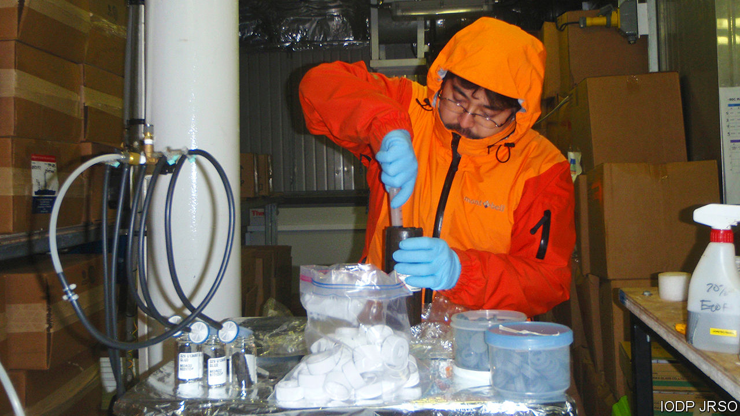

FAR FROM the life-sustaining light of the sun, the deep sea floor appears barren and desolate. Its appearance, however, belies a thriving bacterial ecosystem that may contain as much as 45% of the world’s biomass of microbes. This ecosystem is fuelled by what is known as marine snow—a steady shower of small, nutrient-rich particles that fall like manna from the ocean layers near the surface, where photosynthesis takes place.

Not all of the snow is digestible, though. And the indigestible parts build up, layer upon layer, burying as they do so the bugs in the layer below. To look at how well these bacteria survive entombment a group of researchers led by Morono Yuki of the Japan Agency for Marine-Earth Science and Technology and Steven D’Hondt of the University of Rhode Island studied samples collected in 2010 by the Integrated Ocean Drilling Programme, a decade-long international expedition of which they were part. Their results, just published in Nature Communications, are extraordinary. They seem to have brought back to life bacteria that have been dormant for over 100m years.

For many microbes, burial is an immediate death sentence. Some, however, are able to enter a state of dormancy—slowing their metabolisms down almost, but not quite, to zero. They can remain in this state for considerable periods. But precisely how long has been a subject of debate.

The samples Dr Morono and Dr D’Hondt chose for examination came from a place in the Pacific Ocean where the sea bed is nearly 6,000 metres below the surface. That made drilling a challenge. But the expedition was able to recover sediment cores stretching all the way down to the underlying rock—a thickness of 100 metres in some cases. The oldest material in these cores dated back 101.5m years, to the middle of the Cretaceous period, the heyday, on land, of the dinosaurs.

Examination of the sediments showed that even the oldest still contained a few bacteria. The question was, were these organisms dead or alive? To find out, the researchers incubated the samples, slowly feeding them compounds rich in carbon and nitrogen in order to coax any still-living microbes out of their dormancy.

The results shocked Dr Morono, “At first I was sceptical, but we found that up to 99.1% of the microbes in sediment deposited 101.5m years ago were still alive.” And there was quite a variety of them, too. The team found representatives of phyla called Actinobacteria, Bacteroidetes, Firmicutes and Proteobacteria, all of which are familiar to microbiologists. In one sample (admittedly from a mere 13.5m years ago) they also discovered representatives of the archaea, a group of organisms that resemble bacteria under a microscope, but have a biochemistry so different that they are regarded as a separate domain of life.

## Cretaceous Park

To find such living fossils from as far back as the Cretaceous is extraordinary. It is not possible to be sure, given the length of time involved, that they have undergone no growth and cell division whatsoever. But if they have, it will have been minimal given the lack of nutrients in the ooze they were found in. Nor is it likely that they migrated there from layers above. The ooze in question was sealed off by a bacteria-proof layer of chert-like material called porcellanite.

This discovery will therefore throw interesting light on the evolution of bacteria on Earth. It will also raise the spirits of those who hope to find life elsewhere in the solar system. The sediments that will be examined for signs of biology by Perseverance, an American Mars rover which took off from Cape Canaveral, in Florida, on July 30th, are 35 times older than those studied by Dr Morono and Dr D’Hondt, and have not had the protective shielding from environmental degradation that comes from being buried at the bottom of the sea under many metres of overburden. But future Mars rovers will drill beneath the planet’s surface into strata that have had equivalent levels of protection from rock above them, if not from seawater. And a factor of 35, though large, does not sound insurmountable.■

This article was downloaded by calibre from <https://www.economist.com/science-and-technology/2020/08/01/researchers-revive-bacteria-from-the-era-of-the-dinosaurs>

|  |  |  |  |
| --- | --- | --- | --- |
| Previous | Articles | Sections | Next |

|  |  |  |
| --- | --- | --- |
| Science & ... | Sections | Economic & ... |

Books & arts

Ways of seeing: Attention pays

.

Cheating in sport: Through the mousehole

.

Icelandic fiction: Lines of beauty

.

Understanding data: Sums of all fears

.

Home Entertainment: “The Seventh Seal”

.

Perspectives: Cleanliness is next to growth

.

|  |  |  |
| --- | --- | --- |
| Science & ... | Sections | Economic & ... |

|  |  |  |  |
| --- | --- | --- | --- |
|  | Articles | Sections | Next |

#### Attention pays

# Finding beauty in ordinary things

The Japanese aesthetic of mingei is a consolation during lockdown

Aug 1st 2020 | TOKYO



THE BOWL is small enough to balance in the palm of your hand. It is deep enough for tofu, but too shallow for soup. A ghostly white glaze, translucent in the right light, covers the surface. These clay walls are its maker’s gallery. A lone blue figure fills the centre of the bowl, his face a blank oval with a whiskery beard. His spine curves along the same arc as the rim.

At the Nihon Mingeikan (Japan Folk Crafts Museum) in Tokyo, visitors find little by way of description or context alongside this artefact or the hundreds of other simple ceramics, textiles and crafts on display. Yanagi Soetsu, the museum’s founder, believed that nothing should distract from the beauty of the objects. For Yanagi, a prolific writer and collector, “miscellaneous things represent the most original of Japanese arts.” He and two potters, Hamada Shoji (who made the plates in the picture) and Kawai Kanjiro, dubbed these wares mingei, a neologism fusing the characters for “the masses” and “crafts”.

Over several decades from the 1910s, he amassed a collection of more than 17,000 such pieces from around Japan and its expanding empire, which became the foundation of the Mingeikan. By the time Yanagi died in 1961, mingei had entered the language. His ideas left an enduring mark on Japanese design, visible today in the fashion stylings of Issey Miyake and the popular homeware sold by the retailer Muji. At a time when people everywhere find themselves confined to familiar surroundings, his attentive way of looking at the world is a salutary consolation.

Mingei encompasses all manner of everyday things, from clothing and furniture to utensils and stationery. These objects, Yanagi wrote, are “deeply embedded in the life of ordinary people”. They stand in contrast to aristocratic fine arts and eschew needless decoration. Works of mingei are crafted with quotidian use and owners in mind; they are typically the handmade creations of anonymous artisans possessing “unconscious grace”. In the parlance of the pandemic, mingei might be called the essential workers of the material world: “Since these utilitarian objects have a commonplace task to perform, they are dressed, so to speak, in modest wear and lead quiet lives,” Yanagi wrote. “They work thoughtlessly and unselfishly, carrying out effortlessly and inconspicuously whatever duty comes their way.”

Yanagi sought to identify and celebrate the functional beauty of these overlooked items. He believed that defining beauty purely in visual terms, to the exclusion of practicality, was mistaken. “Our aesthetic sense has been severely impaired owing to the fact that beauty and life are treated as separate realms of being,” he argued. Yet this did not mean extolling any old (or new) thing. For Yanagi, objects made with vulgar colouring, shoddy materials and thoughtless forms were not simply eyesores, but “amoral and unethical”. Like the Arts and Crafts movement in Britain which it followed, mingei was in part a response to mechanisation, setting out to elevate older methods over mass production.

## Eye of the holder

Born in Tokyo in 1889 to a family of Meiji-era naval officers, Yanagi’s intellectual life began in the Shirakaba (White Birch) group, a collective of writers and thinkers who explored Western art and literature in their eponymous journal. Yanagi wrote on topics ranging from Tolstoy to Rodin to William Blake. He befriended the English ceramicist Bernard Leach, who would first render Yanagi’s thoughts into English in “The Unknown Craftsman” (published in 1972). A collection of his essays that was recently released as “The Beauty of Everyday Things” is the second widely available English-language volume of his work.

Like many of his peers, Yanagi’s interests drifted towards questions of cultural identity. How should the East assert itself in response to the West? What was Japan’s relationship with the rest of the region? What made Japanese culture distinctive? An encounter with Korean ceramics in 1914 led to his interest in folk crafts. He spent years collecting and promoting Korean work, ultimately opening a small museum in Seoul. His engagement with the crafts of Japan’s colonies led him to speak out against the Japanese empire’s assimilationist and expansionist policies in both Korea and Okinawa, another important venue for his collecting. In “A Letter to My Korean Friends”, written amid a crackdown on Korean independence movements in 1919, Yanagi lamented that “Japan does not yet fully possess a human heart.”

Yet for all his humanism and pacifism, his views could also be interpreted more darkly. In recent decades scholars have advanced a revisionist sense of mingei as a kind of cultural nationalism, an “oriental Orientalism” that became the aesthetic accompaniment to Japanese imperialism. Japanese ultranationalists found much to like in Yanagi’s promotion of the collective over the individual, his search for beauty among the masses, his championing of tradition and his quest for an essential Japaneseness. As Kim Brandt argues in “Kingdom of Beauty”, her study of mingei, “Government ideologues and propagandists embraced the arts and crafts of an idealised folk as a means of insisting on national, and also imperial, unity.” When, during the second world war, the American firebombing of Tokyo brought flames to the Mingeikan’s walls, Yanagi and his wife doused them with brooms and buckets of water, their son Yanagi Sori later recalled.

Sori helped give mingei a second life through his work as a pioneering industrial designer. His iconic pieces, such as his graceful butterfly stool, fused a European modernist training with his father’s mingei spirit. Sori saw an overlap with the Bauhaus movement in mingei’s emphasis on function over form, and, in its belief in the craftsman’s unconscious intimation of beauty, with Surrealism.

After his father’s death, Sori took over as the Mingeikan’s director, inspiring a generation of designers to seek models in mingei. Today there are dozens of affiliated mingei museums in Japan. Martha Longenecker, an American potter, founded the Mingei International Museum in San Diego in the 1970s. Sori’s successor as director of the Mingeikan, the designer Fukasawa Naoto, is himself evidence of mingei’s enduring influence. Mr Fukasawa had a hand in Muji’s designs for suitcases, chairs, lamps, kettles and much else, aiding the firm’s rise to global prominence. Its goods, he says, are examples of “modern-day mingei”. (The name Muji means “no brand”.)

Mingei involves approaching the world with a heightened awareness of the objects that fill everyday lives. Yanagi urges you to ponder the coffee mug that fuels endless Zoom meetings with the same intensity as you contemplate a Cézanne (whose work he once hung in the reception room of the Mingeikan). “Today, when everything is trending toward the frail and sickly, the beauty we see in these common objects is both a blessing and a joy,” he wrote with eerie resonance. He asks people, in short, to appreciate what is under their noses.

Take the humble face mask. Your correspondent’s is sewn out of tan cloth and patterned with fish. Its light-blue ear straps, now frayed, suggest the ocean. A blue mahi-mahi stretches its bulbous forehead over the crease of the nose. A silver tigerperch edges towards the ear. The yellow spines of a John Dory’s dorsal fin spread across the cheek, evoking the beard of the man in the bottom of the mingei bowl. ■

This article was downloaded by calibre from <https://www.economist.com/books-and-arts/2020/08/01/finding-beauty-in-ordinary-things>

|  |  |  |  |
| --- | --- | --- | --- |
|  | Articles | Sections | Next |

|  |  |  |  |
| --- | --- | --- | --- |
| Previous | Articles | Sections | Next |

#### Through the mousehole

# Memoirs of a champion Russian doper

Now in hiding, Grigory Rodchenkov reflects on his country and career

Aug 1st 2020 |

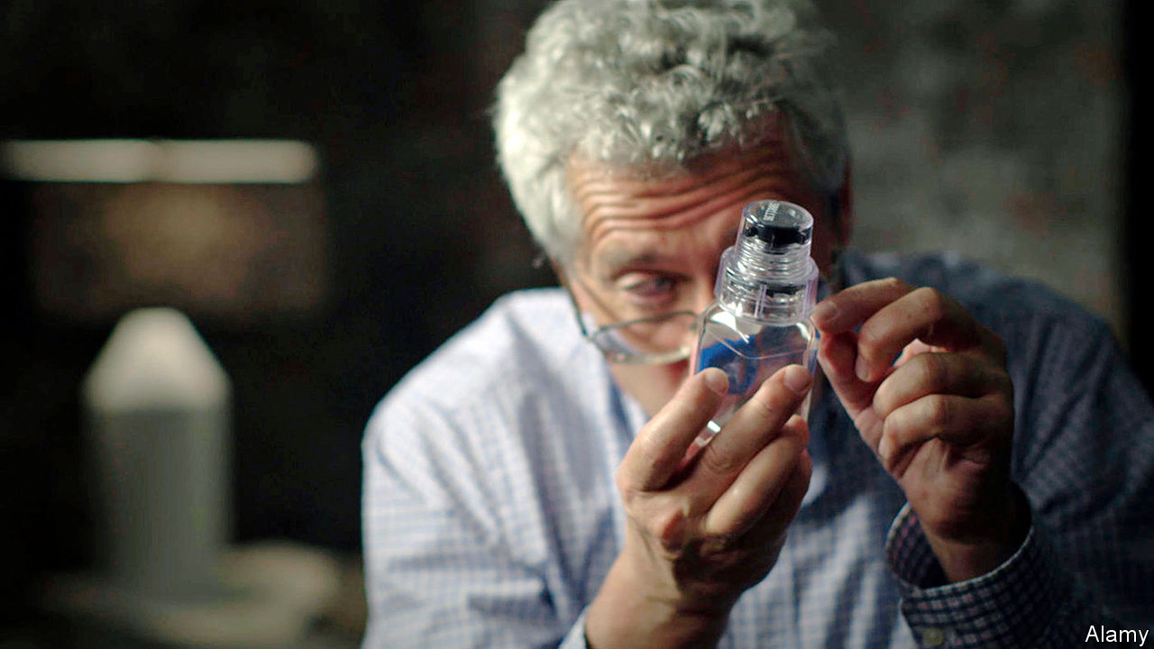

The Rodchenkov Affair: How I Brought Down Russia’s Secret Doping Empire. By Grigory Rodchenkov. WH Allen; 20 pages; £20.

AS A YOUNG man in the Brezhnev-era Soviet Union, Grigory Rodchenkov dreamed of becoming a champion long-distance runner. He wasn’t good enough. Instead, after training as a chemist, he made it to the top of another discipline: doping. His engaging memoir tells the story of how, as head of what was in theory Russia’s national anti-doping laboratory, he masterminded a huge, state-sponsored cheating operation, culminating in the biggest fraud in sporting history: the jaw-droppingly brazen sample-swapping shenanigans at the Winter Olympics of 2014 in the Russian city of Sochi, for which the host country was eventually fingered and banned from international competitions.

His book covers a lot of ground at speed: the history of drugs in sport; the half-hearted efforts of global authorities to crack down; the geopolitical rivalries driving cheating; the pettiness and vindictiveness of Russia bureaucracy; and the morality of doping. Despite his whistle-blowing, Mr Rodchenkov himself remains ambivalent about steroid use. Done judiciously, it can be less harmful than overtraining, he says.

Doping is in Russia’s sporting blood. It seemed quite normal to Mr Rodchenkov to inject Retabolil, a Hungarian steroid, in his early 20s, his mother administering it in their cramped flat in Moscow. Elite athletes took copious quantities. One coach boasted of injecting more than 50 race-walkers a day. In 1984, the author says, the Soviet Union had an abortive plan to send a ship with a secret lab to the port of Los Angeles, to assist with doping for the Olympics (which the Soviets ultimately boycotted).

The “medals over morals” policy, as Mr Rodchenkov calls it, was stepped up under Vladimir Putin, who saw Olympic success as a way to project power in the post-Soviet world. After the embarrassment of the Vancouver Winter Olympics of 2010, in which Russia won just three golds, and with Sochi next, officials were loth to leave anything to chance. Mr Rodchenkov and his team developed a highly effective cocktail of steroids, known as the Duchess, dissolved in Chivas Regal (or vermouth for those who liked it sweeter). During the games, Russian medal contenders’ urine samples were passed through a “mousehole” in the wall of his Sochi lab at night, taken by FSB (security-service) agents who had worked out how to open supposedly tamper-proof bottles without leaving marks, replaced with clean pee and passed back. A spook posing as a plumber oversaw the scam.

Mr Rodchenkov was very good at his job. Across five winter and summer Olympic games, not one elite athlete under his guidance was caught during competitions. The trick, he says, was to offer the odd sacrificial lamb lower down the pecking order so as not to look suspicious. In one case, when a well-known biathlete’s sample tested positive as inspectors from the World Anti-Doping Agency (WADA) looked on, he managed to switch the paperwork, leaving an unknown wrestler to take the fall.

Keeping one step ahead in the cat-and-mouse with WADA and global sports administrators was not hard; WADA was a “hot air machine”, hobbled by indecision. Olympic officials talked tough on doping control but worried that scandals would scare off sponsors and audiences. In the end, this impotent anti-doping regime was forced to get much tougher after a series of revelations in the international media.

The author has since attained celebrity as a snitch, starring in an Oscar-winning documentary, “Icarus” (see picture), and having an American anti-doping law named after him. But his status has come at a cost. Granted political asylum in America, he lives in protective custody in an undisclosed location. When he leaves home, flanked by at least one bodyguard, he sometimes wears a bulletproof vest. He has reason to worry, given Russia’s vengeful attitude to “traitors”. Two former doping officials who stayed in Russia died 11 days apart in mysterious circumstances.

His erstwhile paymasters have been forced to admit violations, but hardly appear chastened. Russia is appealing against a four-year Olympic ban. It continues to play games, submitting “a clumsily adulterated pack of lies” to WADA investigators, which, says Mr Rodchenkov, was “so artlessly counterfeited that it was almost as if they were begging to be caught”. Paraphrasing George Orwell, he concludes that the Russian state is as conscious as ever of the truth, but as wedded as ever to lies. ■

This article was downloaded by calibre from <https://www.economist.com/books-and-arts/2020/08/01/memoirs-of-a-champion-russian-doper>

|  |  |  |  |
| --- | --- | --- | --- |
| Previous | Articles | Sections | Next |

|  |  |  |  |
| --- | --- | --- | --- |
| Previous | Articles | Sections | Next |

#### Lines of beauty

# Sexism and self-discovery in Reykjavik

“Miss Iceland”, Audur Ava Olafsdottir’s latest novel, is captivating

Aug 1st 2020 |

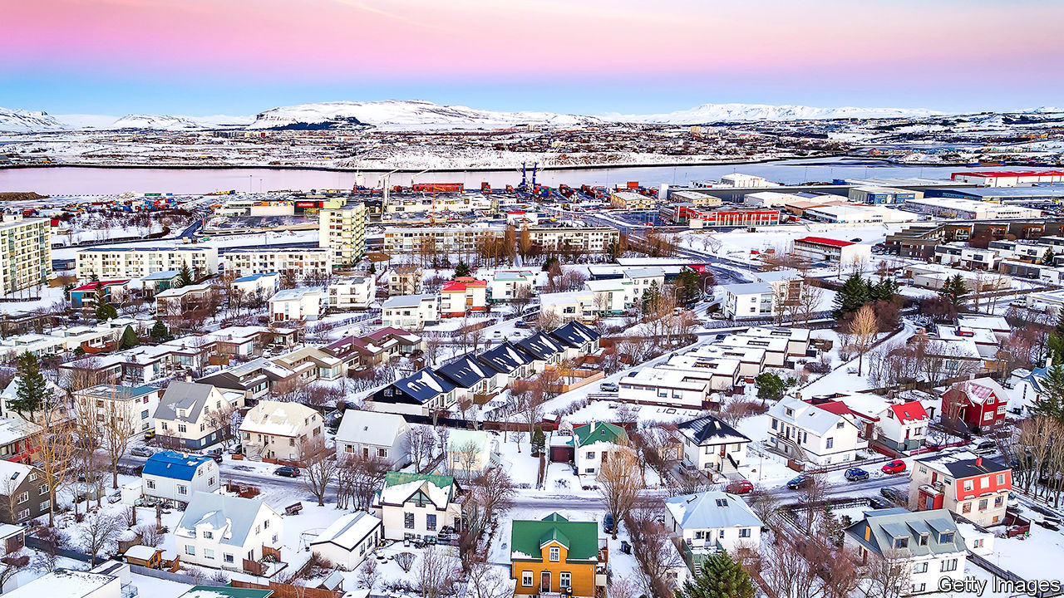

Miss Iceland. By Audur Ava Olafsdottir. Translated by Brian FitzGibbon. Grove Press; 256 pages; $16. Pushkin Press; £9.99.

ONE OF ICELAND’S most celebrated authors, Audur Ava Olafsdottir writes quirky and beguiling fiction about people who leave familiar environments, venture into the unknown and end up learning more about themselves than about their new surroundings. In “Butterflies in November”, a woman turns her back on her worries and heads off with her best friend’s deaf-mute son, her three goldfish and her recent lottery winnings on a zany yet enlightening Icelandic road-trip. In the grittier “Hotel Silence”, a suicidal man books a one-way flight to a war-torn country, but instead of fulfilling his death-wish acquires a fresh lease of life.

In “Miss Iceland”, her latest novel to appear in English—smoothly translated by Brian FitzGibbon—the protagonist embarks on a journey of self-discovery when she moves from her sparsely populated home region to the capital. Her attempts to settle down in a big city and achieve her ambitions in a conservative world make for an absorbing, bittersweet tale.

Hekla arrives in Reykjavik in 1963 with grand plans to become a writer. Almost immediately she is offered a different kind of opportunity. A board member of the Reykjavik Beauty Society tells her it is looking for “unattached maidens, sublimely endowed with both clean-limbedness and comeliness” to participate in the Miss Iceland contest. Hekla declines, but quickly learns that men call the shots and value her looks more than her literary talent.

One who doesn’t is her childhood friend Jon John, who gives her a room of her own in which to write. A gay man who wants to make theatre costumes but instead endures hard graft and homophobia on fishing trawlers, he is one of several characters stuck in a rut. Another is Isey, a housewife who battles loneliness and domestic drudgery in her basement flat while her husband is away. Determined to be different, and desperate to leave behind the leering and groping diners she serves in her waitressing job, Hekla redoubles her efforts to finish her manuscript and get published. Praise from her boyfriend, a less gifted writer, spurs her on: “You’re the glacier that sparkles, I’m just a molehill.” However, as a woman, she finds some avenues closed, and she and Jon John decide to cut their losses and search for freedom and artistic success farther afield.

In previous books, Ms Audur Ava Olafsdottir occasionally relied too much on eccentric foibles and hare-brained antics. In “Miss Iceland” she judiciously downplays the oddities, particularly when exploring weighty issues such as sexual harassment and discrimination. In other welcome changes, she incorporates world events and numerous references to Iceland’s rich literature. And yet this captivating novel’s finest component is its endearing heroine who, at her journey’s end, has learned to follow her dreams but know her limits. ■

This article was downloaded by calibre from <https://www.economist.com/books-and-arts/2020/08/01/sexism-and-self-discovery-in-reykjavik>

|  |  |  |  |
| --- | --- | --- | --- |
| Previous | Articles | Sections | Next |

|  |  |  |  |
| --- | --- | --- | --- |
| Previous | Articles | Sections | Next |

#### Sums of all fears

# How to debunk dodgy data

Carl Bergstrom and Jevin West explain the ways to spot doubtful claims

Aug 1st 2020 |

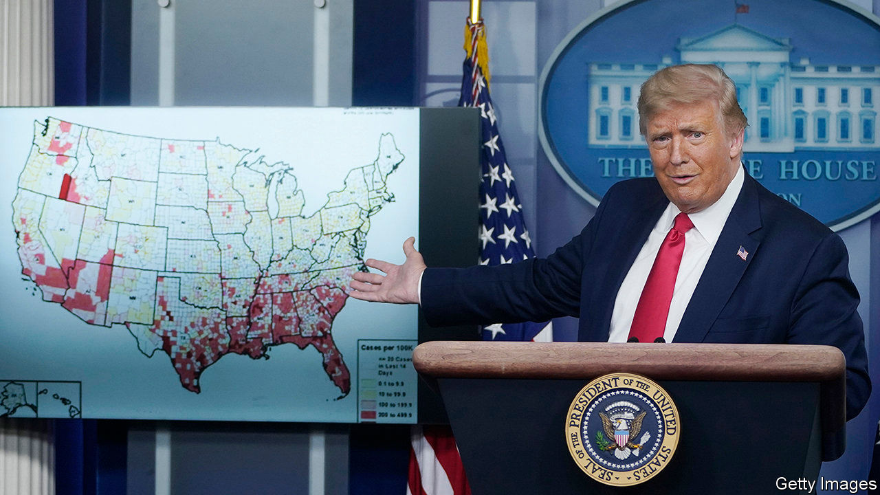

Calling Bullshit: The Art of Scepticism in a Data-Driven World. By Carl Bergstrom and Jevin West. Random House; 336 pages; $30. Allen Lane; £20.

ON JULY 2ND the American state of Georgia counted a total of 87,709 cases of covid-19. Fifteen days later the number had risen to 135,183. Yet the state government’s online heat map looked largely the same. There appeared to be no increase in the number of crimson red areas where the outbreak was most severe. How come?

As it turned out, the threshold for places to turn red had been lifted from 2,961 cases to 3,769. This example of misleading data visualisation was called out by Carl Bergstrom and Jevin West. It joined the ever-growing catalogue of “bullshit”, malign and otherwise, which they debunk for students at the University of Washington.

Out of that course they have spun “Calling Bullshit”, a helpful guide to navigating a world full of doubtful claims based on spurious data. Using clever anecdotes, nods to online culture and allusions to ancient philosophy, the book tells ordinary readers how to spot nonsense—even if they are not numerical whizzes. As well as sketching the difference between correlation and causality, the authors outline visualisation techniques and explain machine learning to arm people against assertions that seem, and so probably are, either “too good or too bad to be true”.

There is, alas, no shortage of material. In one of their examples, a widely shared scholarly article seems to show that musicians from genres such as rap and hip-hop die much younger than those who play blues or jazz. The researchers in question calculate that half of all hip-hop musicians are murdered—a classic case of a claim too bad to be true. Messrs Bergstrom and West show where they went wrong: the raw numbers are not incorrect, but the picture they paint is incomplete, because they discount performers who are still alive. As rap music only began in the 1970s, rappers who have already died tend to have done so younger than those from the more venerable genres cited in the article.

The ways of deceit and error with data are many—and the authors point them out ruthlessly. Their fellow scientists, the media, the “TED brand of bullshit”: no one is spared. They describe how the findings of a study can be manipulated to make them seem statistically important even when they are not, and how feeding an algorithm skewed inputs yields unreliable results. For instance, in 2017 two scientists sparked ethical concerns by claiming to have built an algorithm that could guess whether a person was gay or straight on the basis of pictures gleaned from a dating site. The paper, which The Economist covered at the time, failed to mention that their “gaydar” may have been responding to variations in how people choose to present themselves (make-up, poses and so on), rather than to authentic physical differences.

While charts depicting the life expectancy of musicians are hardly lethal themselves, purporting to discern a person’s character from dodgy variables is perilous. Amid the pandemic, misinformation about infection rates and the efficacy of drugs—often bolstered by sneaky graphics, as in Georgia—is a particular concern. Some scientists are bypassing the usual peer-review process. Meanwhile newsrooms are under ever-greater pressure to attract clicks. More and more bullshit is contaminating debate. Mr Bergstrom and Mr West picked a good time to expose it. ■

This article was downloaded by calibre from <https://www.economist.com/books-and-arts/2020/08/01/how-to-debunk-dodgy-data>

|  |  |  |  |
| --- | --- | --- | --- |
| Previous | Articles | Sections | Next |

|  |  |  |  |
| --- | --- | --- | --- |
| Previous | Articles | Sections | Next |

#### Home Entertainment

# Ingmar Bergman’s contemplation of plague and death is life-enhancing

“The Seventh Seal” might seem dauntingly sombre. But it has a lighter side

Aug 1st 2020 |

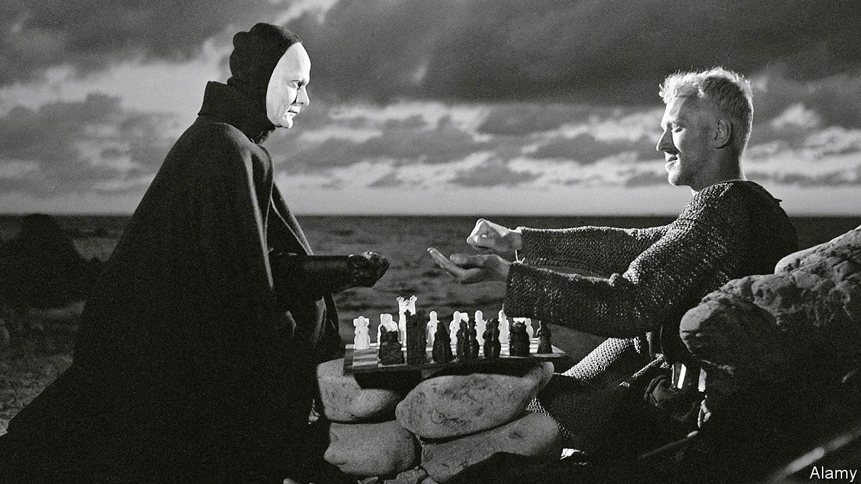

THE INSPIRATION for one of the most legendary (and parodied) images in world cinema lies a half-hour’s drive north of Stockholm, up near the ceiling of a small medieval church. A fresco shows a ghoulish skeleton and a young man, dressed in a green robe and a brown hat, hovering over a large chessboard. The mural at the Taby church was painted in the 1480s. It came to life nearly five centuries later, when it led Ingmar Bergman, the Swedish director, to cast Max von Sydow as Antonius Block, a troubled knight, and to pit him against Death in a chess match.

Death is everywhere in Bergman’s “The Seventh Seal”. It rages in the Holy Land, where Block and his squire Jons have spent years as Crusaders, and back home in Sweden, where the bubonic plague has started to spread. Before it takes him, Block wants to understand whether his life has made any sense, and what might await in the hereafter. To do so he needs time, and to have time he needs to play for it.

Between the chess game to which Block challenges the grim reaper, the ethereal expression fixed on his face throughout the film, and the backdrop of disease, “The Seventh Seal” can seem unbearably heavy, especially during today’s pandemic. Block cannot come to terms with God’s silence. He yearns to have faith in faith, and not in the facile kind either. He scoffs at the monks who claim that the plague is divine punishment, and pities the penitent zealots, with their crosses and relics, whipping themselves senseless with scourges. He meets a young girl accused of being possessed by the devil and soon to be burned at the stake, and stares into her eyes, looking for some greater truth. He finds none. “Faith is a torment,” he says. “It is like loving someone who is out there in the darkness but never appears, no matter how loudly you call.”

But there is a lighter, earthly side to “The Seventh Seal”, in the form of Block’s sidekick, Jons, who thinks of faith as less a torment than a waste of time. “He grins at Death, mocks the Lord, laughs at himself and leers at the girls,” Jons says of himself. “His world is a Jons-world, believable only to himself, ridiculous to all including himself, meaningless to Heaven and of no interest to Hell.”

Jons goes into a church, much like the one Bergman entered in Taby, where he finds a painter putting the last touches to a grisly mural, the “Dance of Death”. What, he wonders, is the point of scaring people like that? To make them think, answers the painter. And if they think, Jons says, they get more scared, and run to religion for solace. Jons and the painter run to a barrel of brandy instead, and get roaringly drunk.

The struggle between man and death is always one-sided, and largely pointless. The chess game is rigged. Von Sydow died earlier this year, Bergman in 2007. Yet as he, the son of a pastor, suggests in “The Seventh Seal”, salvation may await not in the next world, but in this one. ■

Editor’s note: Some of our covid-19 coverage is free for readers of The Economist Today, our daily [newsletter](https://my.economist.com/user#newsletter). For more stories and our pandemic tracker, see our [hub](https://www.economist.com/news/2020/03/11/the-economists-coverage-of-the-coronavirus)

This article was downloaded by calibre from <https://www.economist.com/books-and-arts/2020/08/01/ingmar-bergmans-contemplation-of-plague-and-death-is-life-enhancing>

|  |  |  |  |
| --- | --- | --- | --- |
| Previous | Articles | Sections | Next |

|  |  |  |  |
| --- | --- | --- | --- |
| Previous | Articles | Sections | Next |

#### Perspectives: Hygiene

# How hand-washing explains economic expansion

The history of economic growth is, in many ways, a tale of cleaniness

Aug 1st 2020 | WASHINGTON, DC

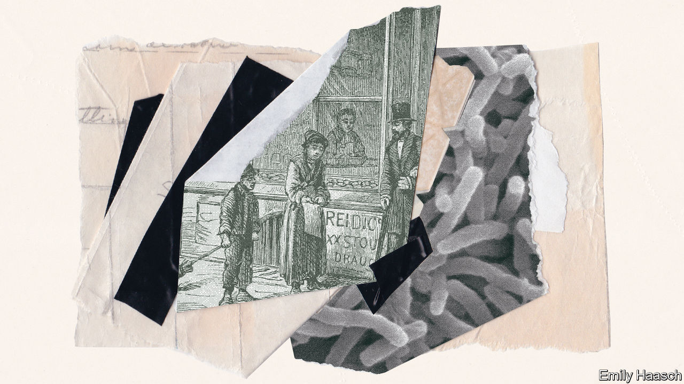

IN THE DECADES after the Industrial Revolution cities choked with dirt. Charles Dickens, the great chronicler of the hardships of early modern life, wrote in “Oliver Twist” of a slum in Bermondsey, in south London, that consisted of “rooms so small, so filthy, so confined, that the air would seem too tainted even for the dirt and squalor which they shelter”. It contained, he continued, “every repulsive lineament of poverty, every loathsome indication of filth, rot, and garbage”.

Today London is a powerhouse. When not besieged by covid-19, its gleaming skyscrapers contain floors of high-income knowledge workers. Its economy accounts for roughly a quarter of British output. Partly thanks to such riches, its residents and those in its commuter belt live longer than those anywhere else in Britain. In Bermondsey the slums have long been replaced with barista coffee shops and art galleries.

London resembles most other cities in the world—in which people, activity and innovation are increasingly concentrated. Two millennia ago, real incomes across much of the world, such as they were, stood between perhaps $1,000 and $1,500 or so in today’s money. Incomes in advanced economies are now 20 times that or more. High incomes are the consequence of decades of compounding economic growth, a process in which urbanisation has played a fundamental role. By crowding people together cities have long been humanity’s best means of creating large markets and gathering places where people come together to exchange ideas; from the Lyceum of Athens to the startup incubators of Silicon Valley.

But whenever people have come together to swap goods and ideas, the exchange of germs has inevitably occurred, too. Indeed, for a time the progress of the industrialising world seemed threatened by the kind of filth that Dickens described. In order to unleash the economic power of humankind, a revolution was required in the way that people live and how they interact with others. To become rich people had to learn how to clean up themselves and their cities. The story of economic growth is in large part a tale of the evolution of hygiene.

The Roman Empire, which had high levels of urbanisation, was repeatedly ravaged by pandemics. These occasionally threatened to topple the state: including, in the 6th century CE, the first major outbreak of bubonic plague, which killed as many as 30m people. When the plague again roamed across Eurasia eight centuries later, claiming the lives of between 30% and 60% of Europeans, it once more followed traders from city to city. People in the 14th century had no knowledge of the microscopic world around them. Illness was commonly viewed as a matter of bad fortune or divine retribution.

Even so, the progression of the bubonic plague from settlement to settlement was obvious enough to make people aware of the threat of contagion. Communities began taking some of the first steps toward preserving public health by closing themselves off to foreigners or otherwise limiting access to their towns. It was this second plague epidemic, which began in 1348 and raged intermittently for five centuries, which gave the world the word quarantine, from the Venetian word quarantena, or “40 days”: the amount of time arriving ships were required to sit in isolation before passengers could come ashore.

Quarantine aside, day-to-day life in the late Middle Ages remained a mucky affair. People ate with unwashed hands from shared plates. They crowded together in close proximity to household refuse and human waste. In homes with earthen floors, residents would often urinate on the ground. Spitting was common; people blew their noses into their hands.

Habits changed slowly—though improvements were rarely responses to concerns about health or disease. Instead, conducting oneself in a manner intended not to cause offence to others became a mark of refinement, and a means of distinguishing a class from the literally unwashed masses. Norbert Elias, a German sociologist, described the centuries-long accumulation of hygienic habits as the construction of an “invisible wall of affects” which activates “at the mere approach of something that has been in contact with the mouth or hands of someone else”.

Consider the use of forks, which slowly spread across Western Europe during the late Middle Ages. These provided a more hygienic means of moving food to the mouth than fingers. But their power as a status symbol derived more from the dainty, dexterous handling required by the utensil. In the absence of a germ theory, fashion could only take society so far. Giovanni Della Casa, an Italian poet and authority on 16th-century etiquette, discouraged his readers from hand-washing after using the privy, “as the reason for...washing will arouse disagreeable thoughts in people”.

## A bar of faith and hope

By the 18th century the first stirrings of a more systematic approach to public health began to appear. Larger cities established public bodies charged with determining when and how to conduct quarantines in response to outbreaks of diseases like smallpox. Many set up hospitals to care for the ill. But it was the beginning of industrialisation, and the associated growth of cities, that proved the most consequential health development of the century.

London’s population roughly doubled in the 18th century, to about 1m inhabitants. It then rose nearly sevenfold in the 19th. That of New York City grew from about 30,000 people to 3.5m between 1790 and 1900. Manufacturing centres across Europe and North America transformed from modest villages to swelling metropolises in the space of a lifetime.

The consequences for public health were devastating. Factories pumped smoke into the air. Sewers emptied waste into rivers and lakes used for drinking water. Epidemics of water-borne diseases like cholera and typhoid killed thousands of people. As a result, death rates in cities were substantially higher than those in rural areas. They were also higher than the urban birth rate. In the early 19th century, as many as half of the children born to the working class in London died by the age of five. Only the steady flow of people migrating from the countryside kept cities from shrinking.

The hardship of city life during the first century of industrialisation fed the deep discontent with capitalism brewing among the working classes. Friedrich Engels, in his writing on “The Condition of the Working Class in England” (1845), made much of the state of sanitation in the districts occupied by poor labourers, like St Giles in London, where “heaps of garbage and ashes lie in all directions, and the foul liquids emptied before the doors gather in stinking pools.”

But dirt posed a greater threat to the sustainability of capitalist growth than socialist thinkers did. High urban mortality rates placed a ceiling on the extent to which early industrial societies could urbanise, of about 30%—or roughly the share of the population of the Netherlands considered urban in the 18th century. The deadliness of industrial cities became a bottleneck to modern economic growth.

Such terrible conditions slowly moved people to demand action. Nascent studies on chronic infectious disease made clear that cities themselves were deleterious to health, though the best minds of the day could not be certain precisely why. This was no small problem. The rapid pace of change within cities, and the sheer number of sources of nastiness which might contribute to ill health, made the problem of spurious correlation nearly insurmountable.

Some 18th-century scholars speculated that ailments might pass from person to person through the movement of unknown microscopic particles. In the absence of the equipment and know-how needed to detect such particles, empirically serious scholars dismissed the notion in favour of the idea that miasma, or foul air, was the cause of infectious disease. The theory found further favour with businessmen who disliked the trade-interrupting effects of quarantines and reformers keen to clean up the cities.

In the 19th century scores of public-minded individuals began pitching schemes to clean up cities. Edwin Chadwick, a British lawyer who contributed to the reform of the English Poor Laws, oversaw the drafting of a scathing report on sanitary conditions in Britain, published in 1842, which documented that the average age of death for tradesmen in London was just 22, and for labourers just 16. Chadwick cited miasma as the chief contributor to infectious illness and called for large-scale public investments in drainage and sewage systems. Similar figures across the industrialising world sought to build support for policies to clean up deadly cities. Dickens was one of them.

It was not easy. Despite reports such as Chadwick’s, scientific understanding remained scant. In 1849 The Economist declared that:

The belief in contagion, like the belief in astrology and witchcraft, seems destined to die out; and as we have got rid of all regulations for consulting the starts or attending to omens before we begin any undertakings, and of all the laws against feeding evil spirits and punishing witches, so we shall no doubt in time get rid of the quarantine regulations that were established from the old belief in contagion.

So too did stubborn citizens grow weary of the lecturing of muckraking do-gooders. By 1854, outbreaks of infectious disease had killed thousands of Londoners of all classes, and yet an editorial in The Times huffed, “We prefer to take our chance of cholera and the rest rather than be bullied into health.”

Instead the concept of a collective responsibility to invest in public goods had to be cultivated. As Johan Goudsblom, a Dutch sociologist, noted: “Increasingly, it dawned upon the rich that they could not ignore the plight of the poor; the proximity of gold coast and slum was too close.” Governments at all levels began to take on direct responsibility for tidying up large cities. Removal of household waste, cleaning of streets, provision of fresh running water and universal connection to sewage slowly became the norm.

The effects of this sanitary revolution were dramatic. Though data from the late 18th and early 19th centuries are patchy and flawed, the broad picture is clear. Across industrialising cities, mortality rates, for the young especially, held steady at high levels or climbed slightly in the early 19th century, as rapid urbanisation unfolded, despite a dramatic decline in smallpox mortality over this period associated with the rise of inoculation. From around 1840, however, a trend toward declining mortality rates began to take hold. Life expectancy at birth rose about 6 years, on average, across large British cities from 1838 to the end of the century. In Paris it rose by about ten years over this period; in Stockholm by roughly 20. In America the crude death rate per 1,000 people rose in New York City from about 25 in the early 1800s to roughly 35 in 1850, before falling to near 20 by the end of the century. Trends in other large American cities were similar.

## Manners maketh men, and women too

Not all of the improvement in health can be attributed to improvements in sanitation and hygiene. Over the course of the 20th century, economists have debated the relative importance of other factors such as improved medical techniques (in midwifery, in particular) and better nutrition associated with rising incomes. Indeed, nutritional gains do seem to have played a meaningful role in reducing mortality. But the contribution from better diets is difficult to assess, given the fact that the bodies of people who grow up in disease-ridden environments are less able to retain nutrients from the food they eat.



Similarly, while some research suggests that municipal investments in public-health measures can explain most or nearly all of the decline in mortality in the late 19th century, it is difficult to be certain. Cities in which public support for sanitary investments was high, for example, might have been more aware of public-health information generally, and more inclined to practise good personal hygiene.

The effects of declining urban-mortality rates were profound. Healthier cities accelerated the process of urbanisation by boosting the natural rate of increase (births less deaths) within cities. The cap on urban population share placed by high mortality in cities was removed; by the end of the 19th century nearly 80% of the British population lived in towns and cities.

Perhaps more dramatic, however, was the effect of the decline in mortality on the skill level of the workforce. Falling mortality rates, in cities especially, began a process known in the social sciences as the “demographic transition”. The pace of population growth and urbanisation both accelerated. As more children survived to adulthood, families began having fewer of them. Meanwhile industrial economies’ increasing demand for skilled workers raised the return to education. Families began to invest more heavily in the schooling of each child; longer lifespans meant the pay-off to investments in education grew.

The cycle of increasing technological sophistication and increased educational attainment lifted incomes across the economy. So did the effect of slower population growth, which allowed for faster growth in levels of capital per worker. It was the fall in urban mortality in the 19th century that finally launched the world into an era in which brains dominated brawn.

By the end of the 19th century, the bacteria responsible for many endemic infectious diseases had been identified. The first half of the 20th century brought about the discovery of antibiotics and the development of vaccines against a host of viral scourges. Over the course of the century, matters of public health once again shifted in the direction of personal responsibility: toward diet, fitness and lower consumption of alcohol, drugs and the like. Hygiene, meanwhile, became a matter first and foremost of fashion and class, in the rich world at least. For well-heeled metropolitan types, personal care—the juice cleanses, pilates sessions, skin treatments and so forth—is a matter of vanity and identity as much as an effort to prolong life or contribute to the broader public health.

Yet recent history illustrates once more that public health is often a matter of collective action. In the 1980s and 1990s the HIV/AIDS epidemic shook a world accustomed to thinking of deadly disease outbreaks as a thing of the past. It contributed to new public-health campaigns built on the idea that changes in personal behaviour were an important part of keeping both individuals and society healthy.

More recently a backlash against vaccination has put hard-fought gains against diseases like measles at risk. This trend has reinforced the idea that maintaining collective support for public health, and shifting social norms, is an ongoing battle for policymakers to take seriously. So, too, have the recurring pandemic threats of the 21st century, from SARS to covid-19.

Prosperity now, as ever, relies on human connections within great cities. A world more populous and integrated than ever before will continue to face a serious risk of pandemic disease. What is not yet clear is how many accommodations are needed. What new public investments must be made to prevent contagion from shutting down the world economy? What behavioural changes will persist in the years after this pandemic? Which invisible walls of affects will be erected to reconcile our need to be social with our desire for good health? As sophisticated and modern as we perceive ourselves to be, our clumsy efforts to manage the health risks of a growing global economy might well strike the healthier, richer people of the future as depressingly Dickensian. ■

Editor’s note: Some of our covid-19 coverage is free for readers of The Economist Today, our daily [newsletter](https://my.economist.com/user#newsletter). For more stories and our pandemic tracker, see our [hub](https://www.economist.com/news/2020/03/11/the-economists-coverage-of-the-coronavirus)

This article was downloaded by calibre from <https://www.economist.com/books-and-arts/2020/08/01/how-hand-washing-explains-economic-expansion>

|  |  |  |  |
| --- | --- | --- | --- |
| Previous | Articles | Sections | Next |

|  |  |  |
| --- | --- | --- |
| Books & arts | Sections | Graphic detail |

Economic & financial indicators

Economic data, commodities and markets

.

|  |  |  |
| --- | --- | --- |
| Books & arts | Sections | Graphic detail |

|  |  |  |  |
| --- | --- | --- | --- |
|  | Articles | Sections | Next |

# Economic data, commodities and markets

Aug 1st 2020 |

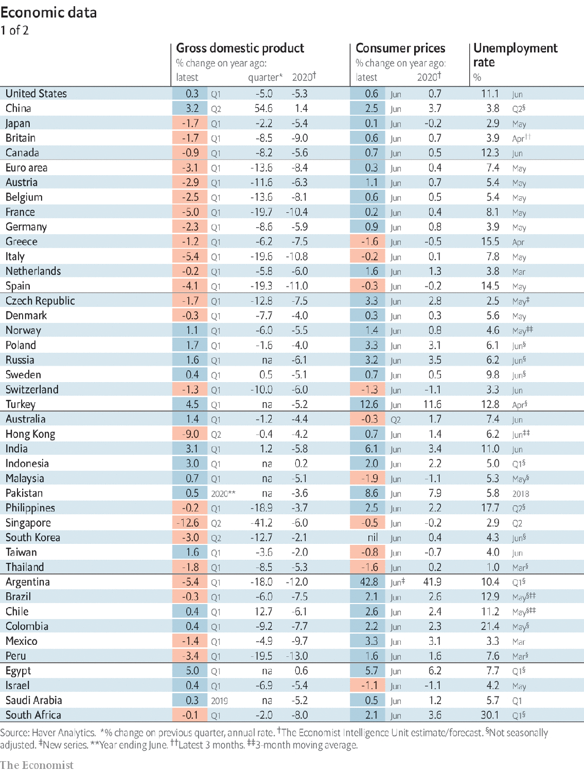

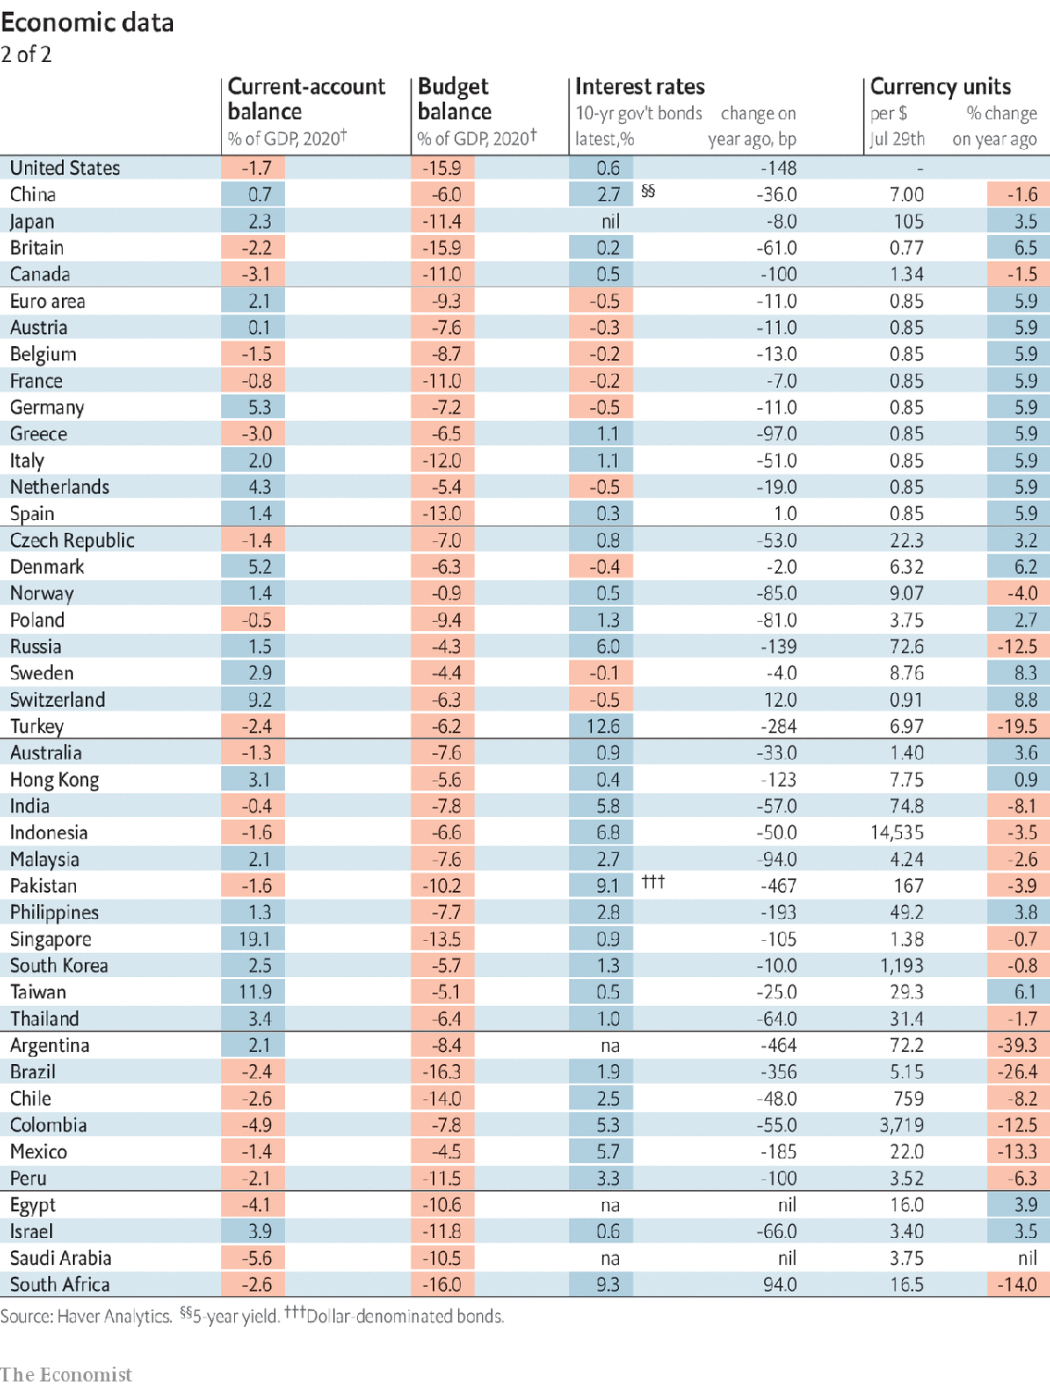

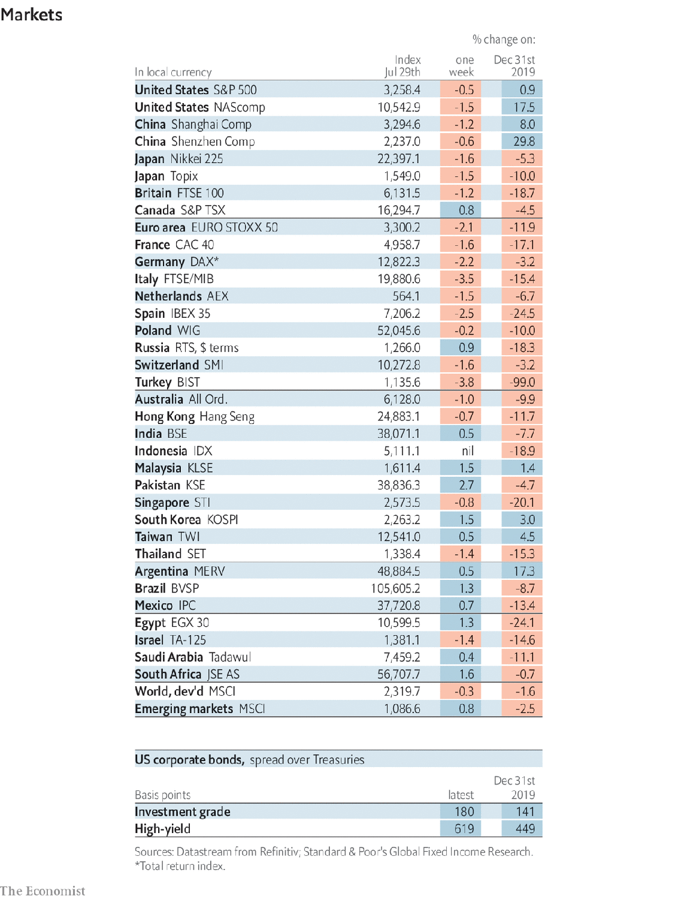

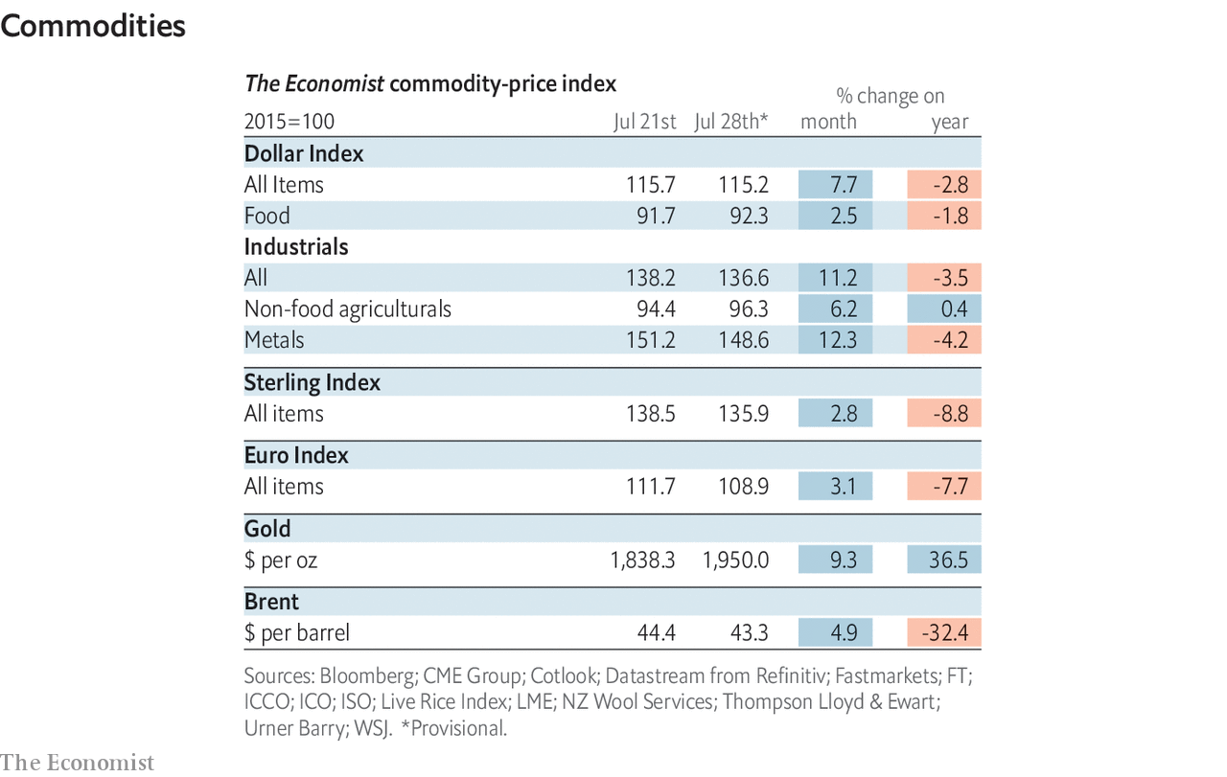

This article was downloaded by calibre from <https://www.economist.com/economic-and-financial-indicators/2020/08/01/economic-data-commodities-and-markets>

|  |  |  |  |
| --- | --- | --- | --- |
|  | Articles | Sections | Next |

|  |  |  |
| --- | --- | --- |
| Economic & ... | Sections | Obituary |

Graphic detail

Twitter’s algorithm: Relevant content

.

|  |  |  |
| --- | --- | --- |
| Economic & ... | Sections | Obituary |

|  |  |  |  |
| --- | --- | --- | --- |
|  | Articles | Sections | Next |

#### Relevant content

# Twitter’s algorithm does not seem to silence conservatives

The platform’s recommendation engine appears to favour inflammatory tweets

Aug 1st 2020 |

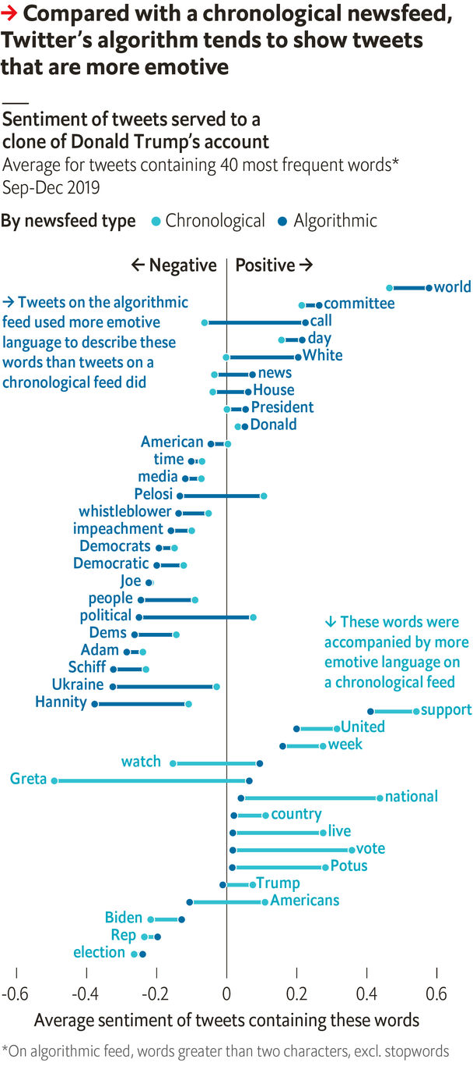

SINCE LAUNCHING a policy on “misleading information” in May, Twitter has clashed with President Donald Trump. When he described mail-in ballots as “substantially fraudulent”, the platform told users to “get the facts” and linked to articles that proved otherwise. After Mr Trump threatened looters with death—“when the looting starts, the shooting starts”—Twitter said his tweet broke its rules against “glorifying violence”. On July 28th the site took down a tweet by Donald Trump junior promoting a malaria drug for covid-19 that plenty of studies discredit.

The president says that “social media platforms totally silence conservatives’ voices.” However, a study by The Economist finds the opposite. Twitter’s feed used to show people the latest posts from accounts they followed, but in 2016 it launched an algorithm to serve “relevant” tweets to users, even if they were days old and from unfamiliar accounts. We compared the two systems, and found that the recommendation engine appears to reward inflammatory language and outlandish claims.

Our experiment began in June 2019, when we created a clone of Mr Trump’s profile. This bot used his picture, biography and location, and followed the same people as he did. We used it to re-post some of the president’s old tweets over several weeks, so that the algorithm could learn what our Trump clone cared about.

Then from September to December we checked every ten minutes if Mr Trump had tweeted something. If so, three things happened. First, our clone repeated the tweet. Second, we checked its Twitter feed and recorded the first 24 posts served by the algorithm. Finally, we simulated what a chronological feed might have looked like, using the 24 most recent tweets by accounts that Mr Trump follows.

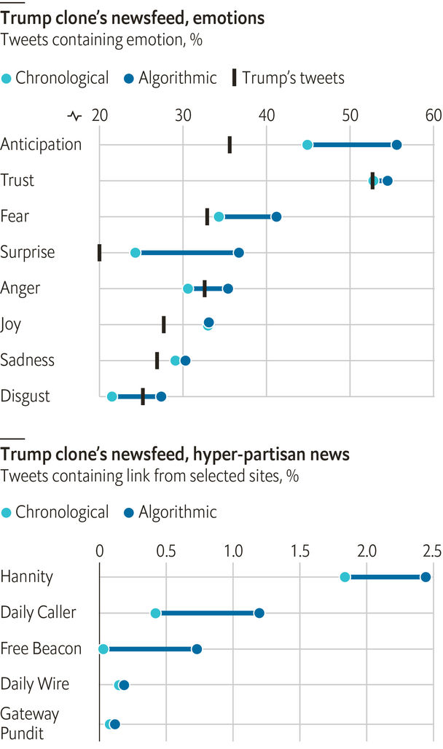

Our algorithmic and chronological feeds differed starkly. Nearly half the recommended tweets were from users whom Mr Trump does not follow. Using sentiment-analysis tools to extract feelings from text, we found the average curated tweet was more emotive, on every scale, than its chronological equivalent—and more so than Mr Trump’s own posts, too.

Sentiment analysis can be confusing. The emotional scores assigned to tweets by, say, Sean Hannity, a right-wing pundit, might be highly negative—not because they reflect poorly on him, but because he stridently criticises others, such as Democrats. Nonetheless, in a sample of 120,000 tweets, the posts recommended by the algorithm were more likely to sit near either end of a positive-to-negative spectrum.

Twitter might also boost extreme views. Researchers at Indiana University have classified a list of left- and right-wing websites as untrustworthy or hyper-partisan. We found 1,647 links to such domains on our clone’s algorithmic feed, but only 895 on the chronological one. (Almost all cases on both feeds were right-wing.)

Our experiment ended when a change in Twitter’s interface broke our bot. The platform also suspended another Trump clone that copied his looting threat. However, if an algorithmic penchant for sensationalism has remained, then Twitter may be amplifying and profiting from misleading tweets, rather than removing them. Its business is serving ads to 330m users, even if that means grabbing their attention by showing them exactly what they want to believe. Flagging a presidential whopper every now and then will not change that. ■

Sources: Twitter; Technology Review; Chen et al. (working paper); The Economist

This article was downloaded by calibre from <https://www.economist.com/graphic-detail/2020/08/01/twitters-algorithm-does-not-seem-to-silence-conservatives>

|  |  |  |  |
| --- | --- | --- | --- |
|  | Articles | Sections | Next |

|  |  |  |
| --- | --- | --- |
| Graphic detail | Sections |  |

Obituary

László Bogdán: The tale of a village

.

|  |  |  |
| --- | --- | --- |
| Graphic detail | Sections |  |

|  |  |  |  |
| --- | --- | --- | --- |
|  | Articles | Sections | Next |

#### The tale of a village

# László Bogdán died on July 14th

The Gypsy mayor who made his Hungarian village famous was 46

Aug 1st 2020 |

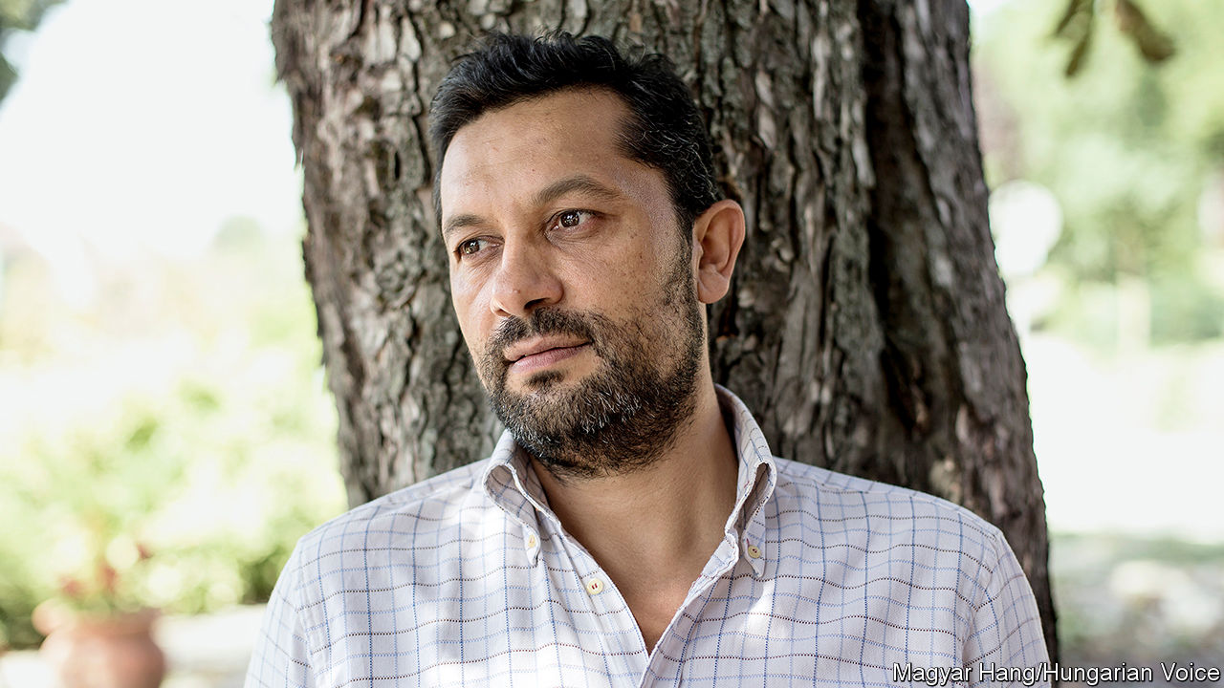

ALONG THE walls of his office in Cserdi, a village of around 350 souls in the gentle hills of southern Hungary, László Bogdán strung several clothes lines. Pegged to them were hundreds of messages written to “Laci”, as they called him: “People are good!” “Our parents have work”. “We have a good mayor”.

These were the voices of the villagers, who since his election as mayor in 2006 had seen their world transformed. Cserdi had once been strewn with rubble and dilapidated houses, with idle, jobless men brawling outside. Petty crime was rampant: up to 300 cases a year, with neighbouring villages terrorised. Now everything was orderly. The houses were neat, and many had gained bathrooms. Small parks had appeared. Out in the fields women worked with hoes, and men with spades, to plant potatoes or dig wells. Four giant plastic greenhouses sheltered crops of peppers and tomatoes. In a good year the village could produce 160,000kg of quality vegetables, with the surplus going to the poor of the county. Officials from far and wide came to inspect this “Cserdi miracle”. But Mayor Laci, pacing up and down with his purple scarf knotted fashionably round his neck, was still dissatisfied. Was it really so special, so exotic, to see Gypsies working?

He spoke as one, a proud Cigány (he hated “Roma”), who revelled in garish shirts that emphasised his Gypsyness, and delivered his vegetables in a red Zsiguli car with a swinging rosary of the sort only Gypsies drove. He showed off Cserdi, where the population was three-quarters Gypsy, to prove that it could be as ordinary as anywhere else. But he knew it was not. The stereotype that most non-Gypsy Hungarians carried in their heads was all too often true: his people (“us”, not “they”, for his people’s sins were his, he took them on himself) were work-shy, cheated, stole, and lived on handouts if they could. The jails were full of dark faces.

Of course, 600 years of history in Hungary had not been kind. Poverty and discrimination, fear of the Other, had stalked his people wherever they went. Under Communism everyone, including Gypsies, was meant to work. Yet it took his father some years to find a job as a miner. Until then, they lived in a shack; he had no shoes of his own until he was 13, and was sent down to scavenge for chewy, rotten meat in the pits where farmers threw the carcasses of their animals. His strongest childhood memory was hunger.

Yet that was no excuse to play the victim. He had never moaned, taking any job he could get after a few indifferent years of school: sweeping floors, packing monitors, eventually becoming production manager in a mobile-phone company. Here was the lesson for “all of us”: Gypsies had to work! If they took responsibility, gained self-respect, hauled themselves up by their bootlaces, prejudice might begin to fade away.

This was the task he set himself as mayor of Cserdi. It was heavy, but he set about it logically. Gypsies belonged nowhere, but if they got land, they could farm it. There was unused land in the village, a rubbish tip; once they had cleared away 15-20 lorryloads of rubble, they could plant potatoes. They then rented 1,200 hectares more. As the enterprise grew, he directed everything. A national public-work scheme provided small wages, but enough. Each day the villagers would gather round him to get their tools and his firm, straight instructions: where they should dig a well, exactly how big it should be, when they should move the paprika plants from the greenhouse. He reminded them what share of their harvest they had promised to give to others, to make them proud: they were givers now, not stealers, not spongers. Then he would wield his spade beside them, getting his hands dirty and urging them on.

The agriculture project was only part of what he was doing in Cserdi. He took village boys to the local jail in Pécs, to show them that if they broke the law they could expect to be buggered there; it shocked them so deeply that crime in the village fell to almost nothing. Teenage girls were taken to universities; would they rather be there at 18, he asked them, or lying on their backs in the wretched local labour ward? Every household’s budget came under his watchful eye, and he would pick through their rubbish too, finding the cigarette packets and beer bottles that proved they were wasting money. He barely had time for girlfriends, certainly not family. The villagers were all his children.

Outside the village, he had enemies. He wanted to see Gypsies integrated and living like other Hungarians, for he was proud of being Hungarian too; he dreamed of dark faces in advertisements, his food in national stores, colour-blind political parties and the money that was spent on self-serving, wasteful Roma minority councils spent, instead, on greenhouses. This didn’t suit those who still wanted to be victims. Others felt that his constant reminders of bad Gypsy ways simply fed the stereotype: he was a self-hater, racist to his own skin. One way and another, he had learned to watch his back when he crossed the road.

Some thought he might make a good Roma leader on the national stage. But he did not want that label. He cared about other minorities too, even inviting migrants—who were hated more than Gypsies now—to come to Cserdi in 2017. Besides, he had no interest in being a “celebrity bastard”. He disliked talking about himself. He was just a semi-literate “scattered soul” who was trying to make his mark on the world, and was doing it in Cserdi. There, his ambitions were still growing. The “Romburgers” the villagers were making for local restaurants were taking off nicely. He was going to produce a range of Gypsy stews in the new processing plant, built with state and EU funds and almost finished. But it was there, on July 14th, that he hanged himself.

He had given no hint of this before. Or perhaps only one: he had admitted that he cried every day, not because he was afraid, but because he felt powerless to do all that had to be done.

In a well-known Hungarian story, two Gypsies were haggling over the price of a horse. As they argued, the horse galloped fast towards a brick wall. “Your horse is blind!” complained the would-be buyer. “Not blind,” said the seller. “Brave.” ■

This article was downloaded by calibre from <https://www.economist.com/obituary/2020/08/01/laszlo-bogdan-died-on-july-14th>

|  |  |  |  |
| --- | --- | --- | --- |
|  | Articles | Sections | Next |